# Molecule Comparisons

## US20070117785A1_p0034_x0977_y2564_c00072

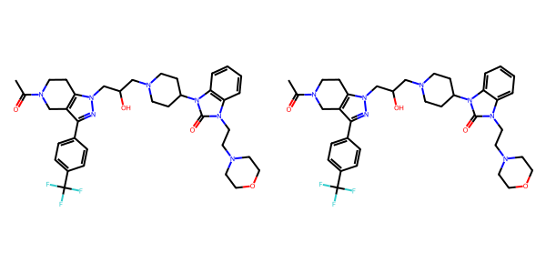

## US20050004369A1_p0017_x1399_y0692_c00023

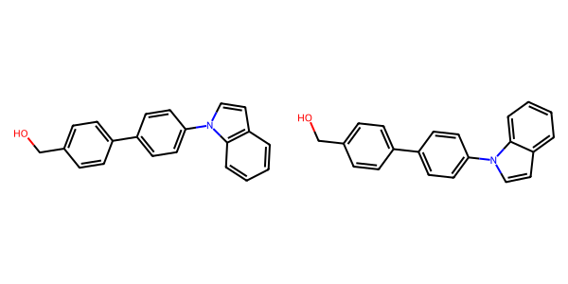

## US20070155803A1_p0002_x1503_y1997_c00000

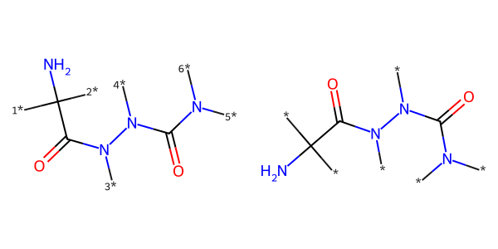

## US20050267177A1_p0023_x0337_y1742_c00072

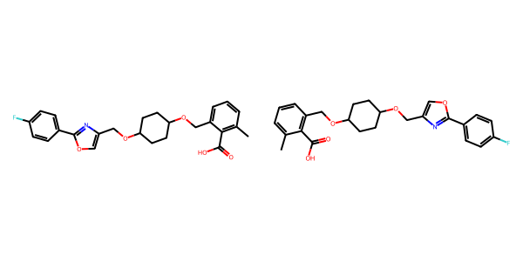

## US20050267177A1_p0034_x0373_y1971_c00127

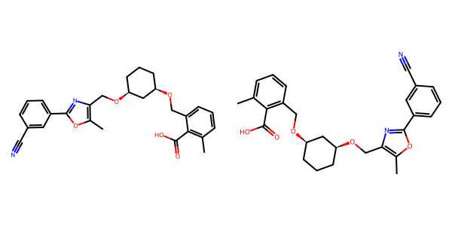

## US20070105909A1_p0025_x0500_y2761_c00061

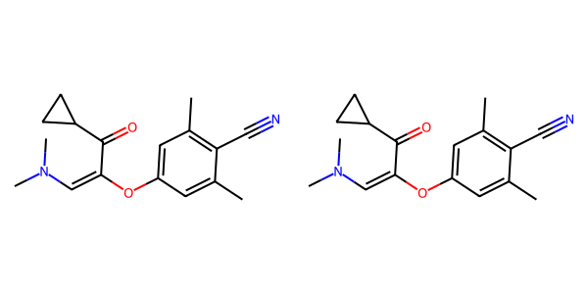

## US20060281700A1_p0071_x0442_y2005_c00098

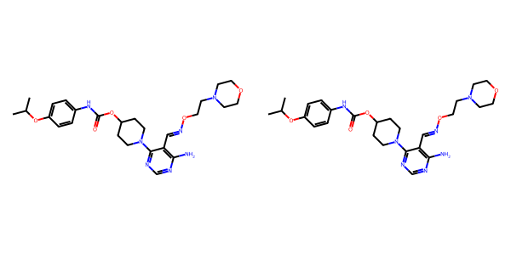

## US20050002859A1_p0024_x1390_y0663_c00121

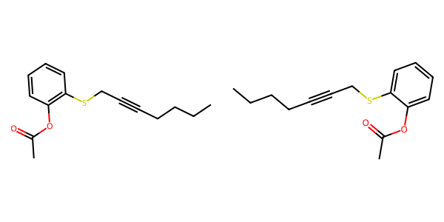

## US20050009817A1_p0023_x0563_y1914_c00076

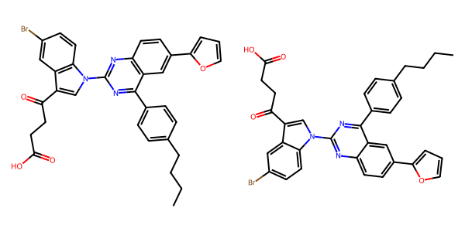

## US20070249620A1_p0006_x1375_y2591_c00009

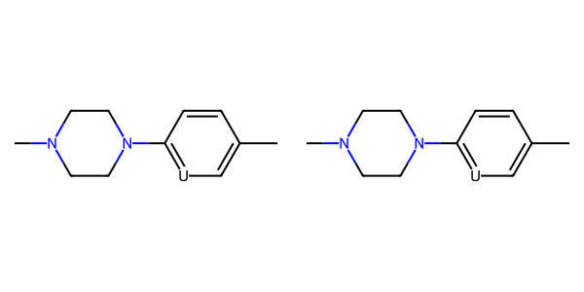

## US20070105909A1_p0025_x1480_y1133_c00062

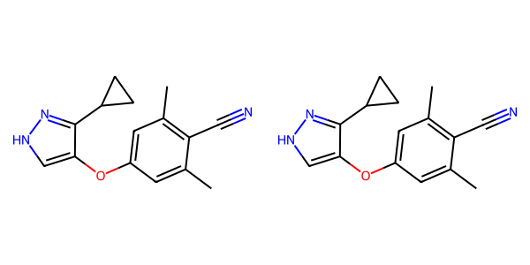

## US20070155803A1_p0023_x0437_y1383_c00047

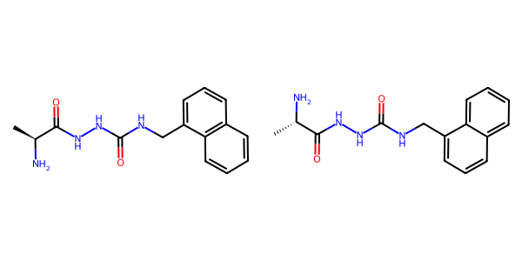

## US20070270434A1_p0019_x1376_y2247_c00047

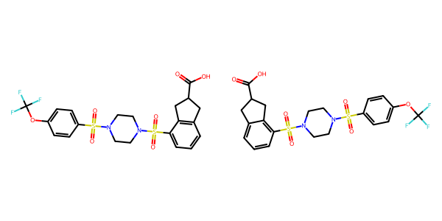

## US20050004369A1_p0031_x0445_y1929_c00060

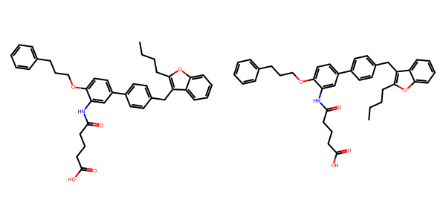

## US20070049758A1_p0023_x0521_y1268_c00038

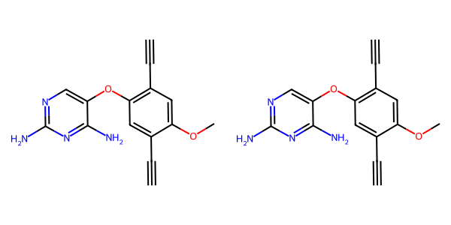

## US20050054819A1_p0014_x1375_y2740_c00047

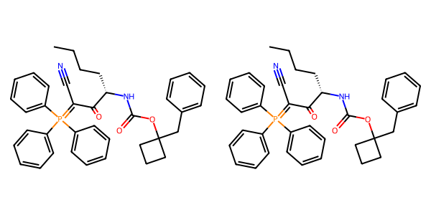

## US20050182067A1_p0039_x0375_y0534_c00148

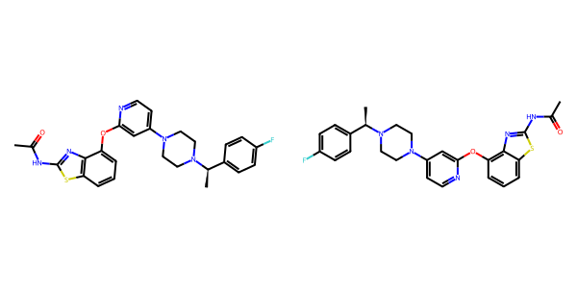

## US20050009817A1_p0016_x1358_y2226_c00056

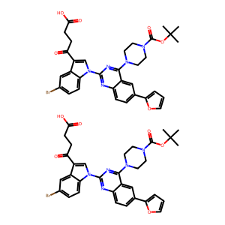

## US20050227932A1_p0031_x1376_y2276_c00051

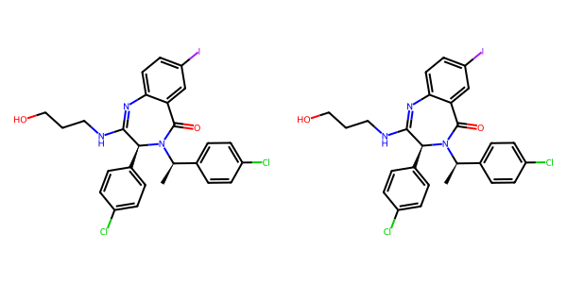

## US20060122222A1_p0027_x1323_y2575_c00081

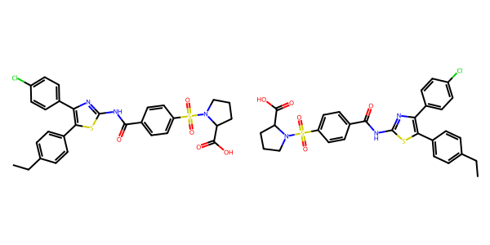

## US20060122222A1_p0006_x1536_y2845_c00004

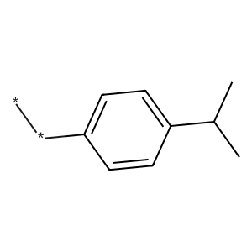

## US20070049758A1_p0023_x0553_y1941_c00039

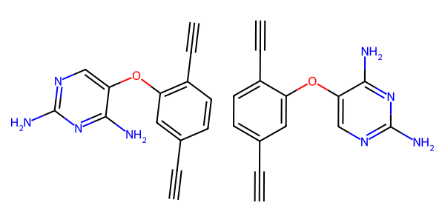

## US20060154945A1_p0012_x1375_y1173_c00035

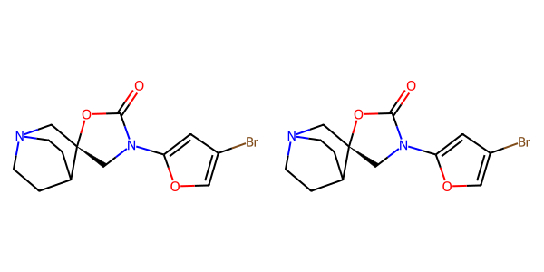

## US20050043351A1_p0018_x1549_y1931_c00057

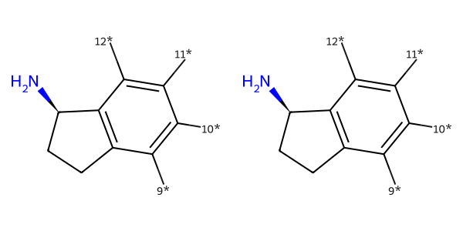

## US20050227932A1_p0036_x1375_y1320_c00065

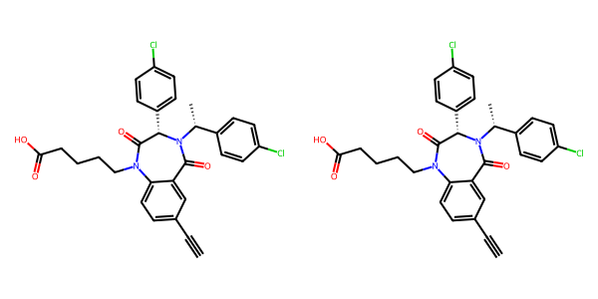

## US20050002859A1_p0022_x1431_y2426_c00111

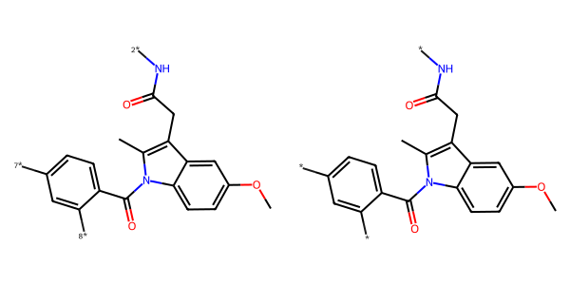

## US20030130506A1_p0043_x0899_y1697_c00142

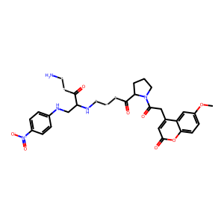

## US20060154945A1_p0019_x0402_y1649_c00070

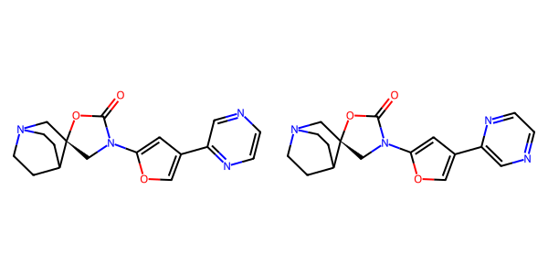

## US20040229890A1_p0002_x0471_y2209_c00000

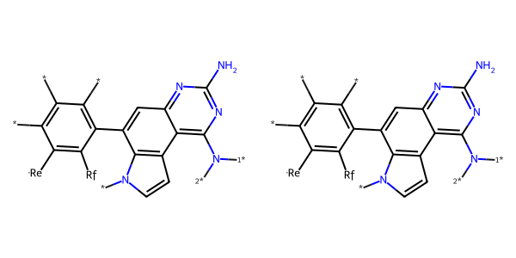

## US20050009817A1_p0032_x0441_y2076_c00092

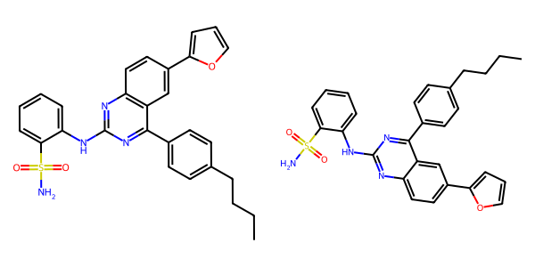

## US20050288357A1_p0011_x0515_y0976_c00006

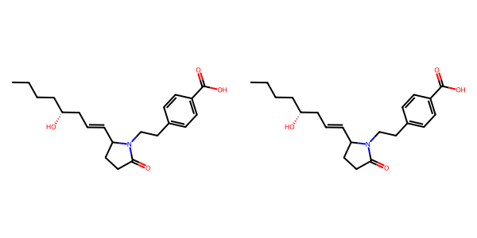

## US20070179154A1_p0045_x0404_y2065_c00064

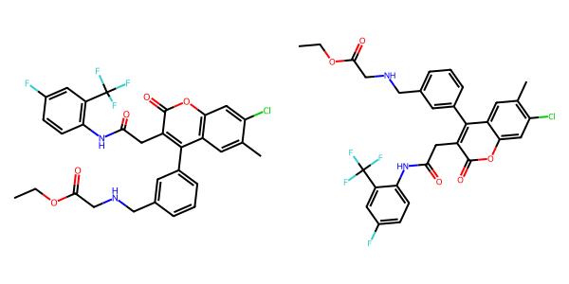

## US20070270434A1_p0024_x0404_y2441_c00067

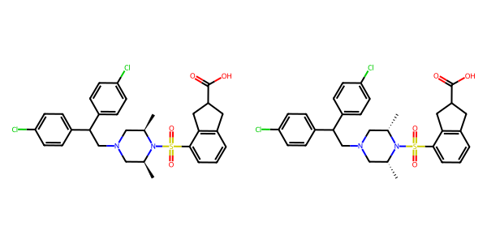

## US20070049758A1_p0018_x0476_y2456_c00020

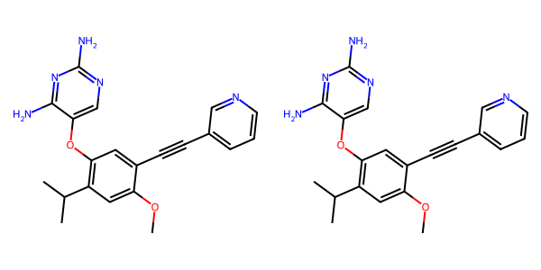

## US20070105909A1_p0018_x1563_y1833_c00027

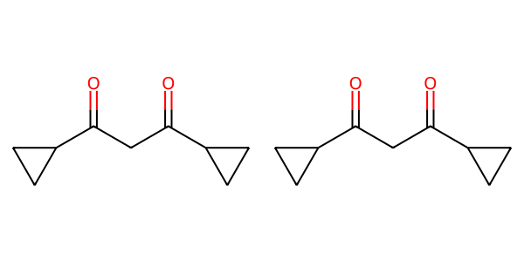

## US20070105909A1_p0026_x1470_y0921_c00066

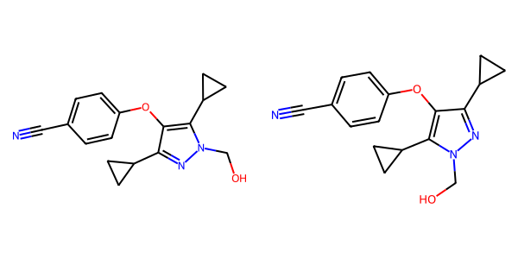

## US20040266789A1_p0031_x1301_y2717_c00054

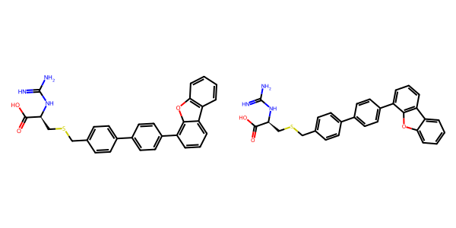

## US20070265270A1_p0026_x0478_y1543_c00104

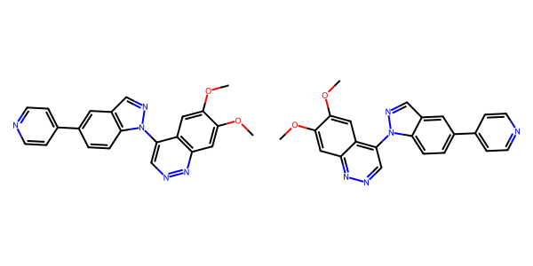

## US20050004369A1_p0021_x1309_y1117_c00033

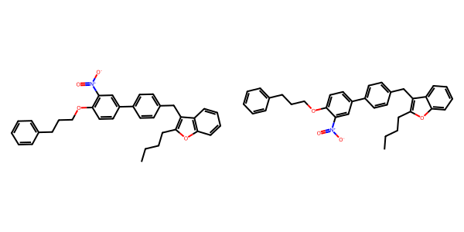

## US20050113580A1_p0042_x0333_y2220_c00064

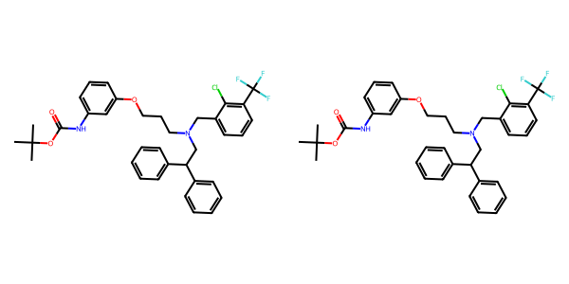

## US20040266789A1_p0043_x1414_y2725_c00072

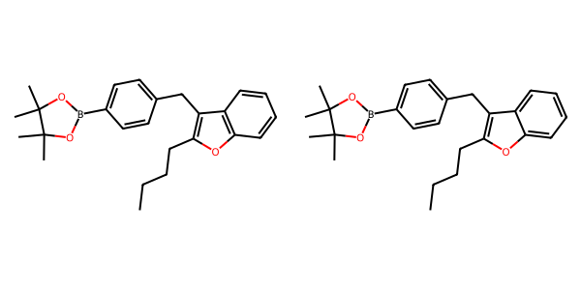

## US20030130506A1_p0046_x1541_y1396_c00157

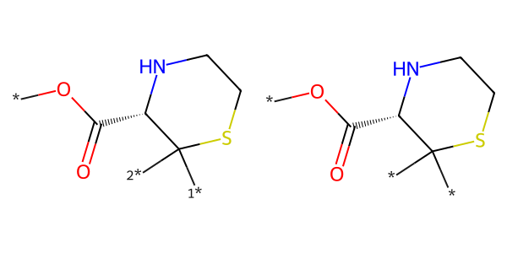

## US20050288357A1_p0057_x0482_y1679_c00112

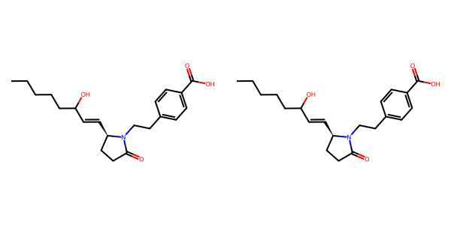

## US20070265270A1_p0029_x1568_y1450_c00117

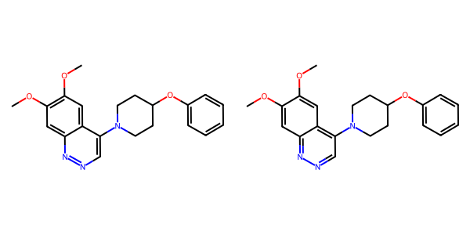

## US20050288357A1_p0012_x0522_y0533_c00012

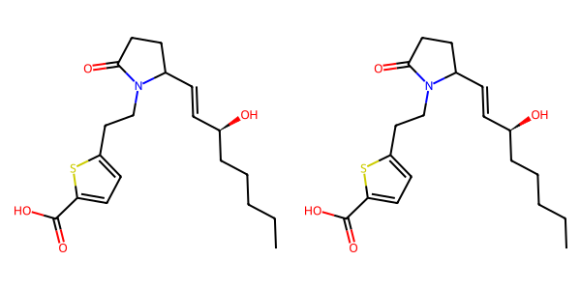

## US20050009817A1_p0020_x0594_y2309_c00068

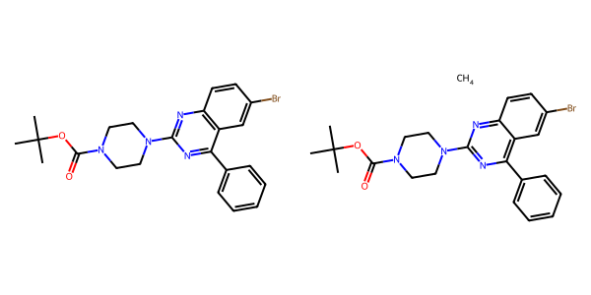

## US20050004369A1_p0032_x0443_y0670_c00061

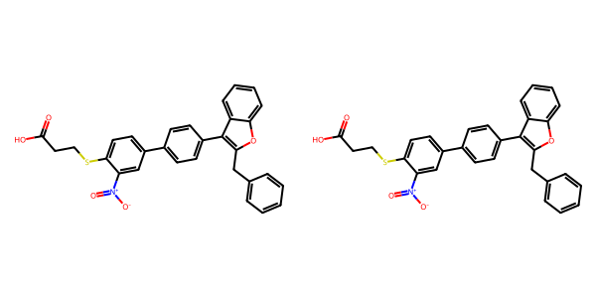

## US20050002859A1_p0015_x1571_y2812_c00093

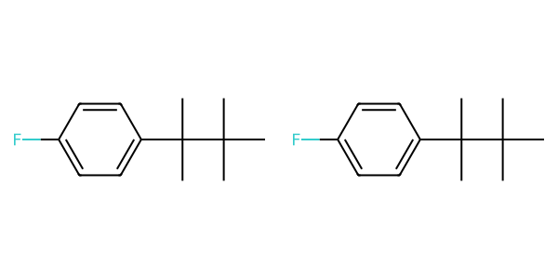

## US20070155803A1_p0017_x1319_y0817_c00023

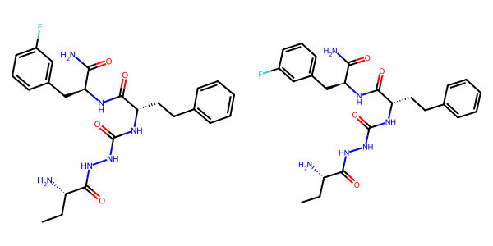

## US20070270434A1_p0023_x1376_y1557_c00064

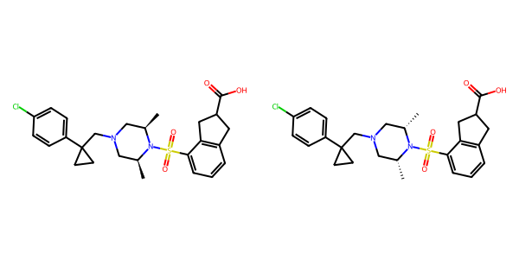

## US20050288357A1_p0038_x1484_y0793_c00069

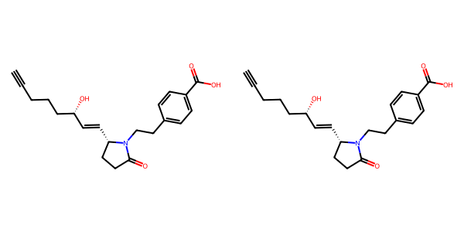

## US20050267177A1_p0018_x1326_y1445_c00045

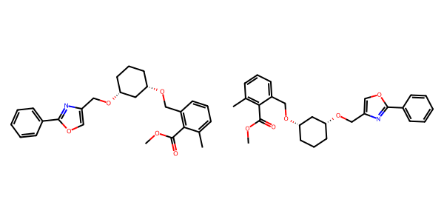

## US20060122222A1_p0025_x1418_y2582_c00073



## US20050009817A1_p0025_x0563_y2390_c00079

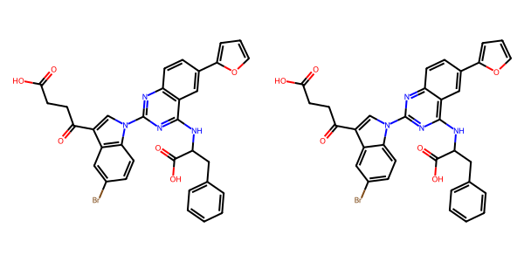

## US20070049758A1_p0024_x0553_y0671_c00041

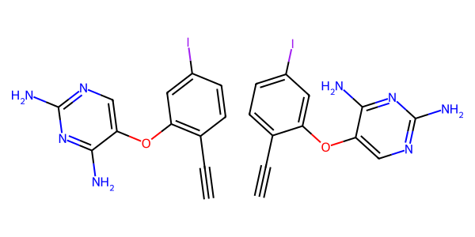

## US20050182067A1_p0029_x1535_y2581_c00099

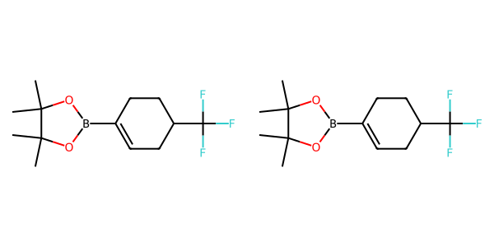

## US20050009817A1_p0037_x0548_y0637_c00105

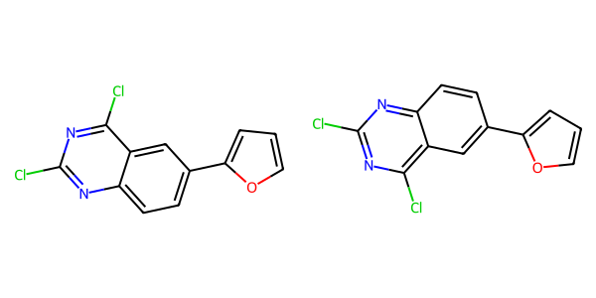

## US20070105909A1_p0021_x0455_y0920_c00037

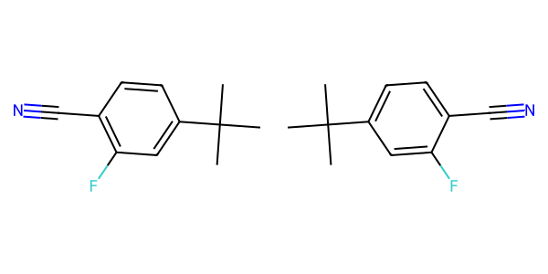

## US20050075347A1_p0027_x0416_y2104_c00062

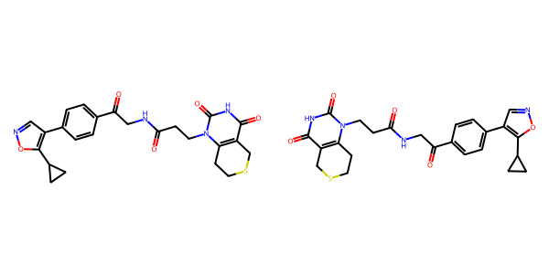

## US20070249620A1_p0018_x1209_y0937_c00010

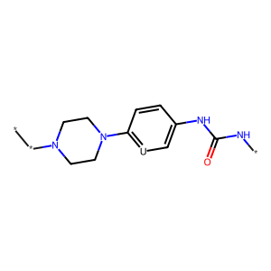

## US20050004369A1_p0024_x1328_y1366_c00041

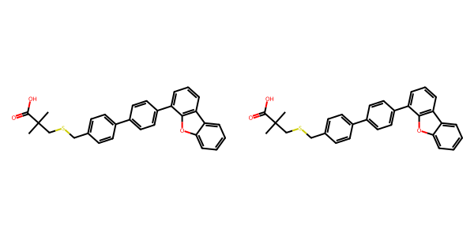

## US20040229890A1_p0013_x1457_y0666_c00057

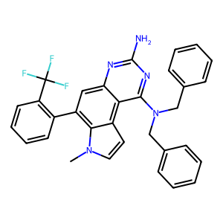

## US20050009817A1_p0021_x0561_y1358_c00070

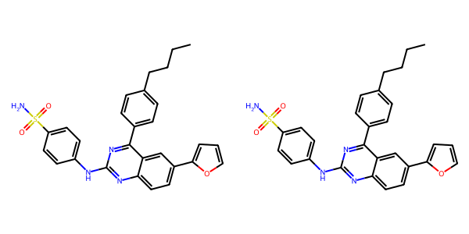

## US20070049758A1_p0026_x0388_y1326_c00051

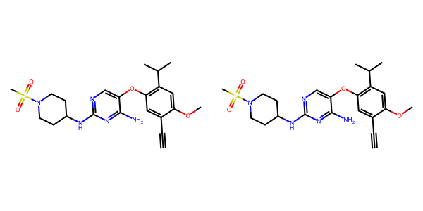

## US20040266789A1_p0040_x1303_y1740_c00067

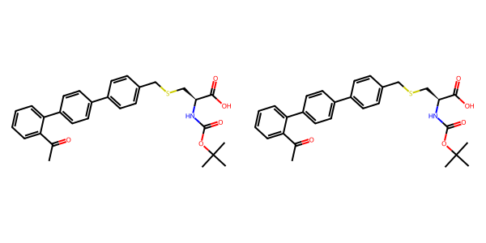

## US20040266789A1_p0046_x0420_y1644_c00078

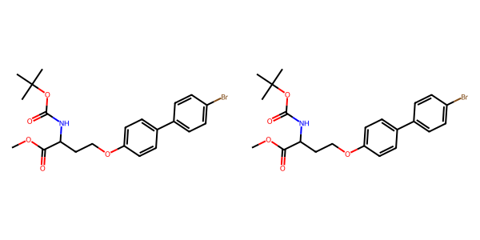

## US20070265270A1_p0030_x0514_y2473_c00121

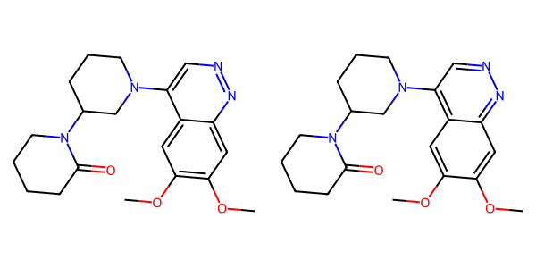

## US20070270434A1_p0018_x0404_y1015_c00039

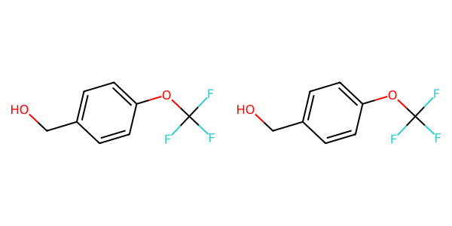

## US20070270434A1_p0017_x1375_y1546_c00037

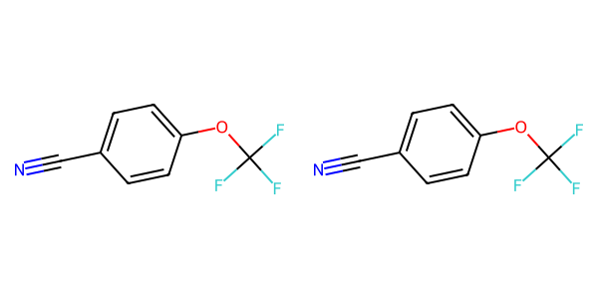

## US20040229890A1_p0016_x0530_y2504_c00071

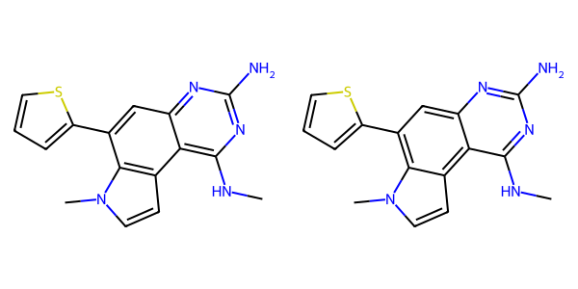

## US20060122222A1_p0025_x0515_y2526_c00071

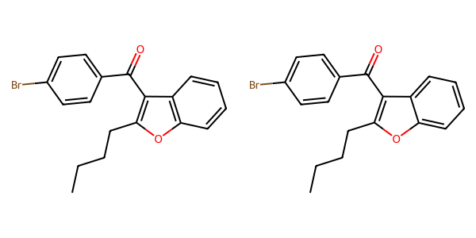

## US20050009817A1_p0032_x1599_y1076_c00093

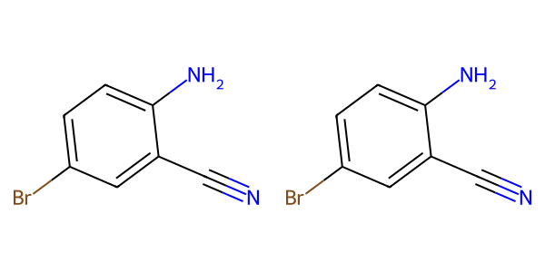

## US20040229890A1_p0014_x0523_y1599_c00060

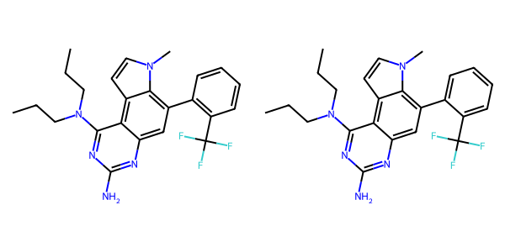

## US20050288357A1_p0063_x0518_y0647_c00115

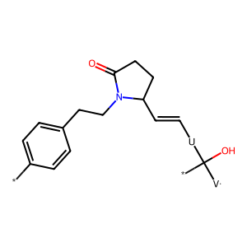

## US20070270434A1_p0016_x1336_y2190_c00033

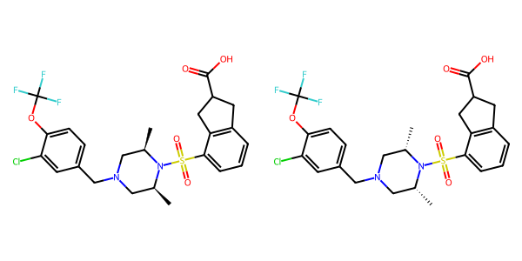

## US20070155803A1_p0015_x1319_y2472_c00017

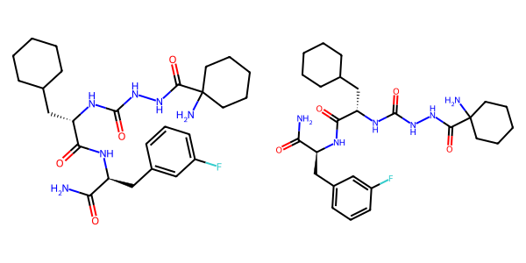

## US20070179177A1_p0031_x1324_y2702_c00165

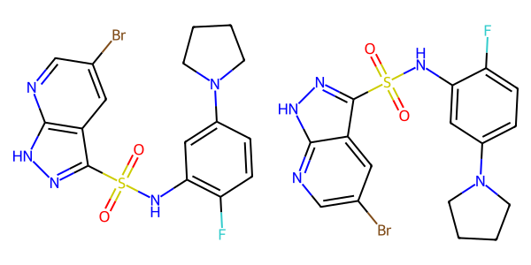

## US20040266789A1_p0033_x0431_y1268_c00056

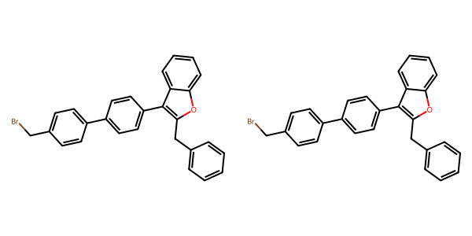

## US20040266789A1_p0045_x0514_y1169_c00075

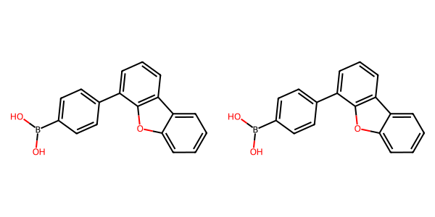

## US20030130506A1_p0010_x0383_y2595_c00033

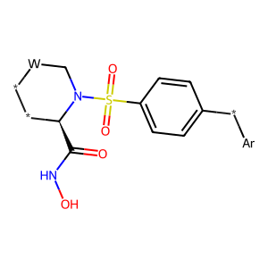

## US20050182067A1_p0030_x0419_y2518_c00102

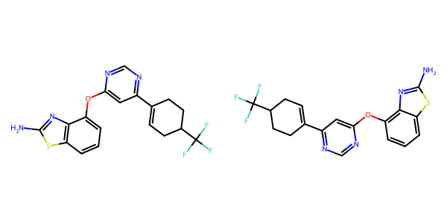

## US20050002859A1_p0016_x0405_y2681_c00096

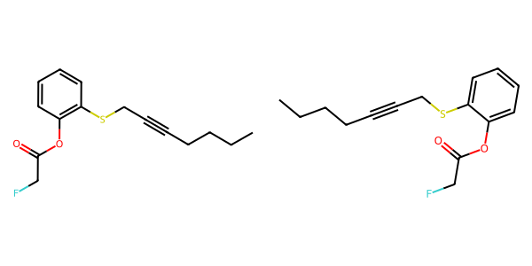

## US20040229890A1_p0016_x0530_y1709_c00070

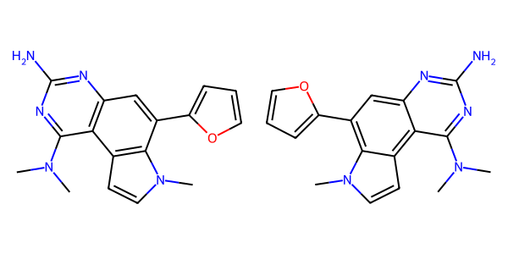

## US20070155803A1_p0029_x0466_y0812_c00069

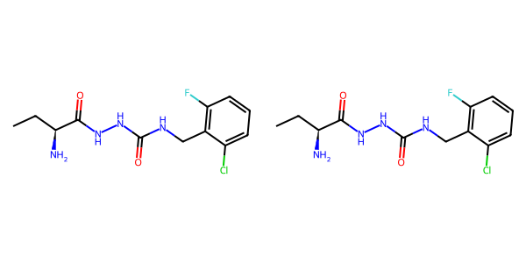

## US20070265270A1_p0024_x0595_y2282_c00095

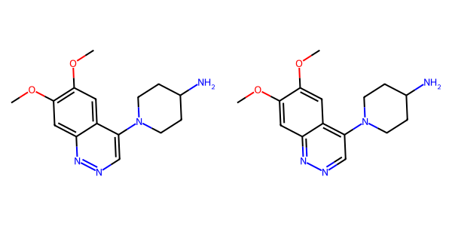

## US20050009817A1_p0032_x0482_y0691_c00091

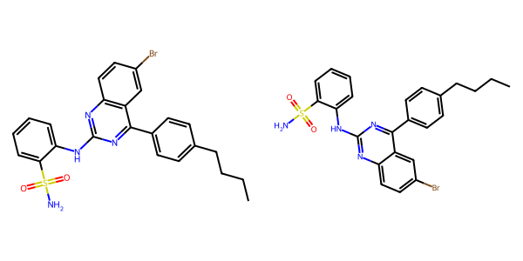

## US20050227932A1_p0027_x1376_y2347_c00035

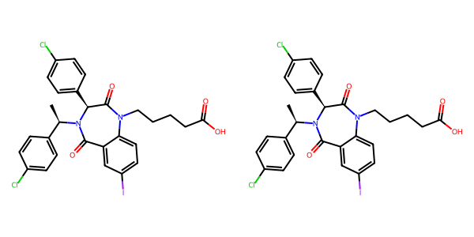

## US20040229890A1_p0011_x1496_y2544_c00050

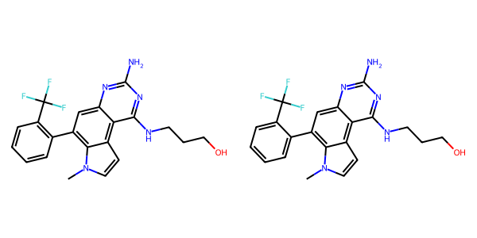

## US20040266789A1_p0022_x1303_y2682_c00041

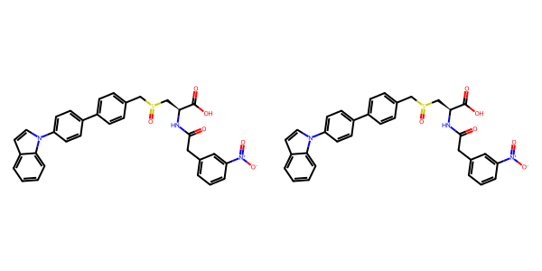

## US20050009817A1_p0036_x0626_y2498_c00102



## US20040266789A1_p0042_x0604_y1041_c00069

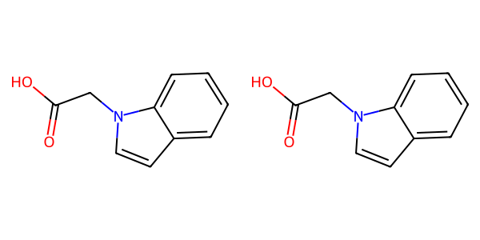

## US20050054819A1_p0014_x0340_y2080_c00044

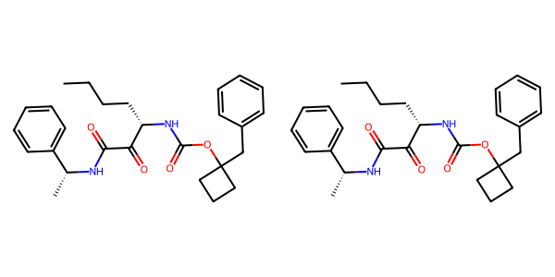

## US20040266789A1_p0037_x0328_y0686_c00062

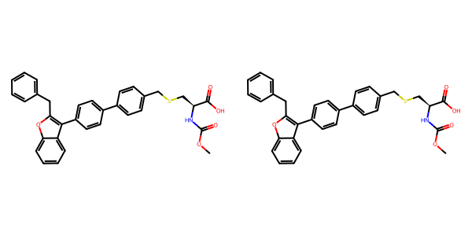

## US20070270434A1_p0019_x0341_y1083_c00044

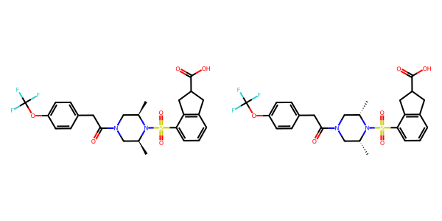

## US20070049758A1_p0022_x0521_y2581_c00036

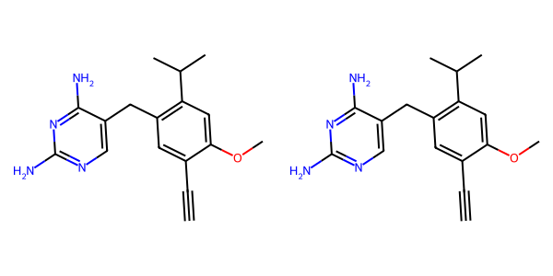

## US20050288357A1_p0053_x0504_y2432_c00102

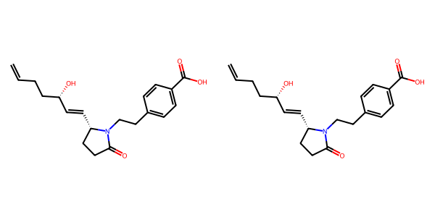

## US20050288357A1_p0046_x1466_y1399_c00082

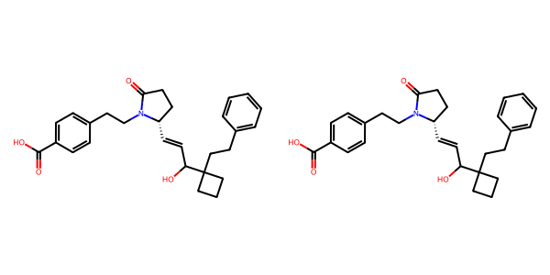

## US20050288357A1_p0037_x0533_y1375_c00067

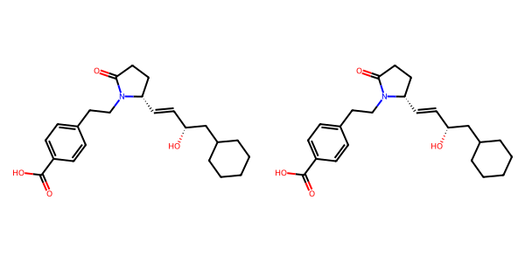

## US20060122222A1_p0025_x1488_y1050_c00072

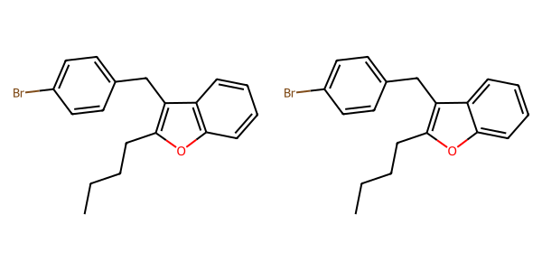

## US20050267177A1_p0018_x1328_y2203_c00046

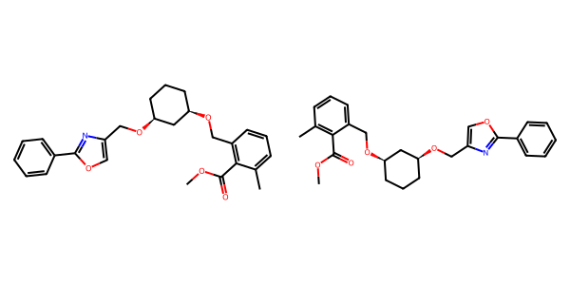

## US20060122222A1_p0026_x0514_y2640_c00075



## US20050288357A1_p0047_x1475_y0848_c00085

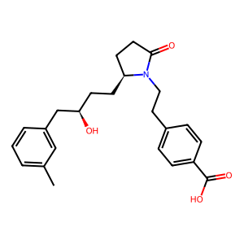

## US20050182067A1_p0035_x1527_y1876_c00131

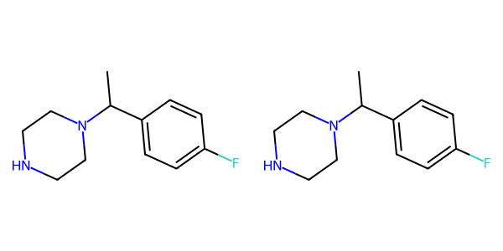

## US20070105909A1_p0020_x0502_y0806_c00032

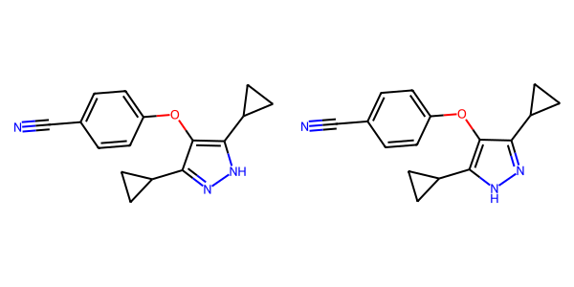

## US20050004369A1_p0031_x0443_y0881_c00059

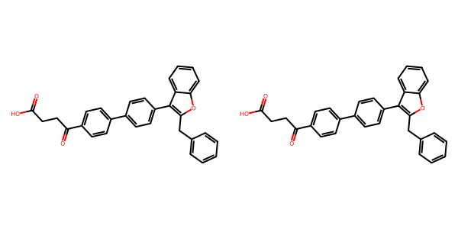

## US20070155803A1_p0026_x0466_y2780_c00063

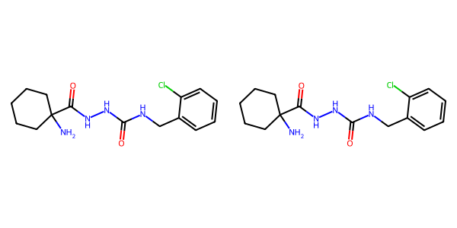

## US20070270434A1_p0016_x0404_y2587_c00031

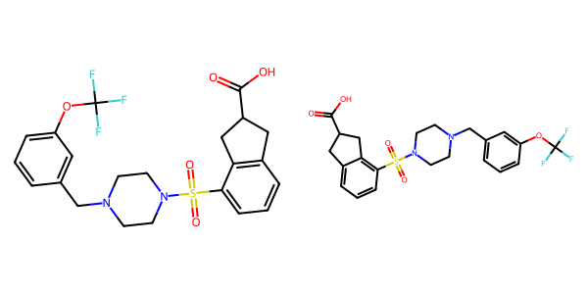

## US20060154945A1_p0022_x1376_y2839_c00091

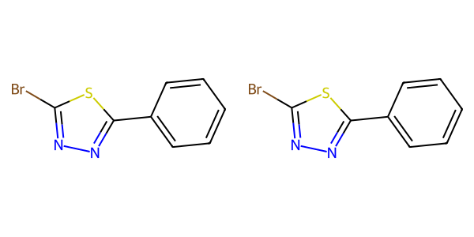

## US20050182067A1_p0034_x1483_y0710_c00124

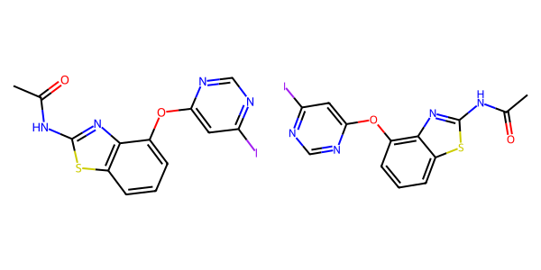

## US20070105909A1_p0018_x1597_y2922_c00028

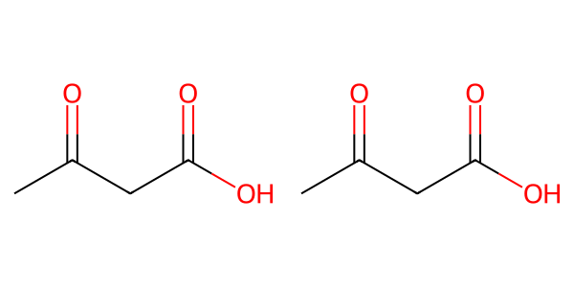

## US20060281700A1_p0074_x0524_y2669_c00123

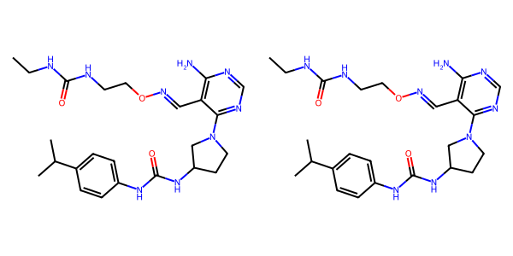

## US20080113922A1_p0021_x1375_y1119_c00062

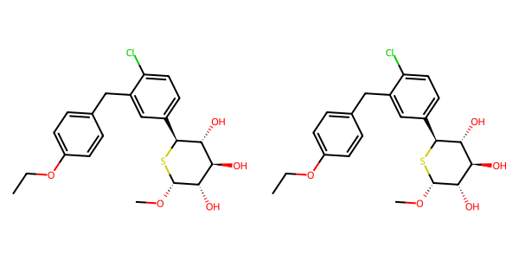

## US20050182067A1_p0026_x1586_y1042_c00010

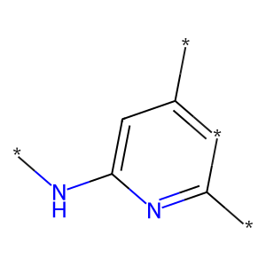

## US20080113922A1_p0012_x1310_y2640_c00041

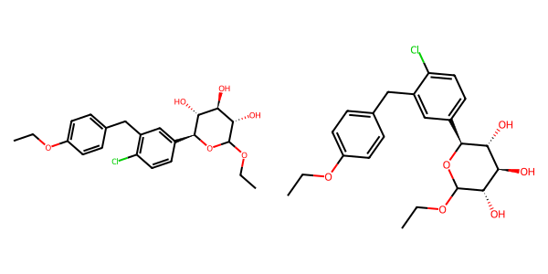

## US20050182067A1_p0036_x0470_y1269_c00133

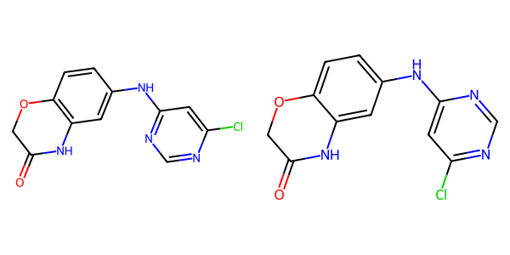

## US20050288357A1_p0011_x0515_y1646_c00007

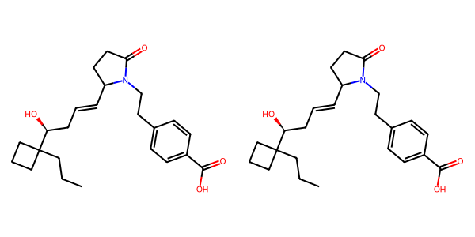

## US20060281700A1_p0074_x1497_y0792_c00124

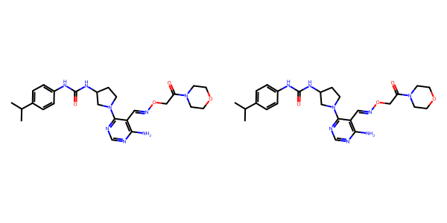

## US20070049758A1_p0026_x0463_y0699_c00050

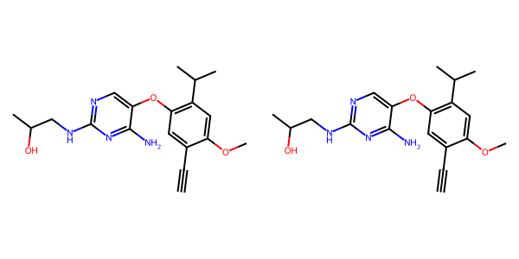

## US20070179154A1_p0031_x0572_y1192_c00012

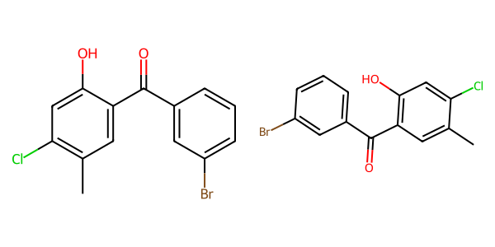

## US20050182067A1_p0038_x1348_y0803_c00146

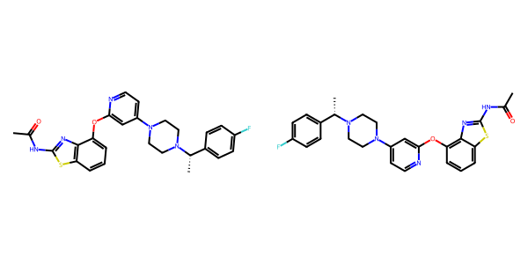

## US20050182067A1_p0048_x0707_y0570_c00164

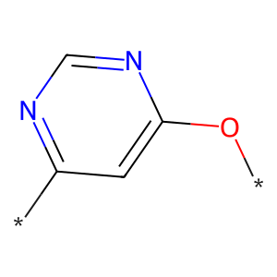

## US20070117785A1_p0043_x0336_y1847_c00084

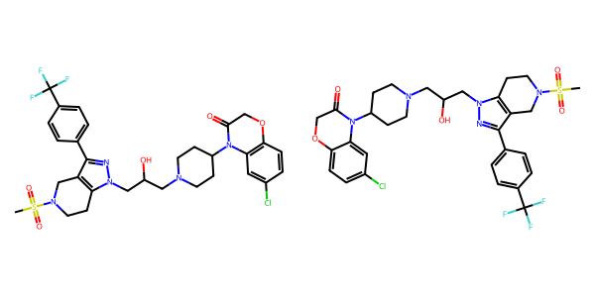

## US20040266789A1_p0018_x1332_y0624_c00029

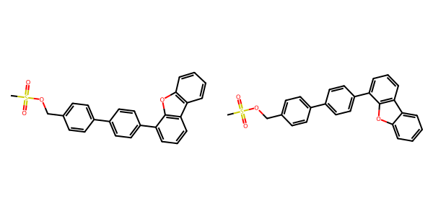

## US20050267177A1_p0029_x1326_y2483_c00106

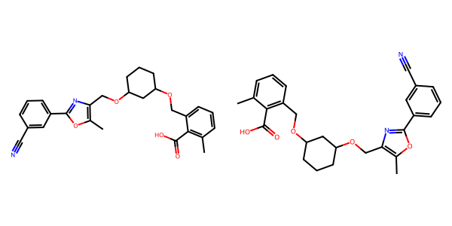

## US20050004369A1_p0028_x1353_y1270_c00051

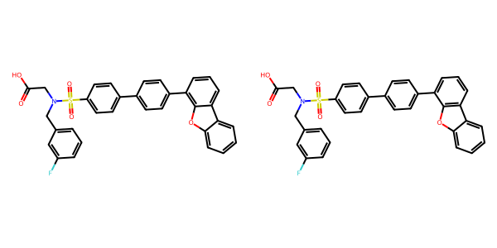

## US20060154945A1_p0012_x0402_y1544_c00033

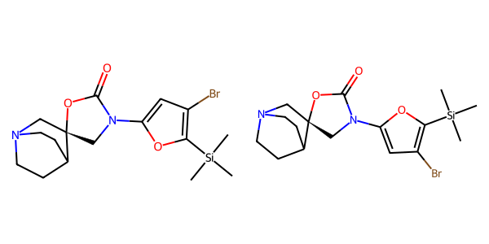

## US20040266789A1_p0020_x0378_y2058_c00037

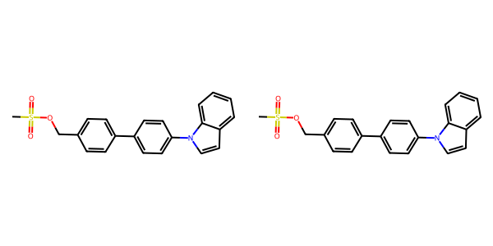

## US20050182067A1_p0038_x0510_y0647_c00143

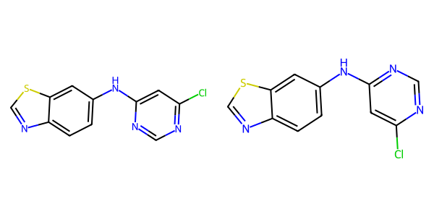

## US20040186132A1_p0003_x0542_y2148_c00001

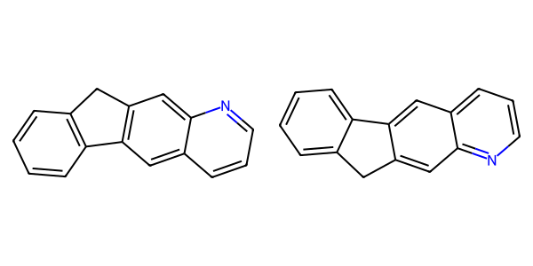

## US20080113922A1_p0011_x1310_y2230_c00039

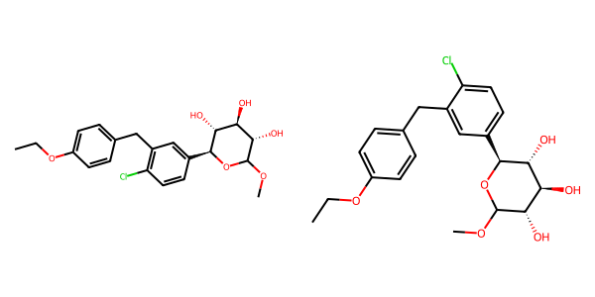

## US20060122222A1_p0030_x0491_y2020_c00089

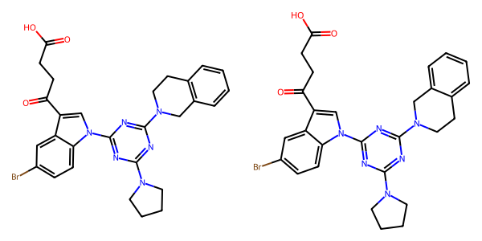

## US20070155803A1_p0018_x1309_y2480_c00029

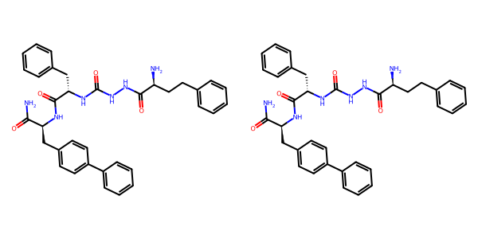

## US20050288357A1_p0033_x1496_y1170_c00063

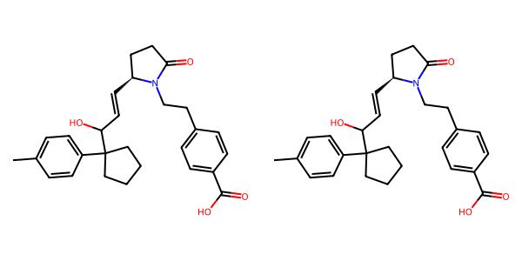

## US20060154945A1_p0017_x0404_y2072_c00059

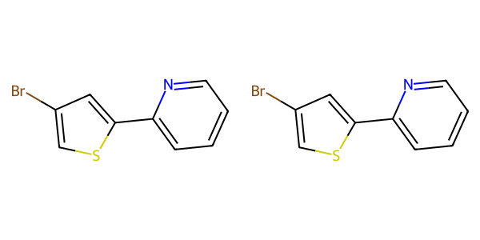

## US20050182067A1_p0030_x0522_y1650_c00101

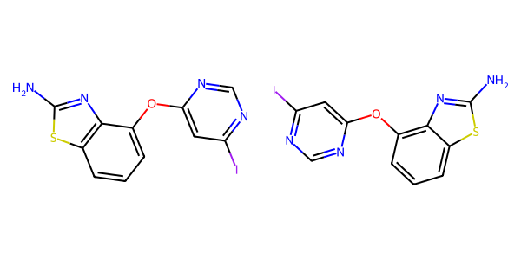

## US20060154945A1_p0018_x0402_y2533_c00065

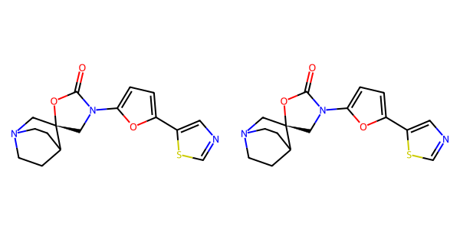

## US20070155803A1_p0018_x1352_y1229_c00027

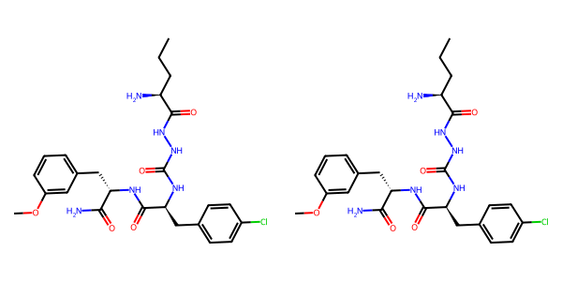

## US20070265270A1_p0031_x1520_y1679_c00127

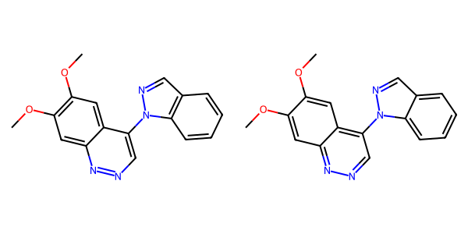

## US20040266789A1_p0018_x1300_y1912_c00030

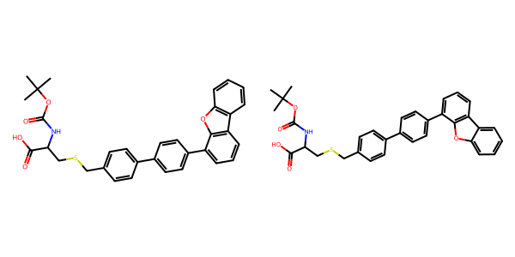

## US20050004369A1_p0023_x0355_y1693_c00037

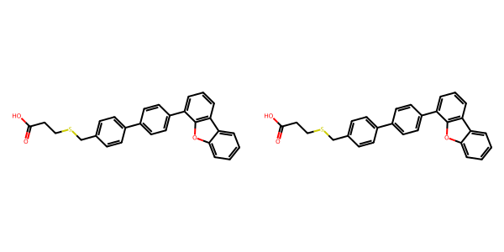

## US20050004369A1_p0022_x0334_y1993_c00036

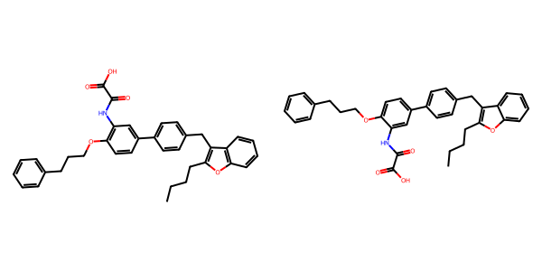

## US20050227932A1_p0026_x0404_y0953_c00028

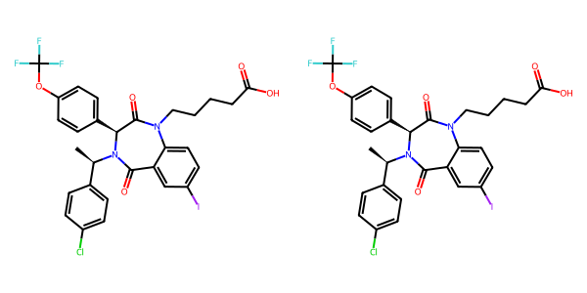

## US20060154945A1_p0018_x1375_y1643_c00067

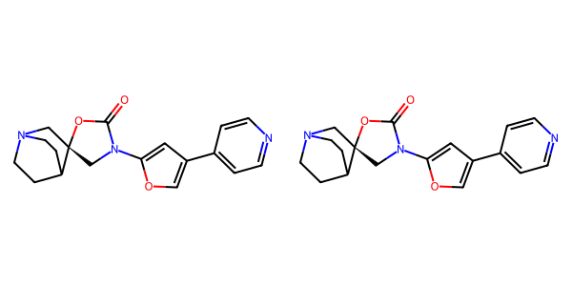

## US20050288357A1_p0047_x0502_y0844_c00083

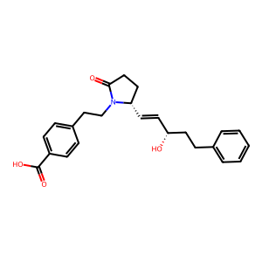

## US20050288357A1_p0011_x1488_y2354_c00011

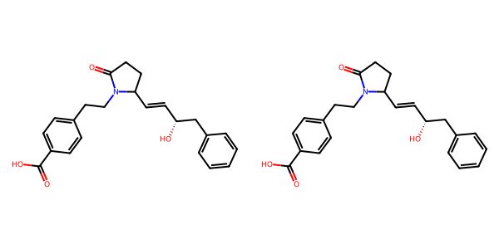

## US20050009817A1_p0036_x1524_y1981_c00104

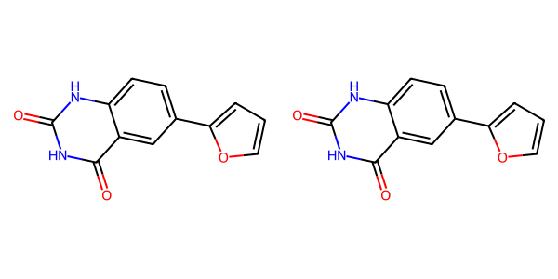

## US20040266789A1_p0010_x1178_y2532_c00013

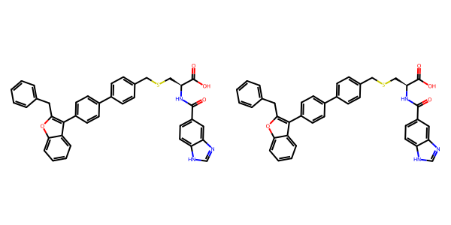

## US20040266789A1_p0030_x1302_y2041_c00052

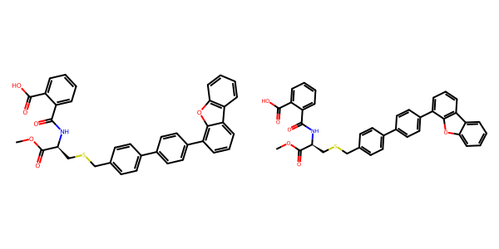

## US20050075347A1_p0014_x0596_y0804_c00034

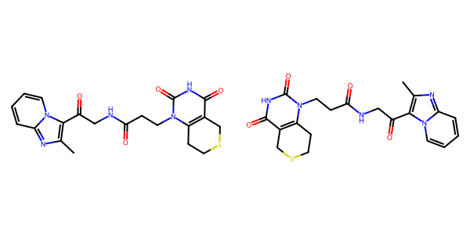

## US20040266789A1_p0028_x0328_y2318_c00048

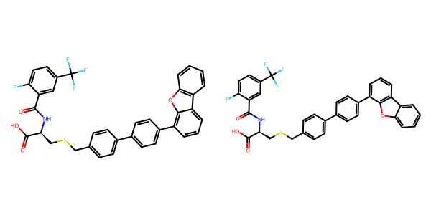

## US20050267177A1_p0015_x0350_y2707_c00024

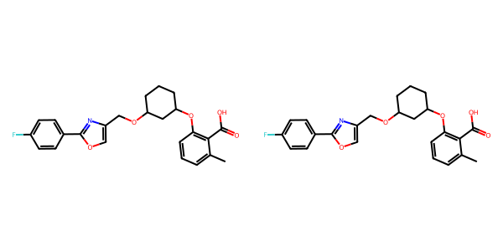

## US20040229890A1_p0014_x1453_y2638_c00064

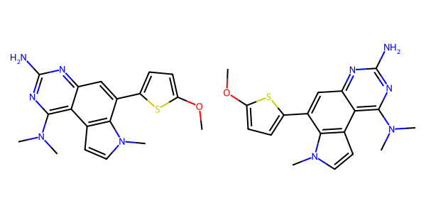

## US20050182067A1_p0032_x0359_y2693_c00112

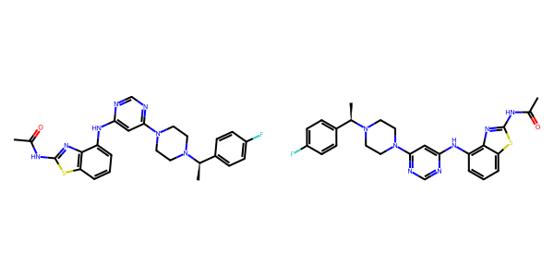

## US20050002859A1_p0016_x1541_y1967_c00099

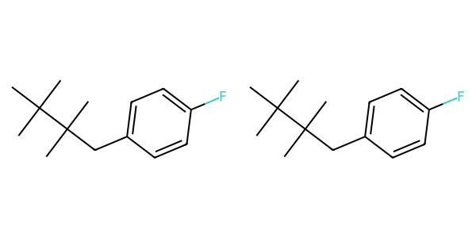

## US20050227932A1_p0040_x1375_y0982_c00076

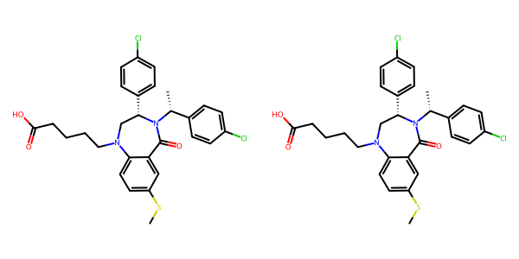

## US20050075347A1_p0008_x1793_y1832_c00023

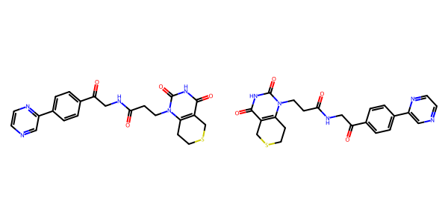

## US20040254236A1_p0007_x0628_y1304_c00002

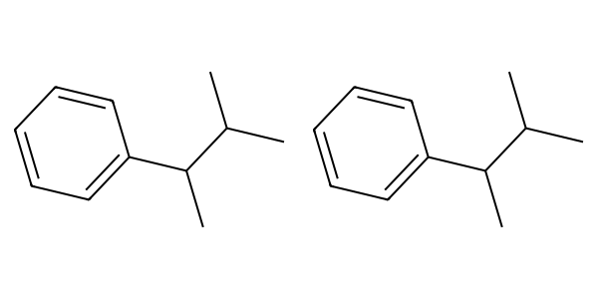

## US20070155803A1_p0030_x0437_y0933_c00075

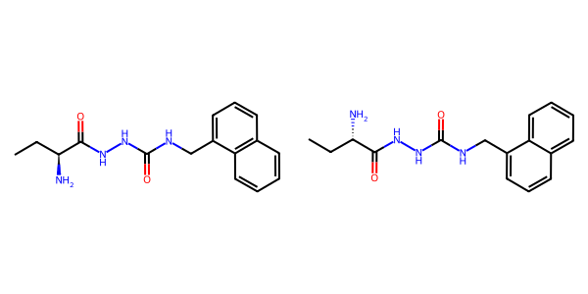

## US20070265270A1_p0029_x0456_y1284_c00114

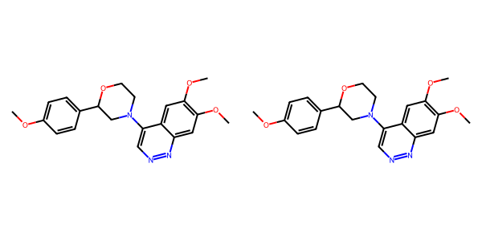

## US20070270434A1_p0019_x0342_y2548_c00045

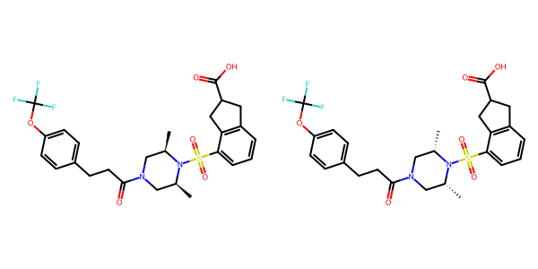

## US20070105909A1_p0020_x1016_y2754_c00035

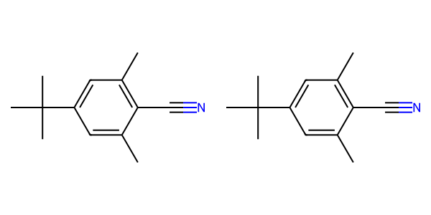

## US20070117785A1_p0056_x0335_y0862_c00100

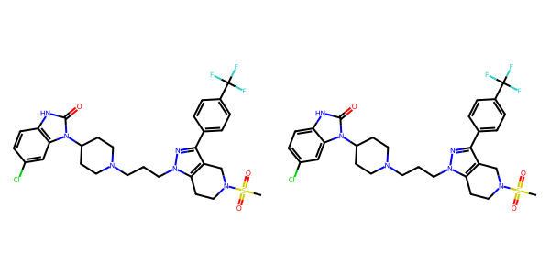

## US20070117785A1_p0007_x0594_y0809_c00001

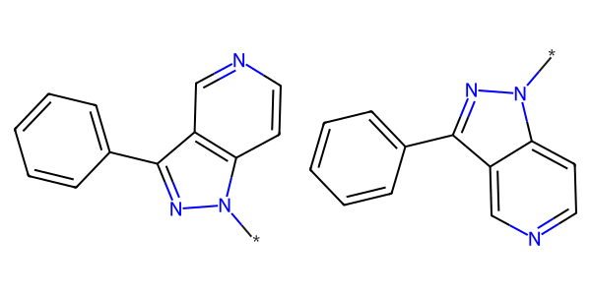

## US20070179177A1_p0022_x0609_y1278_c00136

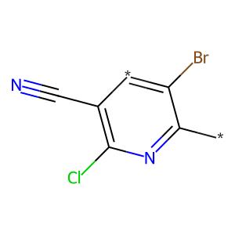

## US20070155803A1_p0022_x0393_y1328_c00042

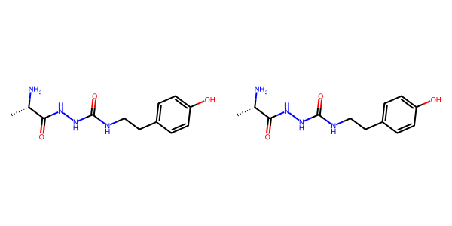

## US20070179154A1_p0033_x1376_y1268_c00019

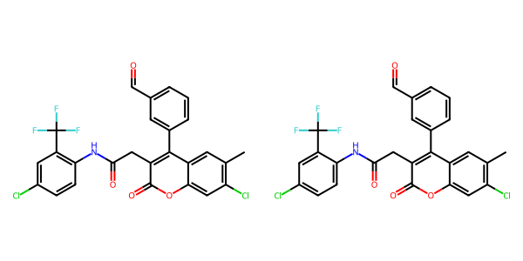

## US20070155803A1_p0029_x1439_y0739_c00072

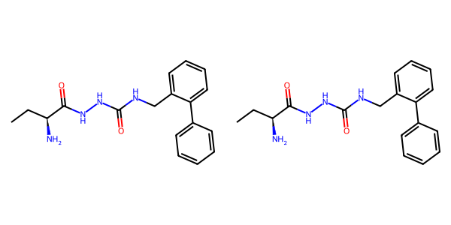

## US20050182067A1_p0007_x0610_y2258_c00004

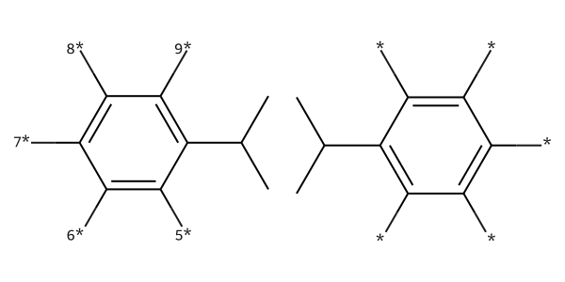

## US20040229890A1_p0017_x0523_y1547_c00076

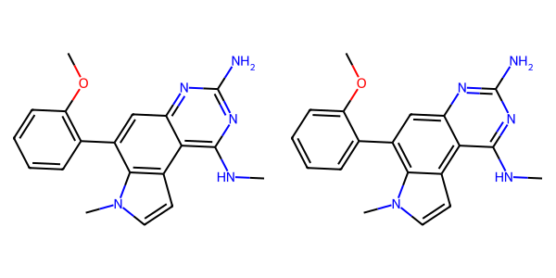

## US20080113922A1_p0016_x1376_y1397_c00050

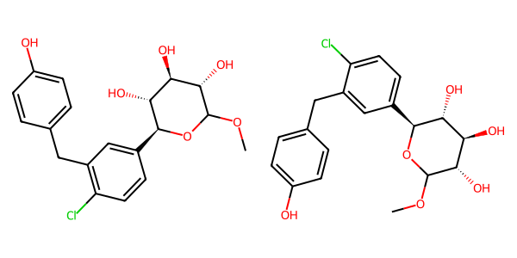

## US20060122222A1_p0023_x1423_y2829_c00065

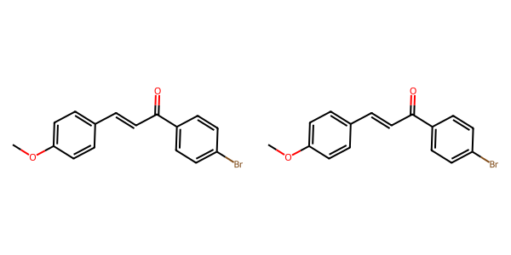

## US20070179177A1_p0031_x1184_y1948_c00163

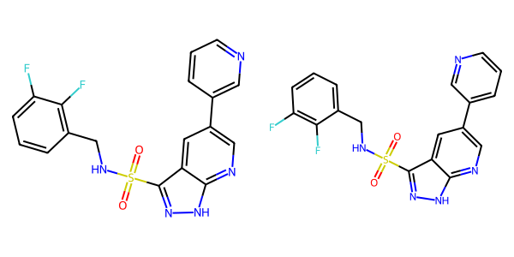

## US20070105909A1_p0027_x1552_y1053_c00070

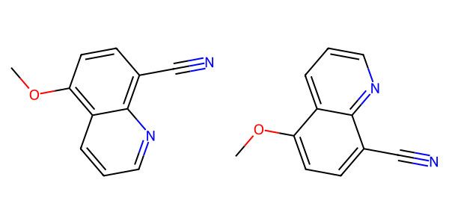

## US20040229890A1_p0014_x1503_y0751_c00062

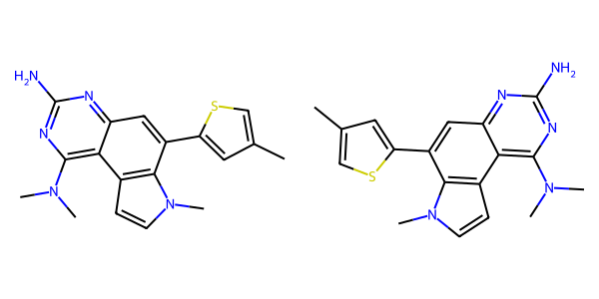

## US20070049758A1_p0012_x0479_y1869_c00005

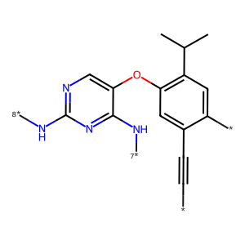

## US20070249620A1_p0001_x1376_y0697_c00000

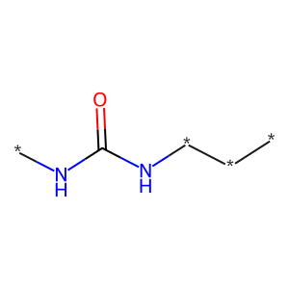

## US20050288357A1_p0012_x0515_y1776_c00014

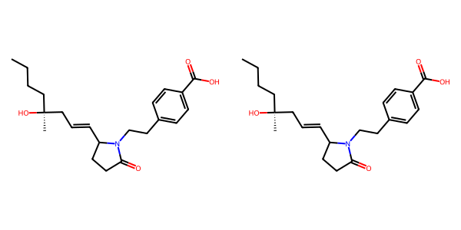

## US20070179154A1_p0038_x0618_y2804_c00038

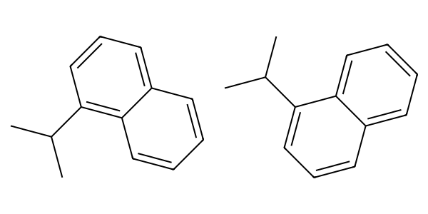

## US20080113922A1_p0020_x0335_y1304_c00059

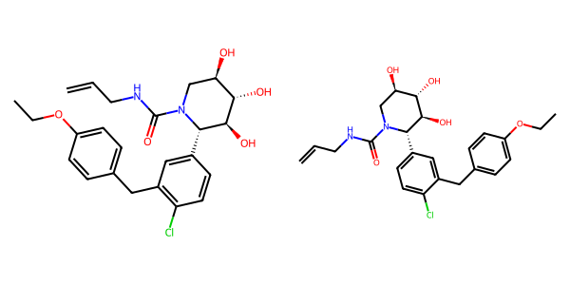

## US20070270434A1_p0022_x0404_y2228_c00057

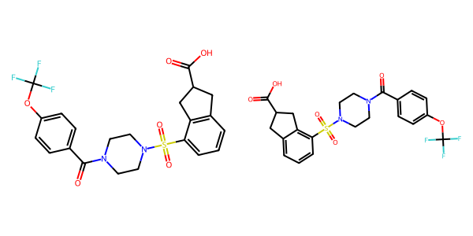

## US20050113580A1_p0080_x0338_y0900_c00155

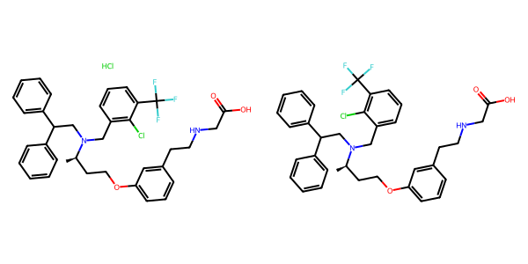

## US20040266789A1_p0006_x1401_y0536_c00004

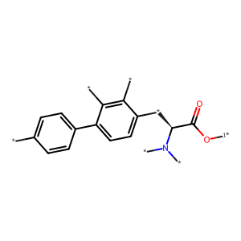

## US20050009817A1_p0009_x0579_y1706_c00011

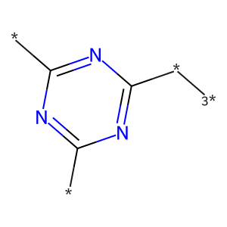

## US20050182067A1_p0034_x0549_y0617_c00121

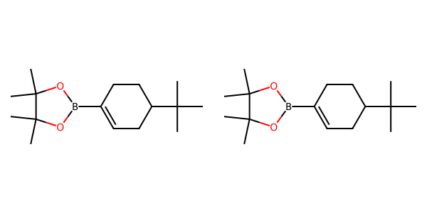

## US20060154945A1_p0015_x1375_y2099_c00051

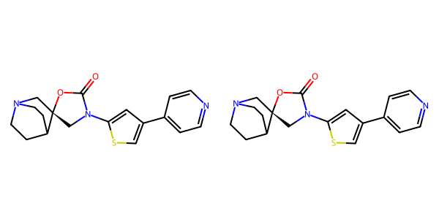

## US20050002859A1_p0015_x1453_y2068_c00092

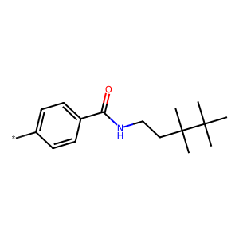

## US20070105909A1_p0025_x0506_y0726_c00060

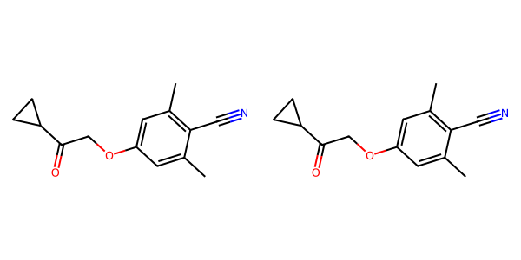

## US20050288357A1_p0011_x1488_y1489_c00010

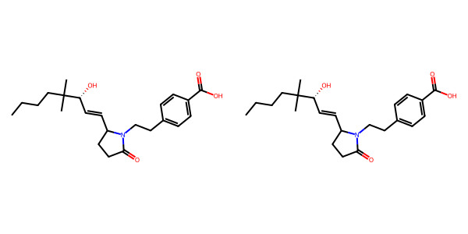

## US20050004369A1_p0023_x1328_y2452_c00040



## US20070270434A1_p0022_x1376_y1589_c00059

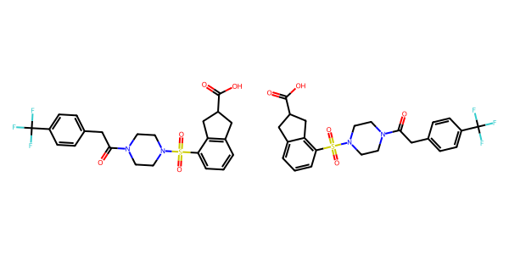

## US20070265270A1_p0031_x1383_y0957_c00126

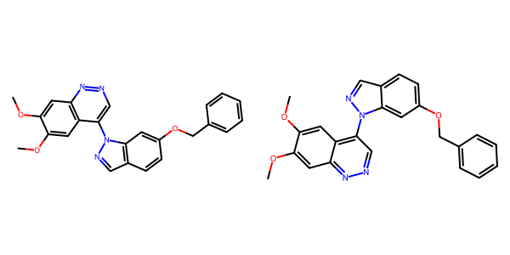

## US20070105909A1_p0033_x0444_y1290_c00103

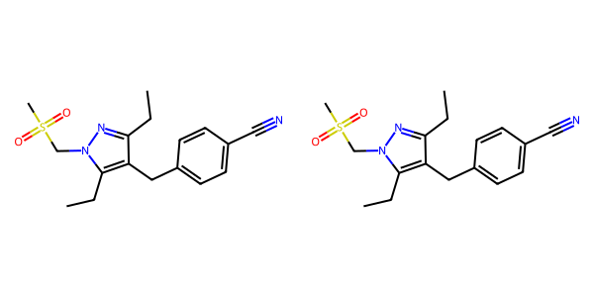

## US20070105909A1_p0022_x0476_y0701_c00044

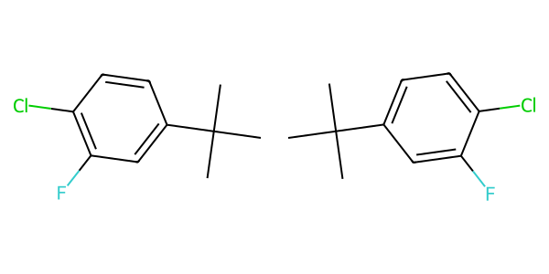

## US20060154945A1_p0012_x1375_y2367_c00036

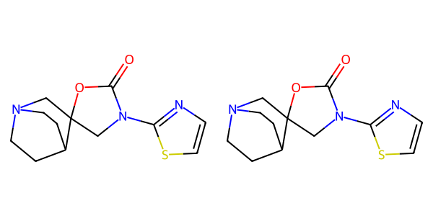

## US20070117785A1_p0047_x0334_y1313_c00088

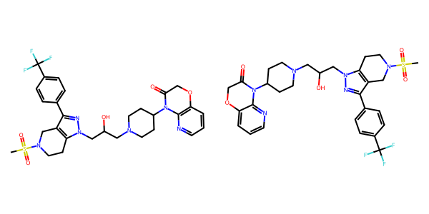

## US20040229890A1_p0012_x1496_y0669_c00053

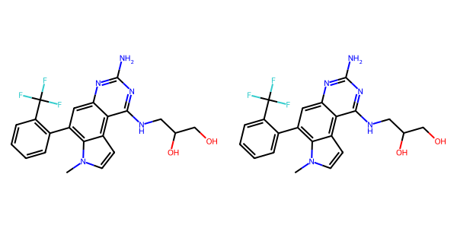

## US20050267177A1_p0023_x1308_y0592_c00074

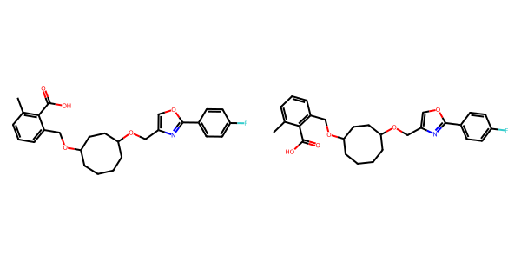

## US20040266789A1_p0025_x0514_y0789_c00044

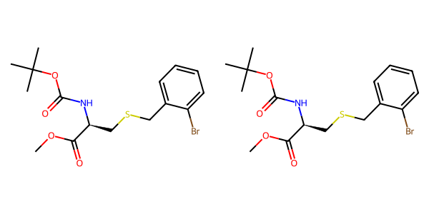

## US20060122222A1_p0040_x1313_y0721_c00105

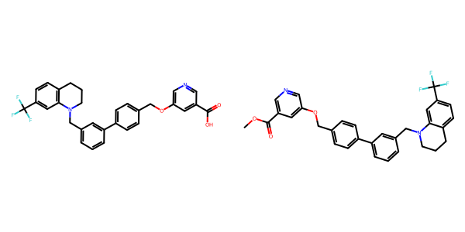

## US20050182067A1_p0032_x1638_y1021_c00113

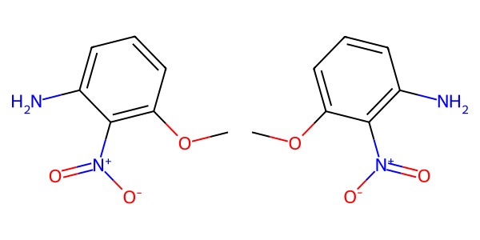

## US20070117785A1_p0050_x0337_y1564_c00092

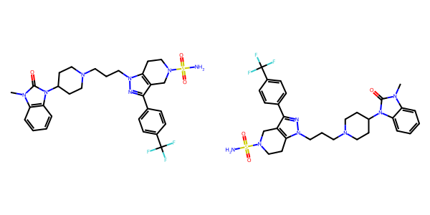

## US20050009817A1_p0021_x0536_y0669_c00069

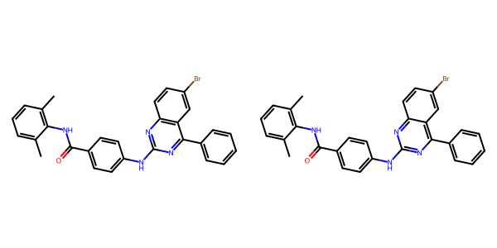

## US20070270434A1_p0020_x0404_y0661_c00048

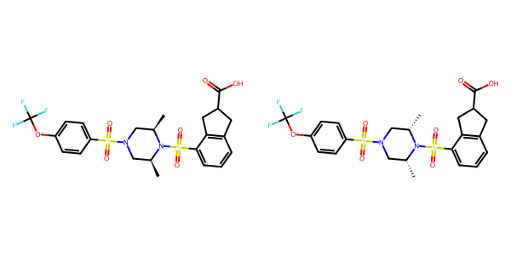

## US20070049758A1_p0016_x1427_y0646_c00012

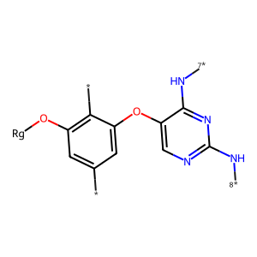

## US20070179154A1_p0056_x0330_y2422_c00118

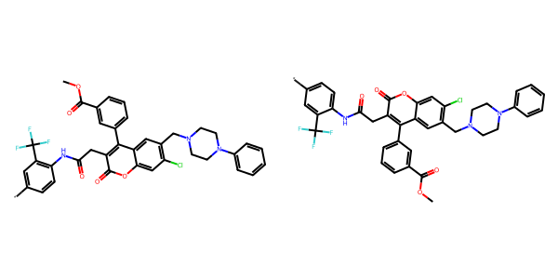

## US20050288357A1_p0041_x1478_y1863_c00075

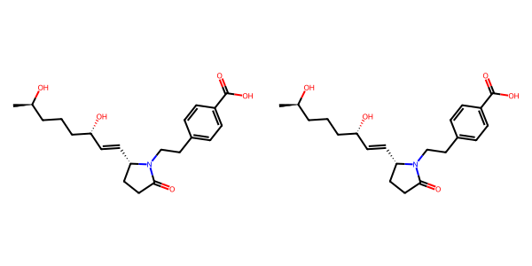

## US20070155803A1_p0024_x1439_y0732_c00054

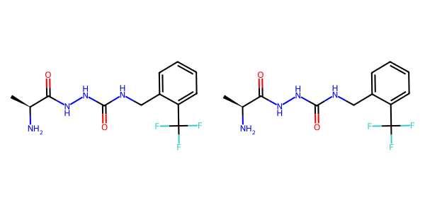

## US20040186132A1_p0003_x1480_y2294_c00006

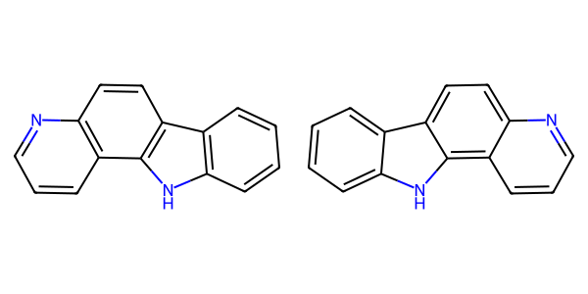

## US20050004369A1_p0020_x1488_y2697_c00030



## US20050043351A1_p0001_x1536_y1025_c00000

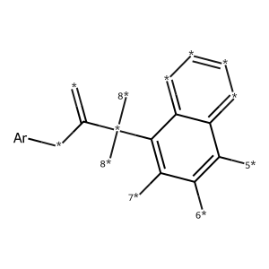

## US20060154945A1_p0018_x0402_y1623_c00064

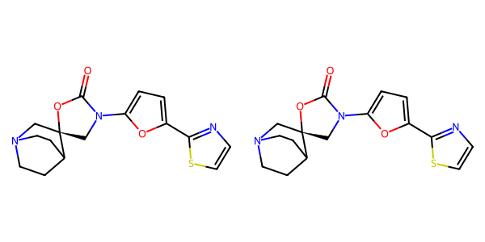

## US20070179154A1_p0041_x1499_y0694_c00053

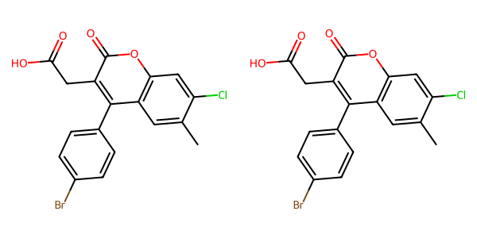

## US20050009817A1_p0035_x0383_y0697_c00101

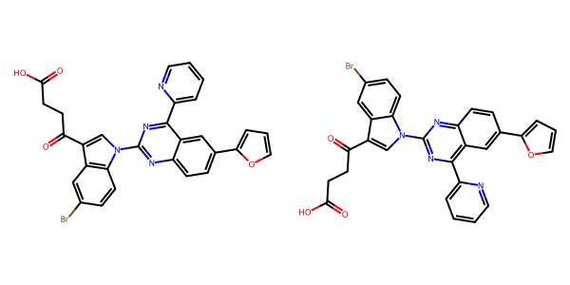

## US20050075347A1_p0026_x0416_y2454_c00060

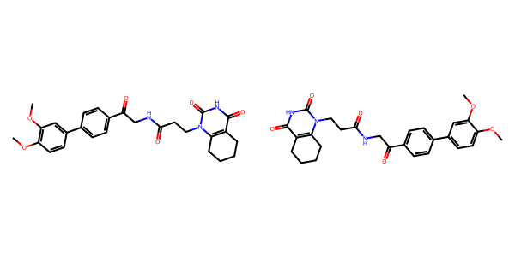

## US20060154945A1_p0018_x0402_y0713_c00063

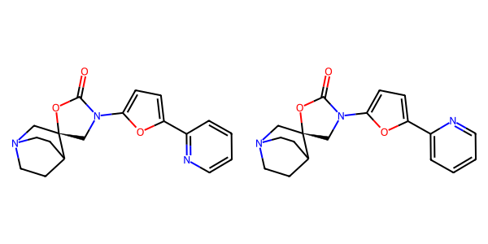

## US20070117785A1_p0056_x0335_y1768_c00101

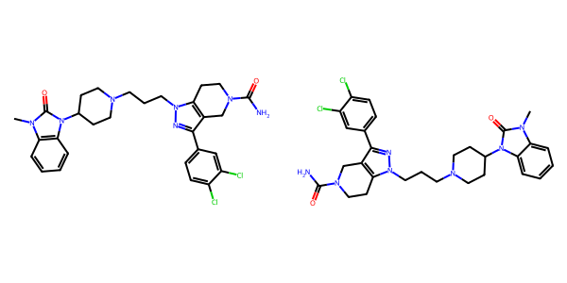

## US20040229890A1_p0003_x0662_y1706_c00007

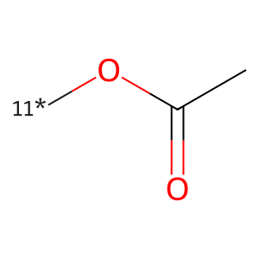

## US20060122222A1_p0035_x1314_y1811_c00096

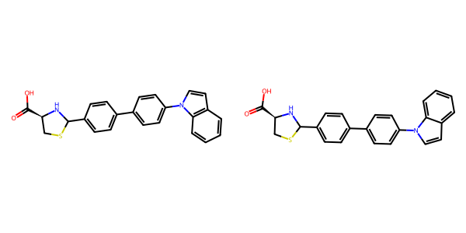

## US20040229890A1_p0010_x1503_y1287_c00045

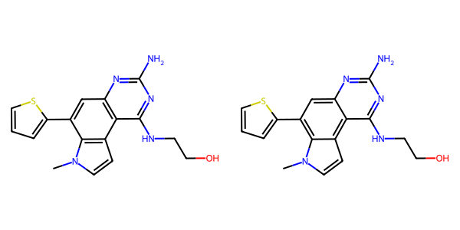

## US20070270434A1_p0018_x0404_y2396_c00040

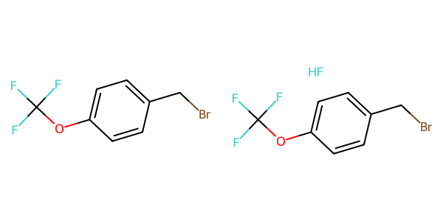

## US20040229890A1_p0013_x1496_y2079_c00058

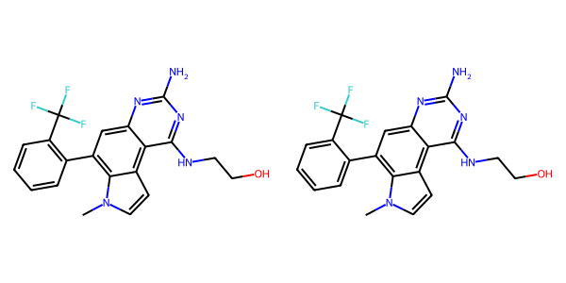

## US20050288357A1_p0026_x1437_y2585_c00055

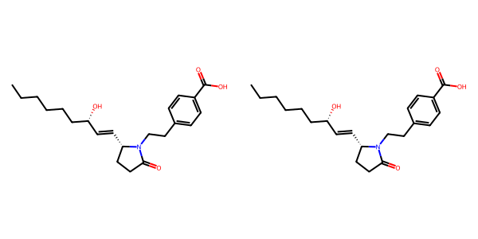

## US20030130506A1_p0004_x0551_y1960_c00008

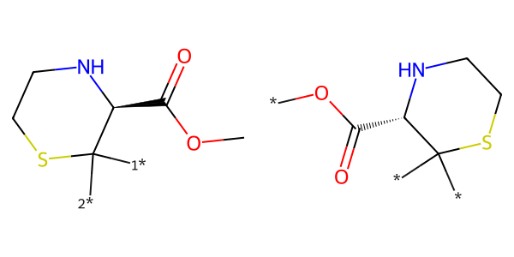

## US20070049758A1_p0017_x0862_y1871_c00015

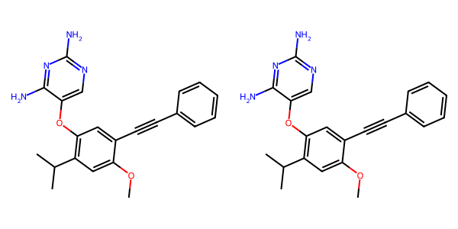

## US20070117785A1_p0031_x1308_y1677_c00069

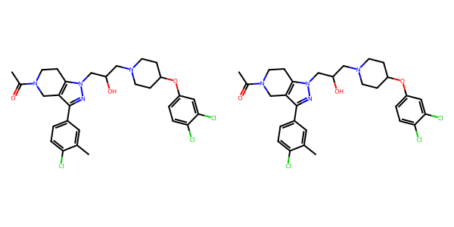

## US20070179154A1_p0038_x0618_y1796_c00035

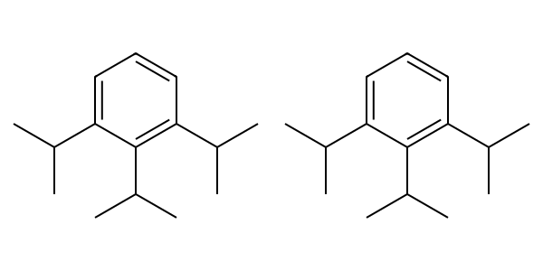

## US20050267177A1_p0024_x1303_y2508_c00082

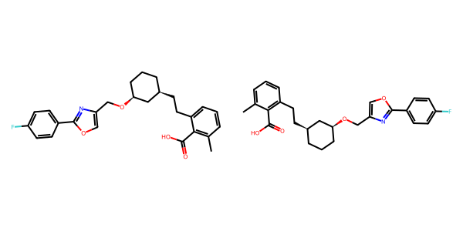

## US20040254236A1_p0032_x0528_y1510_c00136

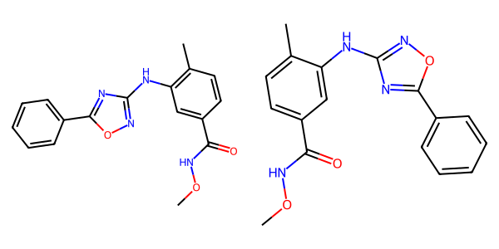

## US20070179154A1_p0055_x0330_y2598_c00115

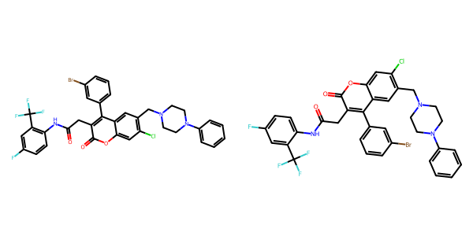

## US20060122222A1_p0023_x1336_y2029_c00064

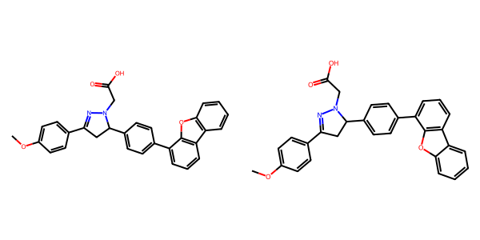

## US20070155803A1_p0022_x1439_y0738_c00044

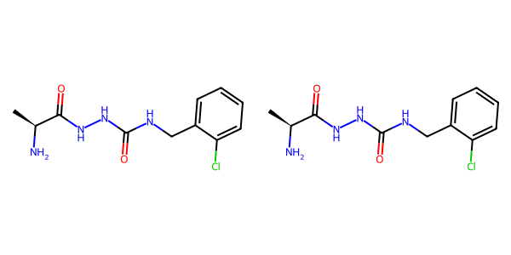

## US20070270434A1_p0023_x0334_y1107_c00061

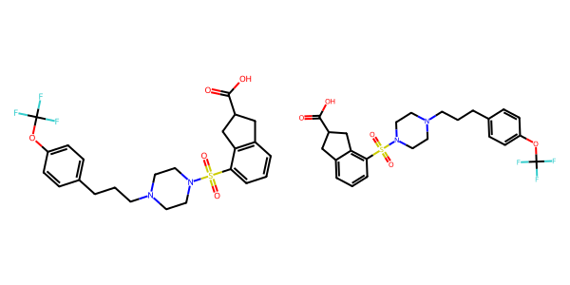

## US20070270434A1_p0016_x0404_y0937_c00030

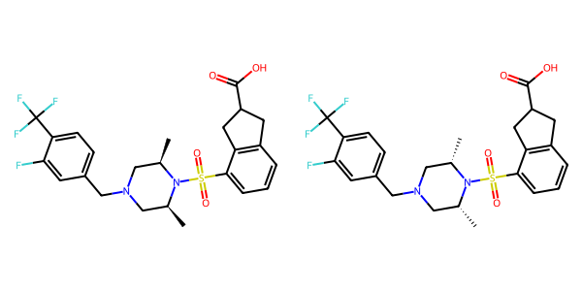

## US20070105909A1_p0024_x0521_y1171_c00057

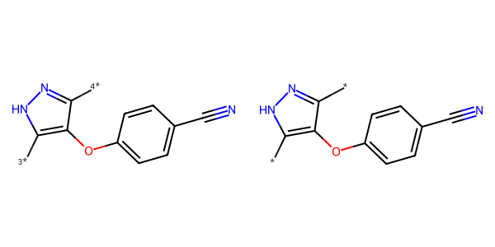

## US20070265270A1_p0029_x1487_y2415_c00118

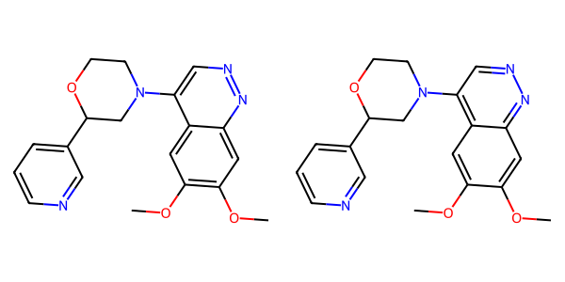

## US20070117785A1_p0058_x0338_y0852_c00112

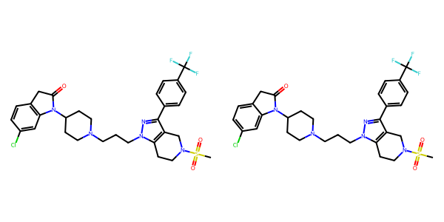

## US20070179177A1_p0021_x1531_y2195_c00134

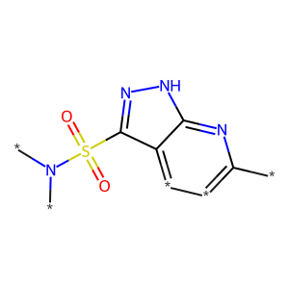

## US20040229890A1_p0012_x0497_y1048_c00051

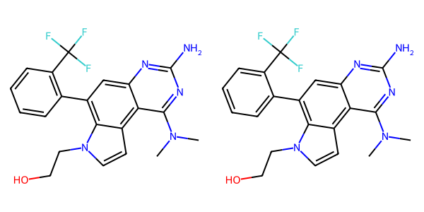

## US20070117785A1_p0051_x0335_y1926_c00093

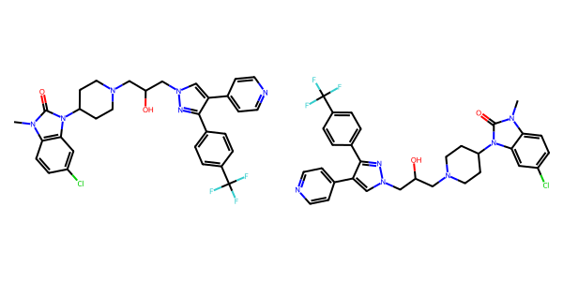

## US20070105909A1_p0022_x0610_y2522_c00049

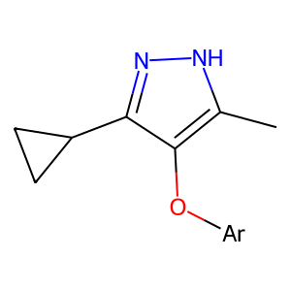

## US20050288357A1_p0049_x1474_y0768_c00091

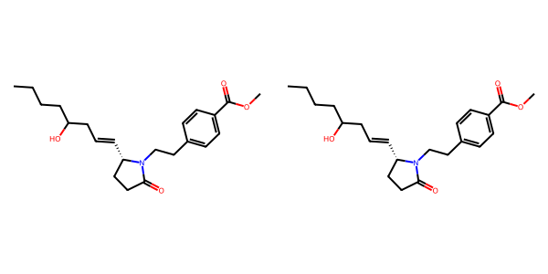

## US20070265270A1_p0027_x1539_y2014_c00109

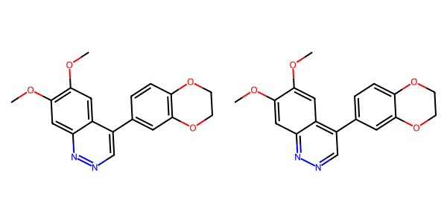

## US20050267177A1_p0022_x1329_y0809_c00069

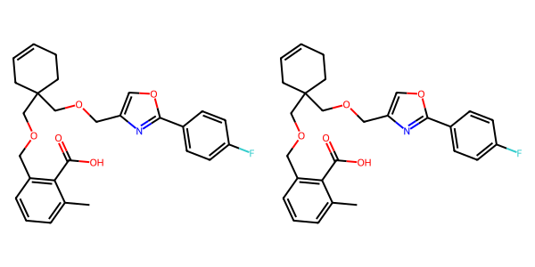

## US20040266789A1_p0017_x1393_y2647_c00027

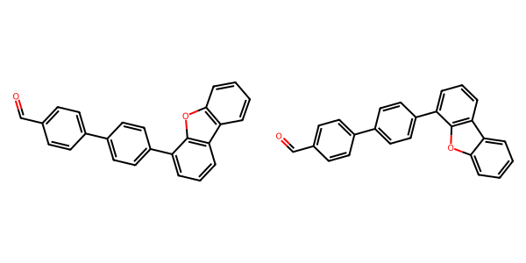

## US20040254236A1_p0037_x0488_y1434_c00146

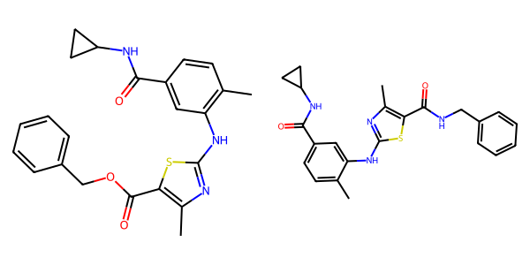

## US20040186132A1_p0003_x1460_y0591_c00003

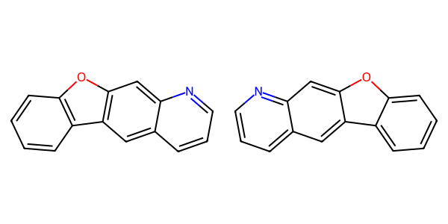

## US20060154945A1_p0019_x1375_y2739_c00074

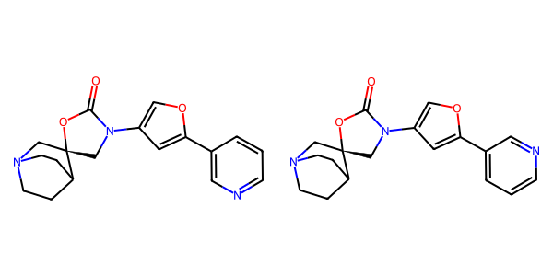

## US20040254236A1_p0008_x1623_y1827_c00004

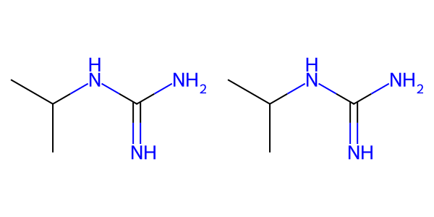

## US20070155803A1_p0020_x0382_y2142_c00036

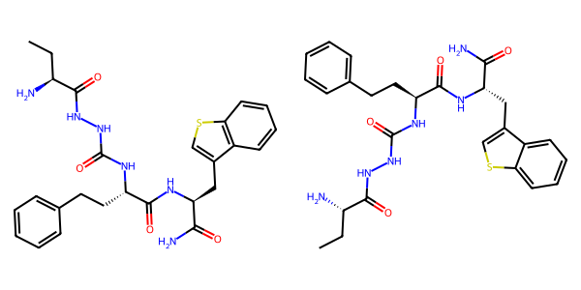

## US20060154945A1_p0023_x0404_y2006_c00093

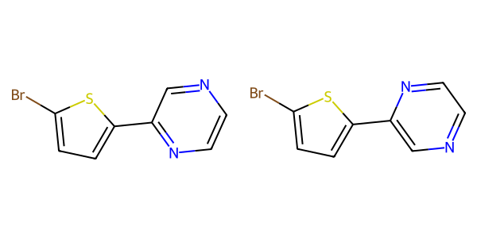

## US20070265270A1_p0030_x0514_y0823_c00119

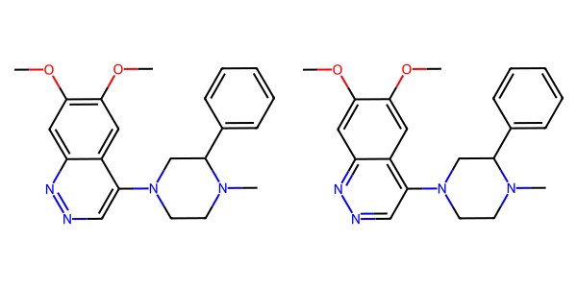

## US20040266789A1_p0010_x1201_y1884_c00012

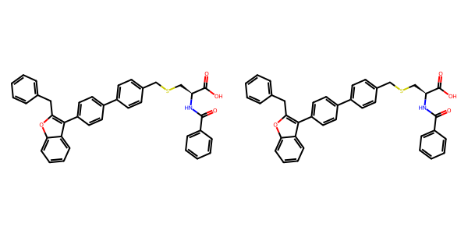

## US20070117785A1_p0049_x1309_y2404_c00091

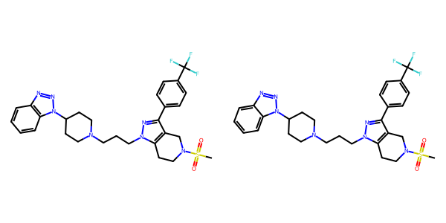

## US20050009817A1_p0016_x1367_y0665_c00055

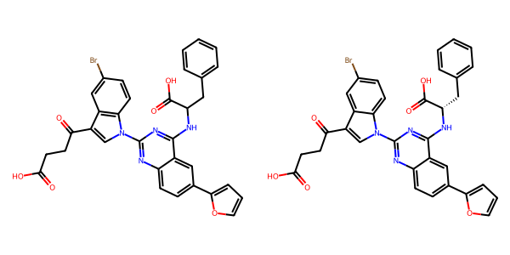

## US20050004369A1_p0025_x0341_y0728_c00043

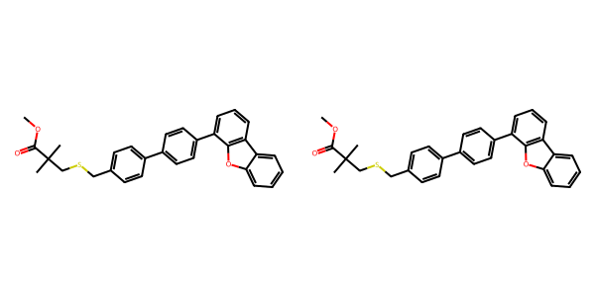

## US20050002859A1_p0038_x0344_y0823_c00135

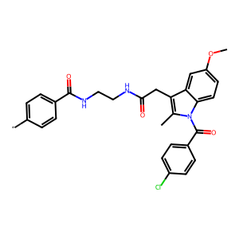

## US20040266789A1_p0022_x0331_y1847_c00040

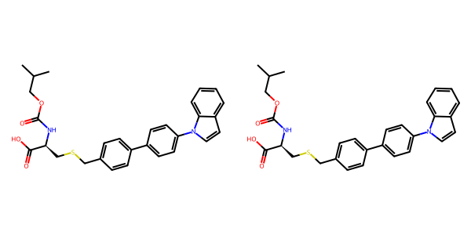

## US20040266789A1_p0047_x1447_y1428_c00080

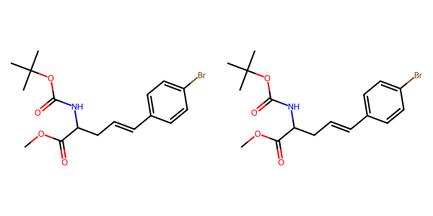

## US20070105909A1_p0022_x0484_y1616_c00047

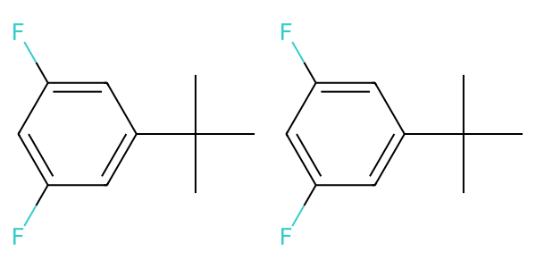

## US20080113922A1_p0008_x1320_y1305_c00020

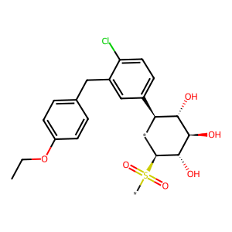

## US20050004369A1_p0017_x0552_y0943_c00022

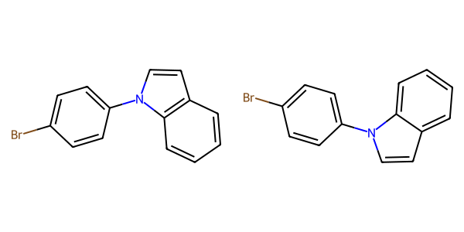

## US20070105909A1_p0021_x0487_y2809_c00043

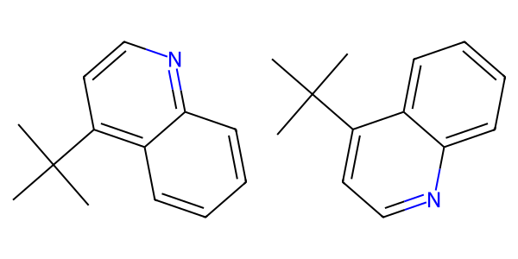

## US20050267177A1_p0040_x0330_y0603_c00160

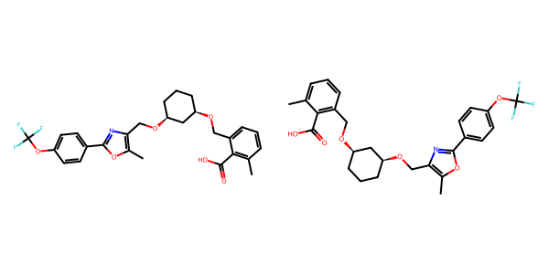

## US20070049758A1_p0014_x1446_y1735_c00009

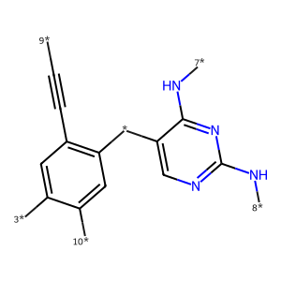

## US20050004369A1_p0021_x0515_y1075_c00031



## US20050054819A1_p0035_x1314_y0766_c00124

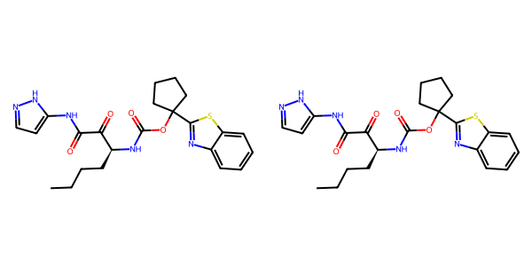

## US20060154945A1_p0021_x1375_y1389_c00085

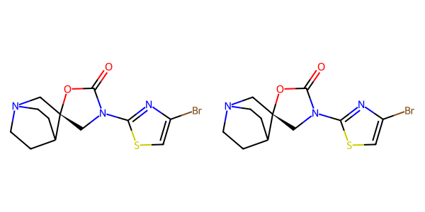

## US20040254236A1_p0033_x1364_y0931_c00138

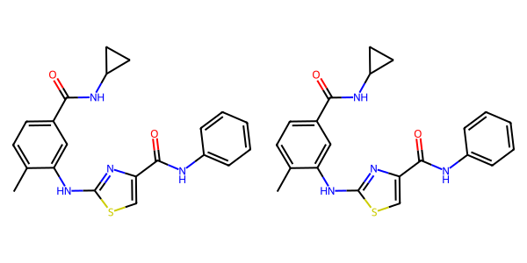

## US20070105909A1_p0033_x0443_y2317_c00104

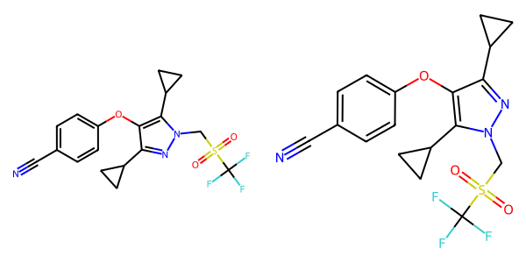

## US20070117785A1_p0042_x0331_y1916_c00082

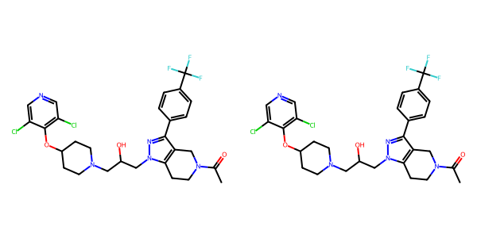

## US20050113580A1_p0038_x1307_y1020_c00053

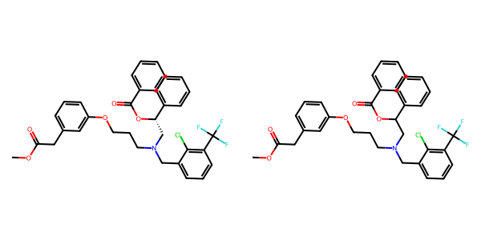

## US20070265270A1_p0031_x0422_y1954_c00125

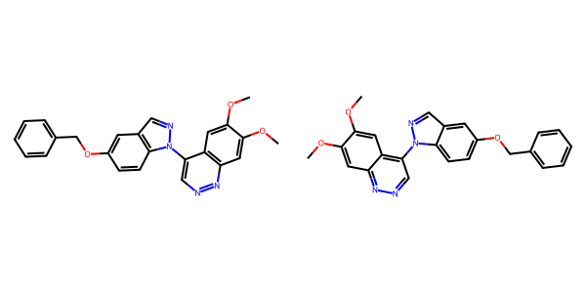

## US20040266789A1_p0045_x1301_y1435_c00077

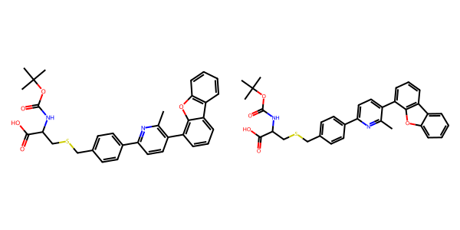

## US20070117785A1_p0058_x0330_y2660_c00114

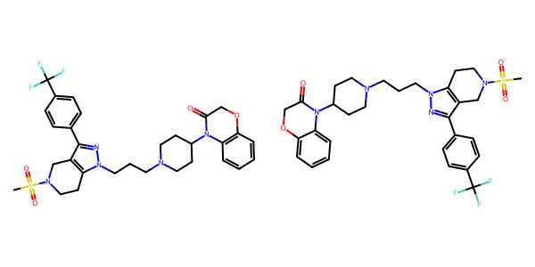

## US20060154945A1_p0018_x1375_y2533_c00068

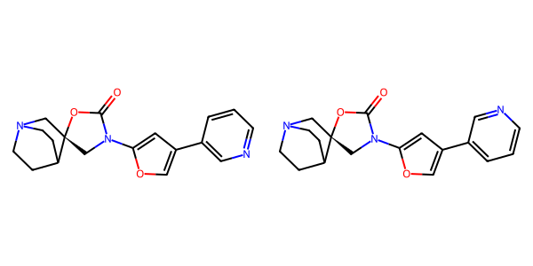

## US20050075347A1_p0012_x1599_y1501_c00032

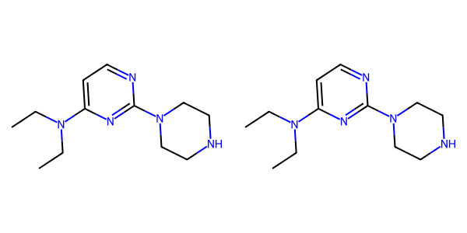

## US20040266789A1_p0011_x0817_y1011_c00015

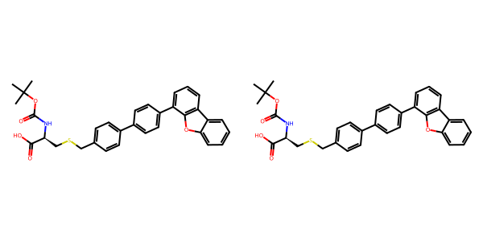

## US20050009817A1_p0028_x0557_y0856_c00083

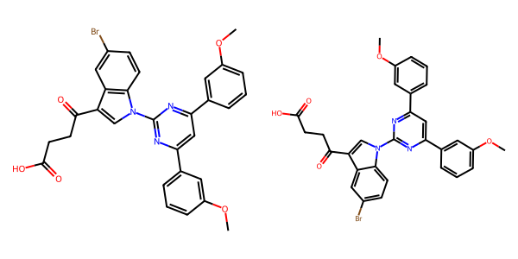

## US20050004369A1_p0017_x1375_y2642_c00024

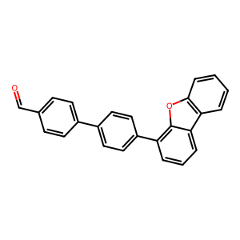

## US20070015754A1_p0015_x0353_y0596_c00066

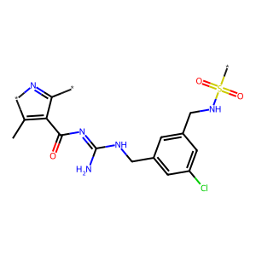

## US20050182067A1_p0039_x1442_y2307_c00151

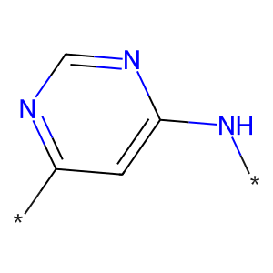

## US20030130506A1_p0003_x0392_y2374_c00002

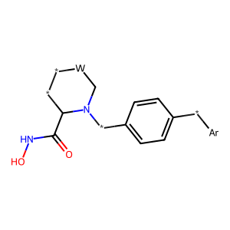

## US20050009817A1_p0019_x0681_y1779_c00065

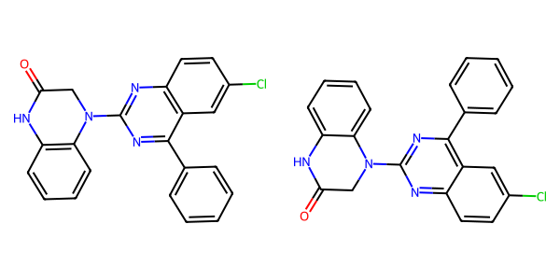

## US20070117785A1_p0033_x0337_y1773_c00071

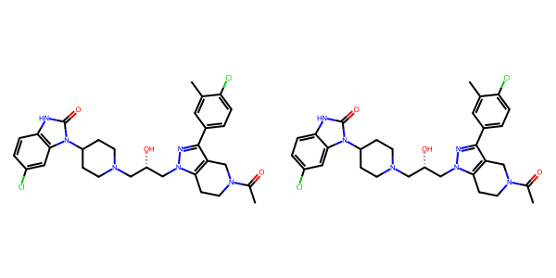

## US20060154945A1_p0014_x1375_y2818_c00046

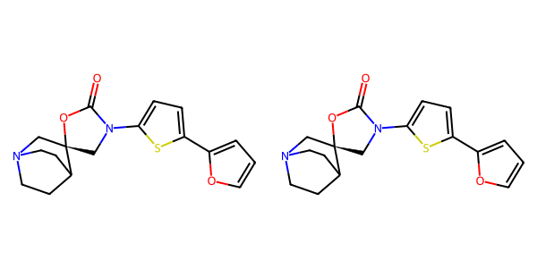

## US20070049758A1_p0020_x0521_y2573_c00028

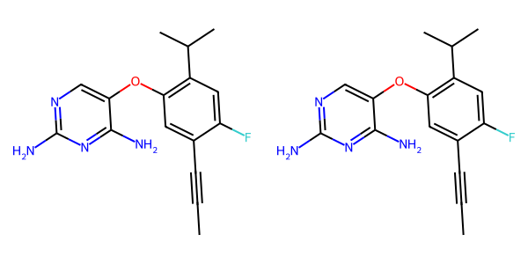

## US20050267177A1_p0034_x0350_y0702_c00126

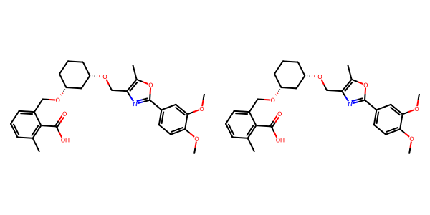

## US20050288357A1_p0027_x1437_y1375_c00056

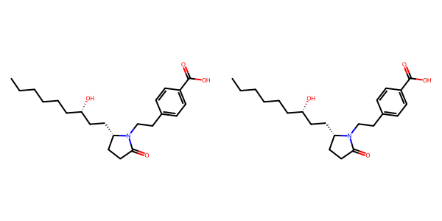

## US20050009817A1_p0020_x0627_y0721_c00066

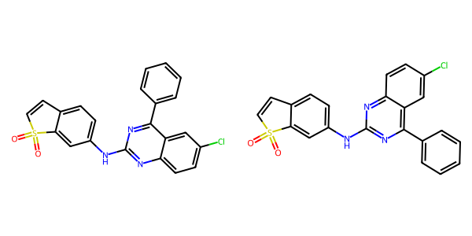

## US20050182067A1_p0037_x0528_y2177_c00139

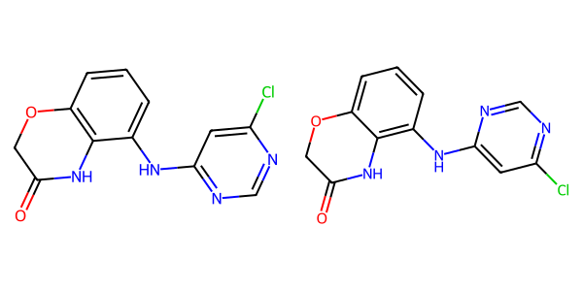

## US20070155803A1_p0022_x1445_y1778_c00045

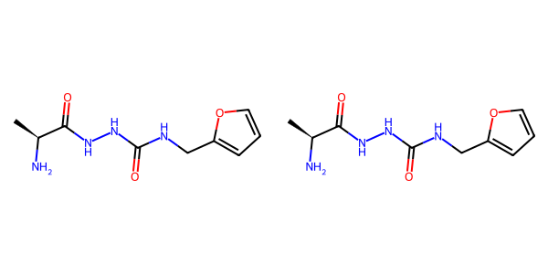

## US20050009817A1_p0019_x0604_y0752_c00063

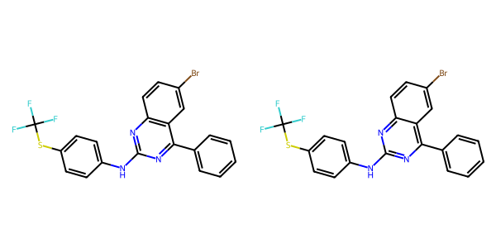

## US20050288357A1_p0056_x0489_y1910_c00108

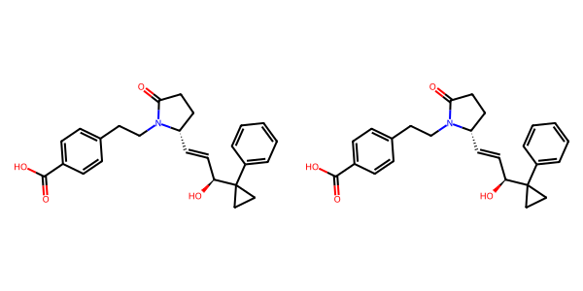

## US20050004369A1_p0034_x0443_y1741_c00070

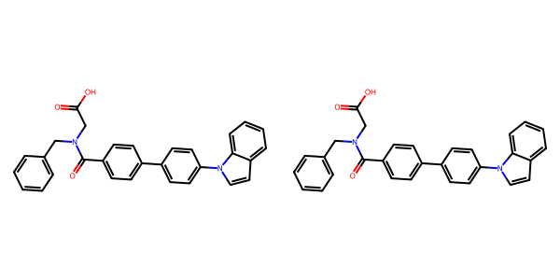

## US20060154945A1_p0014_x0402_y1194_c00042

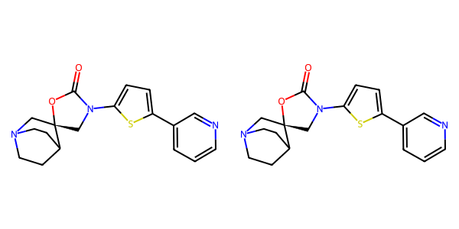

## US20040254236A1_p0055_x0346_y2338_c00214

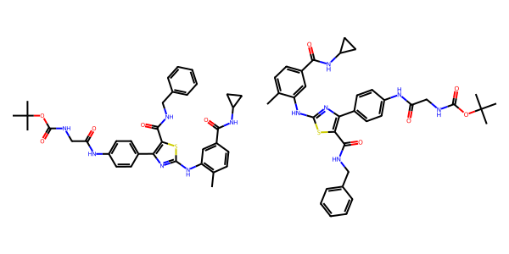

## US20050288357A1_p0009_x0566_y0774_c00005

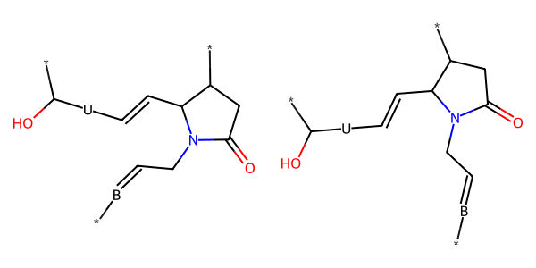

## US20070270434A1_p0019_x1376_y1048_c00046

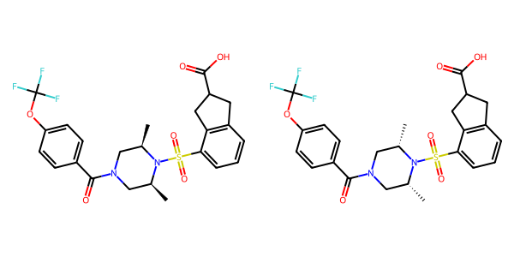

## US20060154945A1_p0011_x1375_y2556_c00031

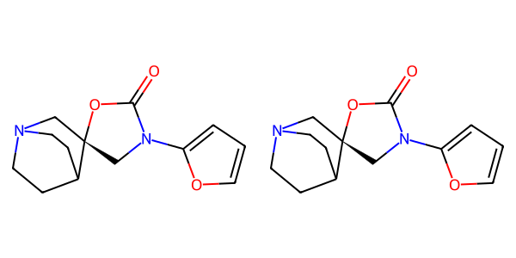

## US20040254236A1_p0034_x0442_y0785_c00139

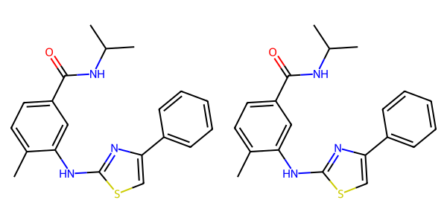

## US20070179154A1_p0032_x0581_y2255_c00016

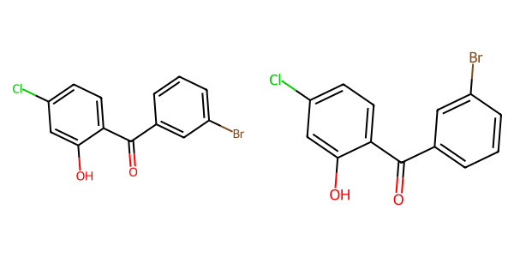

## US20050113580A1_p0031_x0417_y0886_c00036

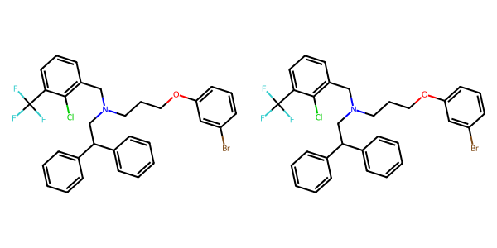

## US20050288357A1_p0028_x0488_y0812_c00057

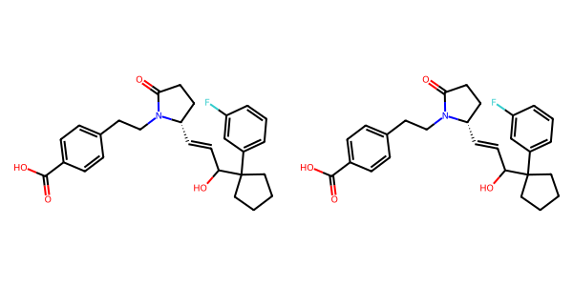

## US20050182067A1_p0029_x1539_y1511_c00098

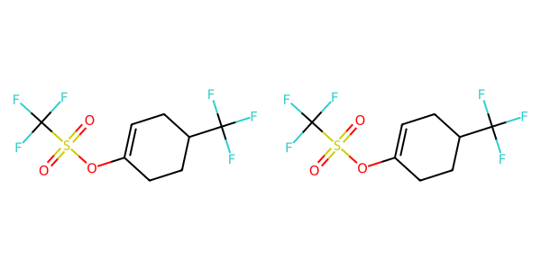

## US20040266789A1_p0038_x1379_y0668_c00064

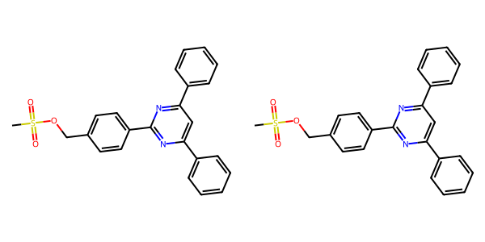

## US20050002859A1_p0015_x0484_y2061_c00089

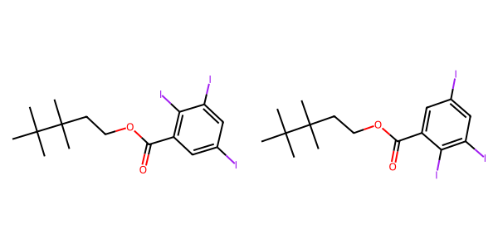

## US20040229890A1_p0014_x1503_y1641_c00063

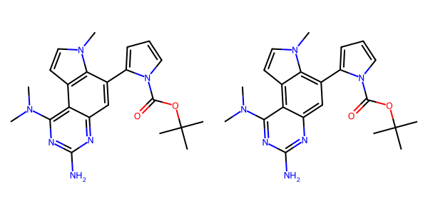

## US20050004369A1_p0033_x0445_y0673_c00064

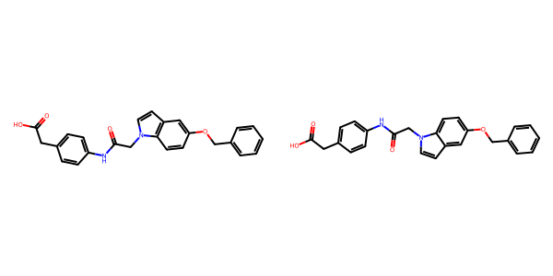

## US20080113922A1_p0022_x0350_y0953_c00063

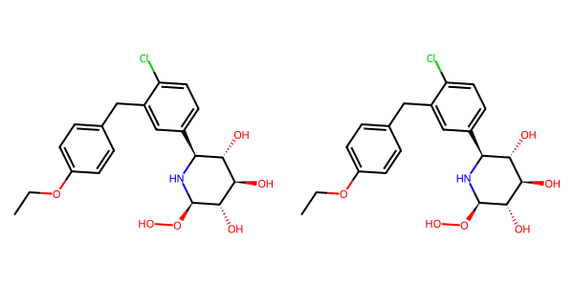

## US20070105909A1_p0034_x1439_y2652_c00109

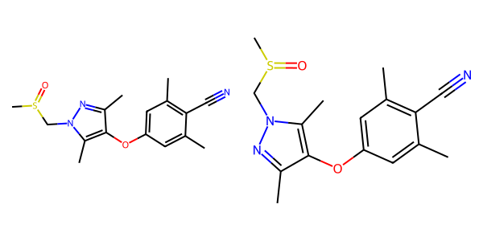

## US20050288357A1_p0042_x1478_y2179_c00076

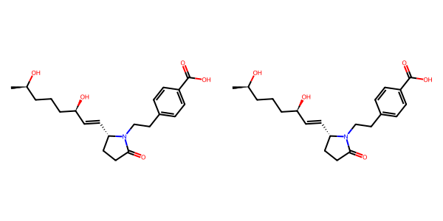

## US20050182067A1_p0036_x1477_y0699_c00135

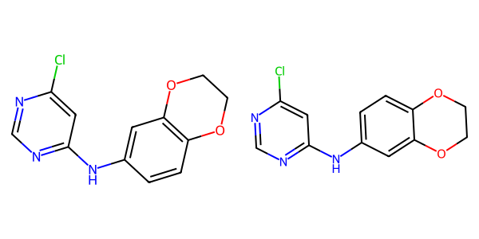

## US20070117785A1_p0058_x1303_y0840_c00115

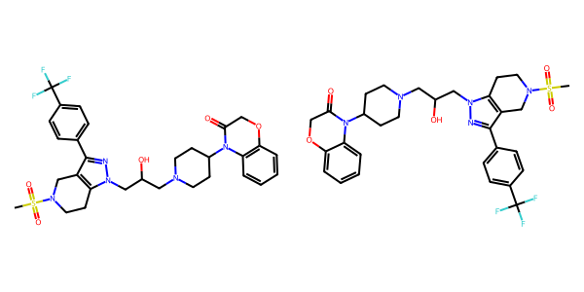

## US20060154945A1_p0020_x1376_y0581_c00078

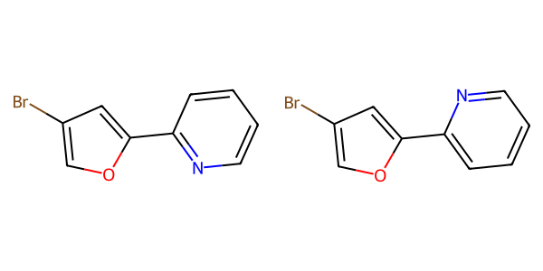

## US20070155803A1_p0019_x0334_y2313_c00031

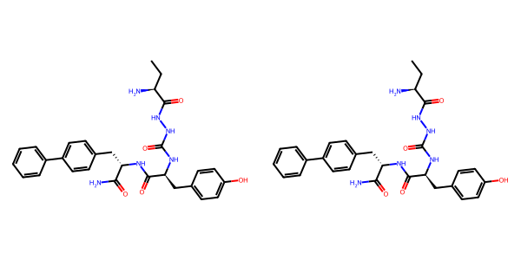

## US20050009817A1_p0017_x1464_y0828_c00058



## US20040266789A1_p0045_x1302_y0549_c00076

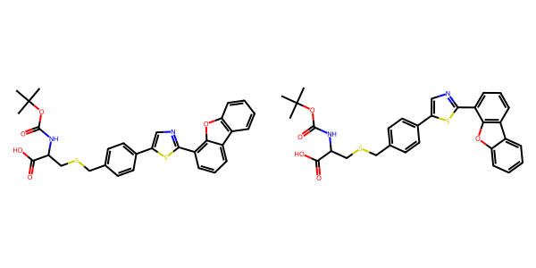

## US20050267177A1_p0023_x0335_y2596_c00073

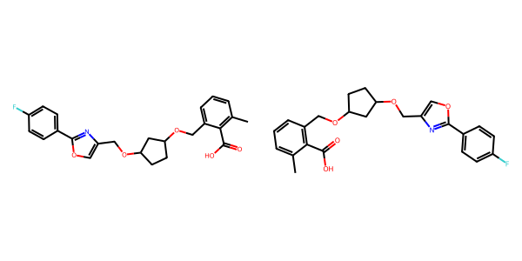

## US20050004369A1_p0036_x0443_y1735_c00076

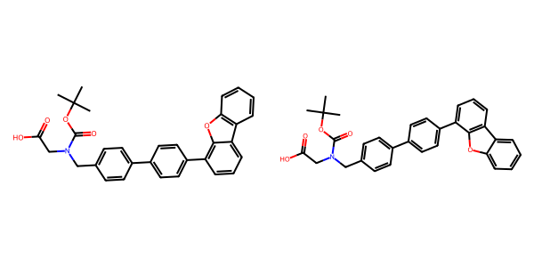

## US20070049758A1_p0023_x0521_y0695_c00037

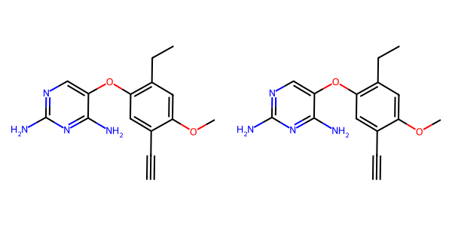

## US20080113922A1_p0012_x1337_y1027_c00040

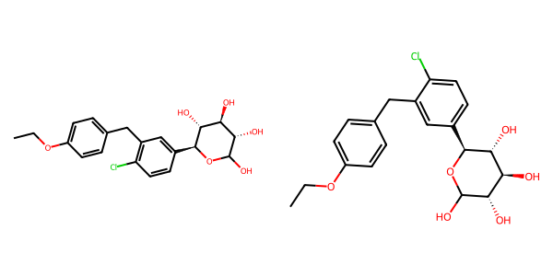

## US20060281700A1_p0082_x1376_y2556_c00162

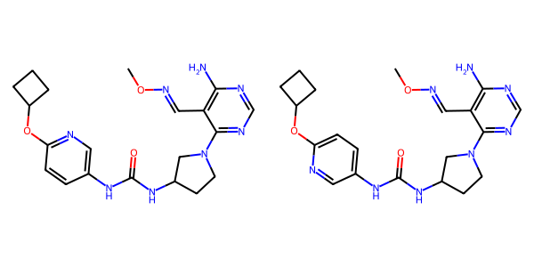

## US20060154945A1_p0021_x1375_y0776_c00084

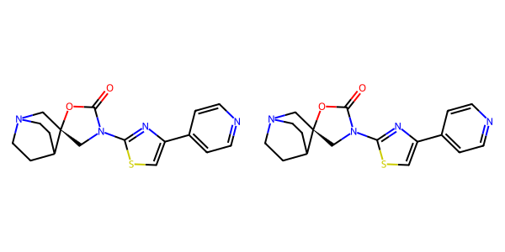

## US20070265270A1_p0027_x1520_y0812_c00108

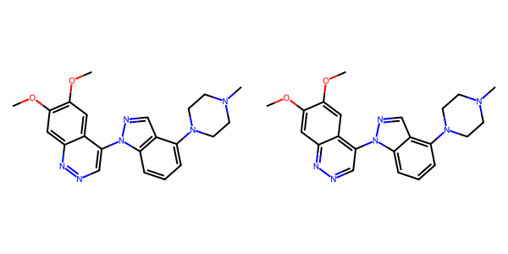

## US20030130506A1_p0010_x0369_y1455_c00032

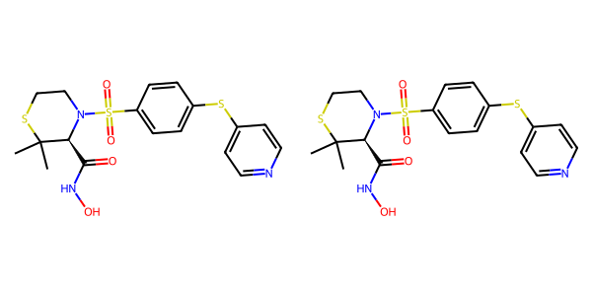

## US20040229890A1_p0016_x1503_y0665_c00072



## US20070179177A1_p0031_x1290_y2275_c00164

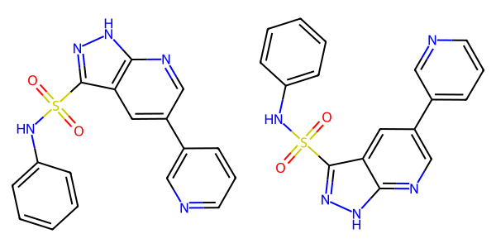

## US20060122222A1_p0024_x1336_y2518_c00069

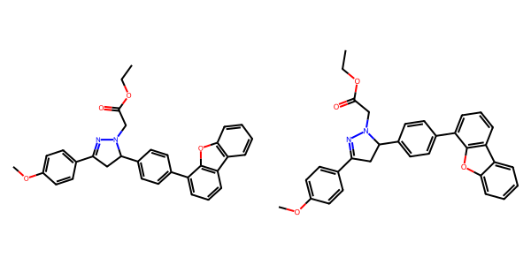

## US20060154945A1_p0013_x0402_y2304_c00038

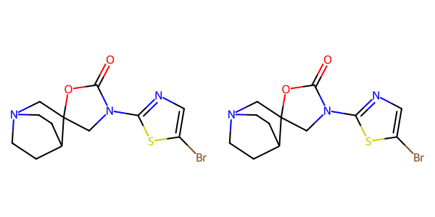

## US20050009817A1_p0021_x0709_y2113_c00071

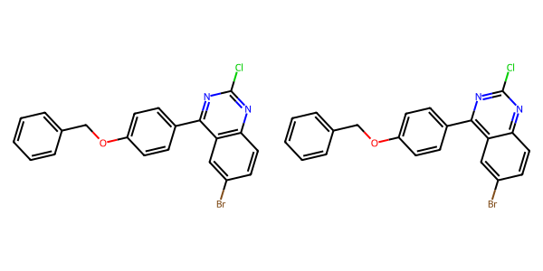

## US20040266789A1_p0038_x0542_y1120_c00063

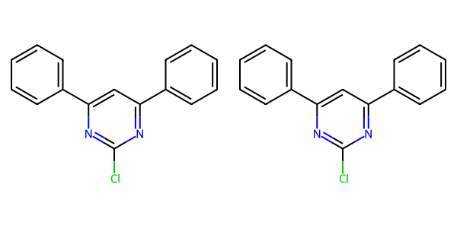

## US20070155803A1_p0027_x1440_y1979_c00066

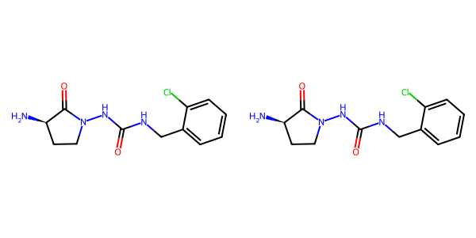

## US20070179154A1_p0046_x1376_y0890_c00066

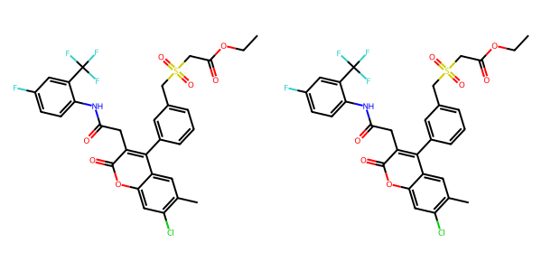

## US20050009817A1_p0022_x0681_y0702_c00073

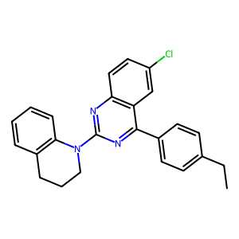

## US20050288357A1_p0066_x1539_y0947_c00118

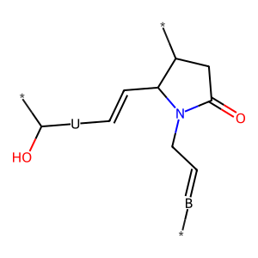

## US20050182067A1_p0031_x0550_y1157_c00106

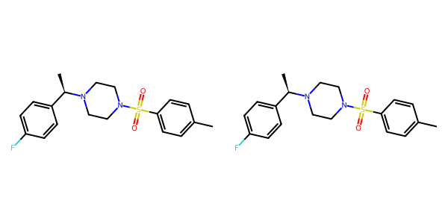

## US20070117785A1_p0037_x1307_y1381_c00075

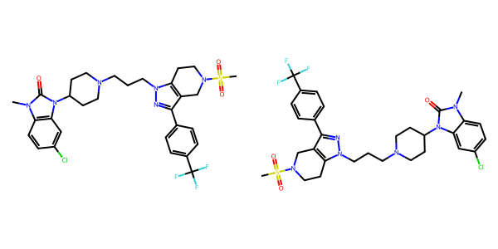

## US20070155803A1_p0018_x0379_y2502_c00028

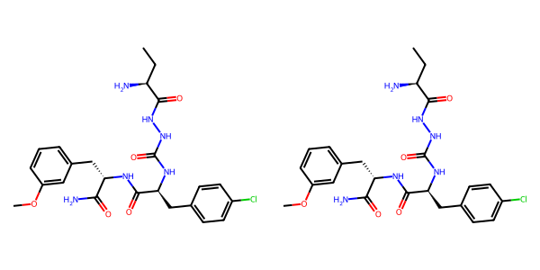

## US20050113580A1_p0033_x1311_y2331_c00040

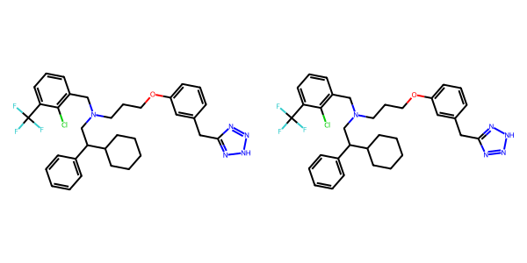

## US20070179154A1_p0058_x0404_y2474_c00125

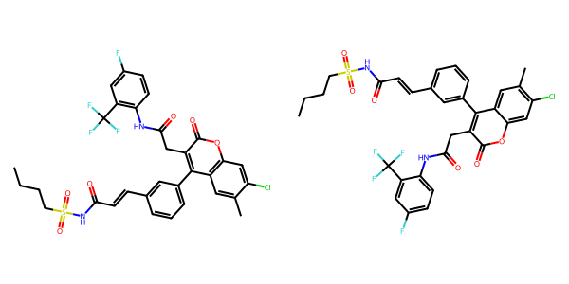

## US20040266789A1_p0035_x1301_y2162_c00060

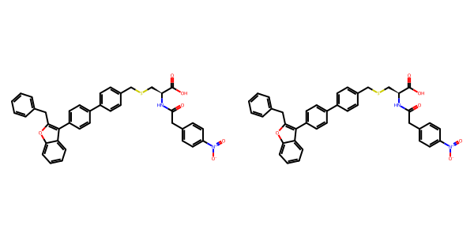

## US20050288357A1_p0048_x1475_y1738_c00089

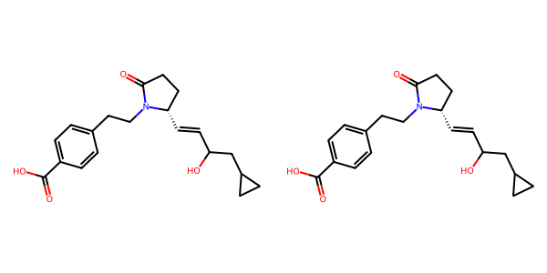

## US20060281700A1_p0073_x0495_y1376_c00112

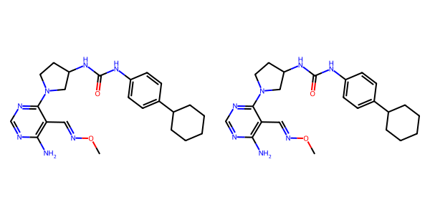

## US20060122222A1_p0038_x1483_y2682_c00100

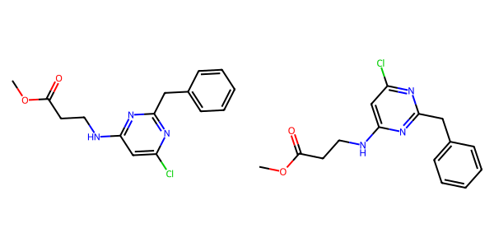

## US20060281700A1_p0072_x0424_y1880_c00106



## US20040229890A1_p0015_x0466_y1678_c00066

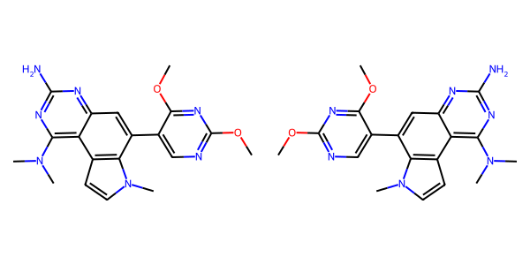

## US20030130506A1_p0004_x0560_y0718_c00006

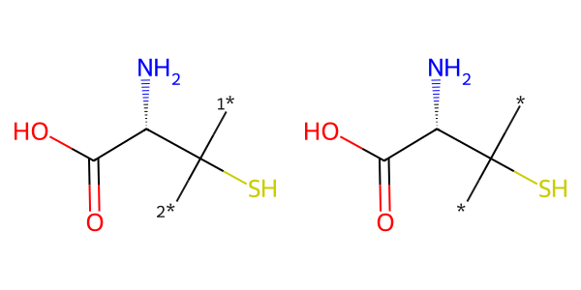

## US20040266789A1_p0030_x0330_y0536_c00051

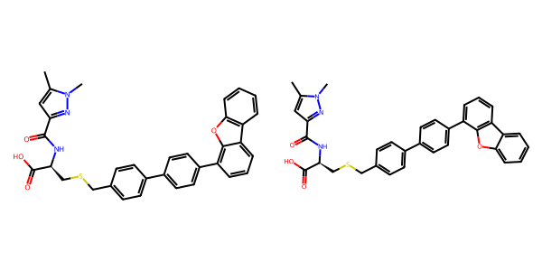

## US20050267177A1_p0017_x0350_y2741_c00037

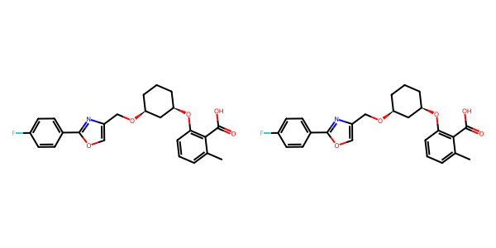

## US20070049758A1_p0021_x0476_y0686_c00029

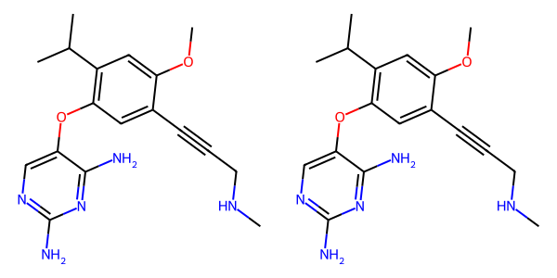

## US20070015754A1_p0040_x0432_y2307_c00250

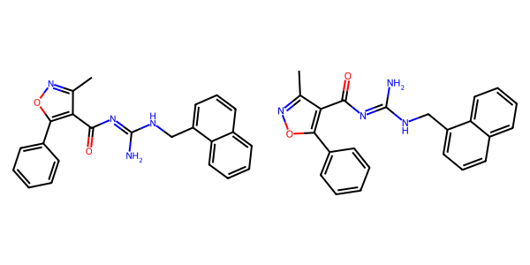

## US20050288357A1_p0041_x0506_y0766_c00073

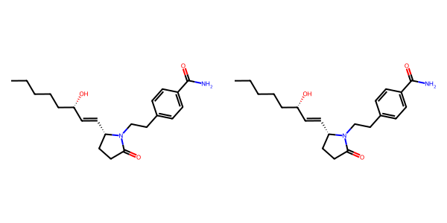

## US20070155803A1_p0021_x1410_y2837_c00041

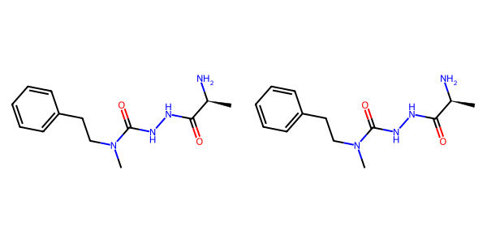

## US20060154945A1_p0022_x1375_y2289_c00090

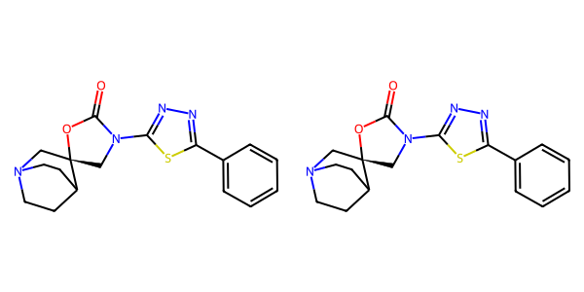

## US20050182067A1_p0037_x0634_y1067_c00138

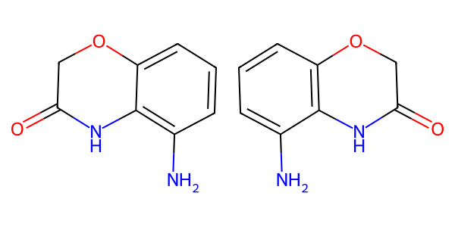

## US20050227932A1_p0025_x1376_y2235_c00027

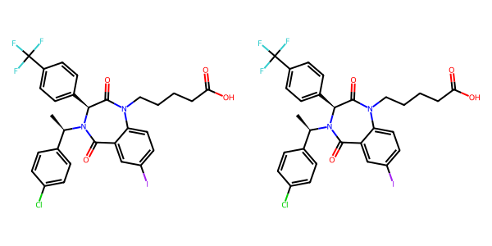

## US20050182067A1_p0036_x1369_y1723_c00136

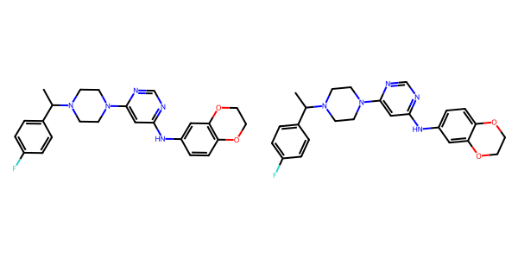

## US20050288357A1_p0056_x0489_y2538_c00109

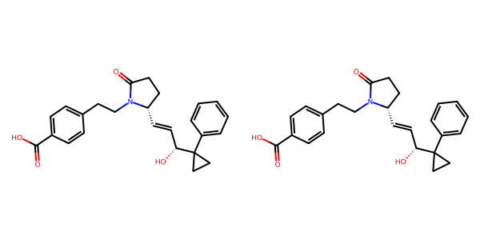

## US20070049758A1_p0027_x0513_y0636_c00054

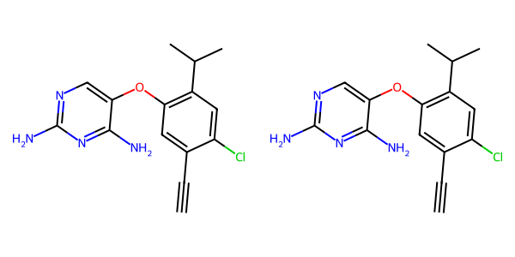

## US20070117785A1_p0057_x1311_y0849_c00109

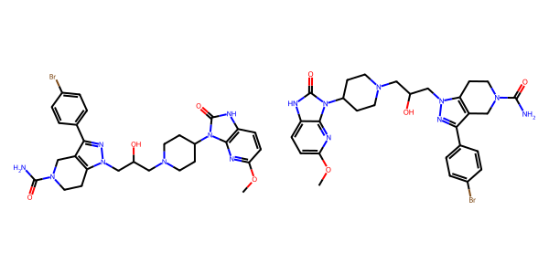

## US20050004369A1_p0030_x0443_y2502_c00058

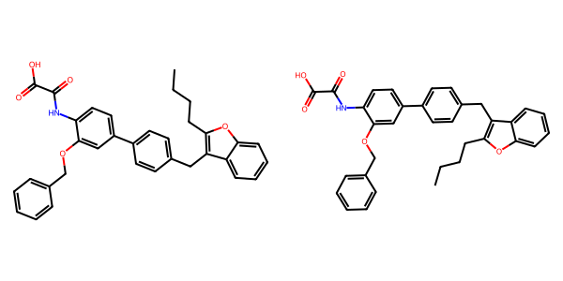

## US20070105909A1_p0033_x1401_y1769_c00105

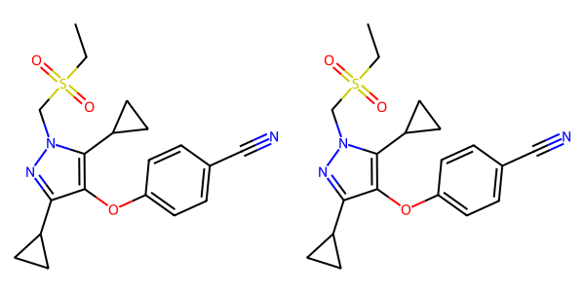

## US20070117785A1_p0055_x1308_y2606_c00099

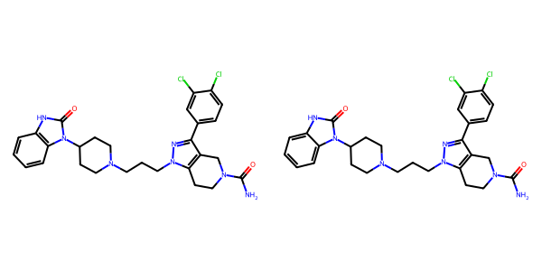

## US20050009817A1_p0028_x0584_y1932_c00084

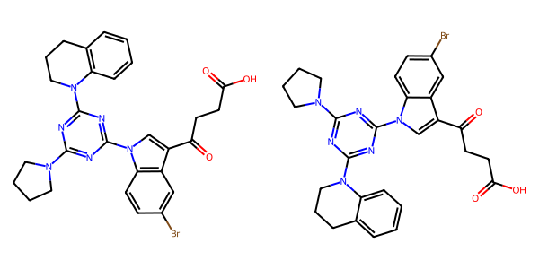

## US20060154945A1_p0023_x0402_y1425_c00092

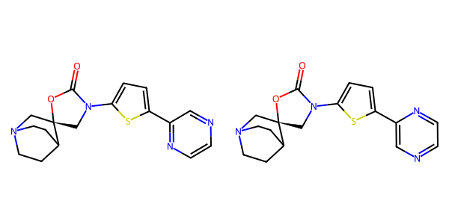

## US20040266789A1_p0029_x1303_y0694_c00050

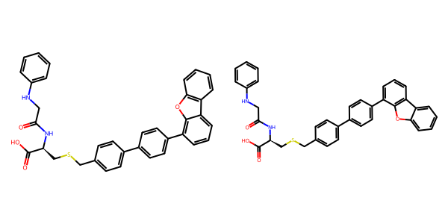

## US20050002859A1_p0024_x1442_y1277_c00122

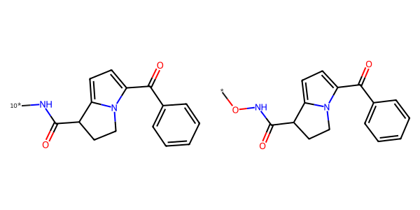

## US20070105909A1_p0027_x0617_y2340_c00069

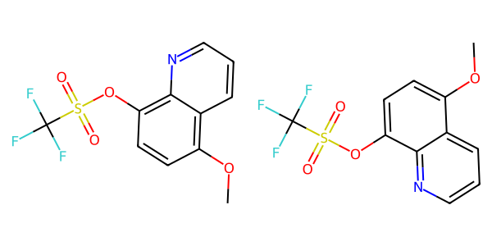

## US20050288357A1_p0024_x0515_y2659_c00051

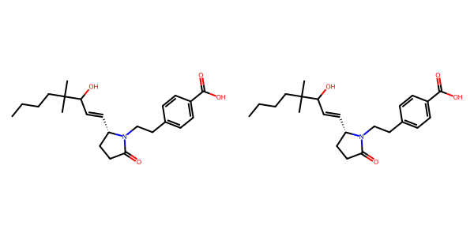

## US20060154945A1_p0014_x1375_y0730_c00044

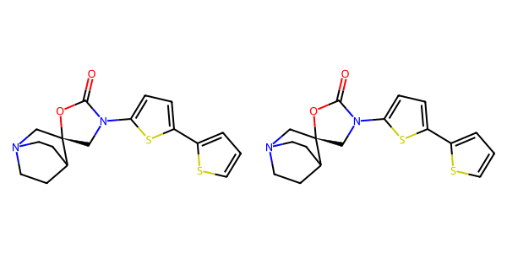

## US20070179154A1_p0042_x1376_y1828_c00057

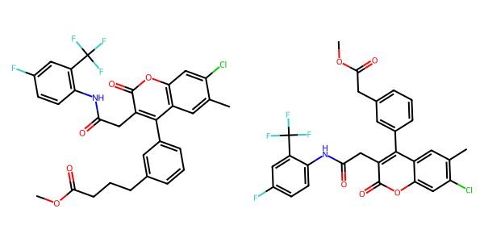

## US20050004369A1_p0018_x1503_y1755_c00025

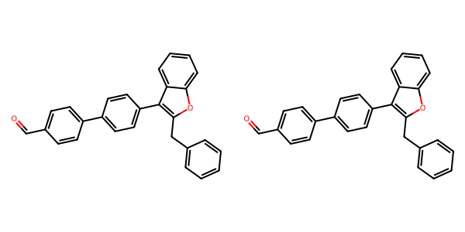

## US20040266789A1_p0043_x1489_y0717_c00071



## US20070179177A1_p0021_x1536_y2786_c00135

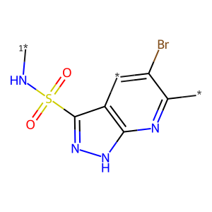

## US20080113922A1_p0020_x1308_y1557_c00061

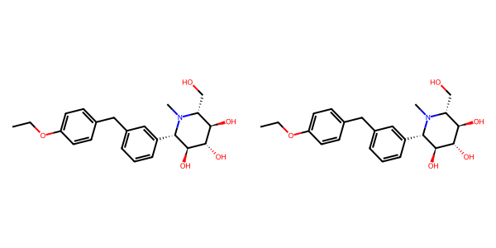

## US20040266789A1_p0019_x0329_y1979_c00032

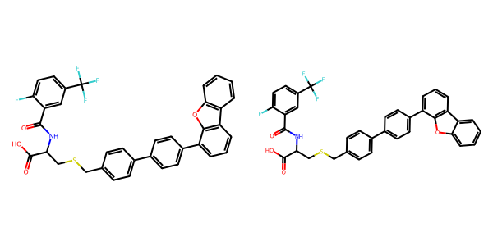

## US20050267177A1_p0023_x0348_y0648_c00071

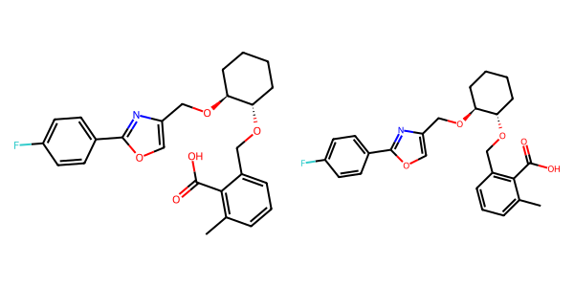

## US20070117785A1_p0058_x1307_y1733_c00116

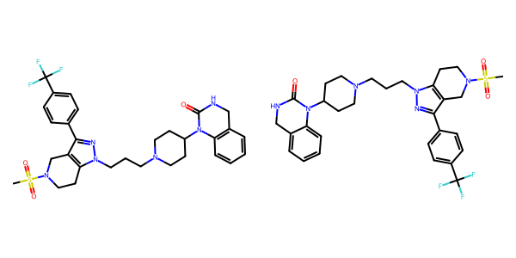

## US20040266789A1_p0047_x0334_y0620_c00079

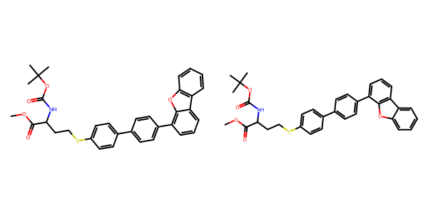

## US20070105909A1_p0034_x0460_y1063_c00106

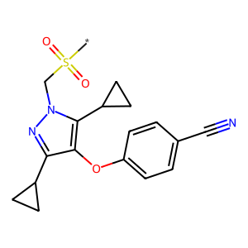

## US20070265270A1_p0028_x1487_y1891_c00113

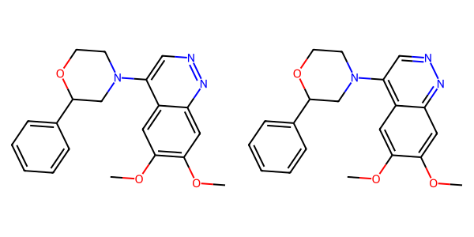

## US20070117785A1_p0055_x1308_y0666_c00097

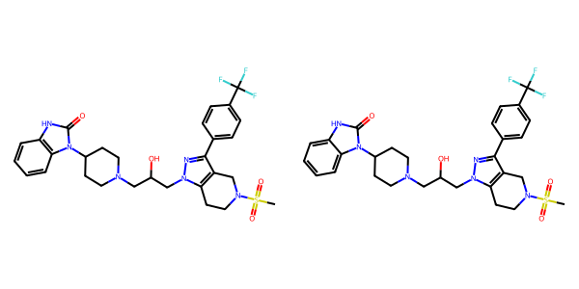

## US20040266789A1_p0050_x1437_y0621_c00083

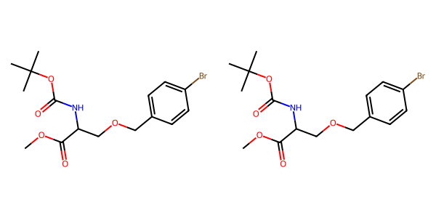

## US20050004369A1_p0032_x0443_y1606_c00062

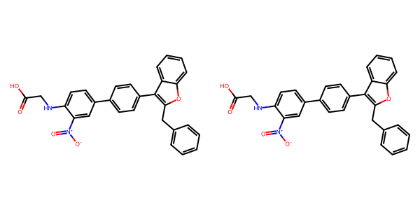

## US20070270434A1_p0016_x1376_y0994_c00032

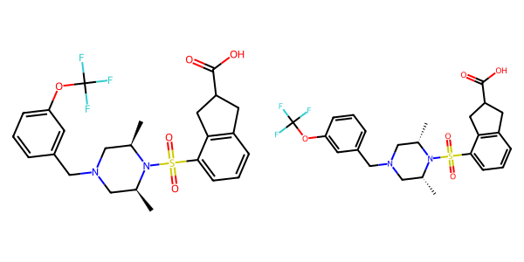

## US20060122222A1_p0033_x0417_y0814_c00092

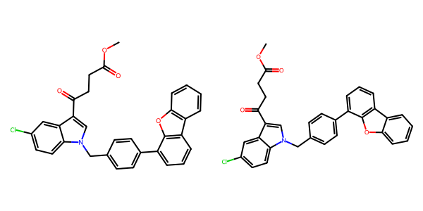

## US20060154945A1_p0003_x0404_y1991_c00004

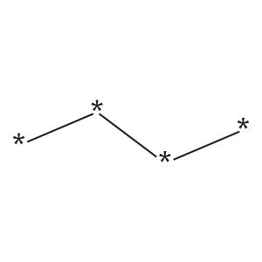

## US20050182067A1_p0031_x1477_y1053_c00108

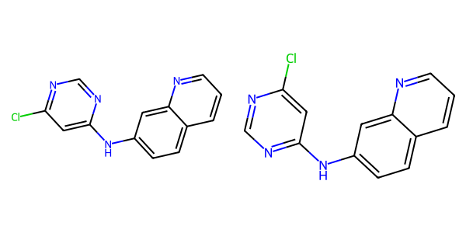

## US20070265270A1_p0030_x0491_y1698_c00120

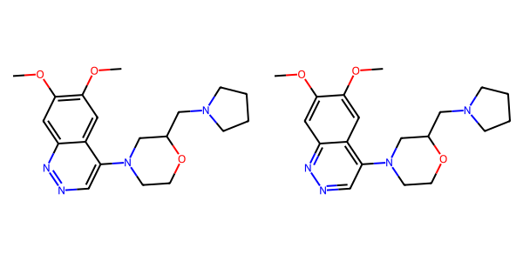

## US20060154945A1_p0011_x0402_y2785_c00029

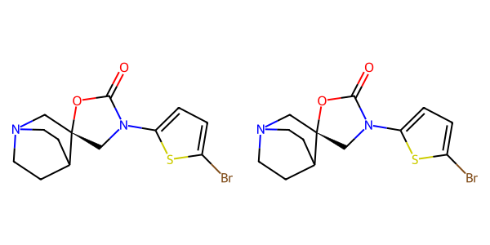

## US20070105909A1_p0022_x0484_y1267_c00046

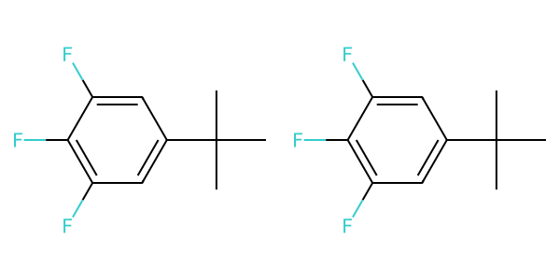

## US20050288357A1_p0032_x1507_y1355_c00062

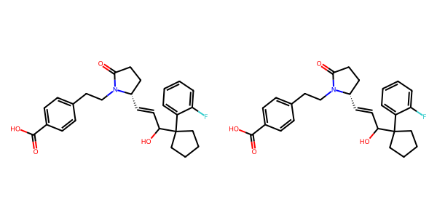

## US20070117785A1_p0057_x0339_y2663_c00108

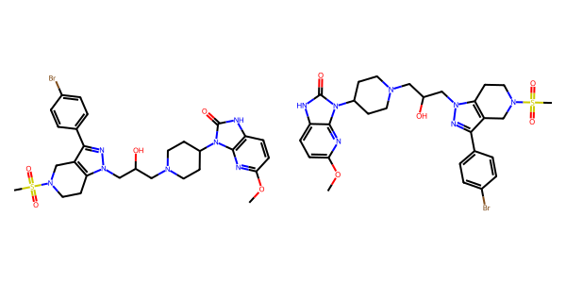

## US20060154945A1_p0020_x0404_y0602_c00075

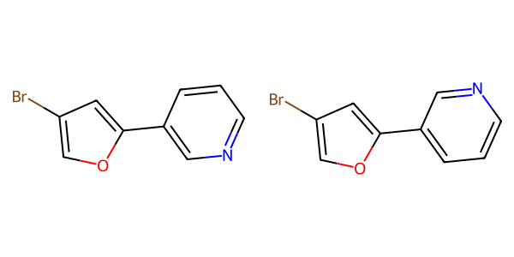

## US20070105909A1_p0034_x0426_y2575_c00107

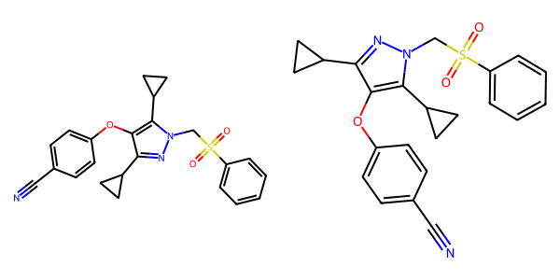

## US20050004369A1_p0026_x1366_y0772_c00045

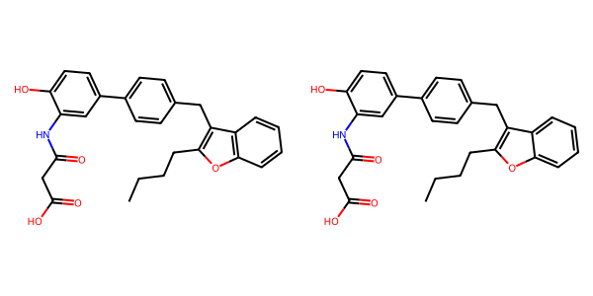

## US20070155803A1_p0028_x1365_y0762_c00067

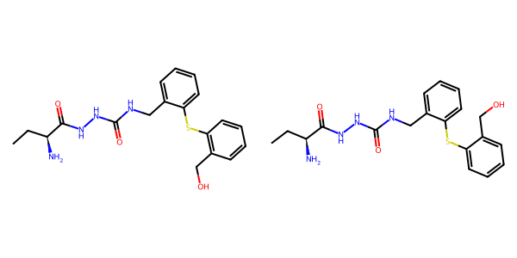

## US20050004369A1_p0016_x0514_y2724_c00020



## US20040229890A1_p0015_x0523_y0792_c00065

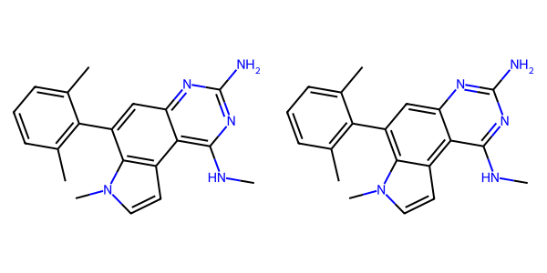

## US20070265270A1_p0023_x1568_y2864_c00094

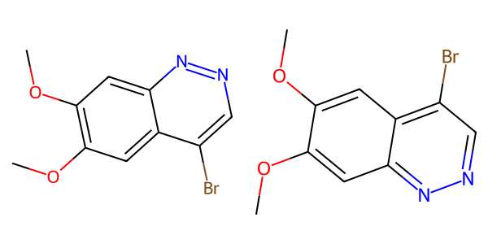

## US20080113922A1_p0020_x0364_y2692_c00060

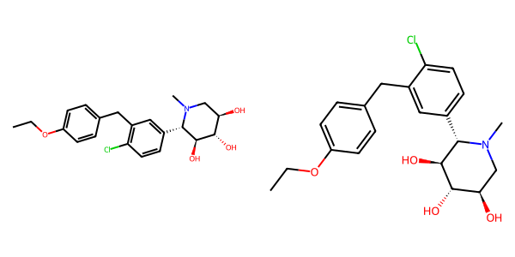

## US20070179154A1_p0040_x0404_y2372_c00050

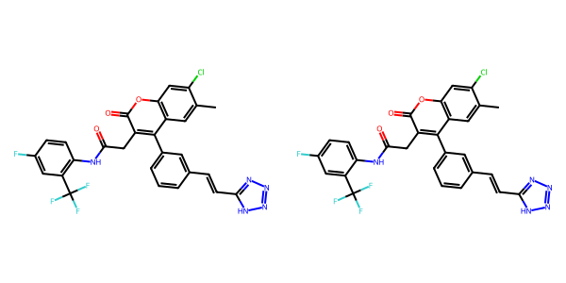

## US20040229890A1_p0011_x0530_y2377_c00047

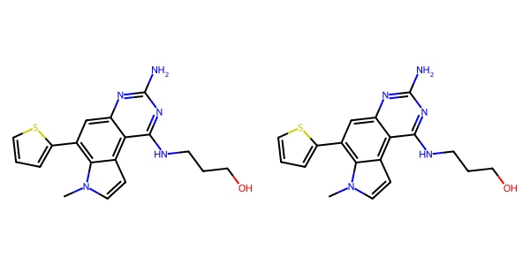

## US20050182067A1_p0048_x0765_y1900_c00165

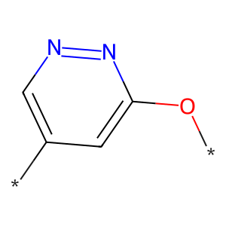

## US20050002859A1_p0024_x0451_y1702_c00119

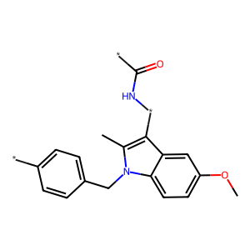

## US20040266789A1_p0044_x1494_y2583_c00074

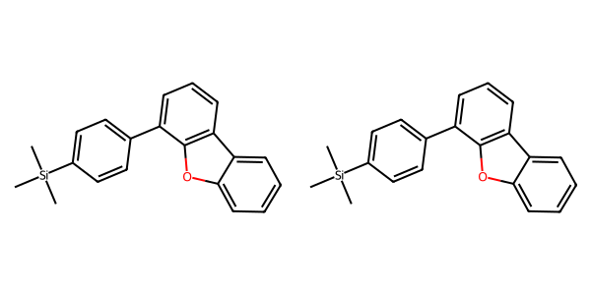

## US20050288357A1_p0048_x0502_y0752_c00087

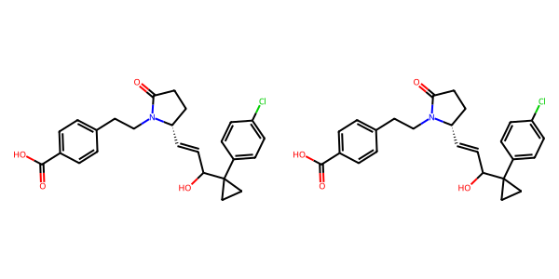

## US20040229890A1_p0015_x0494_y2613_c00067

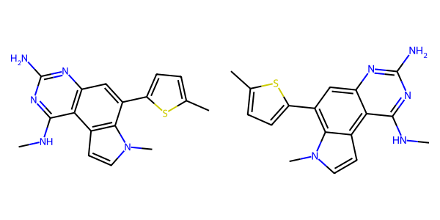

## US20070117785A1_p0056_x1308_y1739_c00104

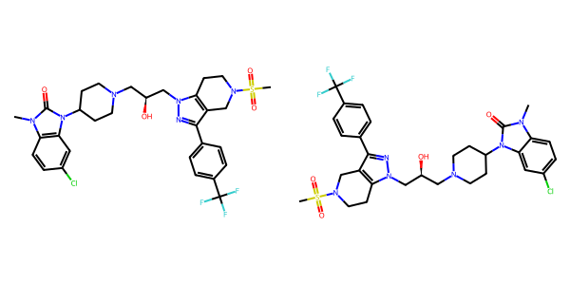

## US20070270434A1_p0015_x0402_y2615_c00028

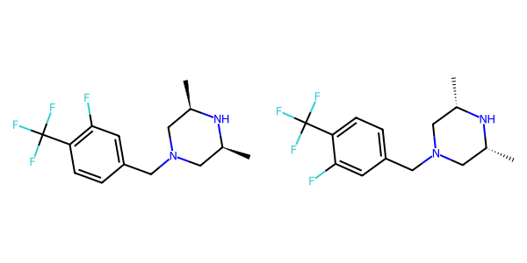

## US20040254236A1_p0035_x0447_y0784_c00140

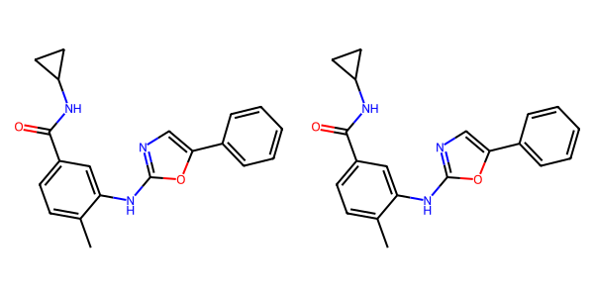

## US20060281700A1_p0075_x1376_y1812_c00130

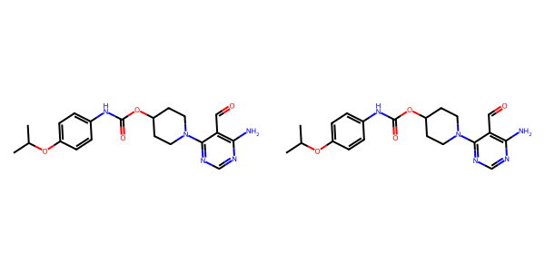

## US20070015754A1_p0014_x1326_y2235_c00065

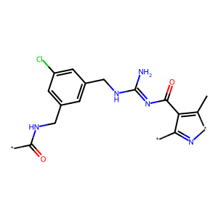

## US20040229890A1_p0015_x1435_y2559_c00068

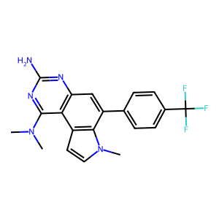

## US20050227932A1_p0028_x0404_y0963_c00036

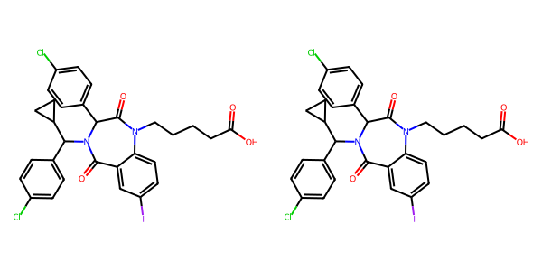

## US20040229890A1_p0012_x1473_y2023_c00054

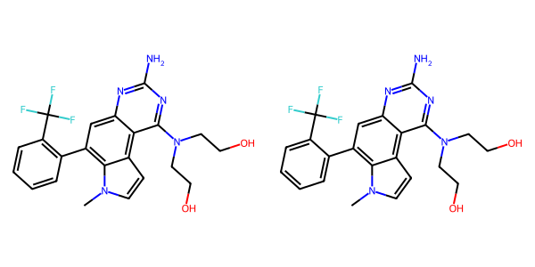

## US20070265270A1_p0017_x0473_y0907_c00075

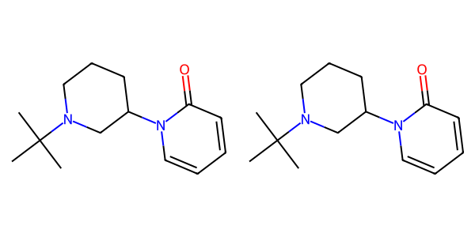

## US20050288357A1_p0024_x0515_y0923_c00050



## US20070270434A1_p0022_x0334_y1026_c00056

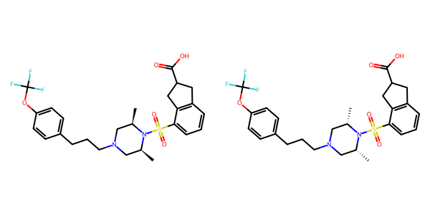

## US20060154945A1_p0022_x0402_y1806_c00087

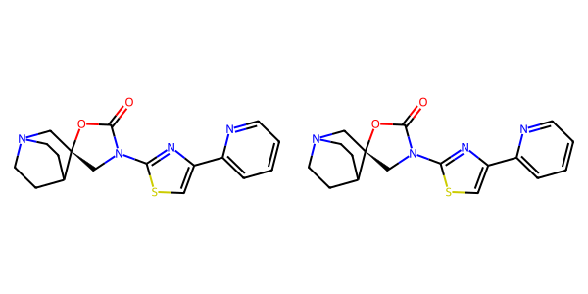

## US20050002859A1_p0023_x0484_y1874_c00113



## US20050009817A1_p0031_x0585_y0933_c00087

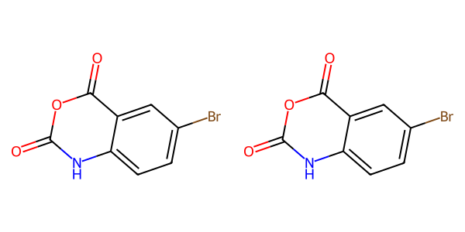

## US20070179154A1_p0035_x0404_y2534_c00025

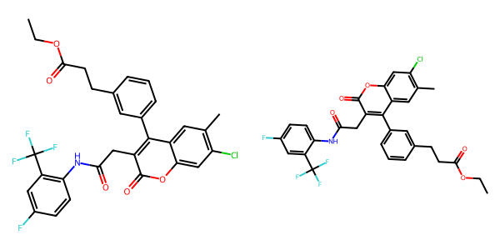

## US20070155803A1_p0019_x0379_y0925_c00030

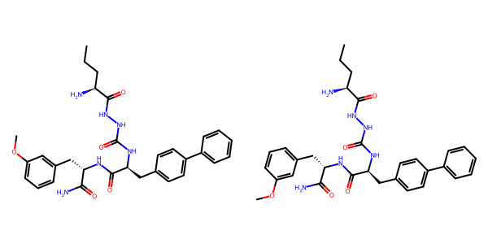

## US20060122222A1_p0035_x0437_y2790_c00095

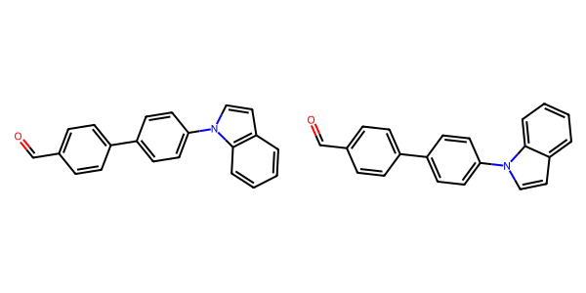

## US20050267177A1_p0022_x0456_y1366_c00067

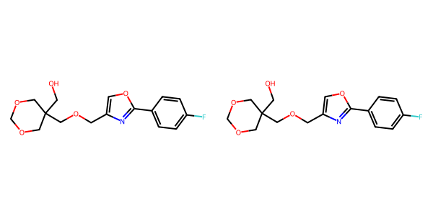

## US20050002859A1_p0015_x1487_y0738_c00091

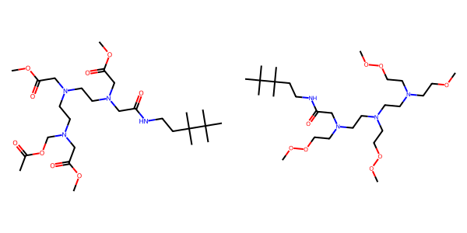

## US20060122222A1_p0033_x0417_y2474_c00093

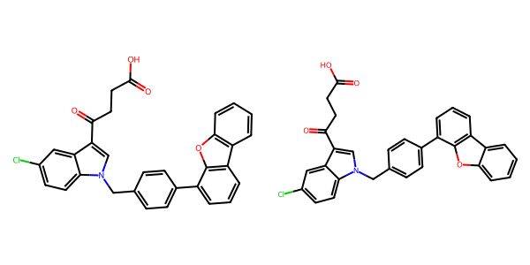

## US20070049758A1_p0023_x0553_y2615_c00040

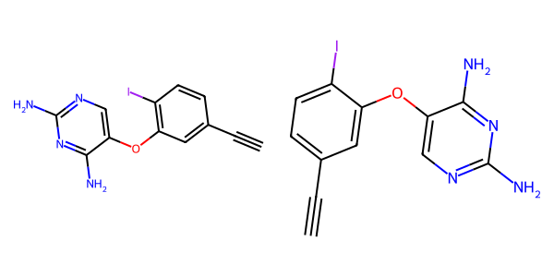

## US20050182067A1_p0039_x0488_y1444_c00149

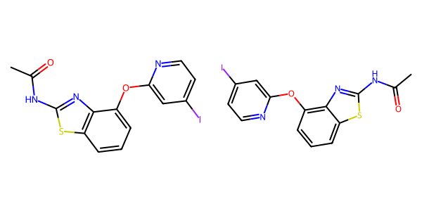

## US20050267177A1_p0040_x1333_y0570_c00162

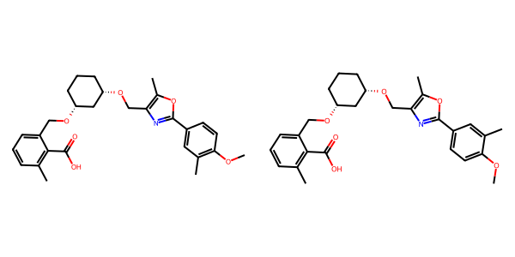

## US20060154945A1_p0019_x1375_y0715_c00072



## US20050288357A1_p0029_x0533_y1011_c00058

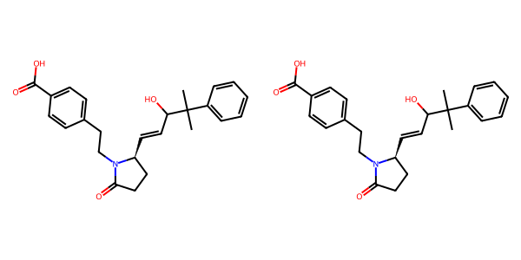

## US20050009817A1_p0024_x0621_y1503_c00077

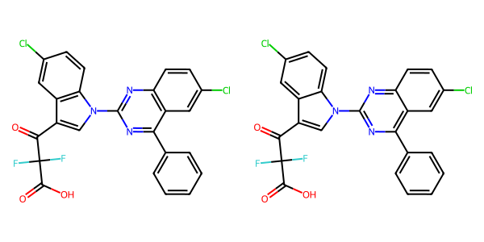

## US20070179177A1_p0031_x1331_y1566_c00162

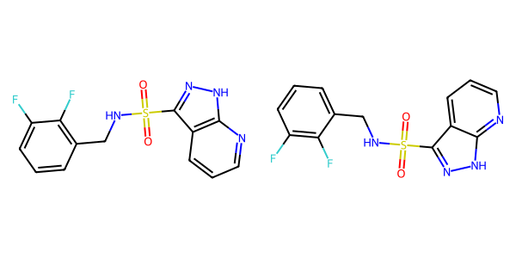

## US20070015754A1_p0022_x1598_y1615_c00118

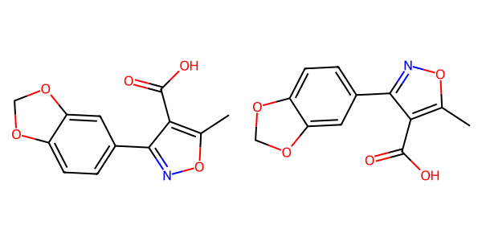

## US20040266789A1_p0007_x1367_y1327_c00007

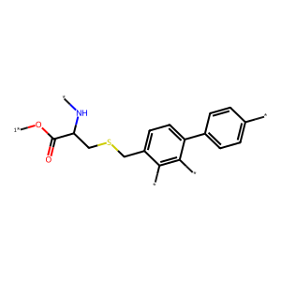

## US20070117785A1_p0048_x0338_y1222_c00089

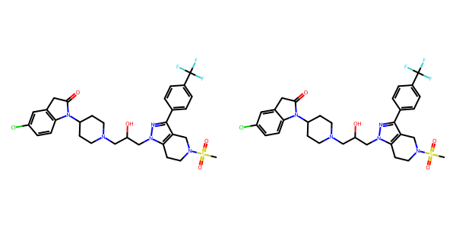

## US20050004369A1_p0033_x0443_y1881_c00066

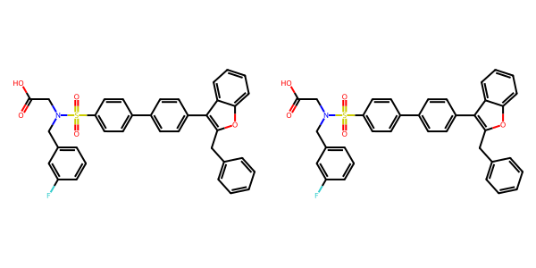

## US20070270434A1_p0015_x1376_y2386_c00029

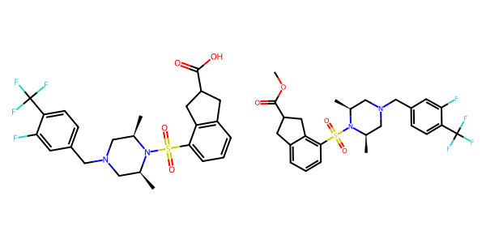

## US20050182067A1_p0038_x0401_y1197_c00144

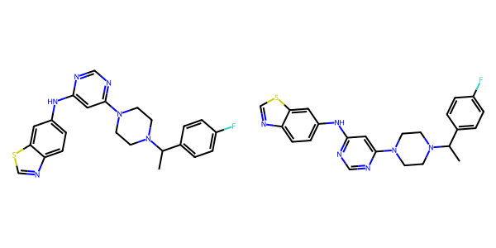

## US20050288357A1_p0050_x1488_y2217_c00094

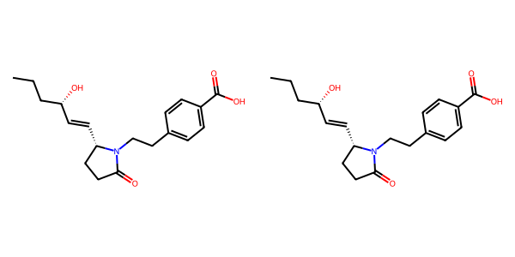

## US20050009817A1_p0022_x0604_y2379_c00075

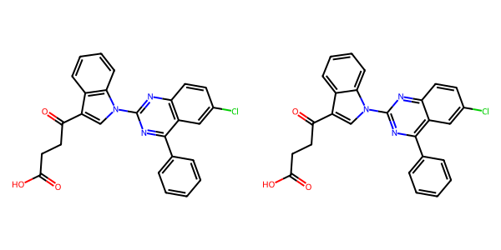

## US20040266789A1_p0019_x0329_y2640_c00033

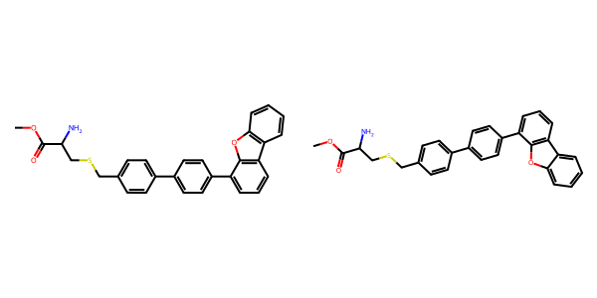

## US20070155803A1_p0020_x1315_y0950_c00035

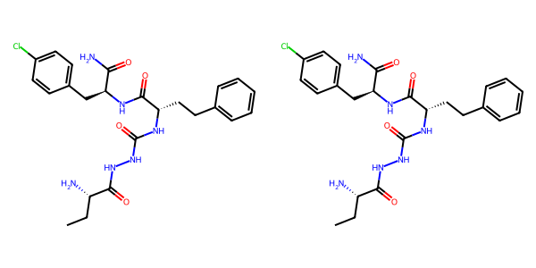

## US20050182067A1_p0031_x0554_y2420_c00107

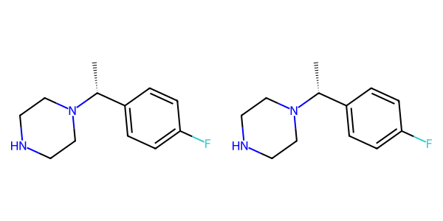

## US20060154945A1_p0016_x1376_y0639_c00055

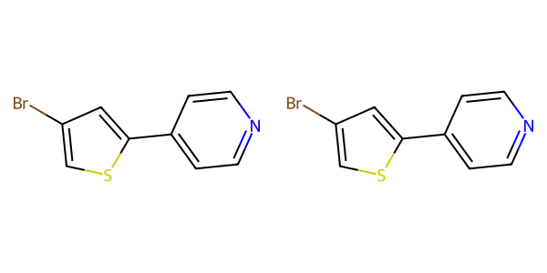

## US20050113580A1_p0040_x0343_y1159_c00056

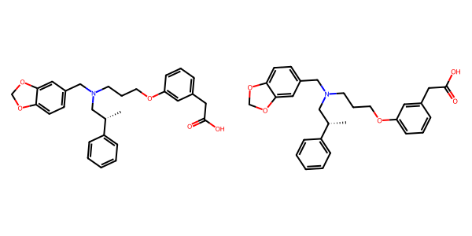

## US20070049758A1_p0022_x0511_y0699_c00033

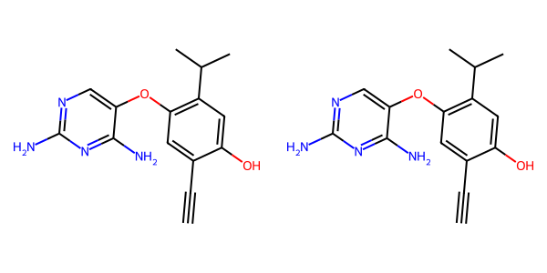

## US20050004369A1_p0029_x0443_y1380_c00054

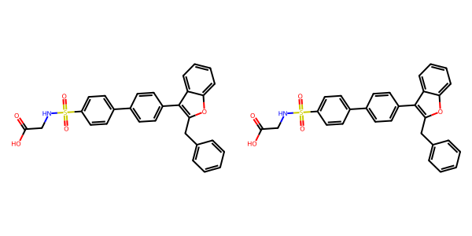

## US20050288357A1_p0006_x1491_y1404_c00002



## US20030130506A1_p0008_x1381_y1349_c00031

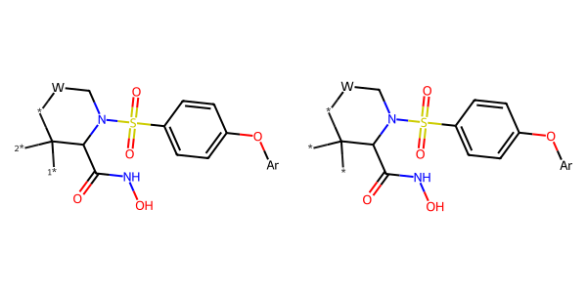

## US20050004369A1_p0030_x0443_y1680_c00057

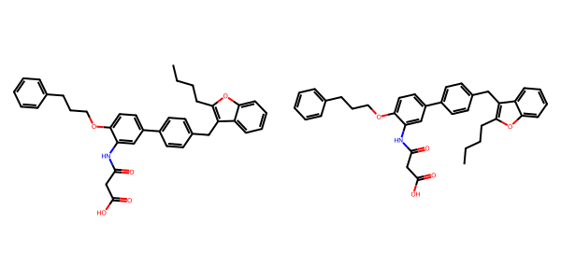

## US20070265270A1_p0033_x0492_y0759_c00133

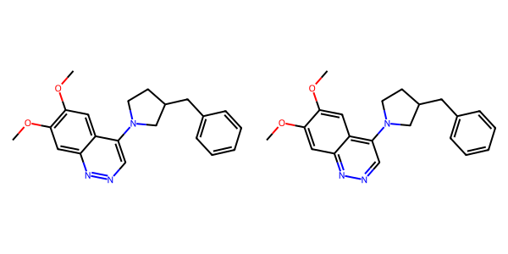

## US20070105909A1_p0001_x1423_y0823_c00000

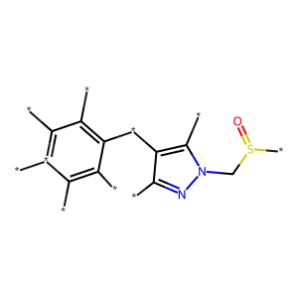

## US20070117785A1_p0054_x0337_y2273_c00096

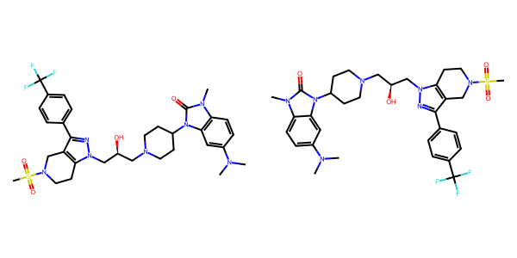

## US20050009817A1_p0031_x1534_y2112_c00090

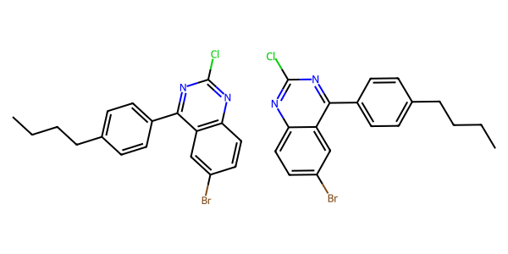

## US20060122222A1_p0027_x0379_y2408_c00079

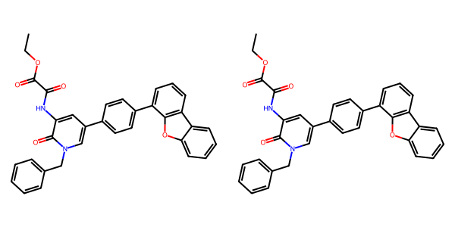

## US20050054819A1_p0034_x0402_y1353_c00120

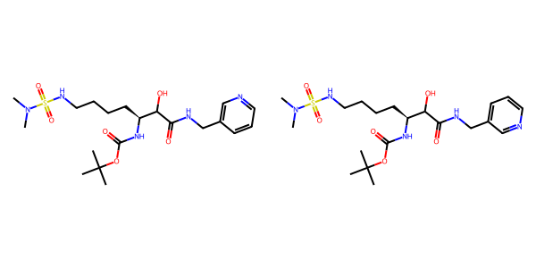

## US20060154945A1_p0015_x0402_y1753_c00048

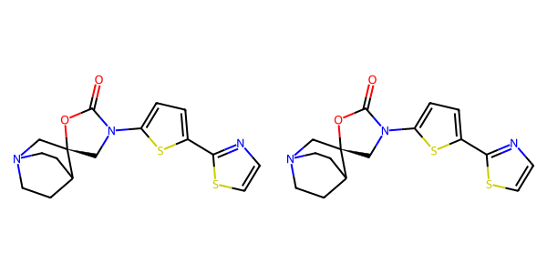

## US20050288357A1_p0052_x0513_y2374_c00099

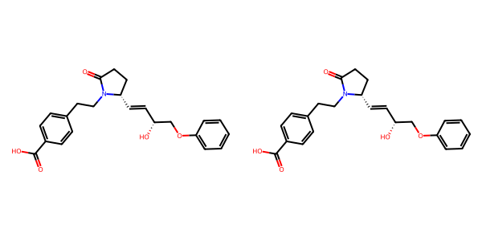

## US20060122222A1_p0029_x1319_y2445_c00088

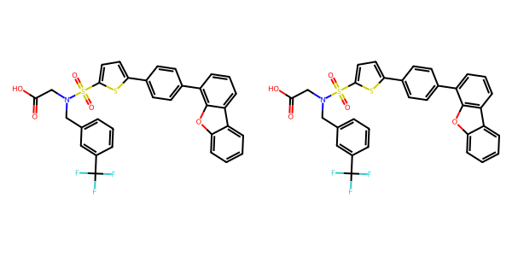

## US20050009817A1_p0018_x0506_y2240_c00062

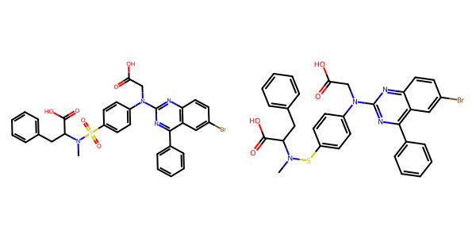

## US20070155803A1_p0026_x0456_y1737_c00062

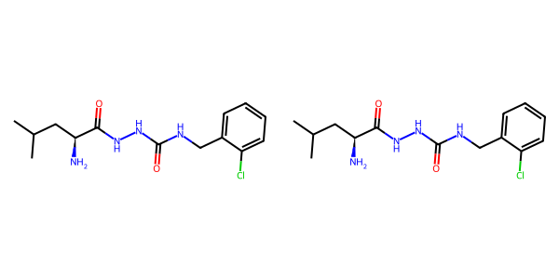

## US20070015754A1_p0050_x1359_y2566_c00281

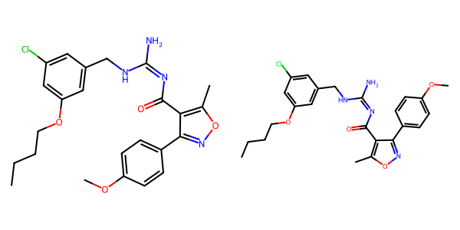

## US20040266789A1_p0021_x1301_y2542_c00039

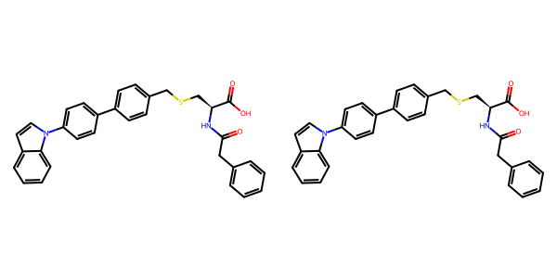

## US20070155803A1_p0028_x1439_y2684_c00068

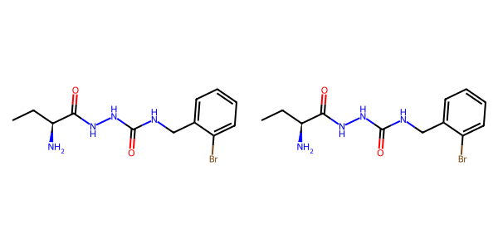

## US20070105909A1_p0022_x0484_y0984_c00045

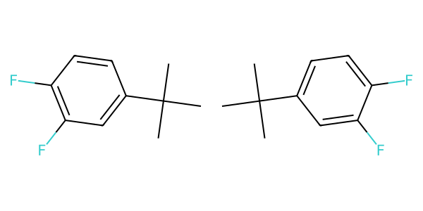

## US20040229890A1_p0022_x1621_y2943_c00101

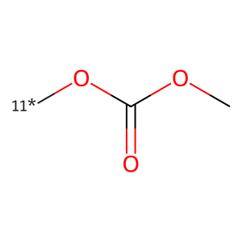

## US20060281700A1_p0071_x0445_y2583_c00099

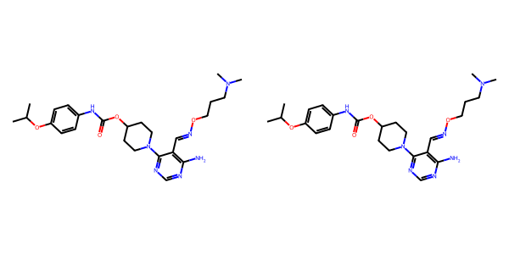

## US20060154945A1_p0016_x0402_y1570_c00053

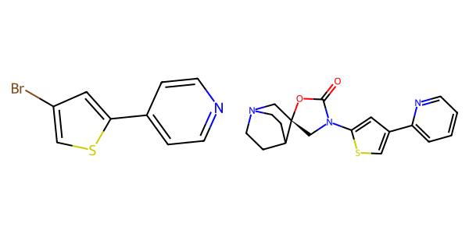

## US20070155803A1_p0016_x0346_y1008_c00018

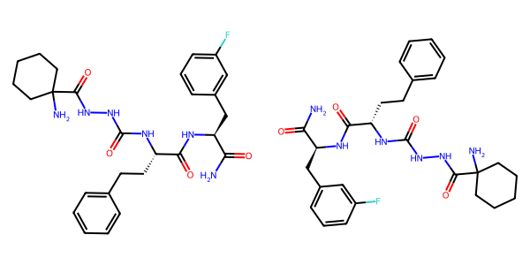

## US20070265270A1_p0034_x0547_y1864_c00136

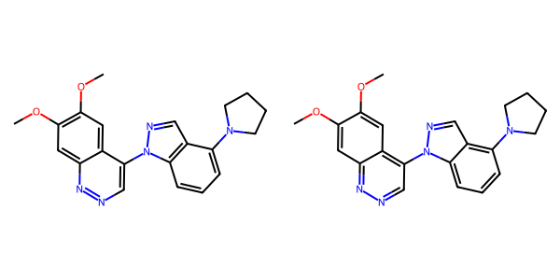

## US20050004369A1_p0034_x0443_y2351_c00071

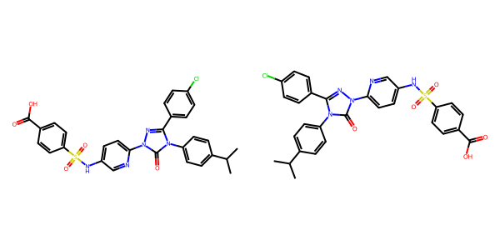

## US20040229890A1_p0016_x0530_y0817_c00069

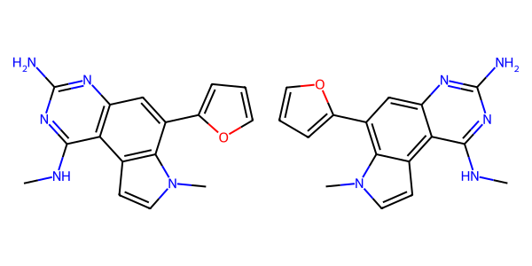

## US20040266789A1_p0034_x1301_y1397_c00058

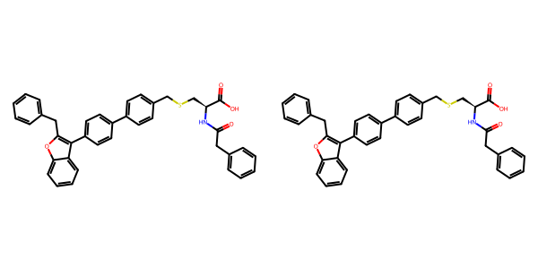

## US20050075347A1_p0001_x1448_y1085_c00000

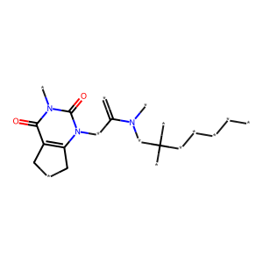

## US20040229890A1_p0013_x0390_y0672_c00055

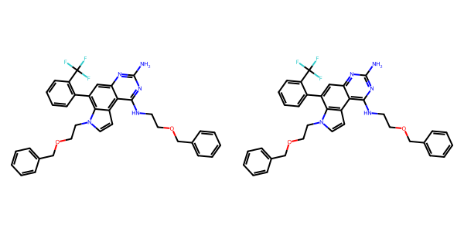

## US20050009817A1_p0032_x1558_y1931_c00094

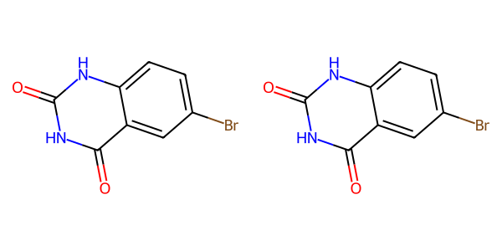

## US20070049758A1_p0022_x0407_y1954_c00035

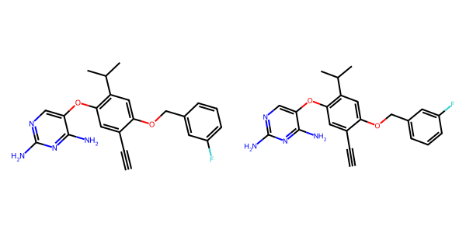

## US20060122222A1_p0032_x0506_y2169_c00091

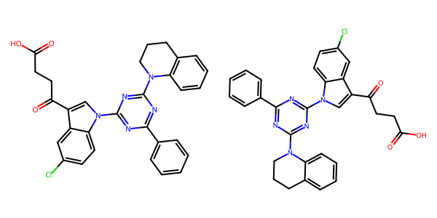

## US20070179177A1_p0004_x0643_y2673_c00001

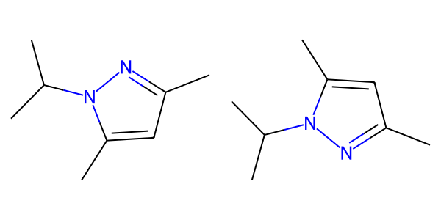

## US20050267177A1_p0027_x0356_y2054_c00096

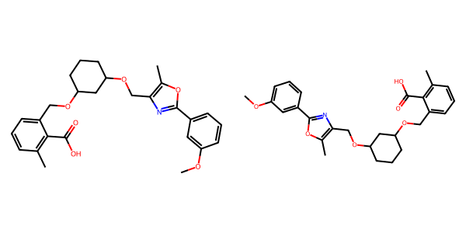

## US20050043351A1_p0017_x1425_y1952_c00047

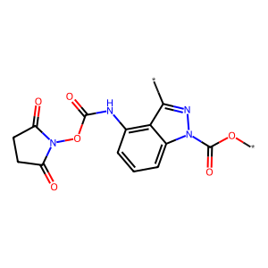

## US20070117785A1_p0056_x1303_y0877_c00103

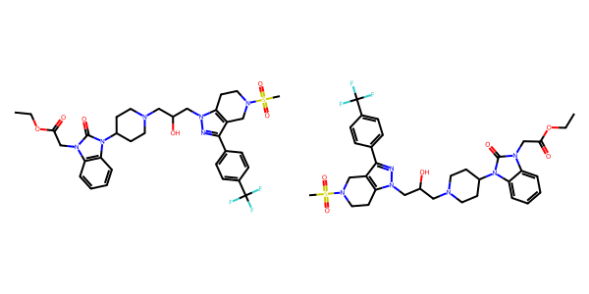

## US20030130506A1_p0026_x0577_y0617_c00141

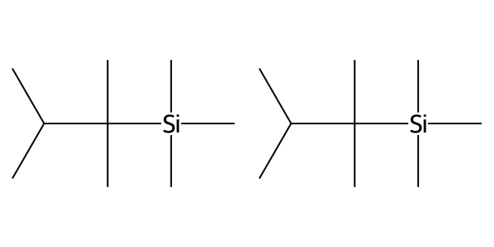

## US20050227932A1_p0026_x1376_y0950_c00030

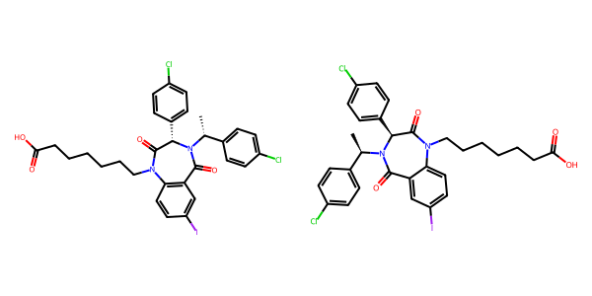

## US20070105909A1_p0026_x1477_y2219_c00067

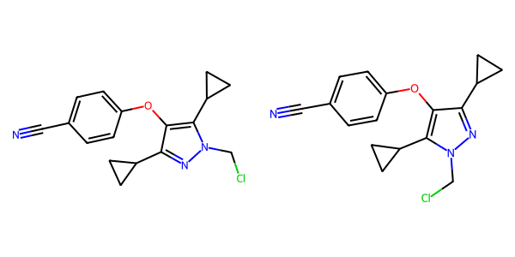

## US20040229890A1_p0014_x0525_y2643_c00061

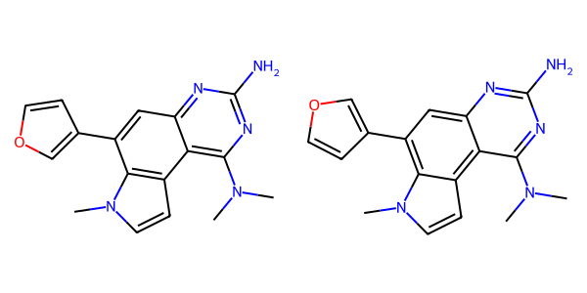

## US20070155803A1_p0029_x1439_y2706_c00074

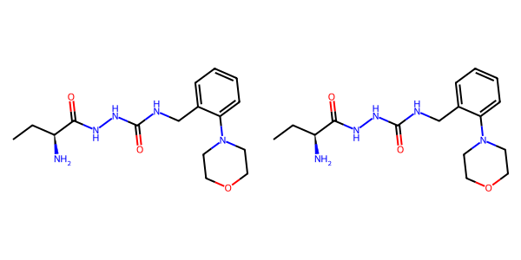

## US20040186132A1_p0003_x0634_y1617_c00000

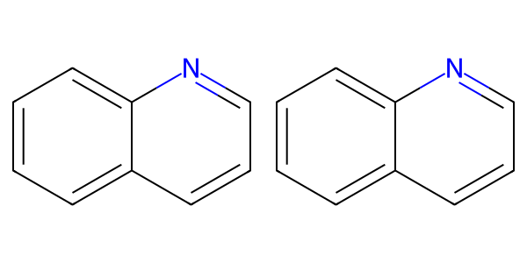

## US20070049758A1_p0026_x0469_y2581_c00053

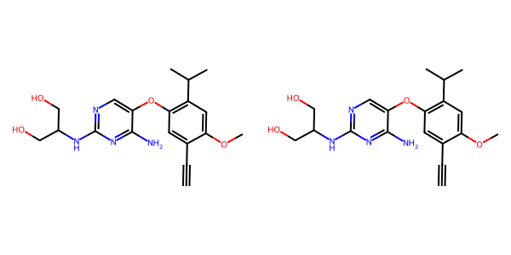

## US20050288357A1_p0011_x1488_y0536_c00009

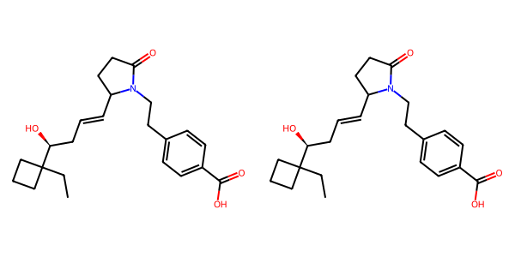

## US20050043351A1_p0023_x0446_y1633_c00095

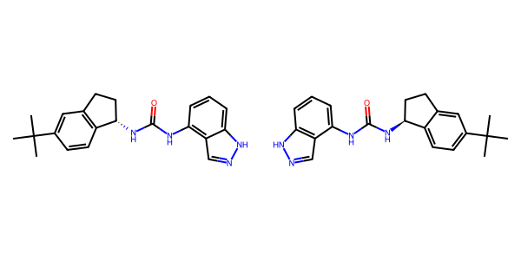

## US20040266789A1_p0020_x1301_y2618_c00038

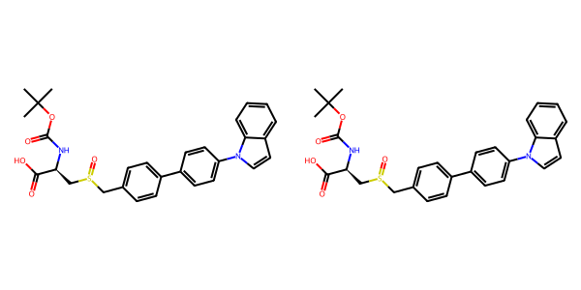

## US20070015754A1_p0039_x1395_y0837_c00247

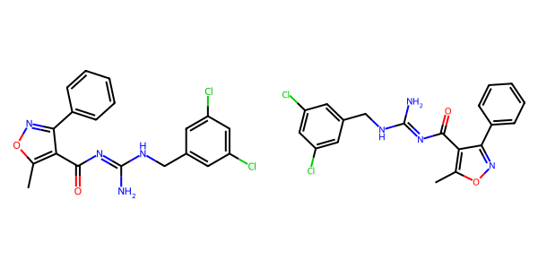

## US20050182067A1_p0031_x1340_y2090_c00109

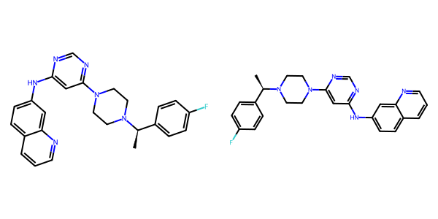

## US20060154945A1_p0013_x1375_y2826_c00041

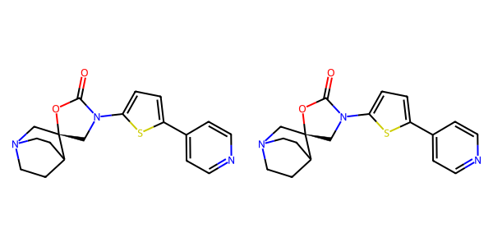

## US20070049758A1_p0024_x0453_y1546_c00043

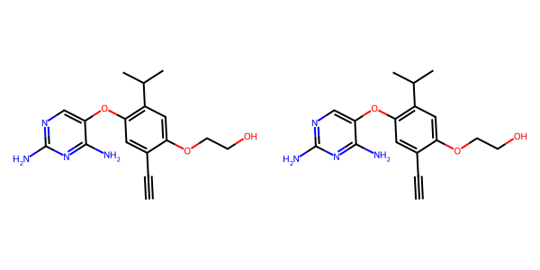

## US20050288357A1_p0053_x1477_y0924_c00103

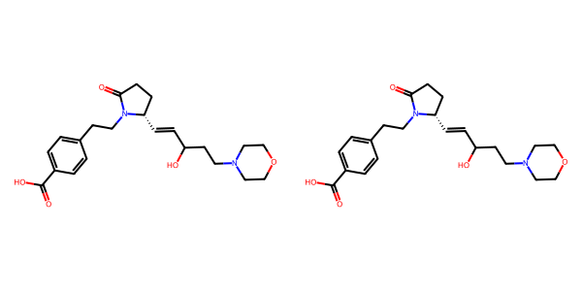

## US20050004369A1_p0033_x0443_y1163_c00065

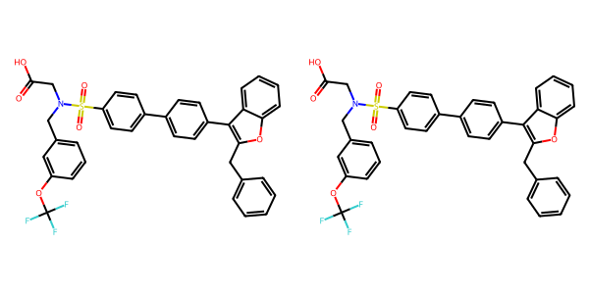

## US20070117785A1_p0057_x1307_y1744_c00110

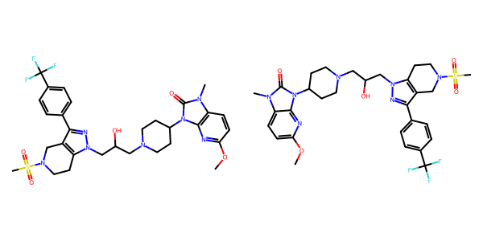

## US20070155803A1_p0030_x0466_y2591_c00077

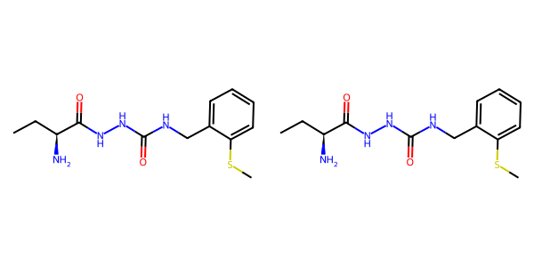

## US20060154945A1_p0020_x1375_y1933_c00079

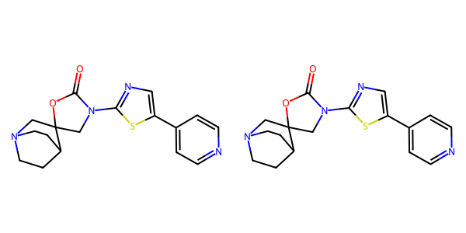

## US20050182067A1_p0045_x0765_y2765_c00160

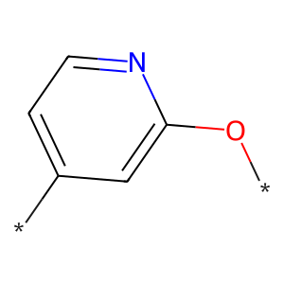

## US20070117785A1_p0058_x1310_y2613_c00117

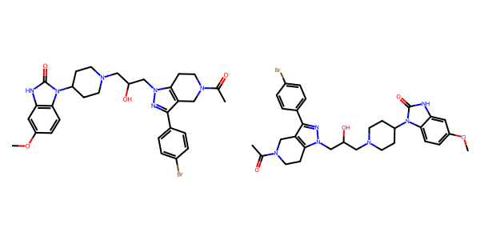

## US20070155803A1_p0024_x1439_y2823_c00056

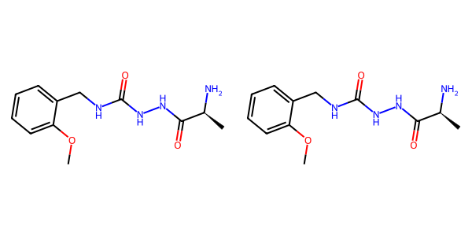

## US20050004369A1_p0028_x0385_y1396_c00050

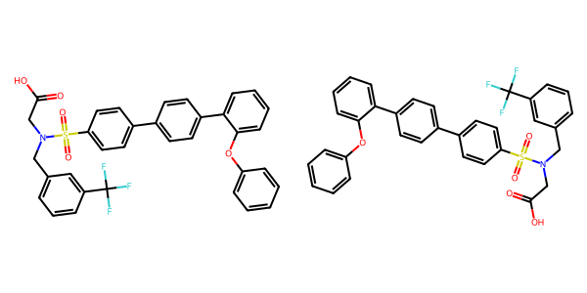

## US20050288357A1_p0053_x1469_y2152_c00104

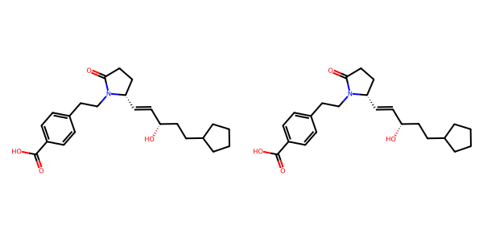

## US20050288357A1_p0026_x0484_y0828_c00054

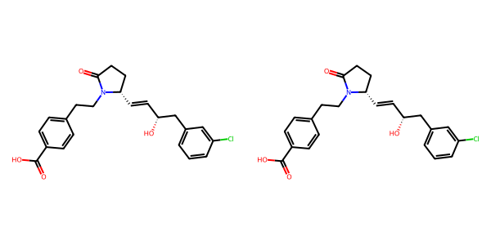

## US20040229890A1_p0016_x1503_y1605_c00073

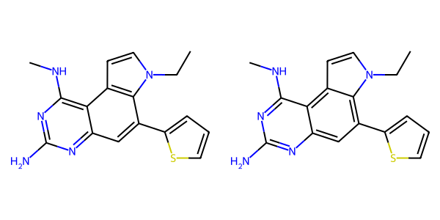

## US20050267177A1_p0031_x1350_y2309_c00117

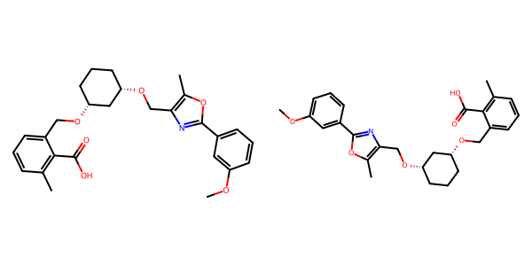

## US20050004369A1_p0021_x0445_y2481_c00032



## US20070105909A1_p0019_x0605_y1321_c00029

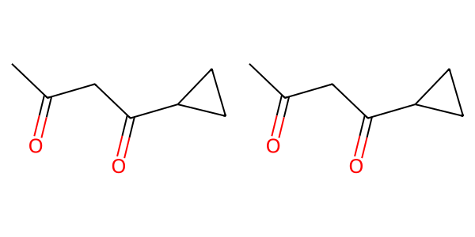

## US20050267177A1_p0025_x0356_y2545_c00085

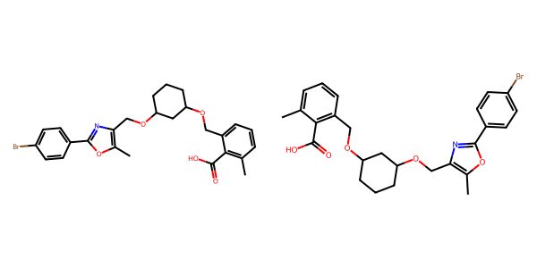

## US20070105909A1_p0027_x1561_y2396_c00071

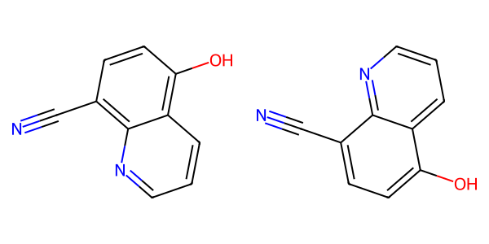

## US20060154945A1_p0020_x0402_y1946_c00076



## US20050182067A1_p0026_x1619_y0585_c00009

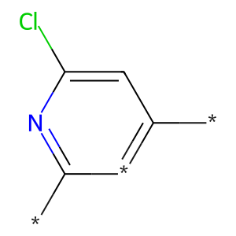

## US20050267177A1_p0022_x0327_y0687_c00066

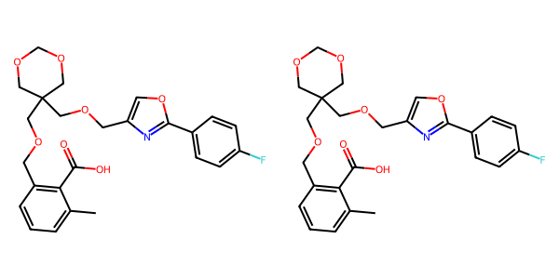

## US20040229890A1_p0011_x1496_y1524_c00049

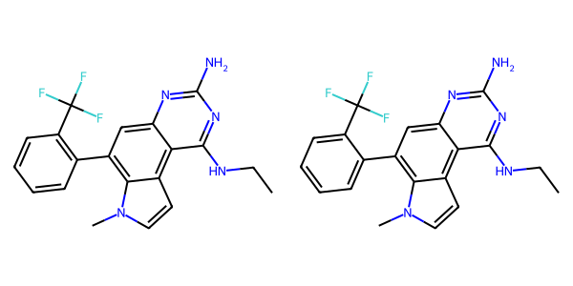

## US20050075347A1_p0013_x0624_y1532_c00033

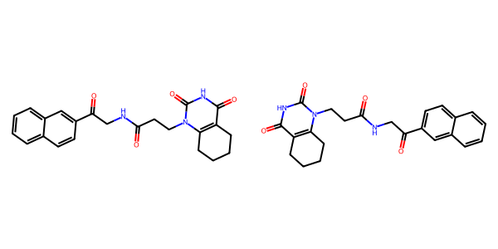

## US20070179154A1_p0038_x0618_y1290_c00033

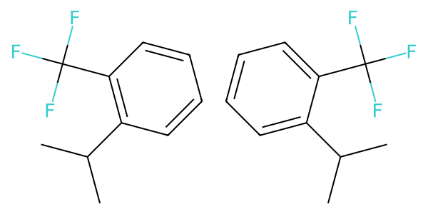

## US20070105909A1_p0016_x1592_y2663_c00019

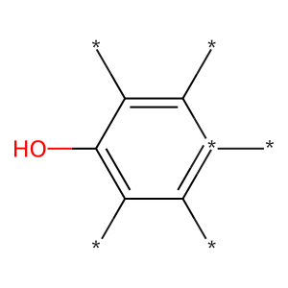

## US20050288357A1_p0050_x0515_y0990_c00092

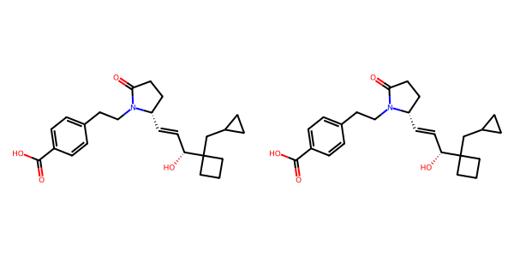

## US20070105909A1_p0028_x1552_y1603_c00073

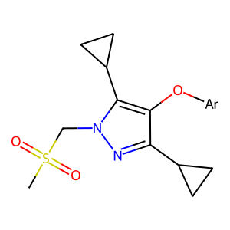

## US20050227932A1_p0025_x1375_y0776_c00026



## US20050288357A1_p0051_x0515_y2157_c00096

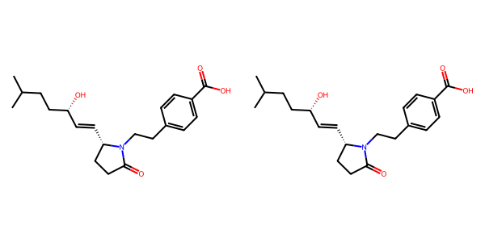

## US20070117785A1_p0040_x1307_y1652_c00079

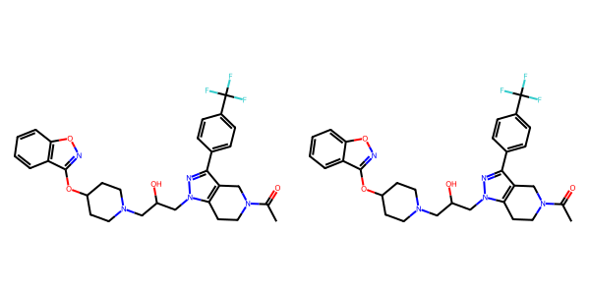

## US20050288357A1_p0044_x1506_y1105_c00078

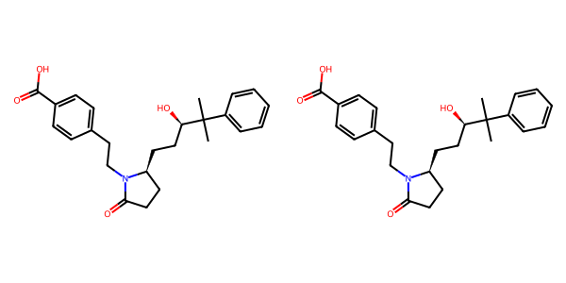

## US20050009817A1_p0033_x1511_y0859_c00097

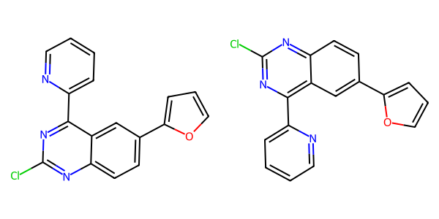

## US20070105909A1_p0017_x1427_y1960_c00026



## US20070155803A1_p0023_x1401_y0733_c00049

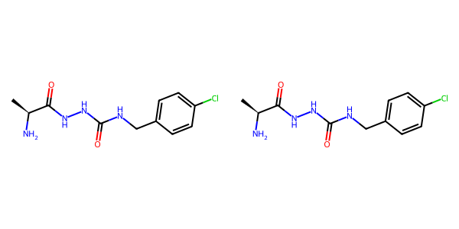

## US20070049758A1_p0010_x1457_y2612_c00003

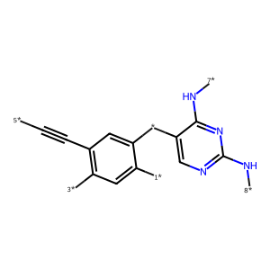

## US20050182067A1_p0037_x1388_y0587_c00140

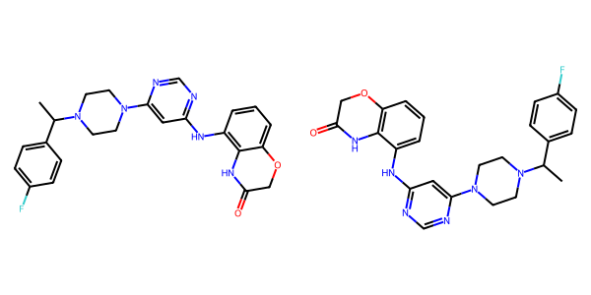

## US20050002859A1_p0016_x1465_y2460_c00100

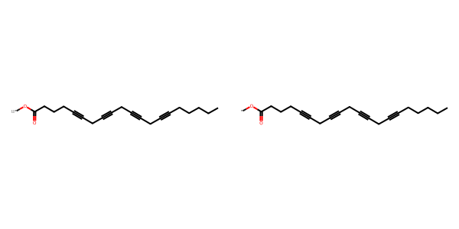

## US20050009817A1_p0006_x1632_y0537_c00005

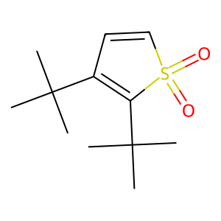

## US20070105909A1_p0034_x1439_y1255_c00108

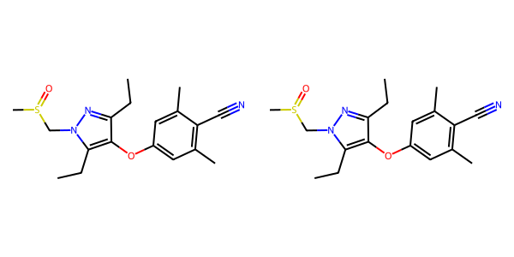

## US20080113922A1_p0008_x1320_y1877_c00021

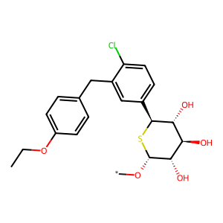

## US20050267177A1_p0017_x0336_y1352_c00036

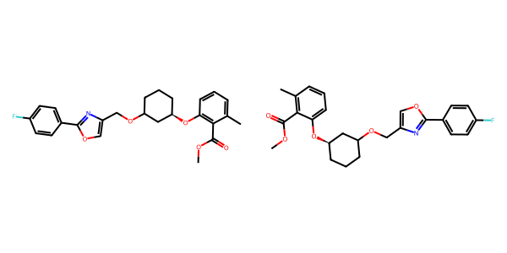

## US20050002859A1_p0015_x0459_y0621_c00087

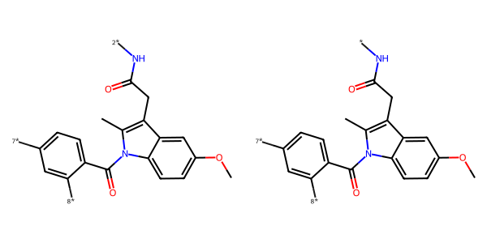

## US20050004369A1_p0036_x0443_y0916_c00075

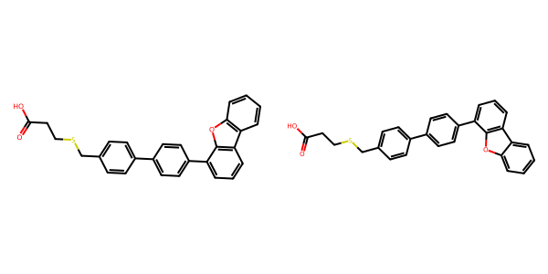

## US20070155803A1_p0023_x0414_y2475_c00048

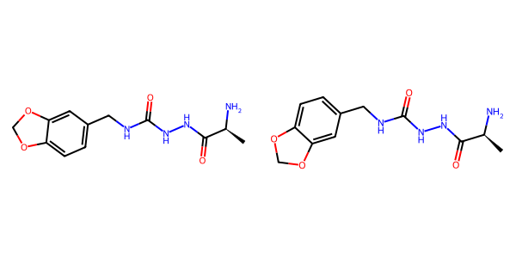

## US20050288357A1_p0039_x1507_y2165_c00071

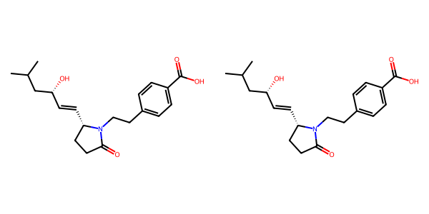

## US20050004369A1_p0024_x1496_y2224_c00042

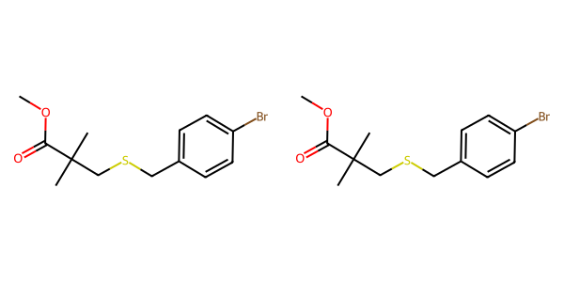

## US20050113580A1_p0041_x0363_y2103_c00061

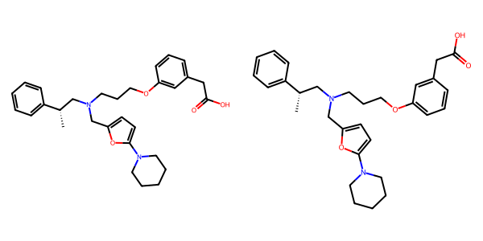

## US20050054819A1_p0033_x1376_y0730_c00118

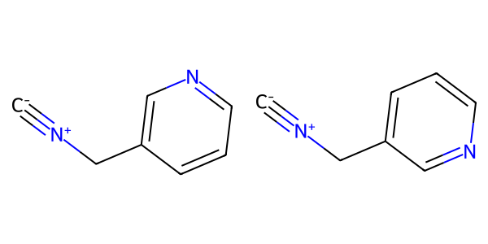

## US20050182067A1_p0035_x0548_y0818_c00127

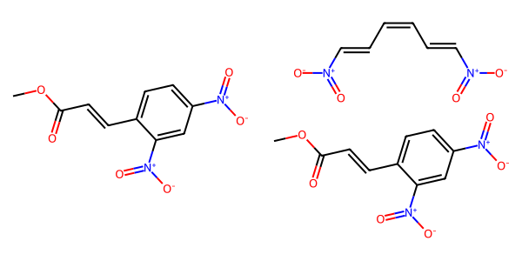

## US20060154945A1_p0011_x0402_y1764_c00028

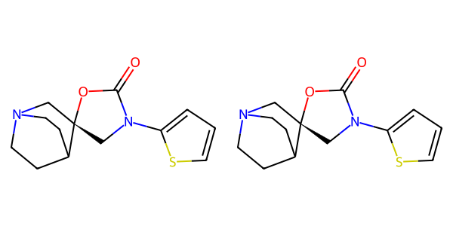

## US20070155803A1_p0017_x0328_y0814_c00022

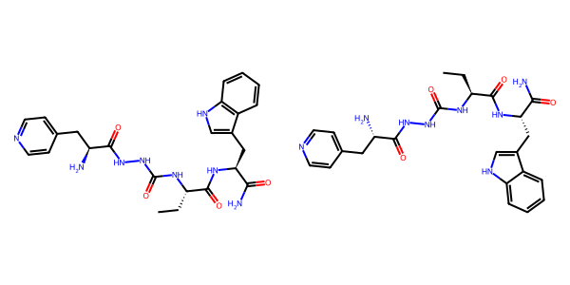

## US20050004369A1_p0035_x0443_y2653_c00074

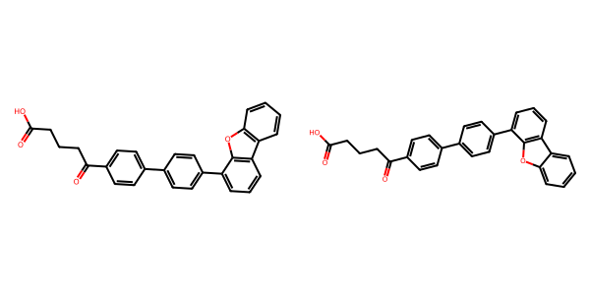

## US20050009817A1_p0016_x0367_y1043_c00054

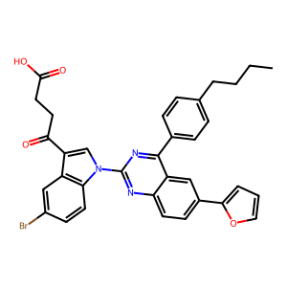

## US20050009817A1_p0020_x0565_y1528_c00067

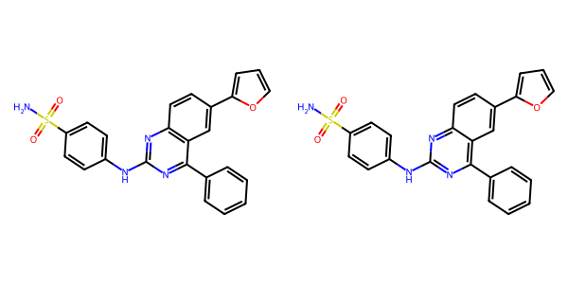

## US20050288357A1_p0054_x1478_y0784_c00105

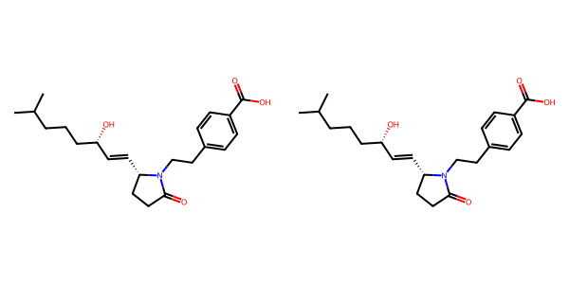

## US20070265270A1_p0017_x1563_y2092_c00078

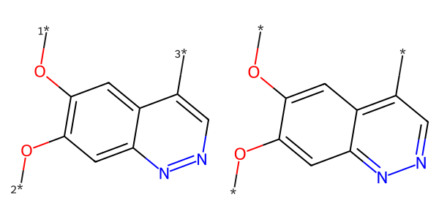

## US20050227932A1_p0028_x0404_y2347_c00037

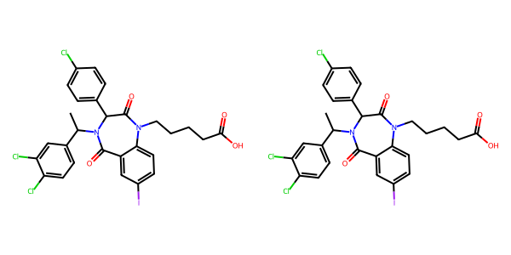

## US20060154945A1_p0019_x1376_y1264_c00073

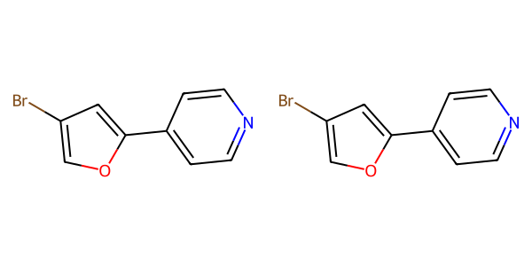

## US20050009817A1_p0018_x0644_y1493_c00061

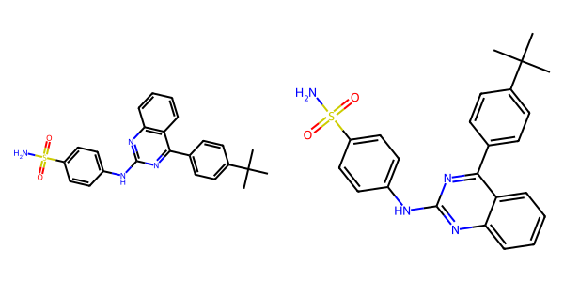

## US20050182067A1_p0035_x1341_y2633_c00132

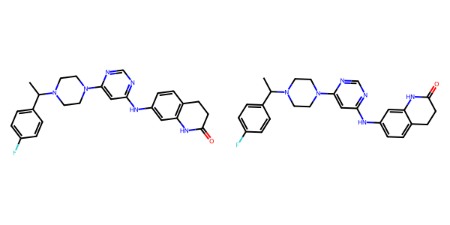

## US20050227932A1_p0027_x1376_y0957_c00034

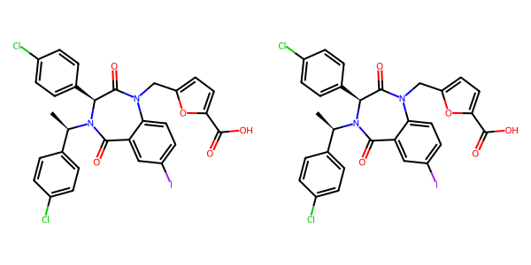

## US20050054819A1_p0026_x0404_y2447_c00090

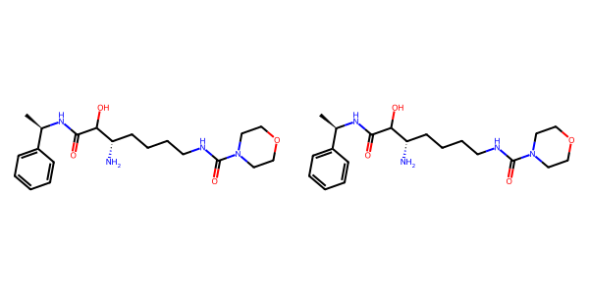

## US20070265270A1_p0012_x0801_y0569_c00058

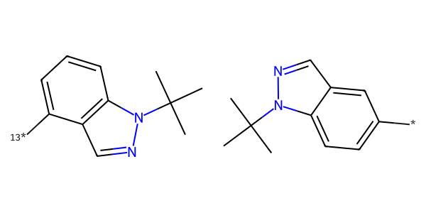

## US20070179154A1_p0011_x0688_y1468_c00003

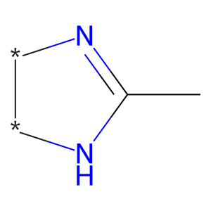

## US20050288357A1_p0045_x0502_y0913_c00079

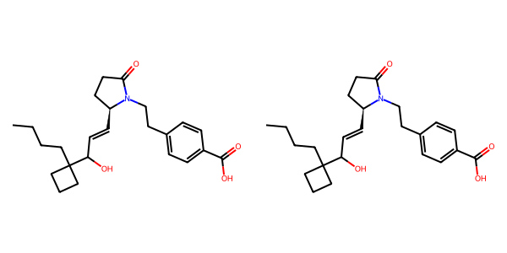

## US20040186132A1_p0045_x0711_y1400_c00355

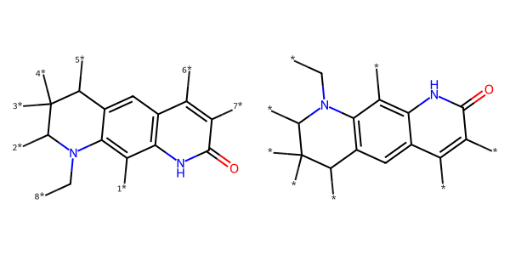

## US20050004369A1_p0027_x1351_y2467_c00049

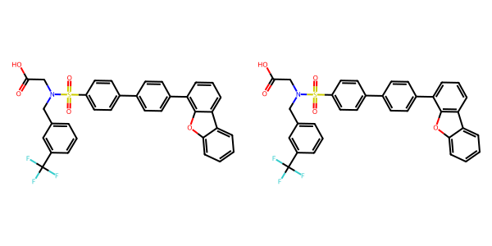

## US20050267177A1_p0016_x1371_y2172_c00035

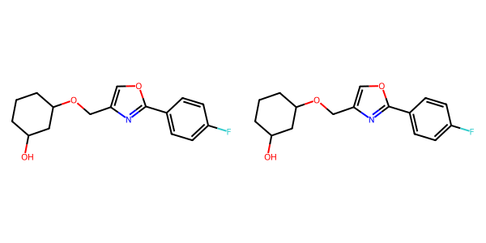

## US20050002859A1_p0038_x1398_y1884_c00138

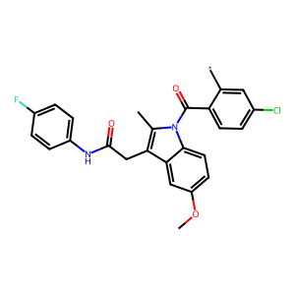

## US20060154945A1_p0011_x1375_y1329_c00030

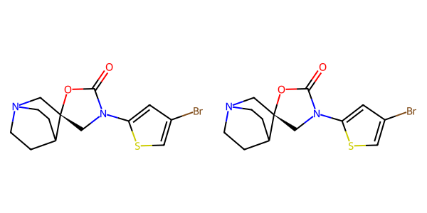

## US20070155803A1_p0020_x0379_y0925_c00034

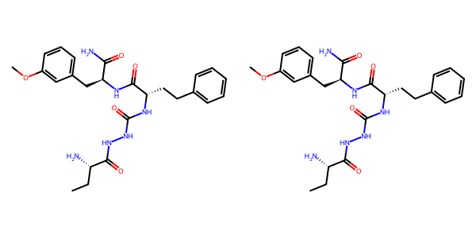

## US20070117785A1_p0059_x0340_y0847_c00118

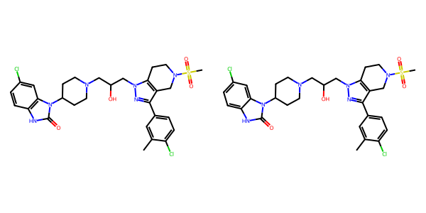

## US20060122222A1_p0040_x0441_y1985_c00104

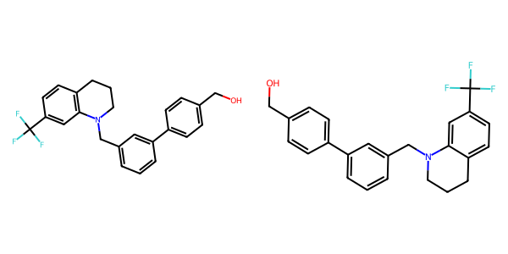

## US20070270434A1_p0021_x0352_y0784_c00052

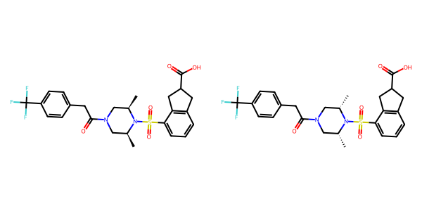

## US20040229890A1_p0017_x1471_y1578_c00079

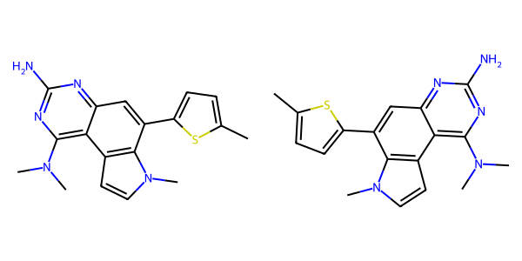

## US20050002859A1_p0024_x0336_y0622_c00118

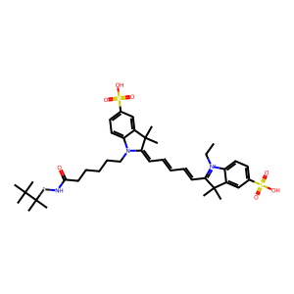

## US20070117785A1_p0056_x0330_y2702_c00102

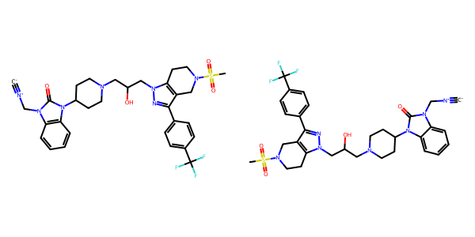

## US20040266789A1_p0027_x1301_y1018_c00047

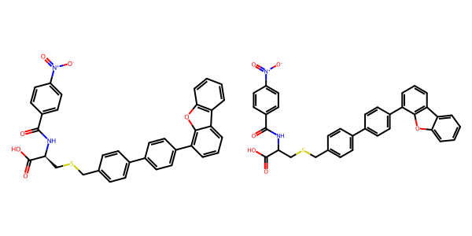

## US20060154945A1_p0013_x1376_y0689_c00039

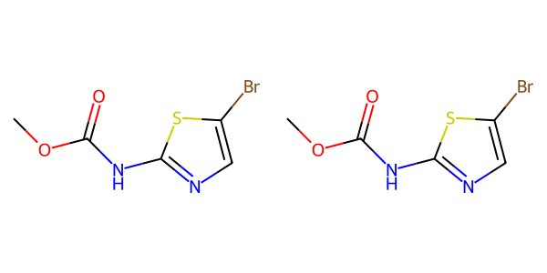

## US20070265270A1_p0026_x0473_y0631_c00103

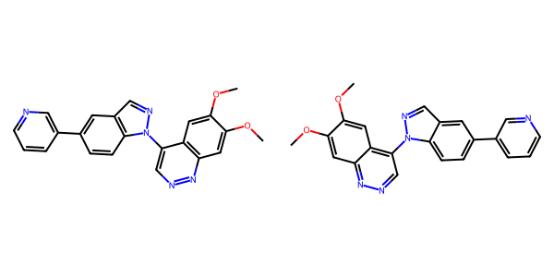

## US20070270434A1_p0017_x1375_y2559_c00038

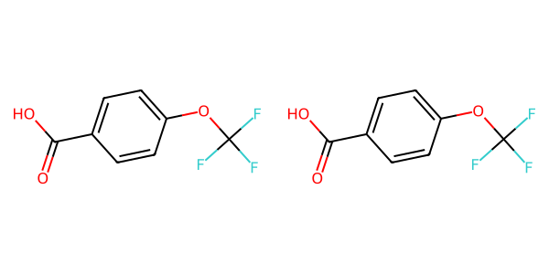

## US20050288357A1_p0056_x0482_y0736_c00106

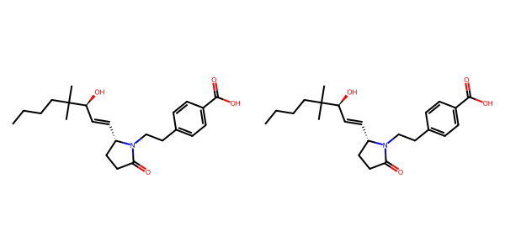

## US20050267177A1_p0023_x1307_y2491_c00076

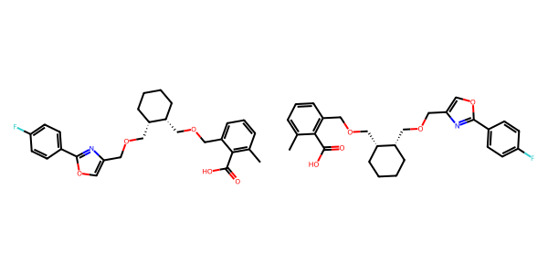

## US20070265270A1_p0030_x1516_y1469_c00123

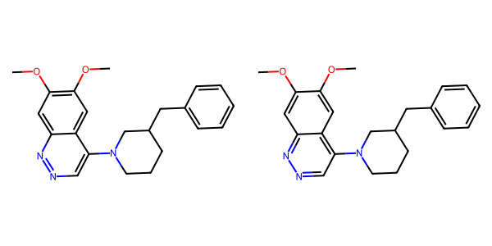

## US20050288357A1_p0031_x1491_y1604_c00061

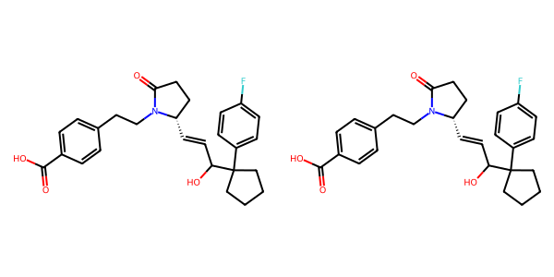

## US20040229890A1_p0014_x0523_y0589_c00059

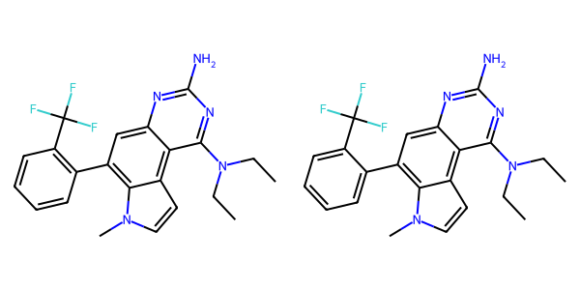

## US20040229890A1_p0002_x1627_y1019_c00002

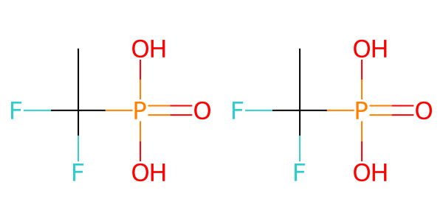

## US20050009817A1_p0033_x0548_y2047_c00096



## US20070049758A1_p0020_x0476_y2006_c00027

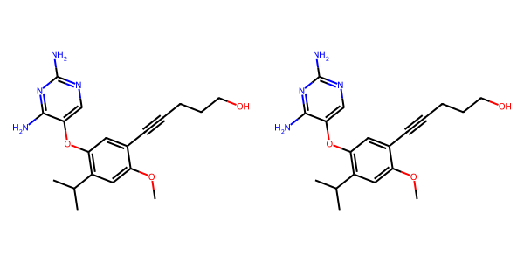

## US20060122222A1_p0025_x0363_y1056_c00070

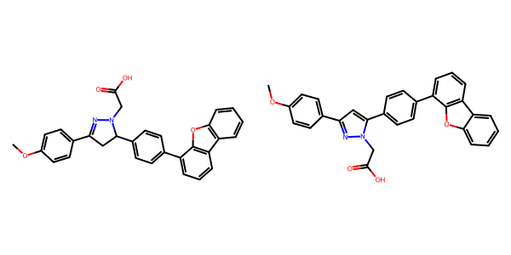

## US20050004369A1_p0026_x1307_y2432_c00046

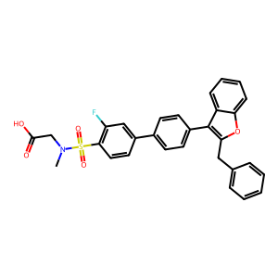

## US20070179177A1_p0006_x1679_y0662_c00010

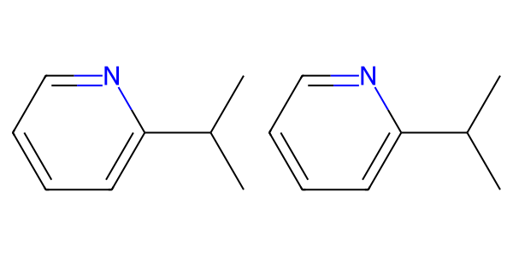

## US20050009817A1_p0008_x0632_y1980_c00009

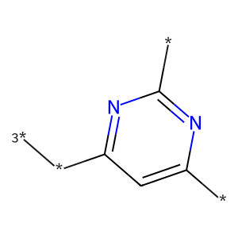

## US20050004369A1_p0025_x0355_y2278_c00044



## US20070270434A1_p0023_x1376_y0575_c00063

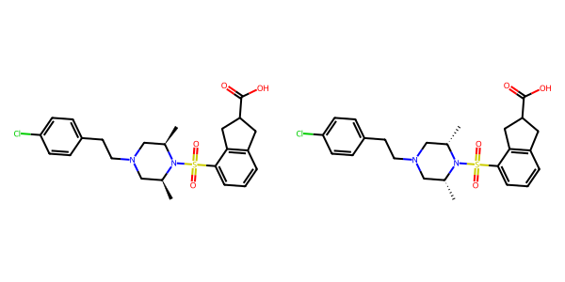

## US20050288357A1_p0050_x1488_y0842_c00093

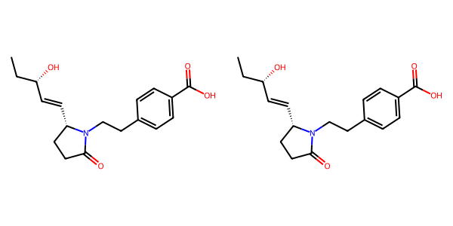

## US20080113922A1_p0017_x1337_y0967_c00052

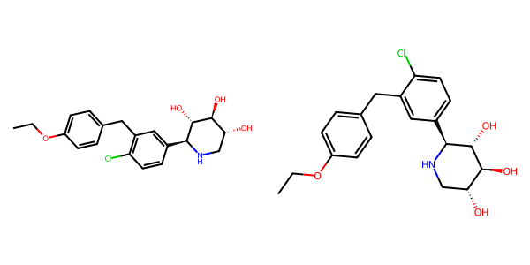

## US20040266789A1_p0017_x1300_y2027_c00026



## US20060122222A1_p0040_x0564_y0740_c00103

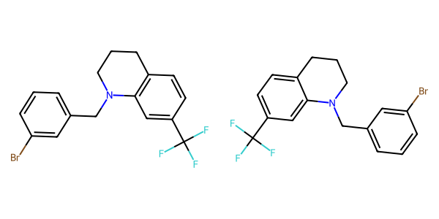

## US20050182067A1_p0035_x0470_y2663_c00129

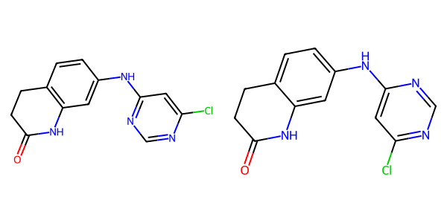

## US20040266789A1_p0023_x1322_y2513_c00043

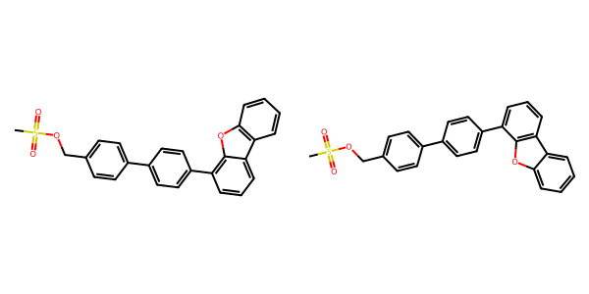

## US20050009817A1_p0017_x0336_y1617_c00057

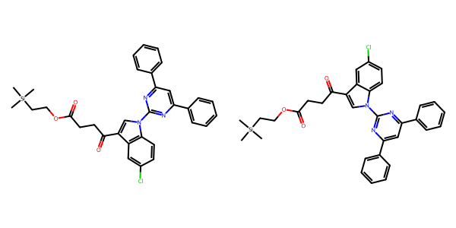

## US20070049758A1_p0024_x0476_y1159_c00042

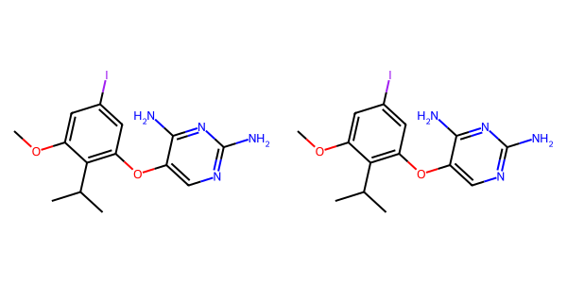

## US20050267177A1_p0017_x1322_y1313_c00038

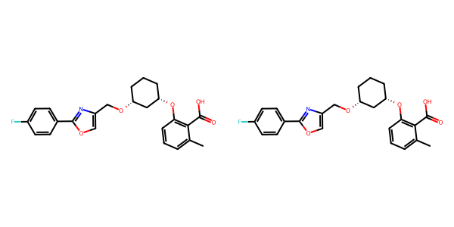

## US20050002859A1_p0014_x1543_y1154_c00082

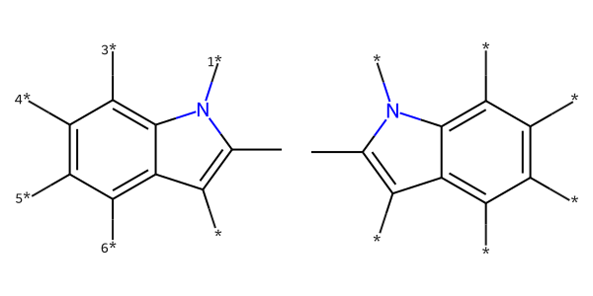

## US20040266789A1_p0049_x1496_y1933_c00082

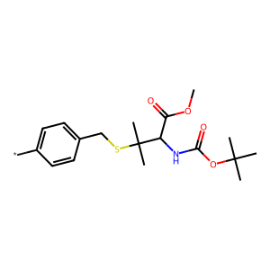

## US20070049758A1_p0028_x0703_y1597_c00063

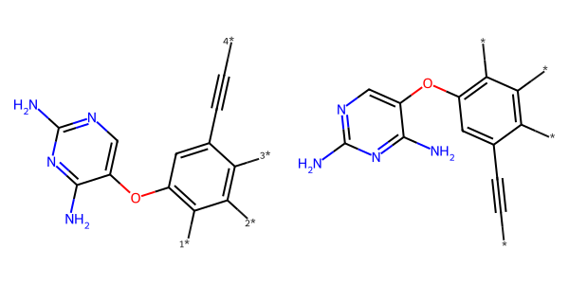

## US20040254236A1_p0045_x0473_y1357_c00173

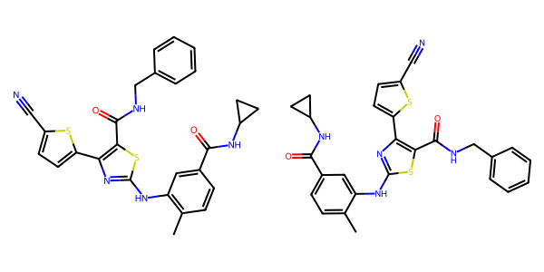

## US20050009817A1_p0031_x1534_y0702_c00089

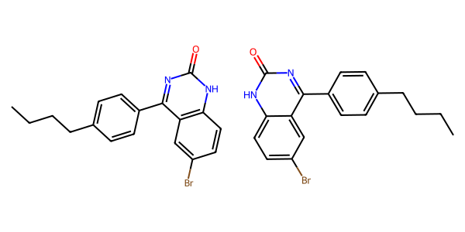

## US20070265270A1_p0036_x0480_y0723_c00141

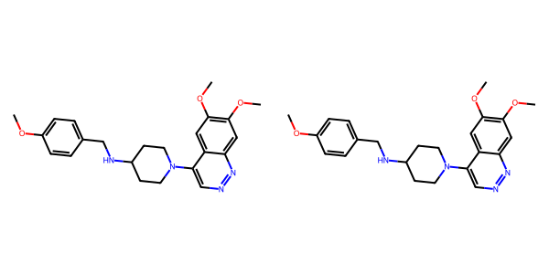

## US20050288357A1_p0011_x0515_y2444_c00008

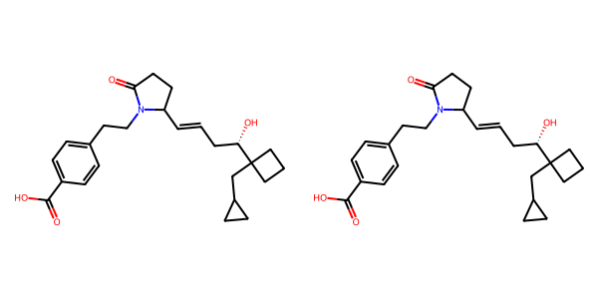

## US20070155803A1_p0029_x1358_y1732_c00073

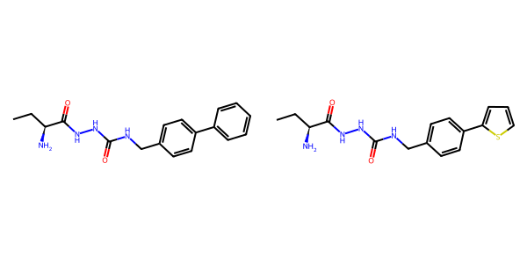

## US20080113922A1_p0015_x0364_y2579_c00048

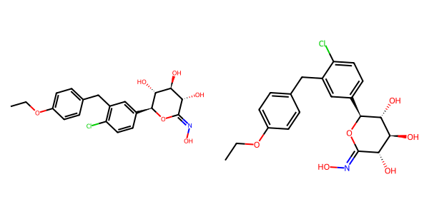

## US20050182067A1_p0037_x1333_y2289_c00142

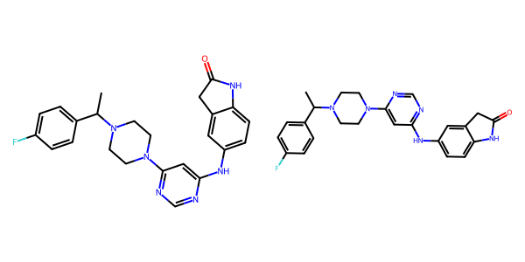

## US20050267177A1_p0017_x1308_y2357_c00039

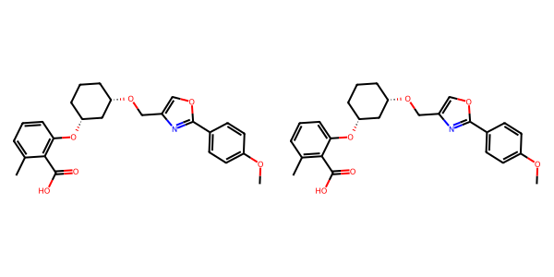

## US20050182067A1_p0030_x0655_y0951_c00100

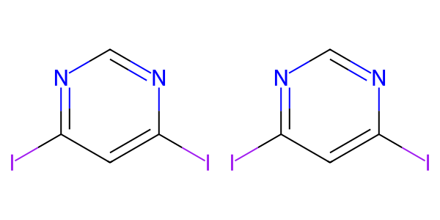

## US20070265270A1_p0025_x1396_y1558_c00101

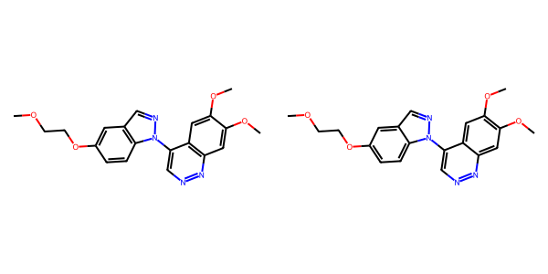

## US20050004369A1_p0027_x0332_y1181_c00047

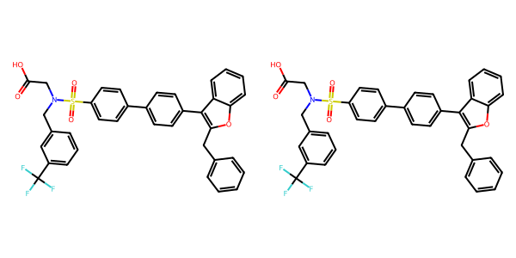

## US20070265270A1_p0029_x1487_y0634_c00116

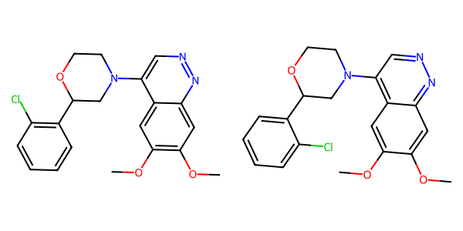

## US20050113580A1_p0039_x1335_y1360_c00055

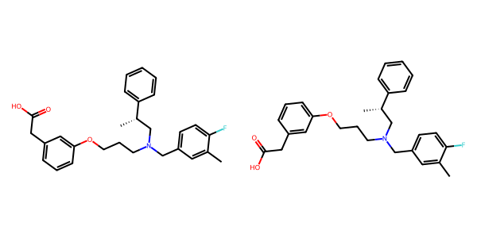

## US20070015754A1_p0015_x0411_y2439_c00068

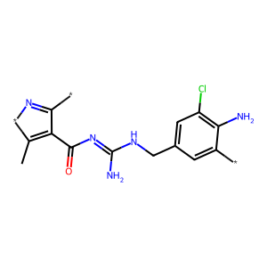

## US20070265270A1_p0034_x1406_y2511_c00138

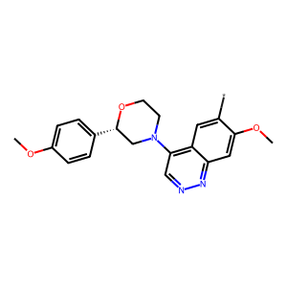

## US20070049758A1_p0011_x1452_y0646_c00004

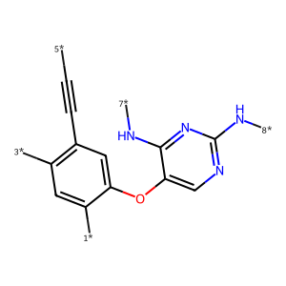

## US20070105909A1_p0031_x1536_y1448_c00094

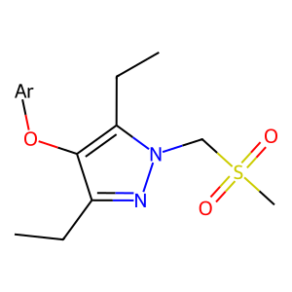

## US20060154945A1_p0015_x0402_y0942_c00047

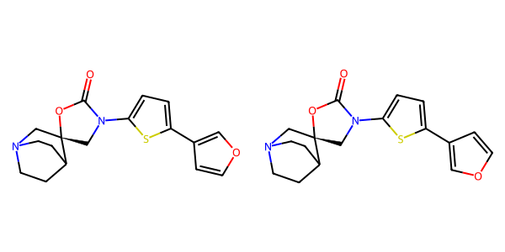

## US20070015754A1_p0038_x0487_y1067_c00240

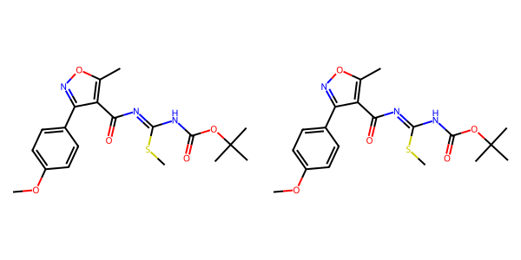

## US20050054819A1_p0024_x1375_y1057_c00085

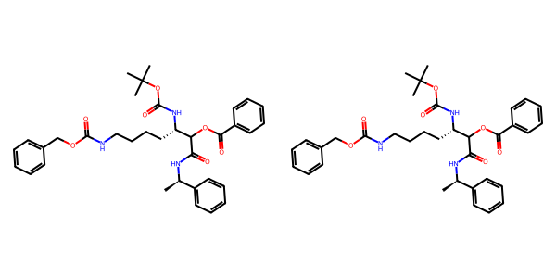

## US20070249620A1_p0039_x0488_y1530_c00035

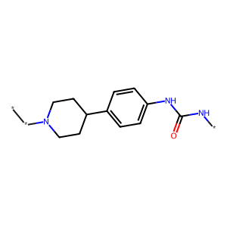

## US20070155803A1_p0023_x1416_y1744_c00050

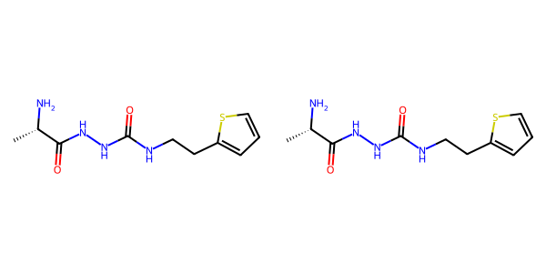

## US20060281700A1_p0071_x0445_y0772_c00096

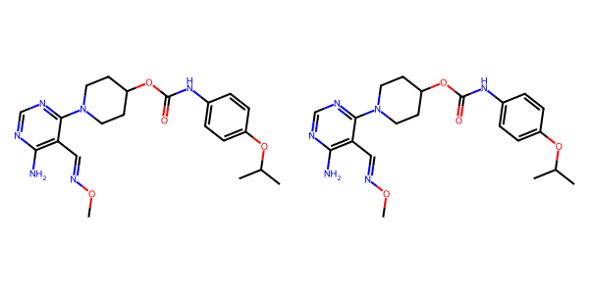

## US20070270434A1_p0022_x1331_y0573_c00058

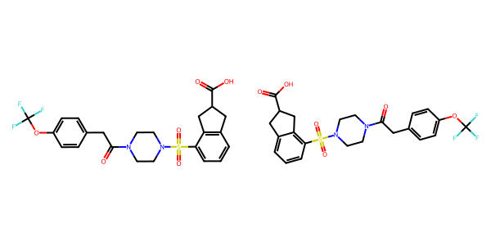

## US20070049758A1_p0020_x0476_y0700_c00025

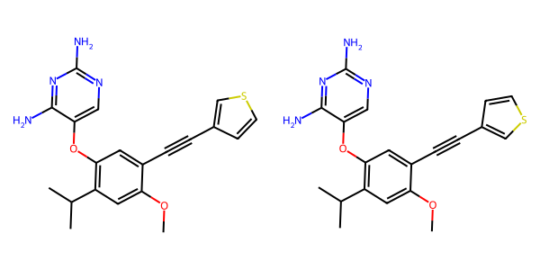

## US20070270434A1_p0023_x0335_y2193_c00062

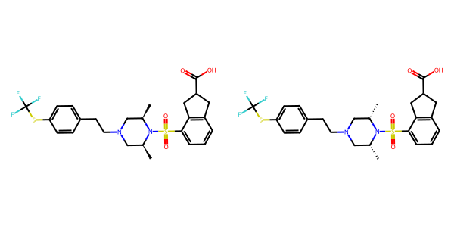

## US20050004369A1_p0028_x1121_y2560_c00052

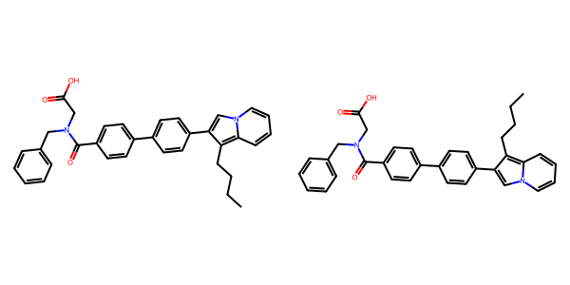

## US20080113922A1_p0015_x0364_y1153_c00047

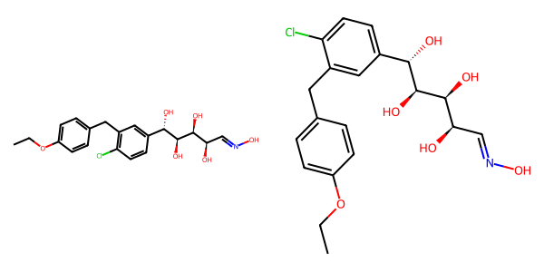

## US20070265270A1_p0017_x0473_y2183_c00076

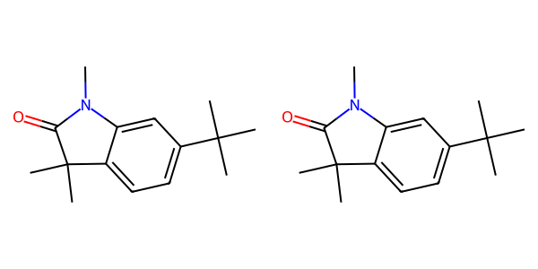

## US20060154945A1_p0013_x1375_y1724_c00040

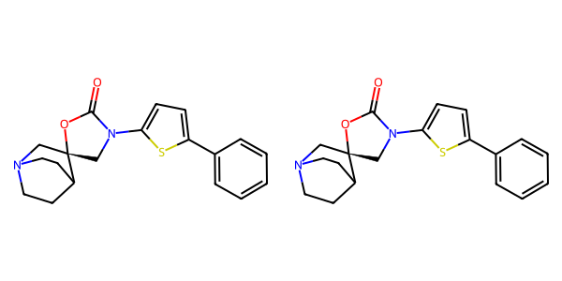

## US20070105909A1_p0025_x1471_y2515_c00063

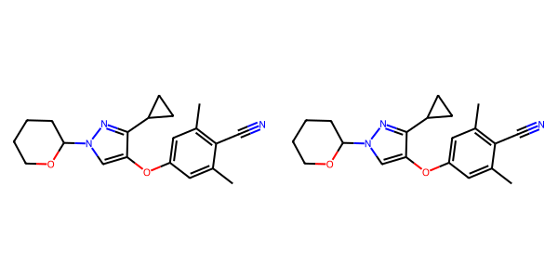

## US20050004369A1_p0030_x0443_y1000_c00056

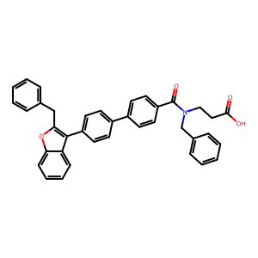

## US20070105909A1_p0019_x1616_y1720_c00031

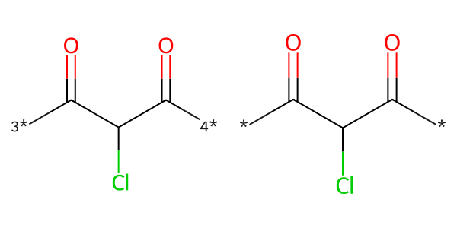

## US20050009817A1_p0029_x0563_y1555_c00085

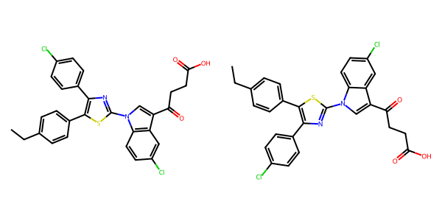

## US20070049758A1_p0025_x0434_y1326_c00047

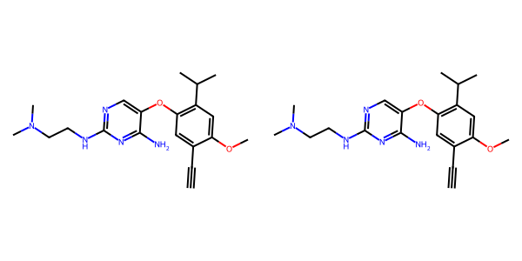

## US20050288357A1_p0062_x0568_y2346_c00113

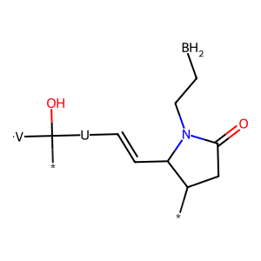

## US20040186132A1_p0003_x1480_y1156_c00004

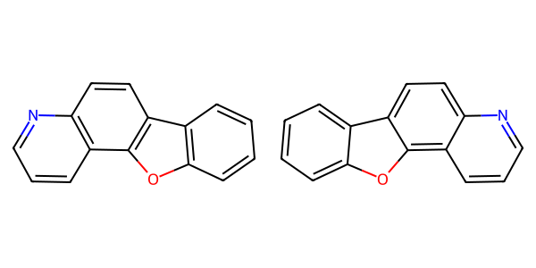

## US20040266789A1_p0026_x1300_y1802_c00046

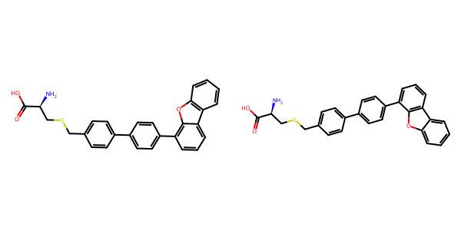

## US20070049758A1_p0018_x0476_y1798_c00019

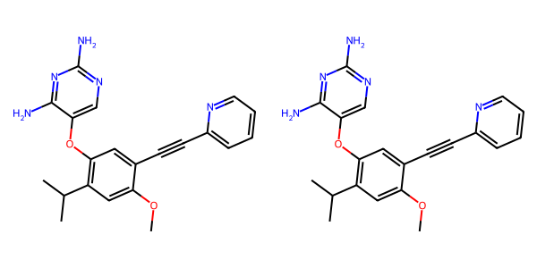

## US20070117785A1_p0042_x1303_y2054_c00083

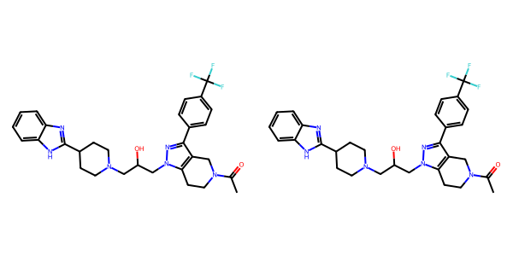

## US20070155803A1_p0020_x1323_y2114_c00037

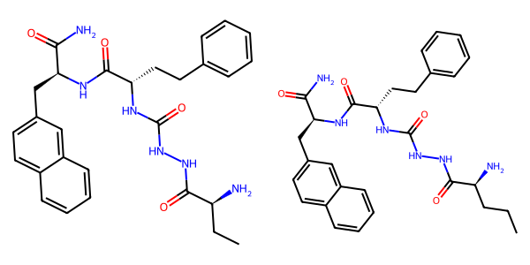

## US20070049758A1_p0019_x0476_y1293_c00022

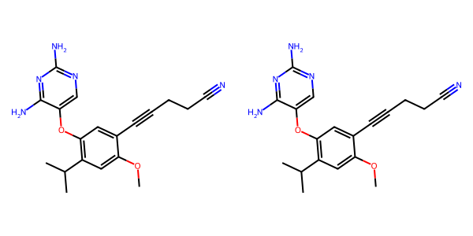

## US20050267177A1_p0021_x1318_y2585_c00065

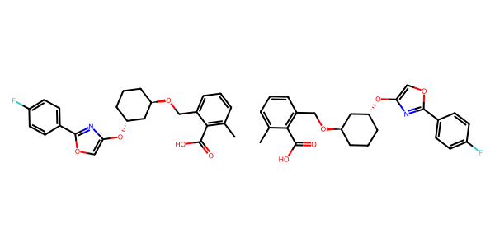

## US20050182067A1_p0034_x0569_y1730_c00122

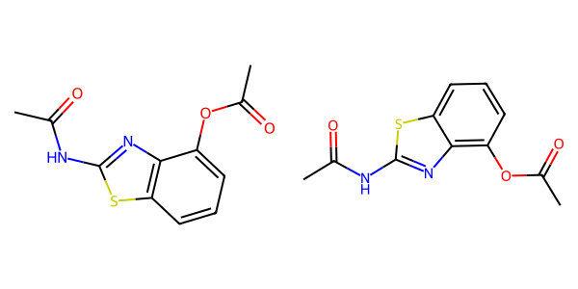

## US20070117785A1_p0056_x1308_y2632_c00105

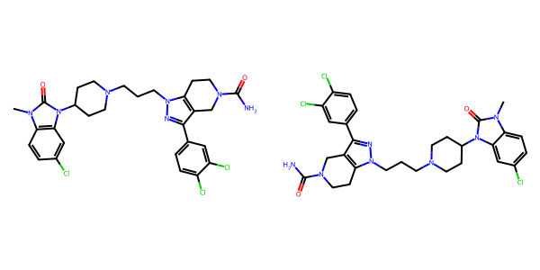

## US20070049758A1_p0032_x0707_y2309_c00081

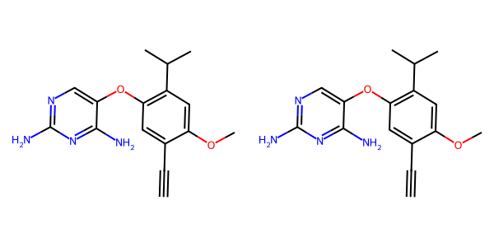

## US20050009817A1_p0036_x1558_y0630_c00103



## US20050288357A1_p0056_x0482_y1323_c00107

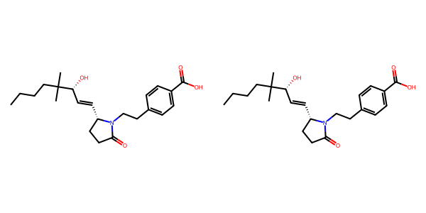

## US20080113922A1_p0019_x0330_y2287_c00056

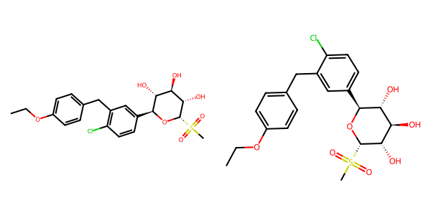

## US20040254236A1_p0047_x0473_y0681_c00180

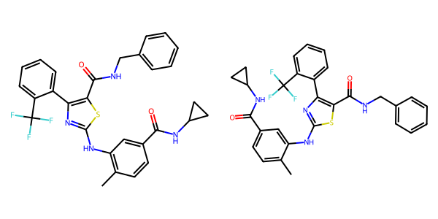

## US20040266789A1_p0039_x1471_y1095_c00065

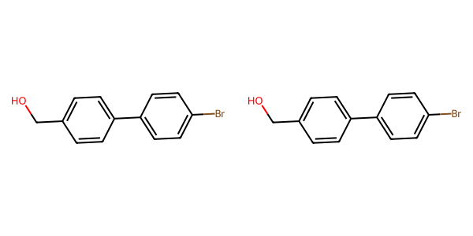

## US20070155803A1_p0021_x0379_y2324_c00039

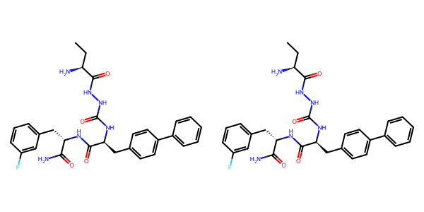

## US20070265270A1_p0028_x0567_y2328_c00111

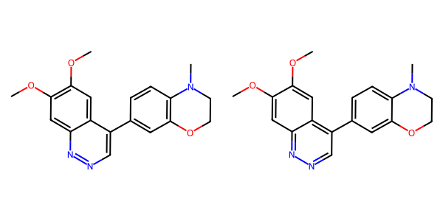

## US20040266789A1_p0044_x1304_y0549_c00073

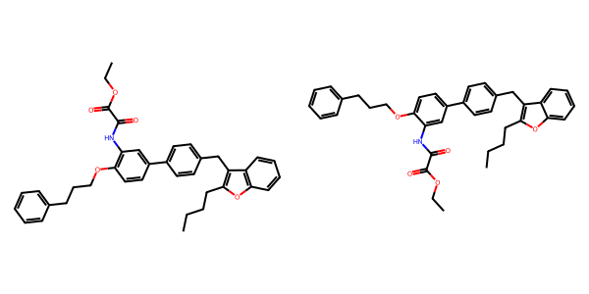

## US20070117785A1_p0006_x1567_y2715_c00000

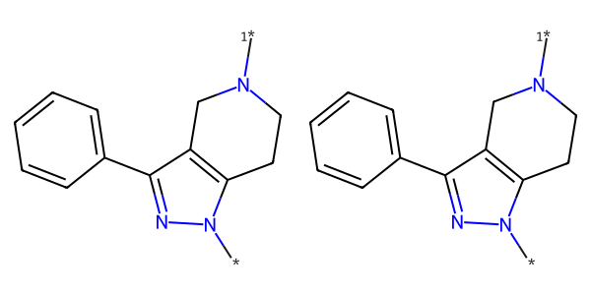

## US20070049758A1_p0019_x0476_y2445_c00024

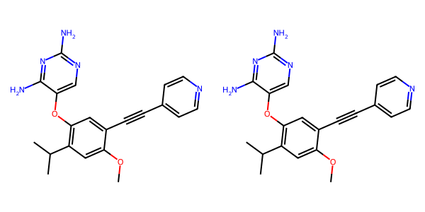

## US20070155803A1_p0029_x0466_y1643_c00070

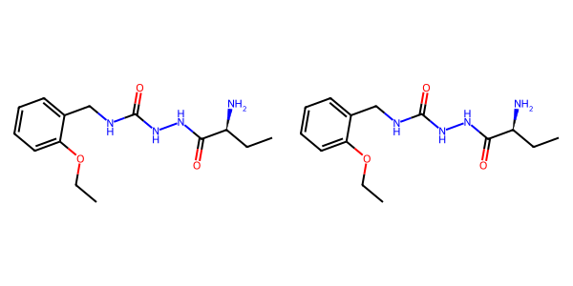

## US20050227932A1_p0025_x0404_y1091_c00025



## US20050054819A1_p0016_x1324_y2582_c00054

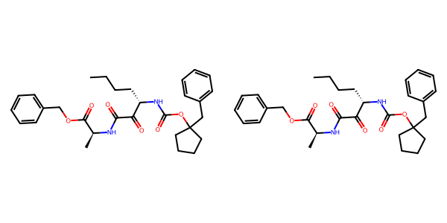

## US20070105909A1_p0019_x0590_y2895_c00030

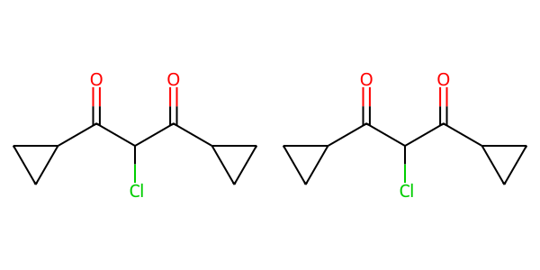

## US20040266789A1_p0049_x0564_y1465_c00081

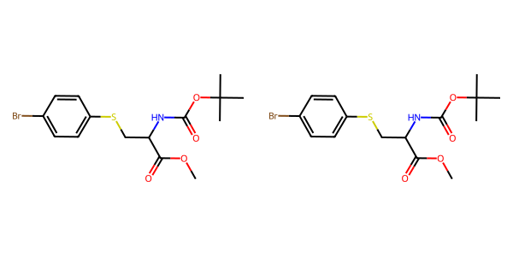

## US20070155803A1_p0025_x0466_y2360_c00058

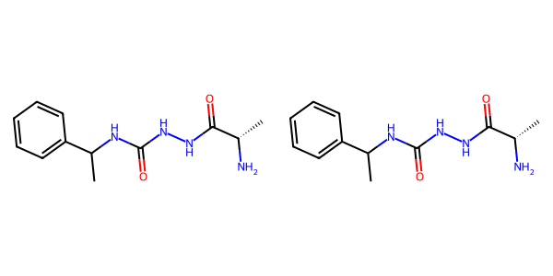

## US20050227932A1_p0026_x1376_y2365_c00031

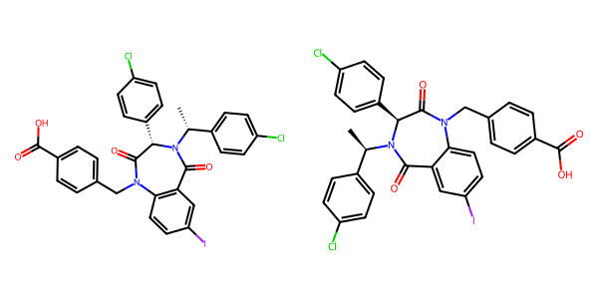

## US20070179154A1_p0037_x0618_y2879_c00031

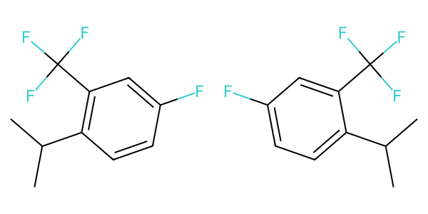

## US20060122222A1_p0040_x1314_y2119_c00106

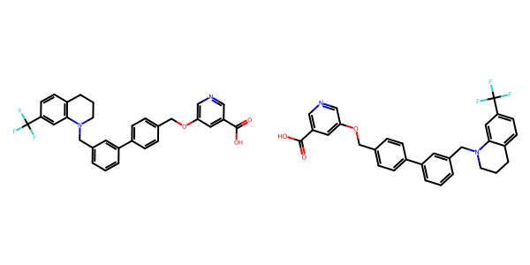

## US20060122222A1_p0037_x0348_y0661_c00097

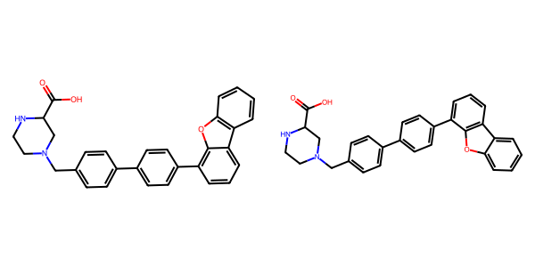

## US20070049758A1_p0021_x0521_y2533_c00032

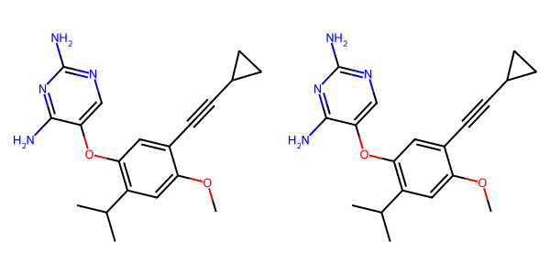

## US20050288357A1_p0046_x0502_y0763_c00080

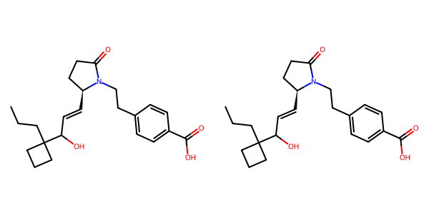

## US20040266789A1_p0028_x1302_y2083_c00049

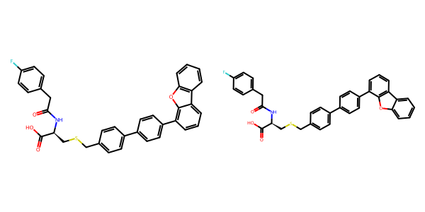

## US20050288357A1_p0051_x1488_y2612_c00098

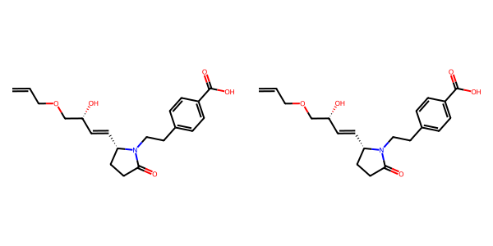

## US20070105909A1_p0021_x0455_y2480_c00042

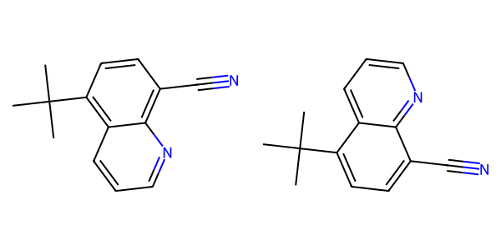

## US20050004369A1_p0032_x0445_y2319_c00063

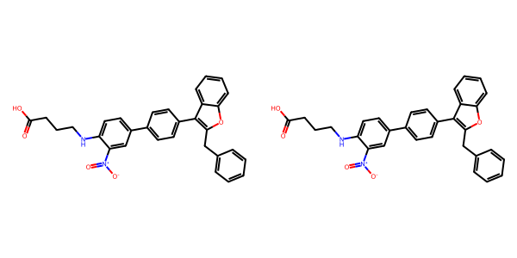

## US20070265270A1_p0013_x0651_y0535_c00064

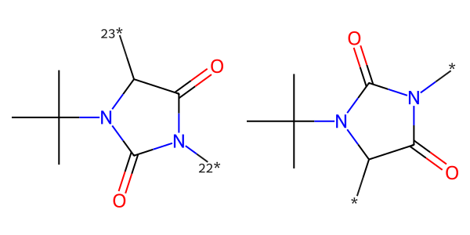

## US20050288357A1_p0039_x0535_y2007_c00070

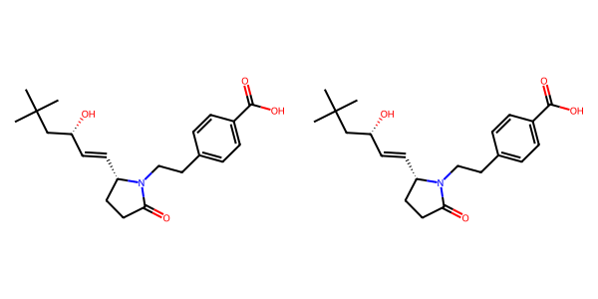

## US20070117785A1_p0029_x1309_y1824_c00067

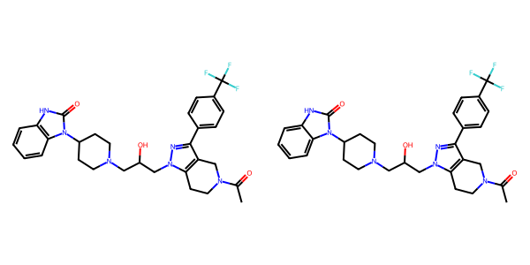

## US20050004369A1_p0020_x1309_y2129_c00029



## US20070155803A1_p0024_x1401_y1779_c00055

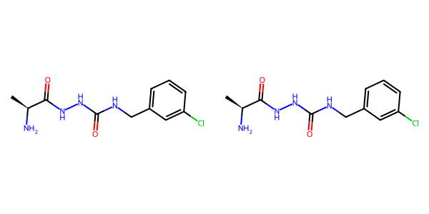

## US20070049758A1_p0017_x0862_y2572_c00016

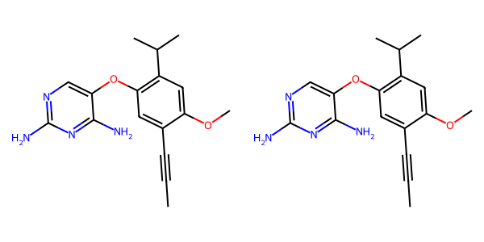

## US20080113922A1_p0008_x0347_y2067_c00017

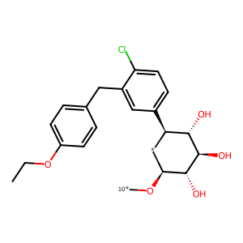

## US20050267177A1_p0024_x0334_y2500_c00079

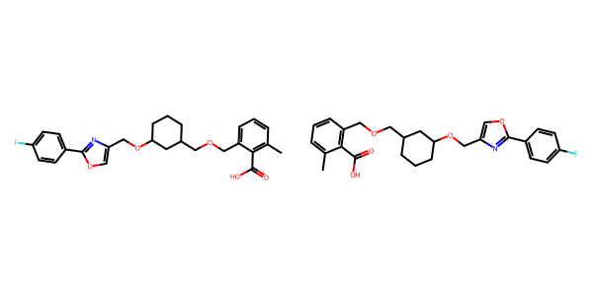

## US20070265270A1_p0026_x0446_y2591_c00105

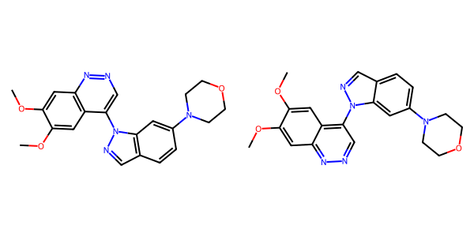

## US20070270434A1_p0017_x1314_y0641_c00036



## US20080113922A1_p0023_x0350_y1614_c00064

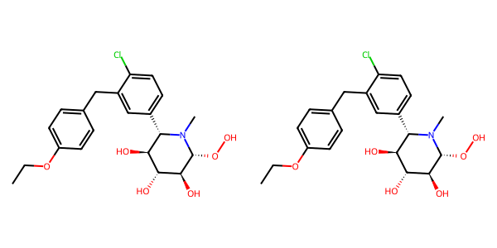

## US20050182067A1_p0039_x1359_y0922_c00150

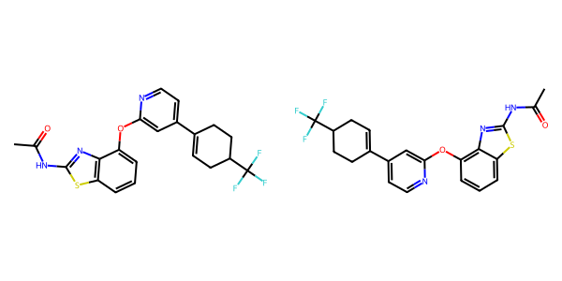

## US20070117785A1_p0041_x1307_y1683_c00081

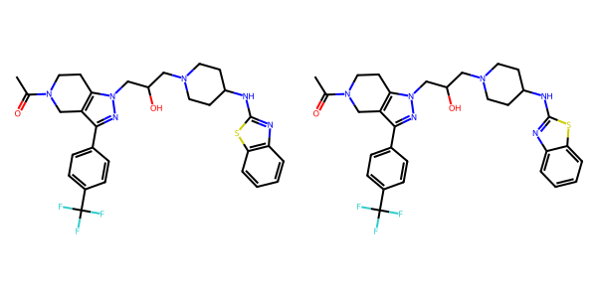

## US20040266789A1_p0023_x0402_y2516_c00042

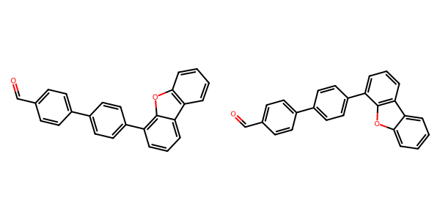

## US20050004369A1_p0035_x0443_y1975_c00073

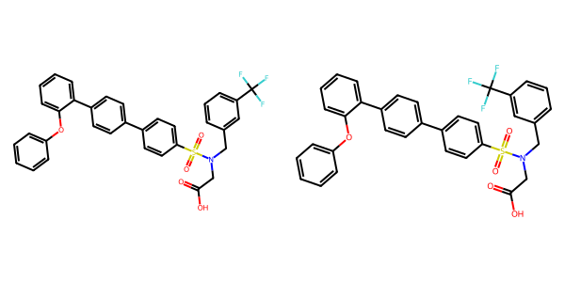

## US20040254236A1_p0057_x0397_y1092_c00220

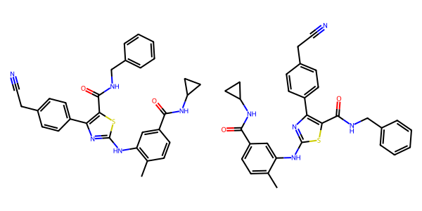

## US20050227932A1_p0026_x0404_y2248_c00029

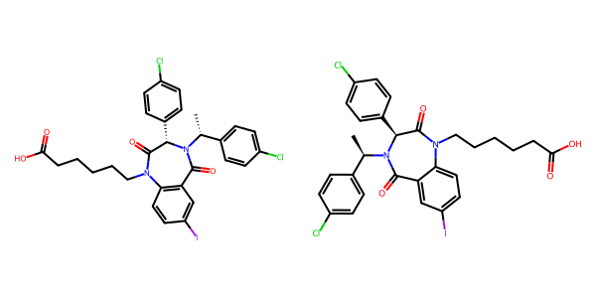

## US20070265270A1_p0033_x0481_y2174_c00134

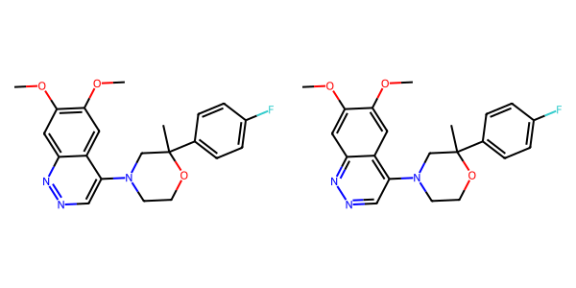

## US20050288357A1_p0040_x0497_y2383_c00072

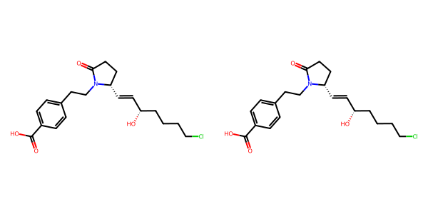

## US20070049758A1_p0025_x0425_y0699_c00046

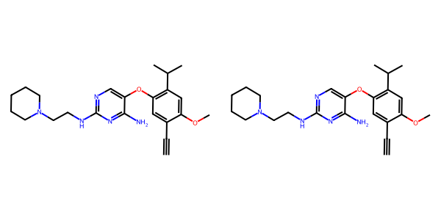

## US20070155803A1_p0026_x1440_y2211_c00065

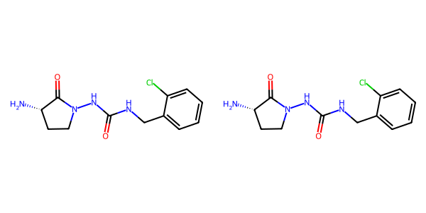

## US20070105909A1_p0021_x0455_y1511_c00039

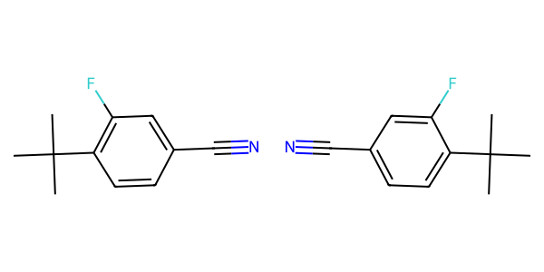

## US20050182067A1_p0033_x0499_y2563_c00118

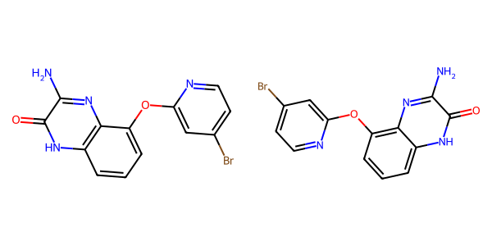

## US20050004369A1_p0027_x1307_y0819_c00048

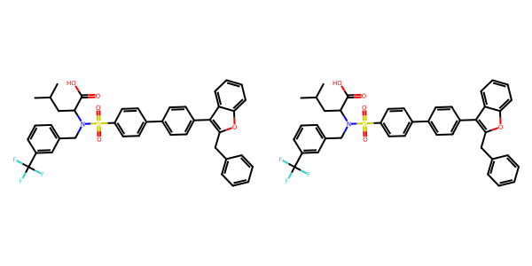

## US20070270434A1_p0024_x0404_y1226_c00066

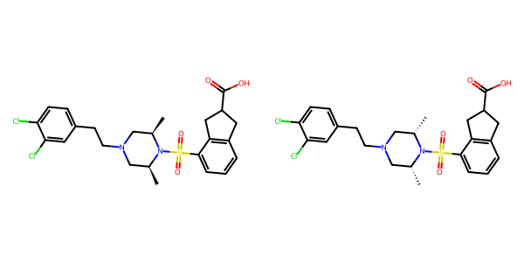

## US20050004369A1_p0016_x0521_y1685_c00019



## US20060154945A1_p0020_x1375_y2784_c00080

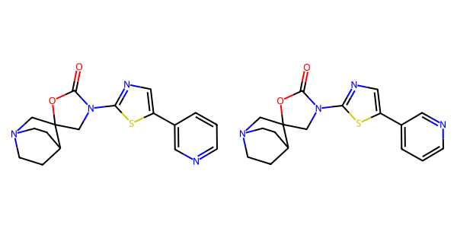

## US20070265270A1_p0035_x1453_y1832_c00140

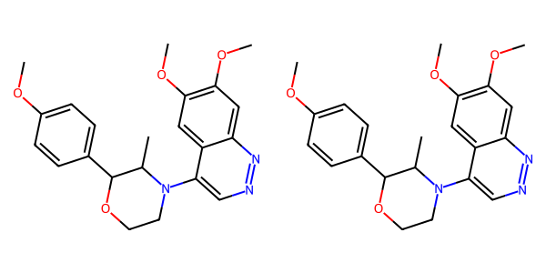

## US20050002859A1_p0016_x1442_y1345_c00098

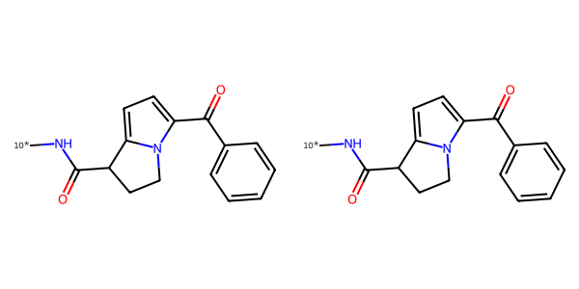

## US20070265270A1_p0025_x0488_y2444_c00100

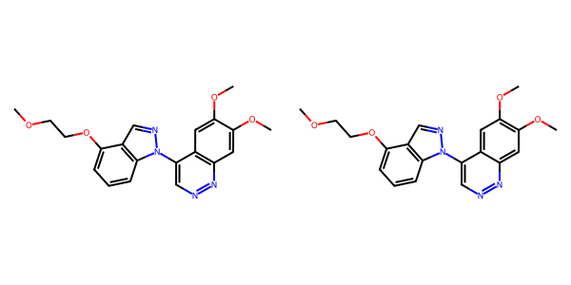

## US20070105909A1_p0021_x0455_y2151_c00041

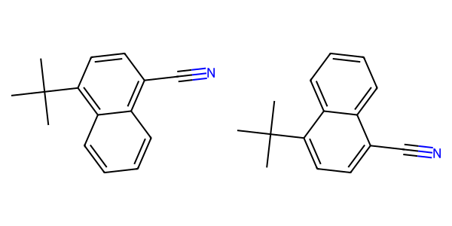

## US20080113922A1_p0008_x1320_y0682_c00019

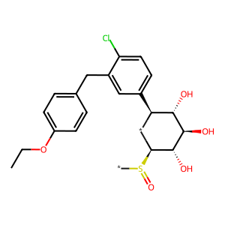

## US20060281700A1_p0073_x1445_y0674_c00116

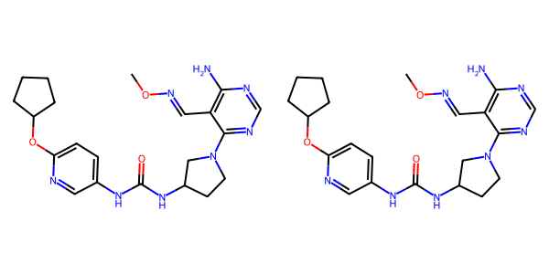

## US20070049758A1_p0025_x0421_y2581_c00049

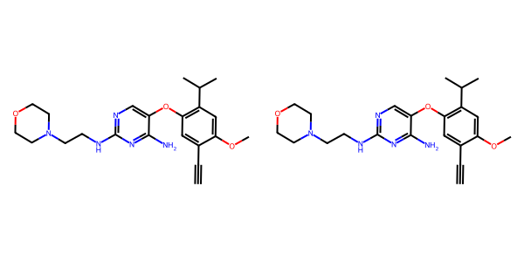

## US20070117785A1_p0039_x1307_y2214_c00077

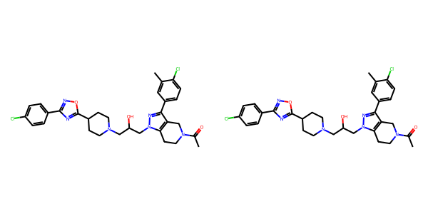

## US20070270434A1_p0017_x0364_y2137_c00035

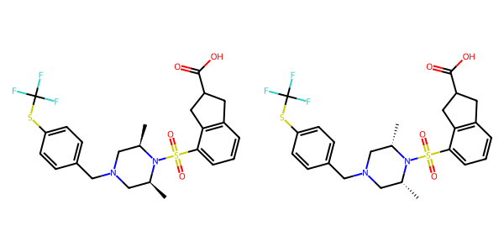

## US20060281700A1_p0072_x0455_y0745_c00104

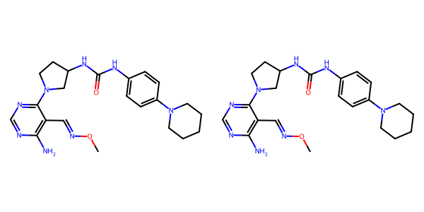

## US20050288357A1_p0047_x0502_y2209_c00084

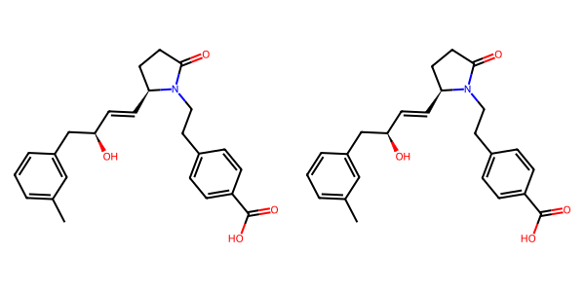

## US20050182067A1_p0035_x1514_y0785_c00130

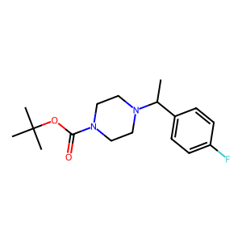

## US20070105909A1_p0021_x0455_y0635_c00036

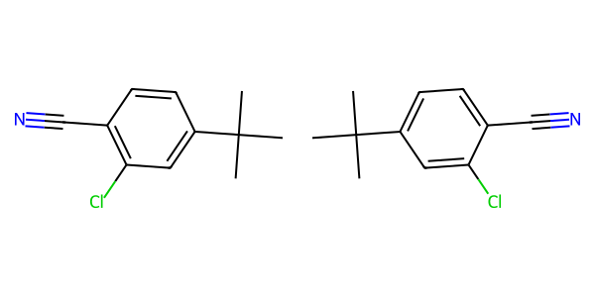

## US20050267177A1_p0024_x0334_y1606_c00078

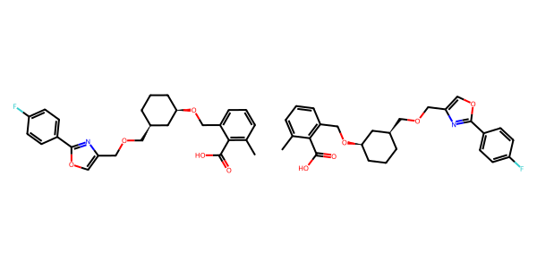

## US20050182067A1_p0038_x1418_y2423_c00147

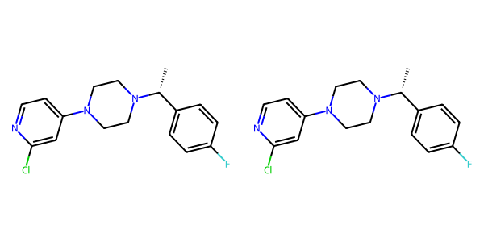

## US20070049758A1_p0019_x0476_y0694_c00021

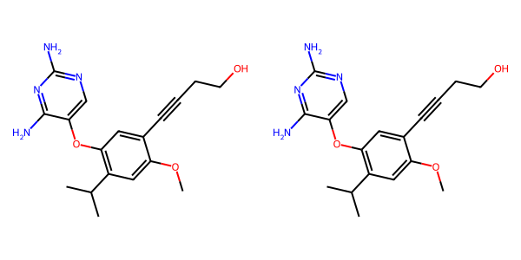

## US20070117785A1_p0052_x1309_y2707_c00095

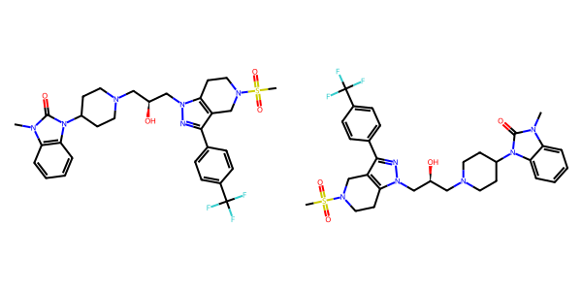

## US20070270434A1_p0021_x0352_y1955_c00053

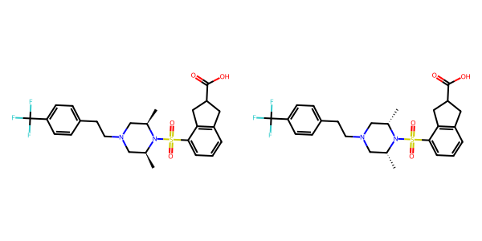

## US20070265270A1_p0033_x1520_y1463_c00135

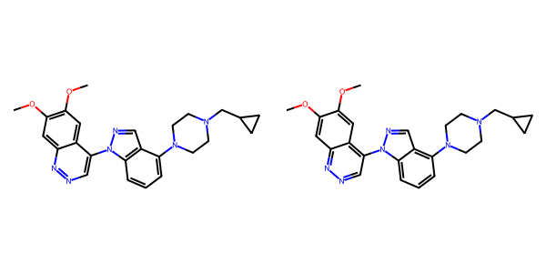

## US20040266789A1_p0026_x0329_y1197_c00045

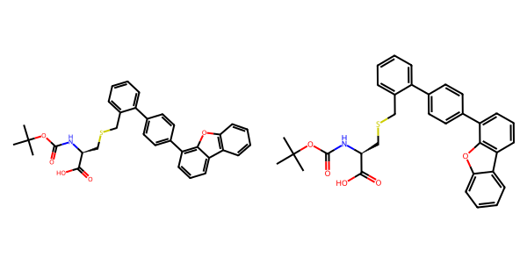

## US20060154945A1_p0022_x0402_y0782_c00086

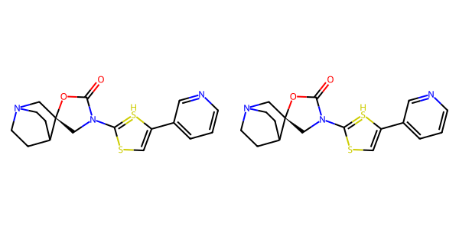

## US20040186132A1_p0003_x1460_y1763_c00005

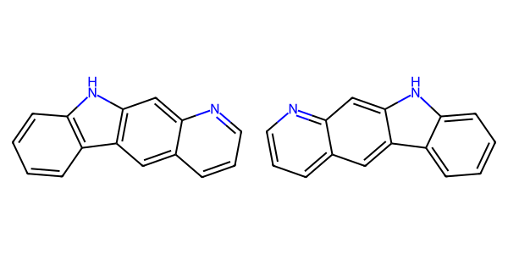

## US20050182067A1_p0032_x0367_y0646_c00110

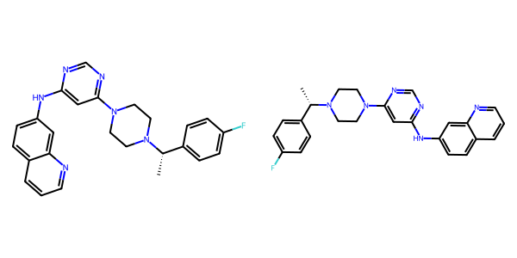

## US20050288357A1_p0035_x1507_y0895_c00065

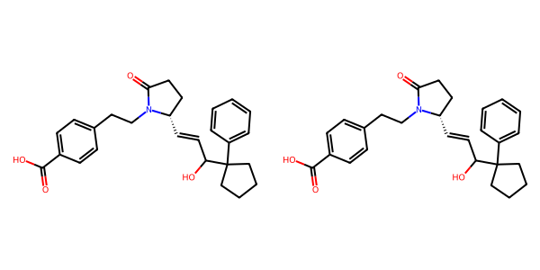

## US20070117785A1_p0057_x0335_y0868_c00106

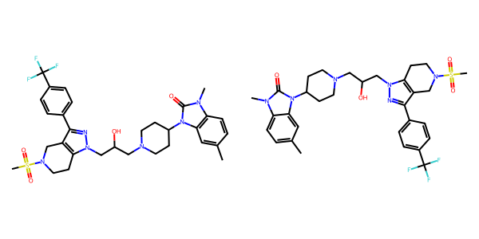

## US20060122222A1_p0031_x1392_y1870_c00090

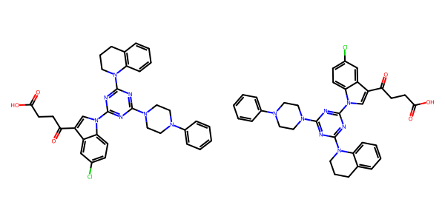

## US20040229890A1_p0011_x1496_y0599_c00048

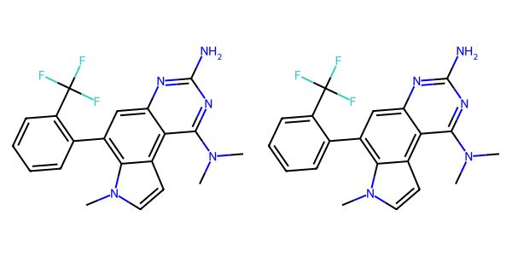

## US20070249620A1_p0037_x0515_y0602_c00032

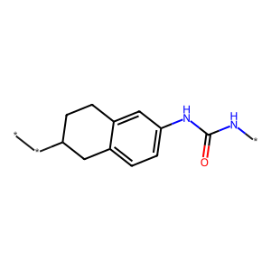

## US20080113922A1_p0016_x0336_y0953_c00049

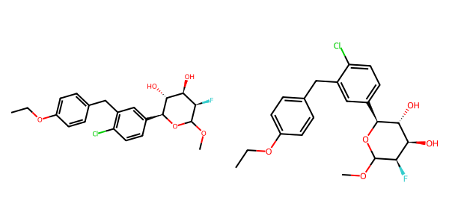

## US20070155803A1_p0024_x0466_y1262_c00052

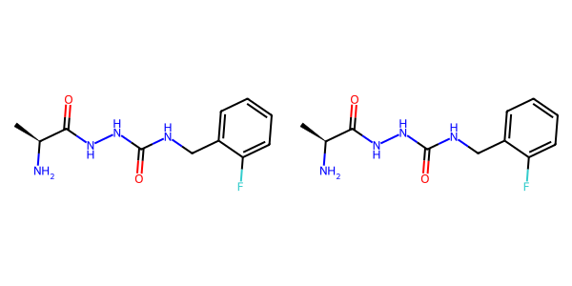

## US20070049758A1_p0022_x0534_y1326_c00034

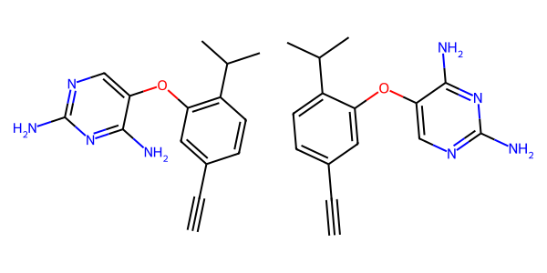

## US20060281700A1_p0074_x1376_y2461_c00126



## US20050075347A1_p0019_x0414_y2029_c00045

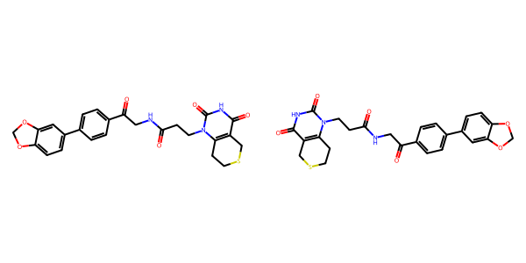

## US20050288357A1_p0041_x0505_y2274_c00074

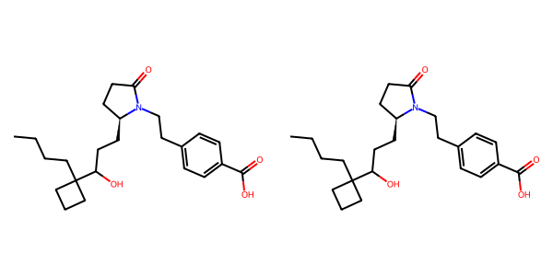

## US20040266789A1_p0042_x1302_y2534_c00070

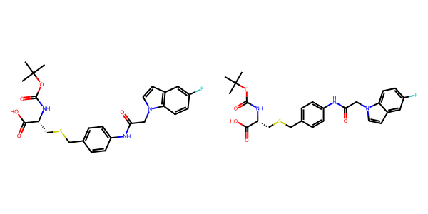

## US20040186132A1_p0003_x0561_y2731_c00002

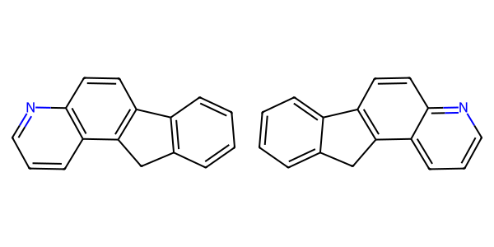

## US20050002859A1_p0016_x0336_y0672_c00094



## US20070265270A1_p0032_x1451_y1874_c00132

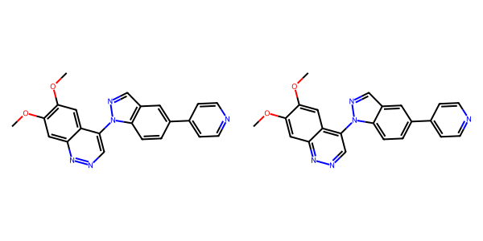

## US20040186132A1_p0026_x0637_y1064_c00178

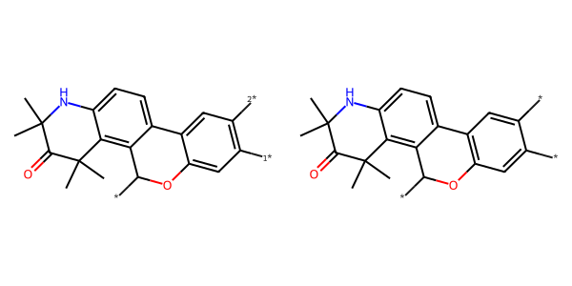

## US20070049758A1_p0021_x0521_y1929_c00031

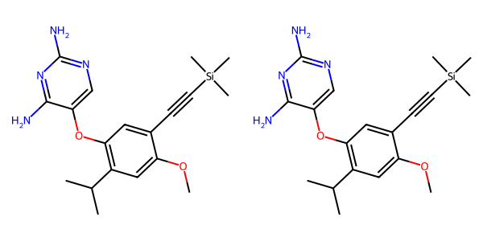

## US20070265270A1_p0030_x1487_y2464_c00124

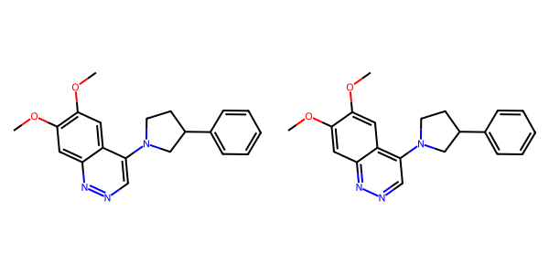

## US20050054819A1_p0023_x1375_y1713_c00083

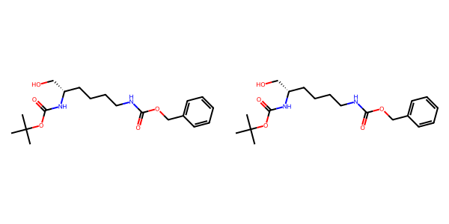

## US20070015754A1_p0045_x0532_y0578_c00269

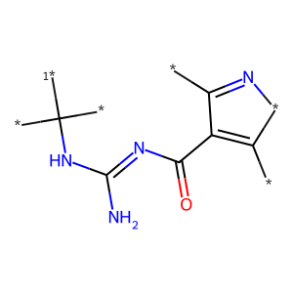

## US20050009817A1_p0022_x0573_y1786_c00074

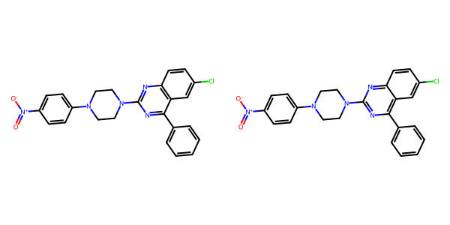

## US20070249620A1_p0041_x0517_y1970_c00038

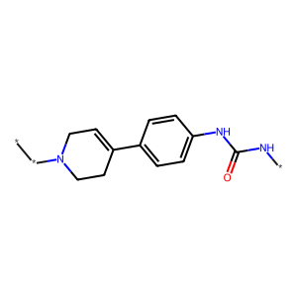

## US20060154945A1_p0016_x0402_y0666_c00052

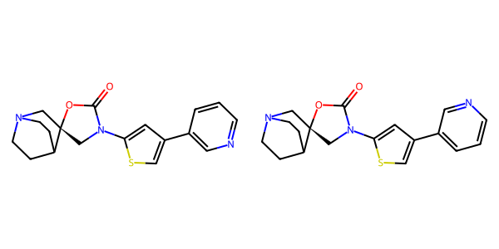

## US20050002859A1_p0023_x0413_y1214_c00112

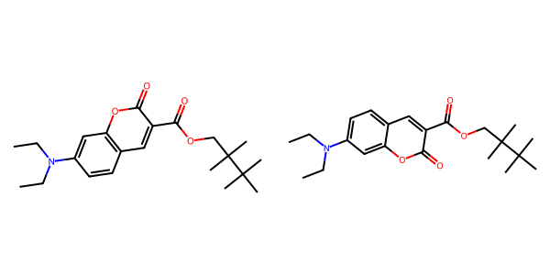

## US20050002859A1_p0015_x0608_y2562_c00090

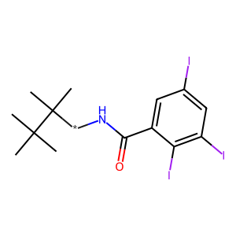

## US20050002859A1_p0016_x0451_y1771_c00095



## US20040229890A1_p0012_x0487_y2174_c00052

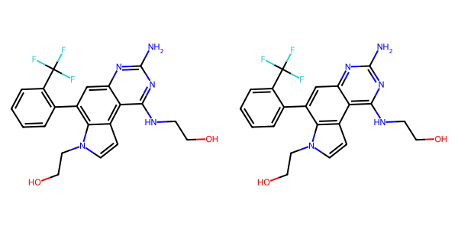

## US20070105909A1_p0027_x0588_y0720_c00068

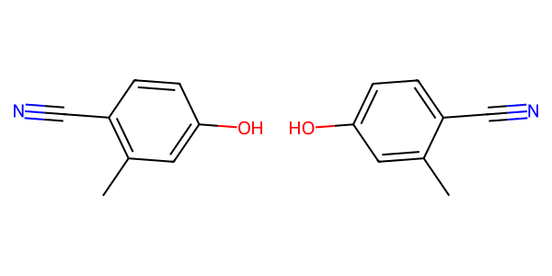

## US20050182067A1_p0037_x1445_y1610_c00141

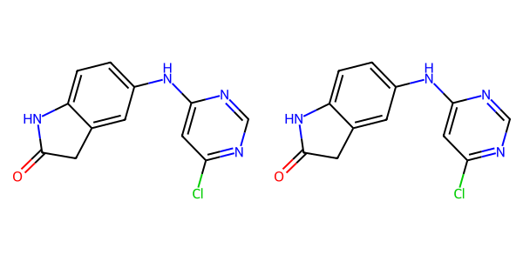

## US20070155803A1_p0021_x0379_y0950_c00038

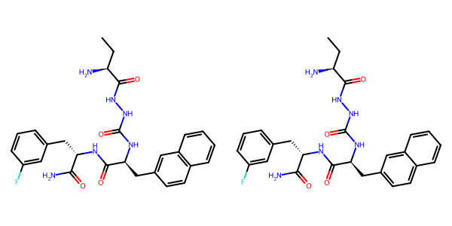

## US20070049758A1_p0020_x0521_y1353_c00026

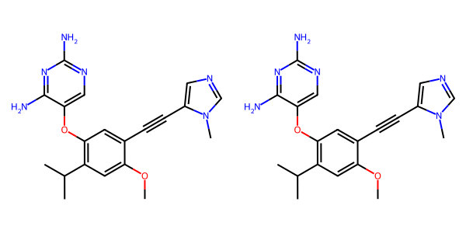

## US20070265270A1_p0027_x0547_y0789_c00107

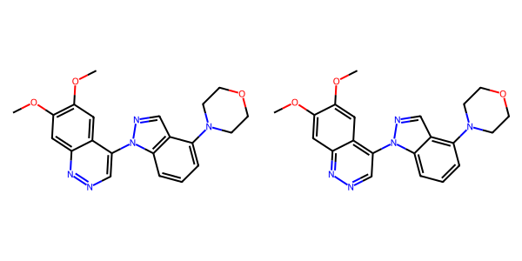

## US20070270434A1_p0020_x1314_y1342_c00051

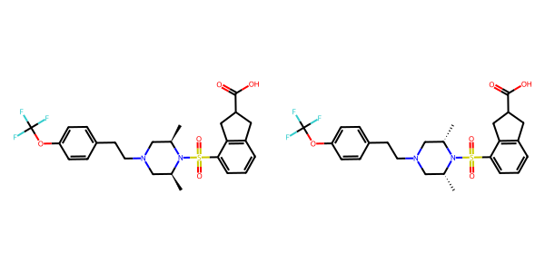

## US20040254236A1_p0031_x1501_y1967_c00135

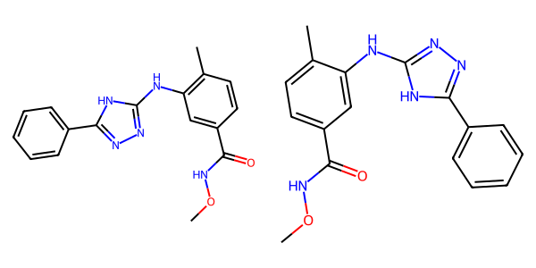

## US20050043351A1_p0021_x0477_y1368_c00074

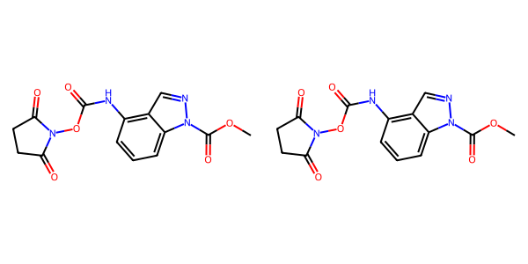

## US20060281700A1_p0071_x1447_y0720_c00100

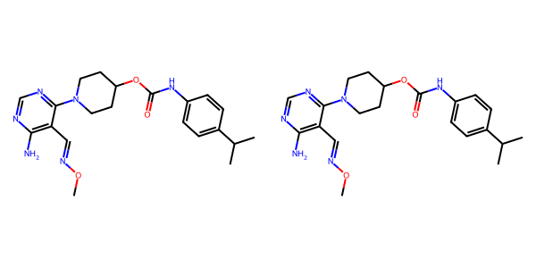

## US20070105909A1_p0029_x0455_y2151_c00081



## US20050002859A1_p0025_x0553_y0594_c00125

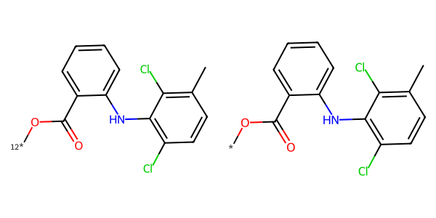

## US20050182067A1_p0033_x1332_y0828_c00119

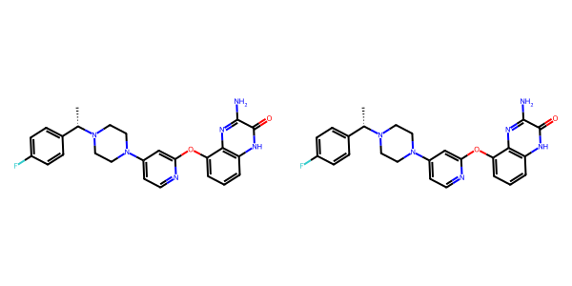

## US20070117785A1_p0028_x1311_y0717_c00066

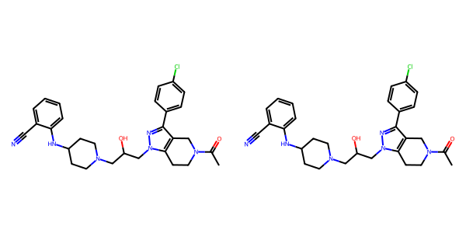

## US20070049758A1_p0026_x0450_y1954_c00052

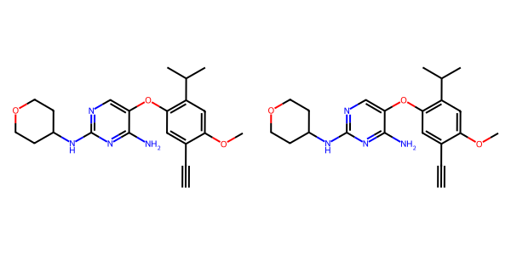

## US20060154945A1_p0017_x1375_y0716_c00060

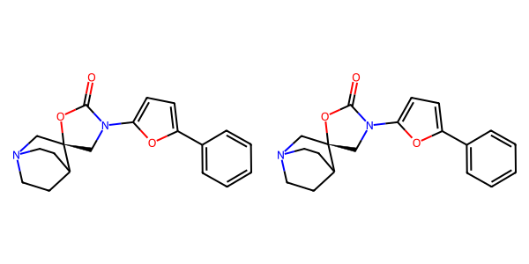

## US20060154945A1_p0019_x0402_y0725_c00069

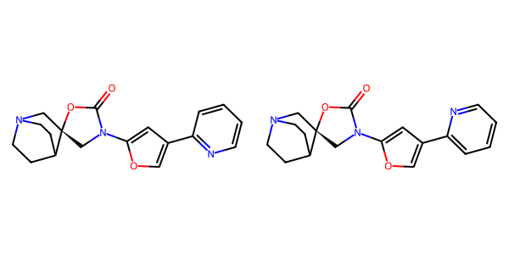

## US20050288357A1_p0046_x0502_y2612_c00081

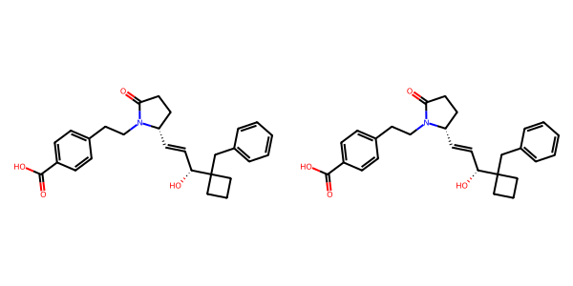

## US20060122222A1_p0024_x0472_y1090_c00066

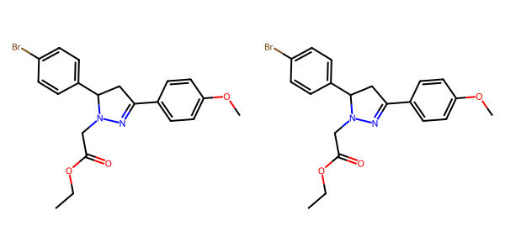

## US20070270434A1_p0023_x1376_y2632_c00065

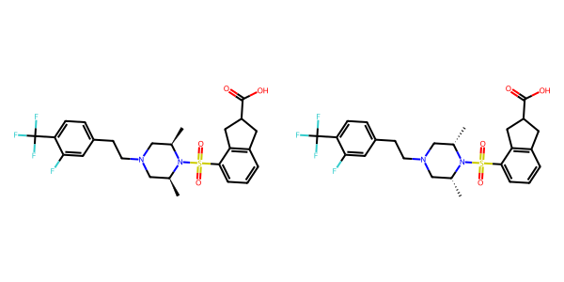

## US20070155803A1_p0016_x1305_y2183_c00021

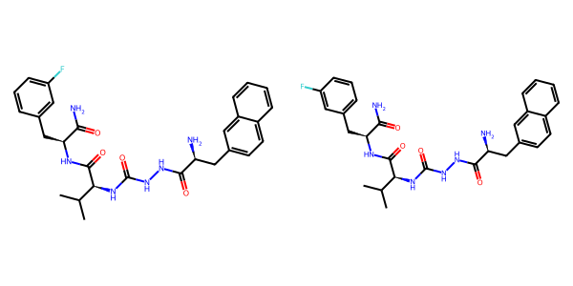

## US20070155803A1_p0026_x1400_y1136_c00064

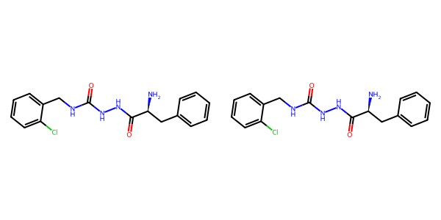

## US20070155803A1_p0016_x0370_y2318_c00019

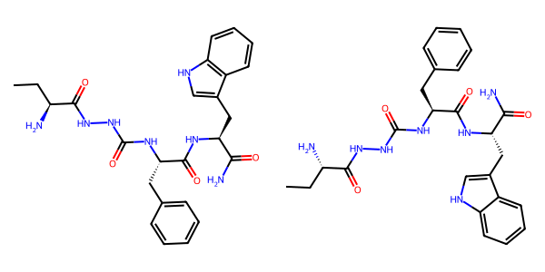

## US20060154945A1_p0012_x0402_y0712_c00032

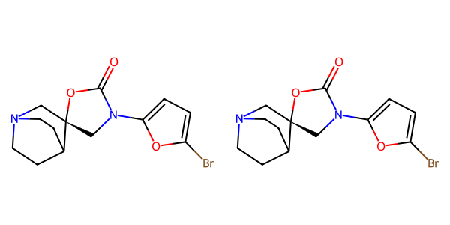

## US20050113580A1_p0038_x1310_y2378_c00054

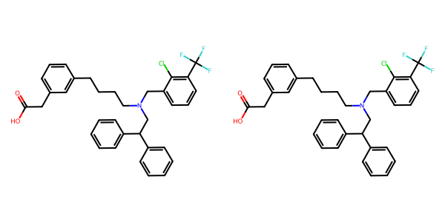

## US20070105909A1_p0020_x1570_y1542_c00033

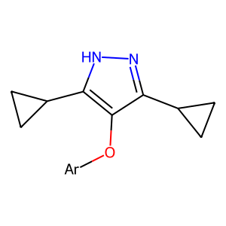

## US20050009817A1_p0037_x0470_y2020_c00106

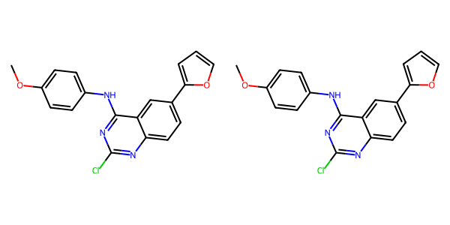

## US20070105909A1_p0028_x0460_y0980_c00072

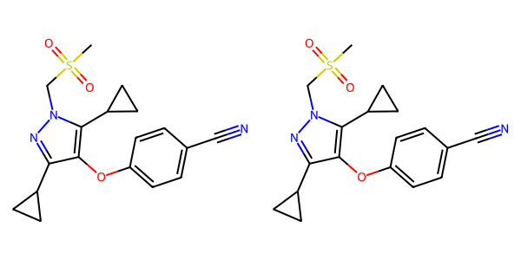

## US20070049758A1_p0017_x0908_y1298_c00014



## US20060154945A1_p0018_x1375_y0708_c00066

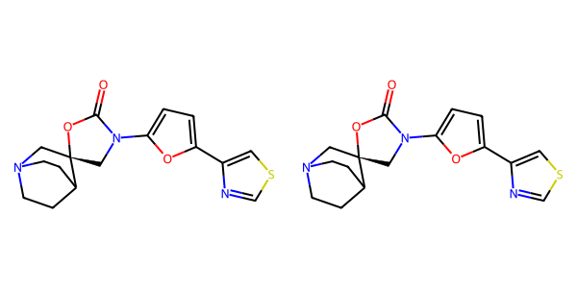

## US20070049758A1_p0027_x0469_y1136_c00055

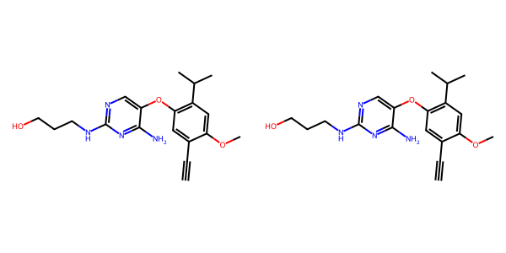

## US20050182067A1_p0043_x0765_y2660_c00157

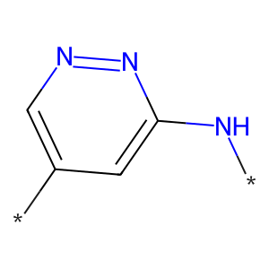

## US20070179154A1_p0058_x0404_y0777_c00124

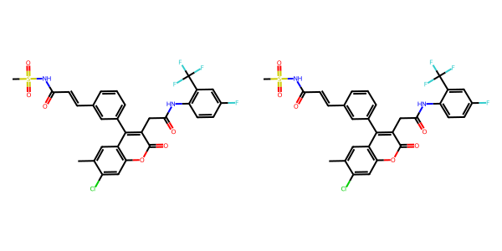

## US20050288357A1_p0049_x0502_y1379_c00090

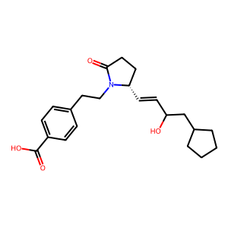

## US20060154945A1_p0019_x0402_y2573_c00071

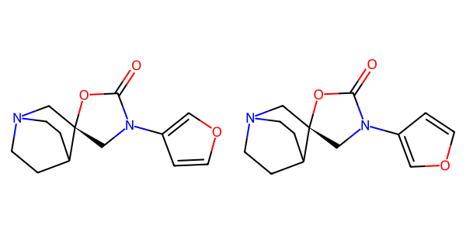

## US20050182067A1_p0040_x0765_y0572_c00152



## US20070155803A1_p0019_x1360_y0949_c00032

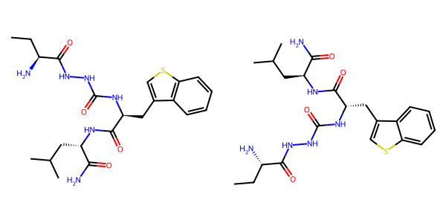

## US20060281700A1_p0071_x0445_y1388_c00097

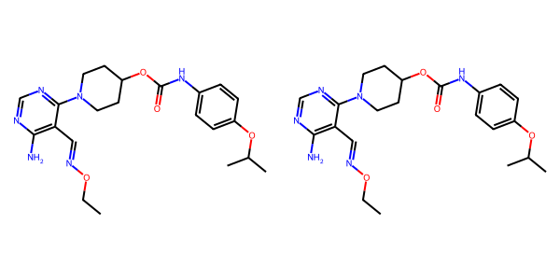

## US20050009817A1_p0026_x0563_y0669_c00080

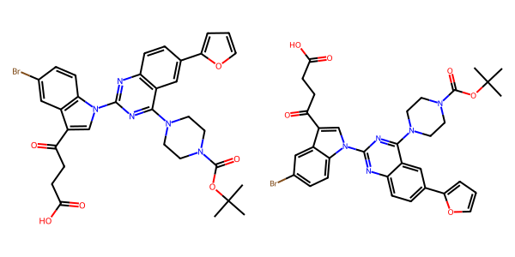

## US20050182067A1_p0033_x0608_y1680_c00117

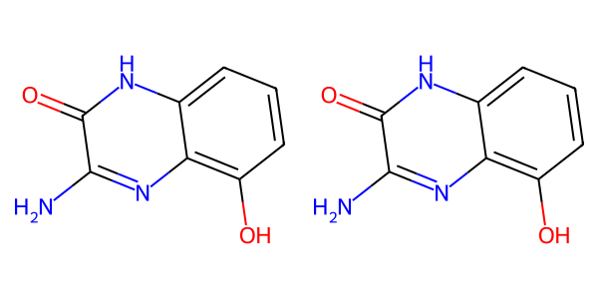

## US20070049758A1_p0019_x0476_y1891_c00023

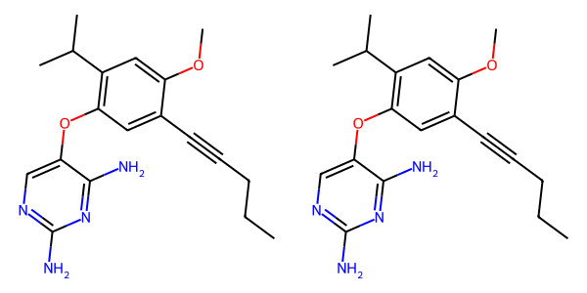

## US20070265270A1_p0035_x0490_y2147_c00139

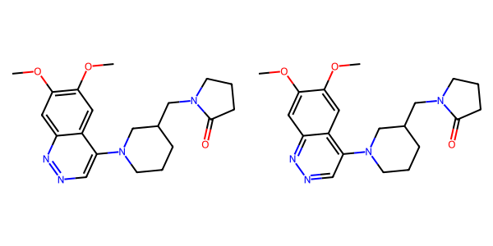

## US20070179154A1_p0055_x0501_y1159_c00114

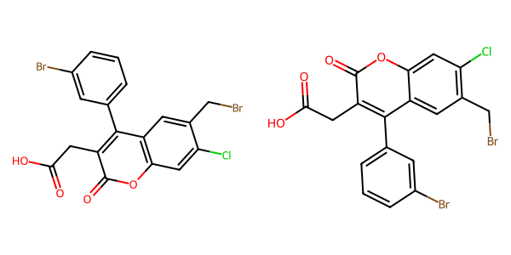

## US20070155803A1_p0018_x0379_y1022_c00026

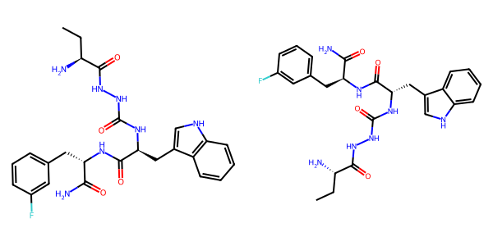

## US20070117785A1_p0051_x1313_y1778_c00094

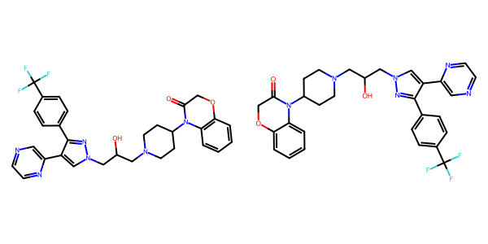

## US20070105909A1_p0021_x0455_y1207_c00038

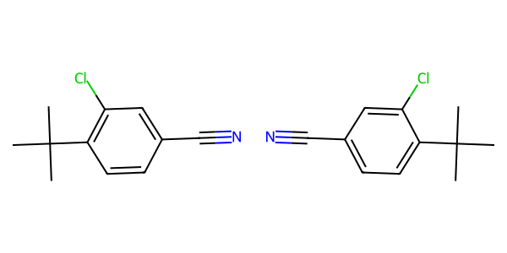

## US20060122222A1_p0027_x0379_y1064_c00078

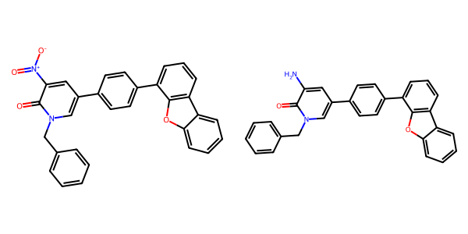

## US20060154945A1_p0015_x0402_y2714_c00049

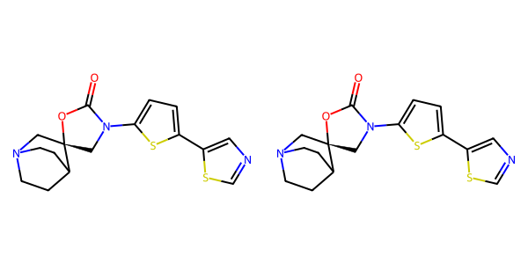

## US20070155803A1_p0021_x1410_y0829_c00040

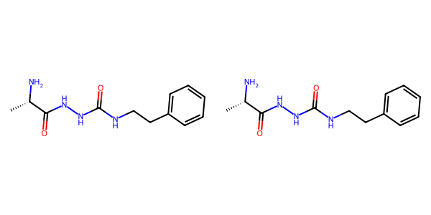

## US20050004369A1_p0023_x0475_y2497_c00038

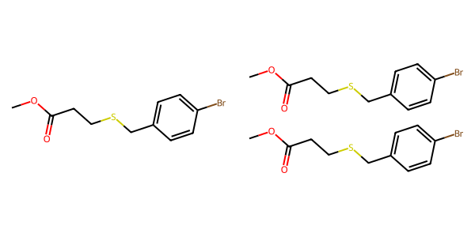

## US20050009817A1_p0037_x1367_y2496_c00108

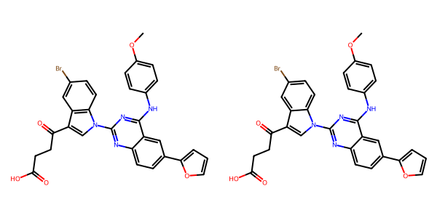

## US20050009817A1_p0034_x1300_y1397_c00100

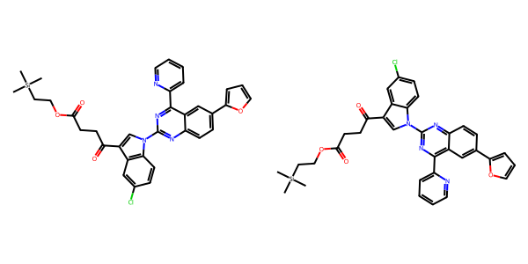

## US20050227932A1_p0042_x0404_y1405_c00079

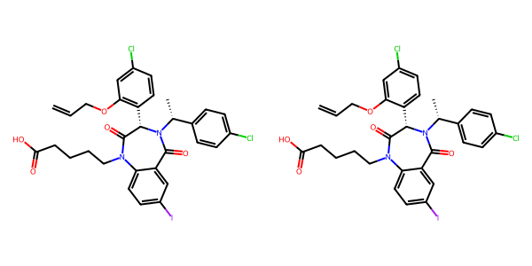

## US20050288357A1_p0047_x1475_y2210_c00086

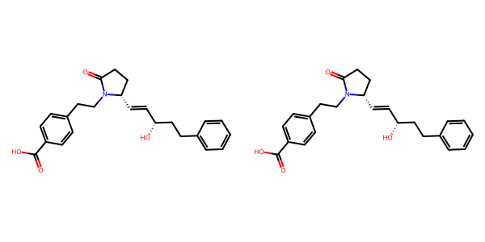

## US20050288357A1_p0053_x0504_y0803_c00101

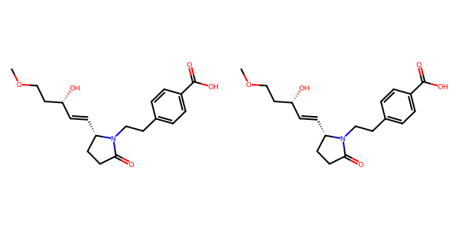

## US20070155803A1_p0022_x1400_y2742_c00046

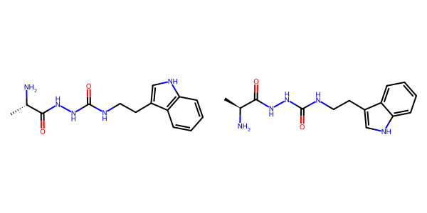

## US20050054819A1_p0014_x1375_y1229_c00046

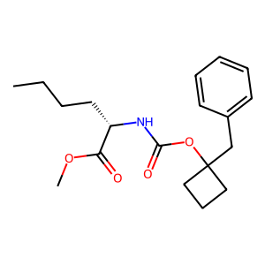

## US20070105909A1_p0021_x0455_y1815_c00040

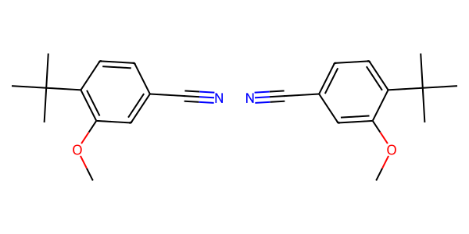

## US20050288357A1_p0030_x0535_y0741_c00059

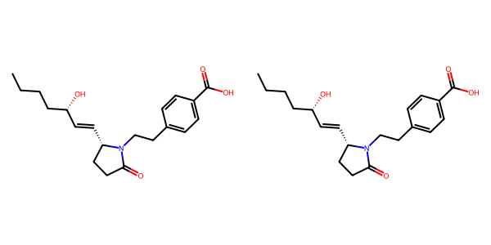

## US20060281700A1_p0083_x0404_y0649_c00163

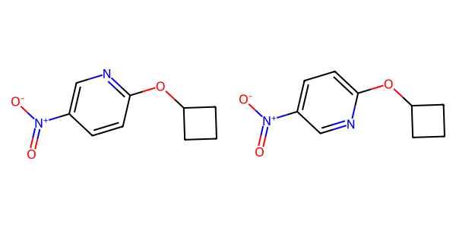

## US20050267177A1_p0023_x1321_y1425_c00075

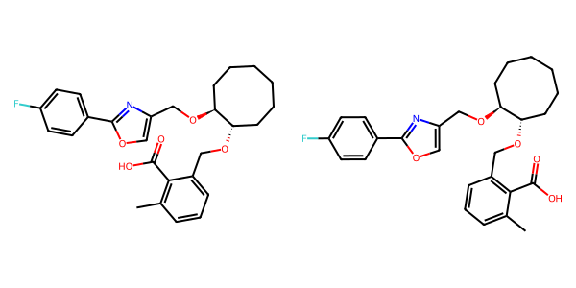

## US20070049758A1_p0014_x1456_y2580_c00010

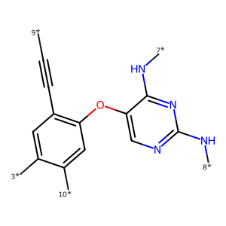

## US20050227932A1_p0028_x1376_y0970_c00038

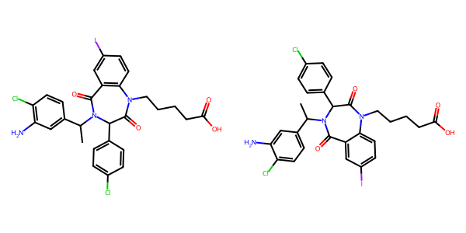

## US20070117785A1_p0044_x0338_y2297_c00085

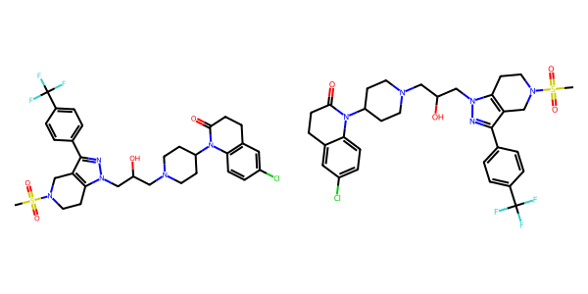

## US20050004369A1_p0029_x0443_y0744_c00053

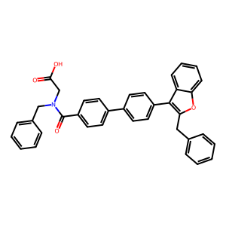

## US20070270434A1_p0020_x0402_y2697_c00050

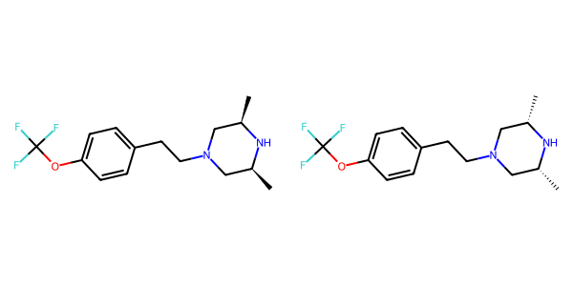

## US20040254236A1_p0032_x1414_y1274_c00137

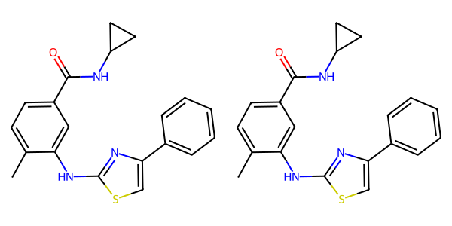

## US20040266789A1_p0032_x1441_y0828_c00055

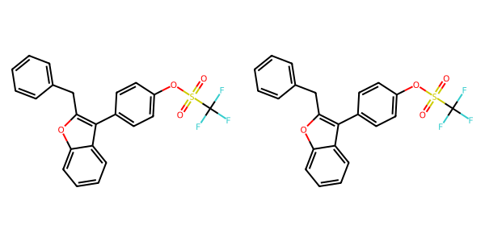

## US20050288357A1_p0005_x1541_y2587_c00000



## US20070105909A1_p0032_x0460_y1166_c00098

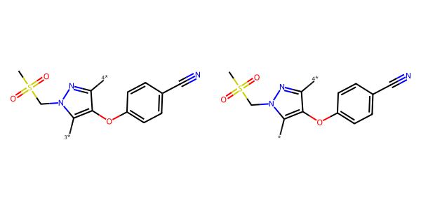

## US20070117785A1_p0030_x1311_y0642_c00068

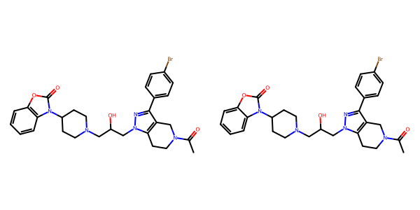

## US20070015754A1_p0038_x1434_y0861_c00242

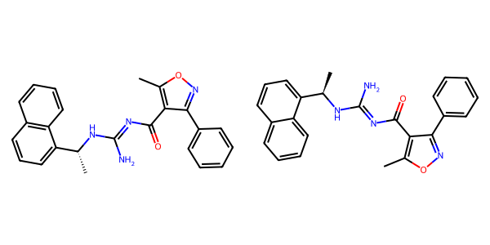

## US20050075347A1_p0028_x0414_y0852_c00063

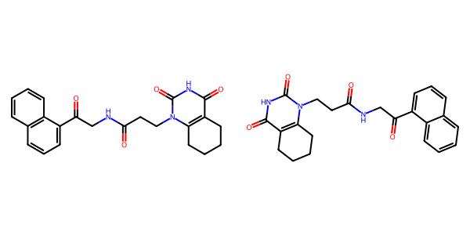

## US20050009817A1_p0027_x0528_y1786_c00082

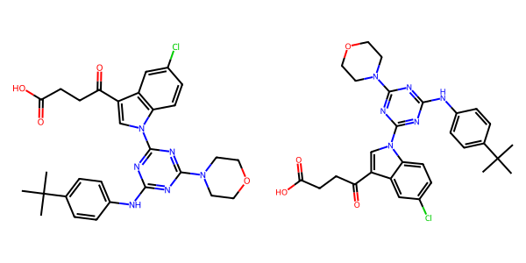

## US20070155803A1_p0026_x0456_y0690_c00061

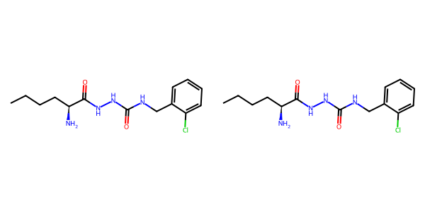

## US20070270434A1_p0018_x1375_y2618_c00043

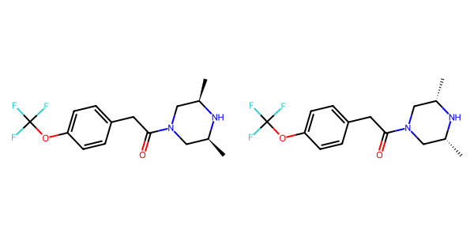

## US20070155803A1_p0024_x0433_y2400_c00053

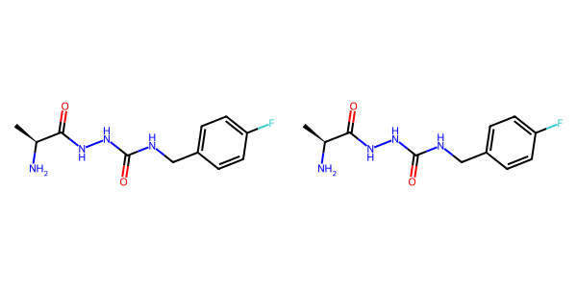

## US20070155803A1_p0025_x0466_y1275_c00057

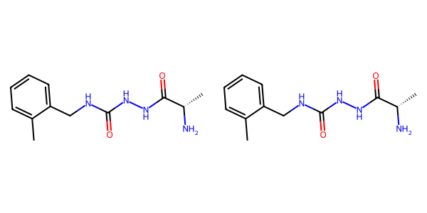

## US20070015754A1_p0022_x1579_y0681_c00117

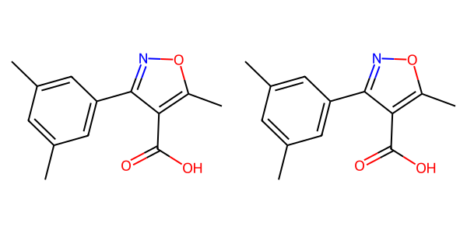

## US20070117785A1_p0032_x1304_y1432_c00070

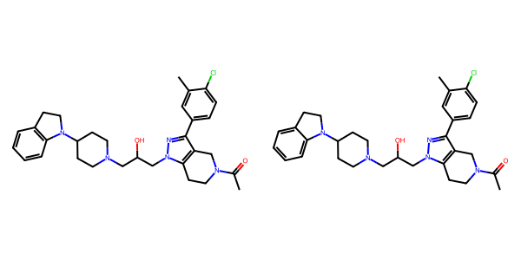

## US20080113922A1_p0018_x1306_y2345_c00055

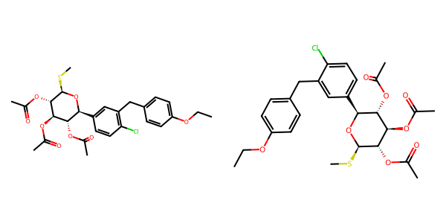

## US20040266789A1_p0011_x0875_y0569_c00014

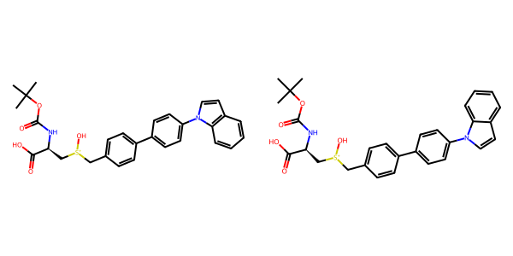

## US20060122222A1_p0034_x0417_y1091_c00094

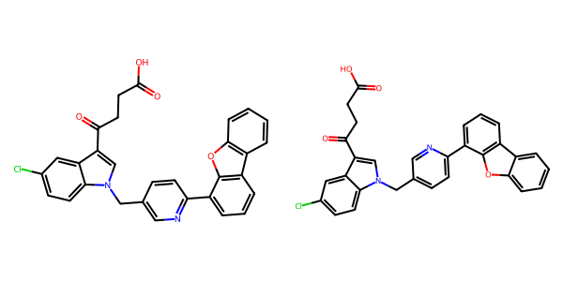

## US20070265270A1_p0030_x1511_y0632_c00122

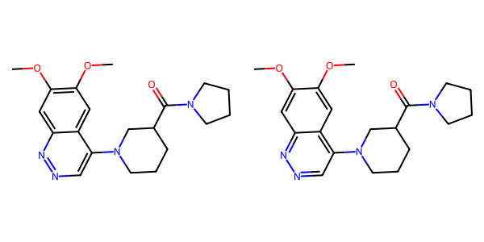

## US20050227932A1_p0028_x1376_y2330_c00039

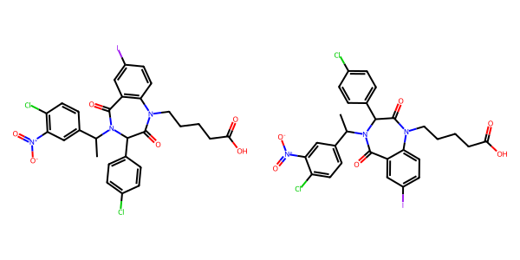

## US20050288357A1_p0012_x0522_y1154_c00013

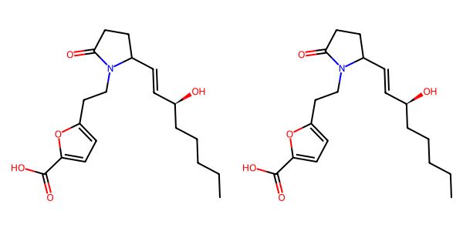

## US20050288357A1_p0030_x1487_y1968_c00060

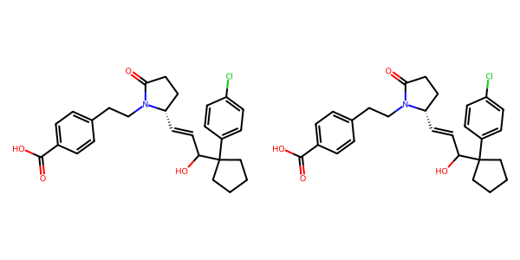

## US20050182067A1_p0036_x1607_y2740_c00137

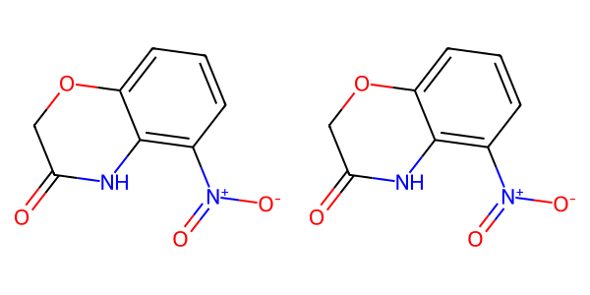

## US20050182067A1_p0032_x0501_y1621_c00111

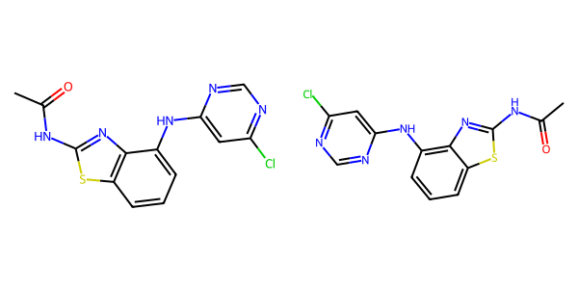

## US20070117785A1_p0041_x0336_y1965_c00080

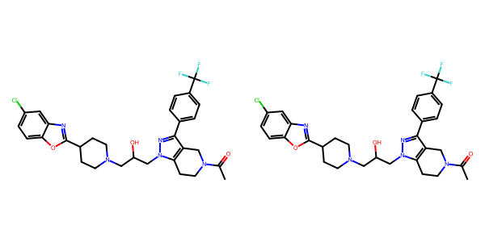

## US20070015754A1_p0015_x0337_y1555_c00067

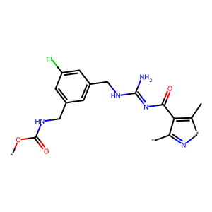

## US20050004369A1_p0029_x0445_y2296_c00055

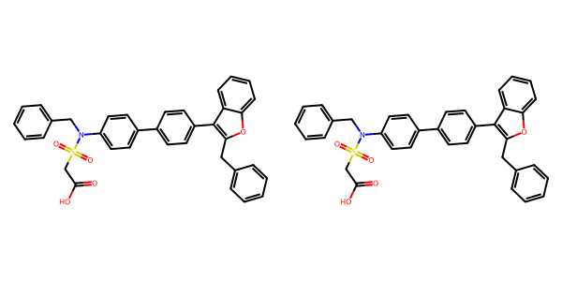

## US20070117785A1_p0036_x0332_y1889_c00074

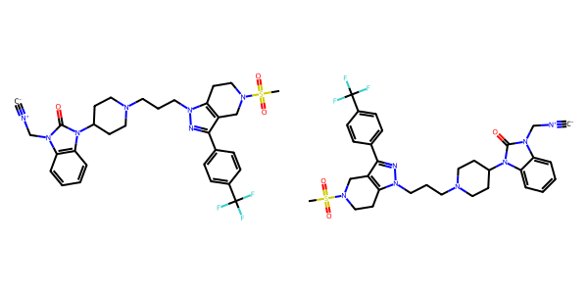

## US20060154945A1_p0020_x0402_y2509_c00077

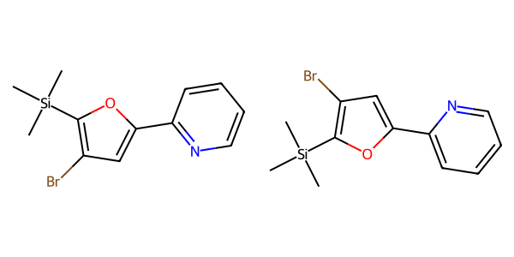

## US20070049758A1_p0024_x0476_y2067_c00044

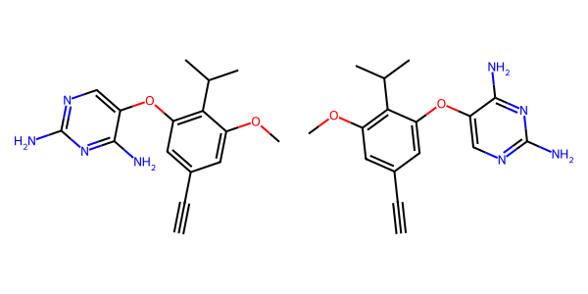

## US20070155803A1_p0025_x1439_y0937_c00059

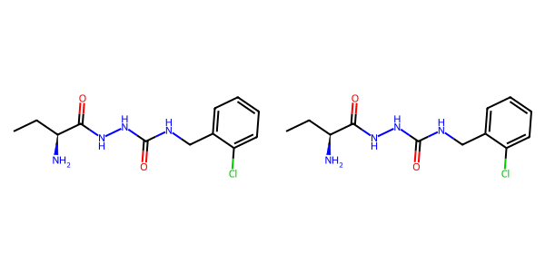

## US20040229890A1_p0018_x0537_y2382_c00083

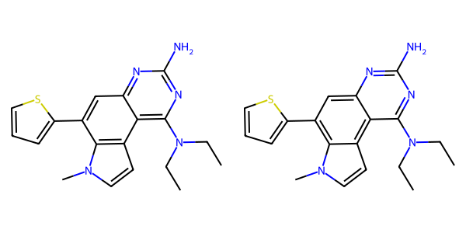

## US20050288357A1_p0048_x0502_y2497_c00088

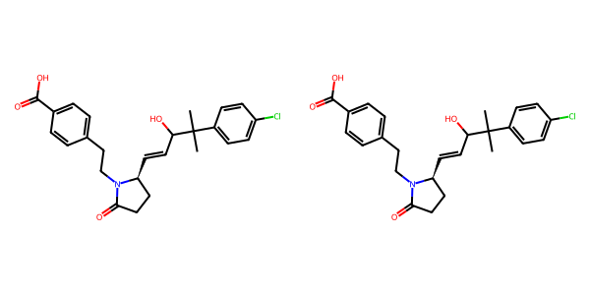

## US20060122222A1_p0016_x0409_y0634_c00045

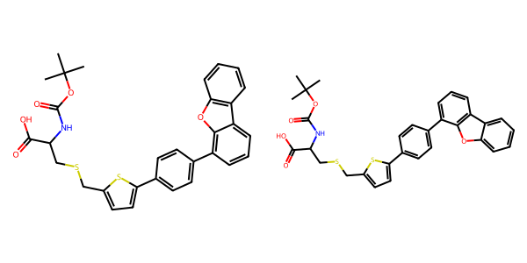

## US20050288357A1_p0036_x1478_y0793_c00066

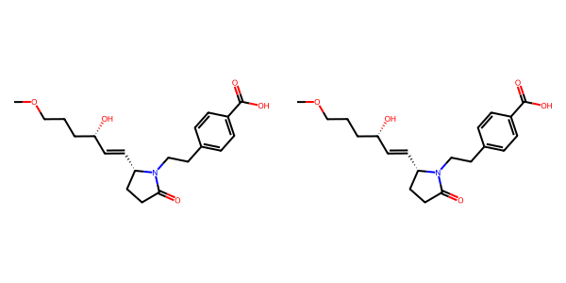

## US20050004369A1_p0021_x1309_y2315_c00034

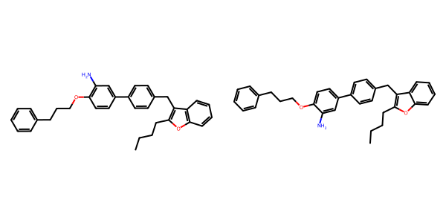

## US20070155803A1_p0017_x1343_y2154_c00025

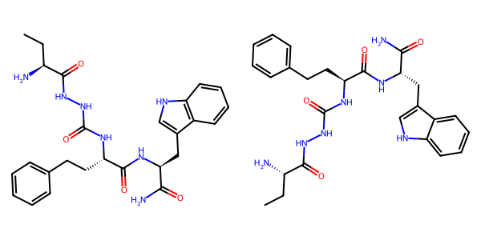

## US20040266789A1_p0035_x0329_y0850_c00059

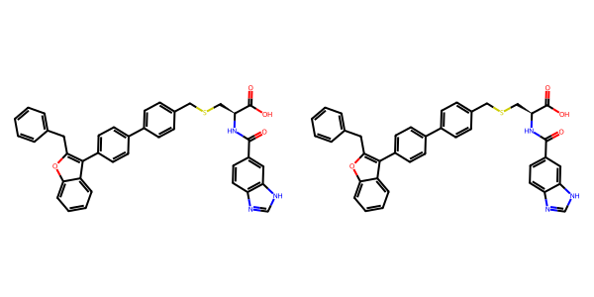

## US20070117785A1_p0057_x0336_y1760_c00107

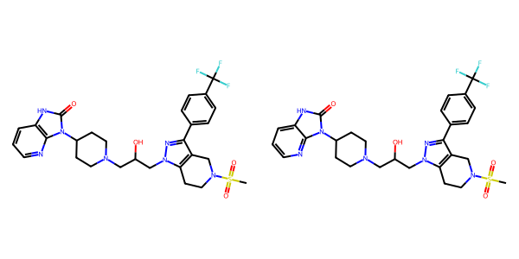

## US20070179154A1_p0057_x1376_y1322_c00123

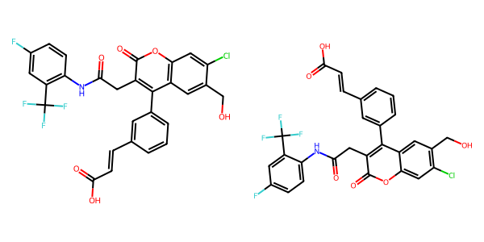

## US20060122222A1_p0015_x0638_y2624_c00044

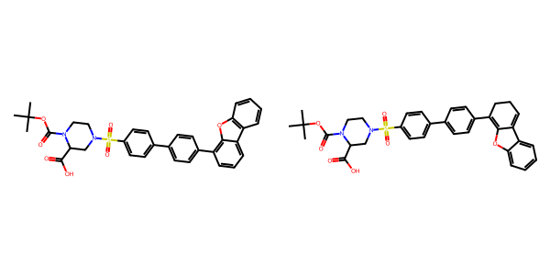

## US20070265270A1_p0028_x1520_y0683_c00112

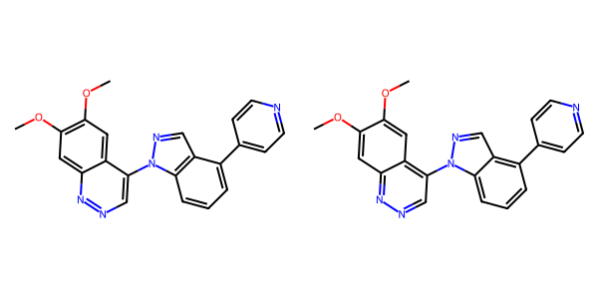

## US20050009817A1_p0018_x0606_y1081_c00060

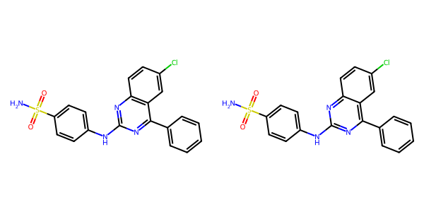

## US20050009817A1_p0048_x0600_y0705_c00115

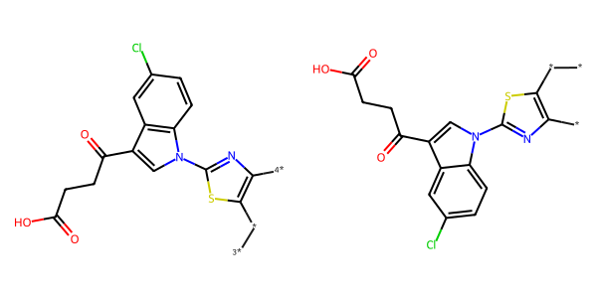

## US20060281700A1_p0062_x0402_y1072_c00039

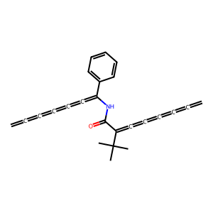

## US20060122222A1_p0028_x0540_y2207_c00083

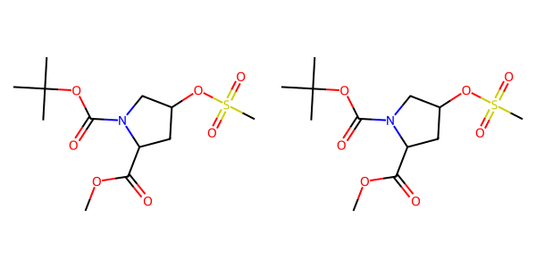

## US20040266789A1_p0041_x1300_y0897_c00068

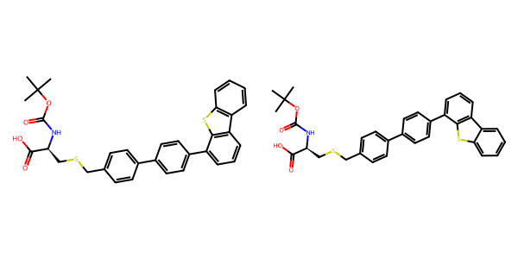

## US20060154945A1_p0017_x1375_y2530_c00062

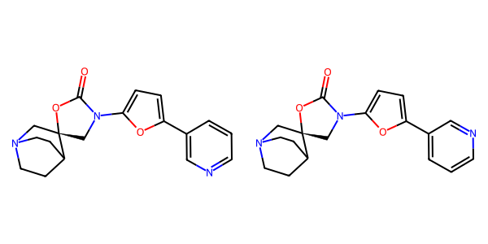

## US20040266789A1_p0040_x0327_y2036_c00066

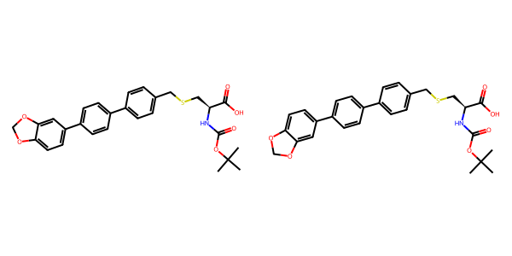

## US20080113922A1_p0019_x1337_y2499_c00058

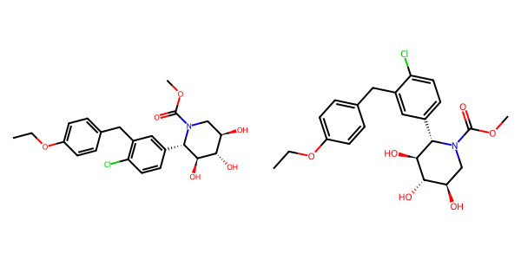

## US20050004369A1_p0035_x0443_y1132_c00072

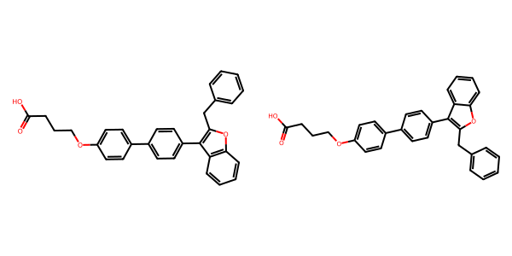

## US20060122222A1_p0037_x0348_y2730_c00098

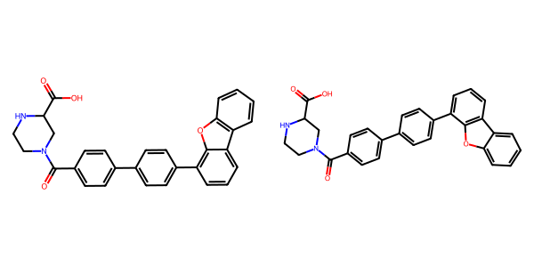

## US20050113580A1_p0046_x0369_y1033_c00079

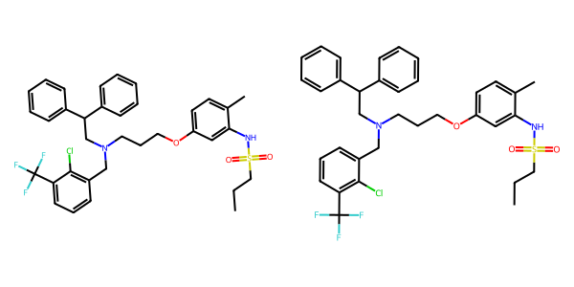

## US20050288357A1_p0057_x0482_y1175_c00111



## US20070155803A1_p0030_x0466_y1711_c00076

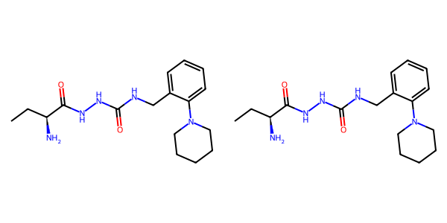

## US20070265270A1_p0016_x1568_y1052_c00073

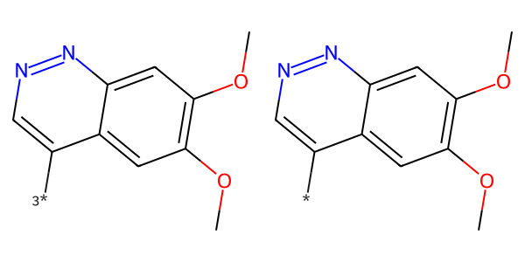

## US20070155803A1_p0014_x1439_y1966_c00014

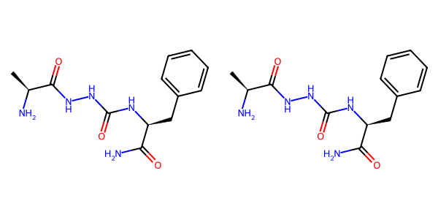

## US20050288357A1_p0051_x0515_y0836_c00095

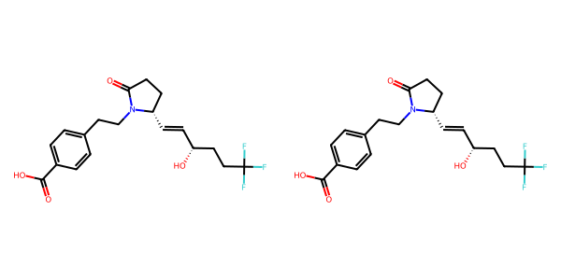

## US20060122222A1_p0028_x0587_y0762_c00082

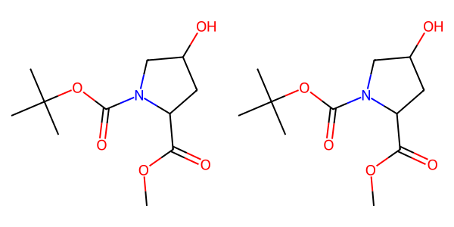

## US20050002859A1_p0017_x0553_y0794_c00101



## US20050009817A1_p0033_x0552_y0651_c00095



## US20070049758A1_p0021_x0476_y1318_c00030

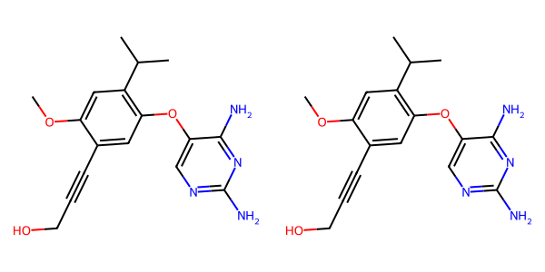

## US20050009817A1_p0034_x0383_y1634_c00099



## US20050288357A1_p0012_x0515_y2405_c00015

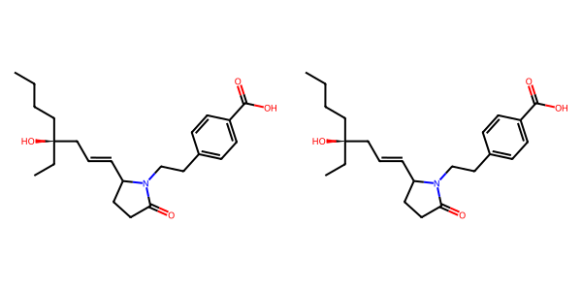

## US20060122222A1_p0039_x1472_y0779_c00101

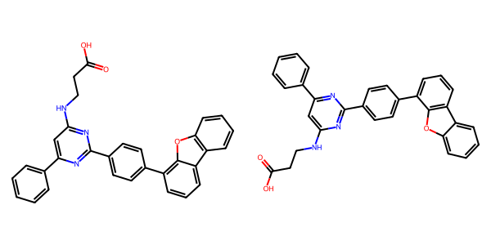

## US20050004369A1_p0022_x0336_y0751_c00035



## US20070049758A1_p0016_x1409_y2383_c00013

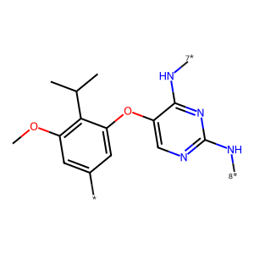

## US20060154945A1_p0002_x0402_y2720_c00001

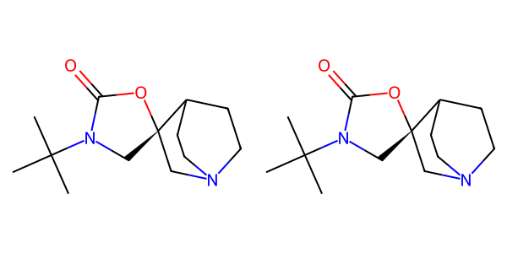

## US20050113580A1_p0038_x0334_y2378_c00052

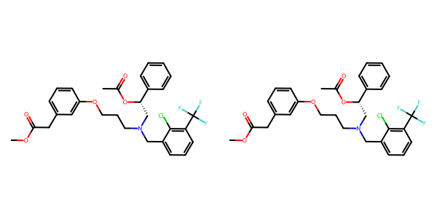

## US20050004369A1_p0023_x1314_y0896_c00039

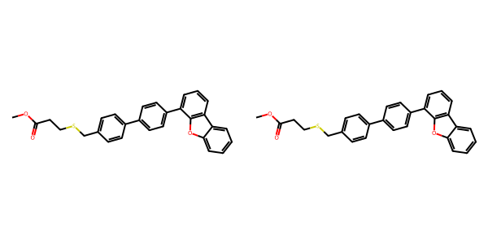

## US20050288357A1_p0037_x1507_y1984_c00068

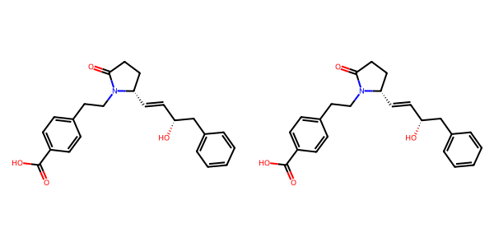

## US20040229890A1_p0013_x0327_y2015_c00056

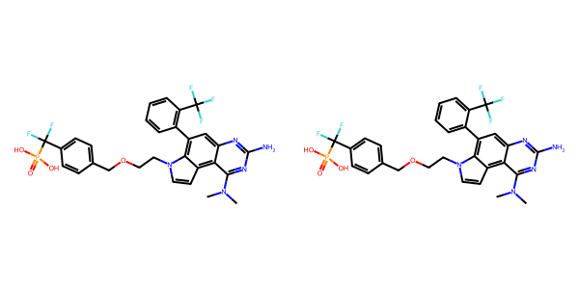

## US20070015754A1_p0033_x0477_y2387_c00202

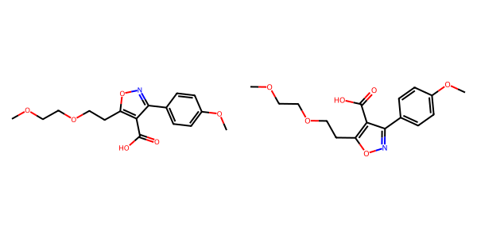

## US20070117785A1_p0040_x0330_y1244_c00078

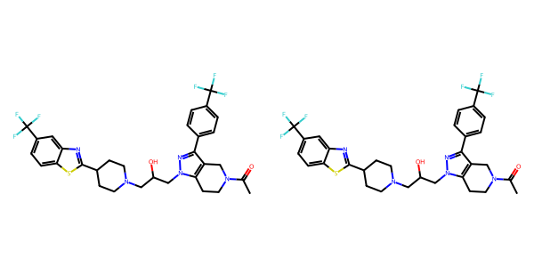

## US20050002859A1_p0038_x0461_y2211_c00136

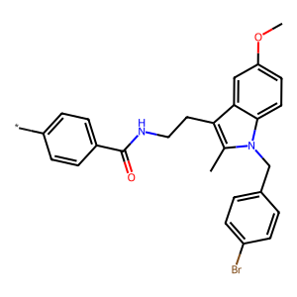

## US20050054819A1_p0016_x1313_y0760_c00053

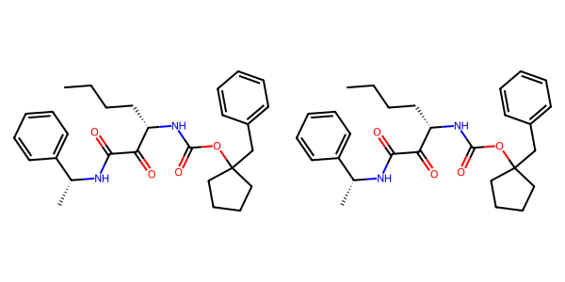

## US20060154945A1_p0017_x1375_y1623_c00061

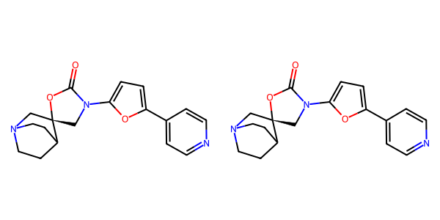

## US20080113922A1_p0017_x0336_y1823_c00051

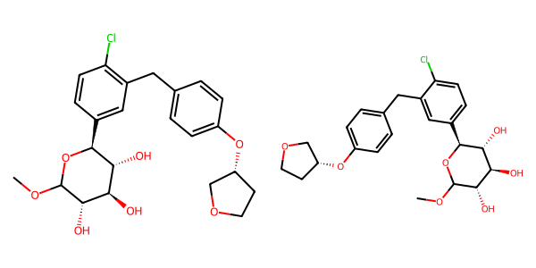

## US20050004369A1_p0034_x0443_y1040_c00069

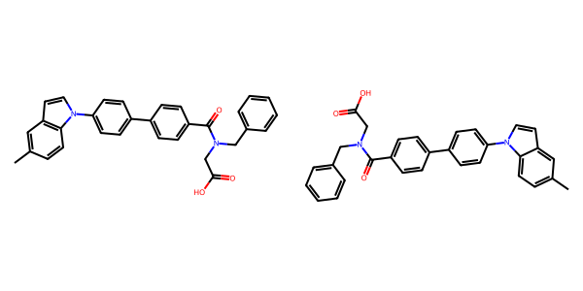

## US20060154945A1_p0012_x1375_y2908_c00037

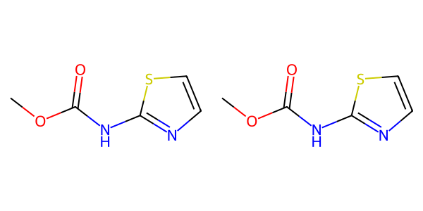

## US20070155803A1_p0023_x1406_y2840_c00051

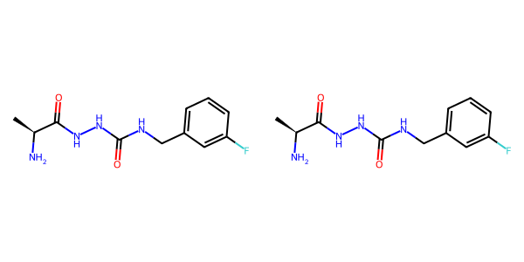

## US20050182067A1_p0035_x0576_y1896_c00128

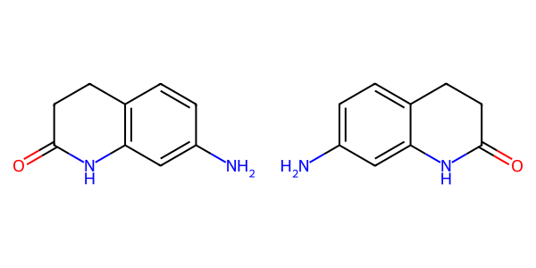

## US20040254236A1_p0047_x0473_y1873_c00182

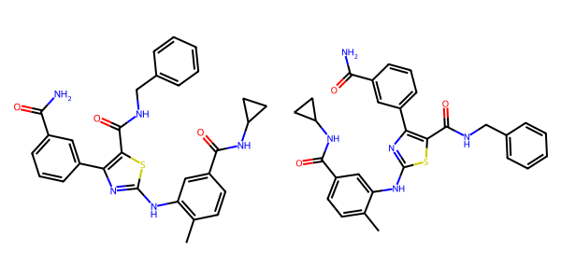

## US20060122222A1_p0029_x0357_y0631_c00086

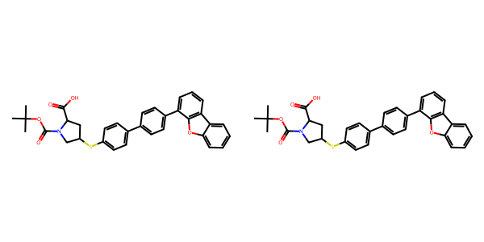

## US20050267177A1_p0027_x1329_y0723_c00097

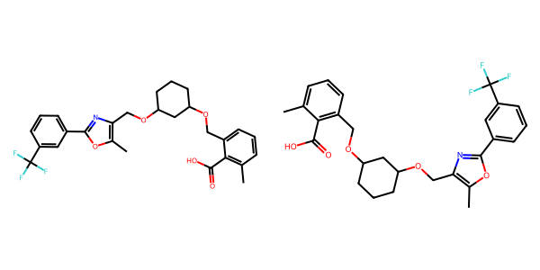

## US20050267177A1_p0022_x0356_y2363_c00068

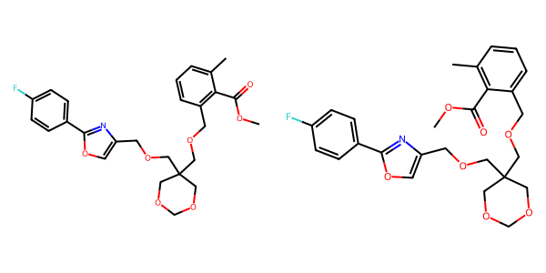

## US20050288357A1_p0043_x0505_y2279_c00077

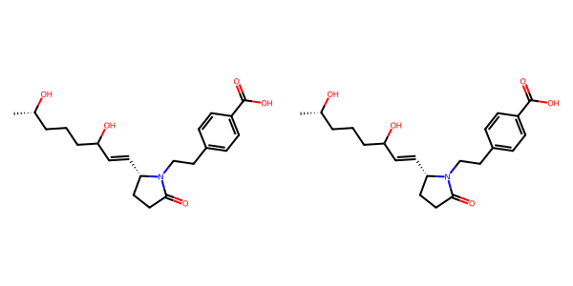

## US20070179154A1_p0031_x1376_y1739_c00014

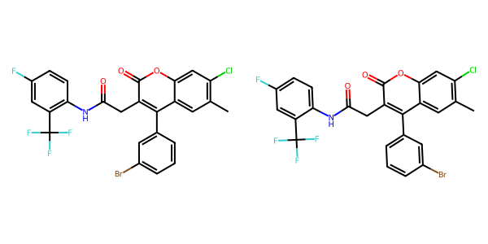

## US20050004369A1_p0033_x0443_y2609_c00067

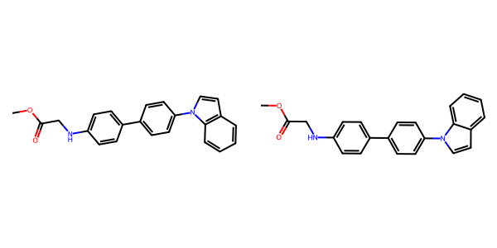

## US20070105909A1_p0024_x0492_y2539_c00058

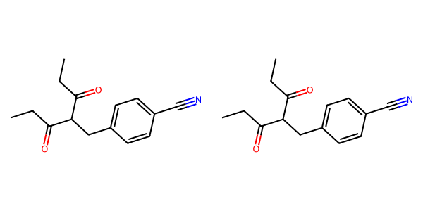

## US20070117785A1_p0039_x0338_y0639_c00076

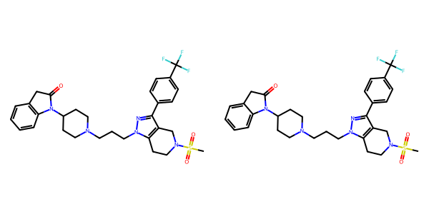

## US20070265270A1_p0002_x1566_y2287_c00000

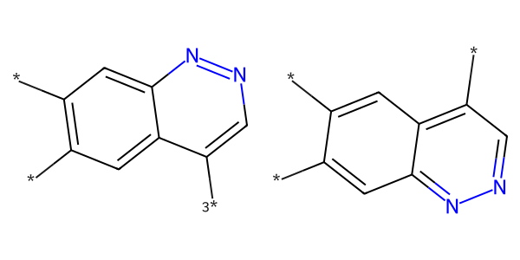

## US20040266789A1_p0051_x0466_y0684_c00084

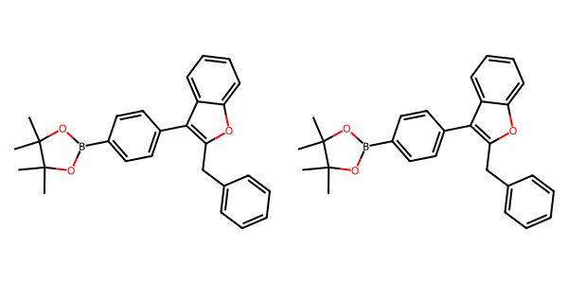

## US20060281700A1_p0077_x0403_y1155_c00136



## US20070049758A1_p0024_x0469_y2587_c00045

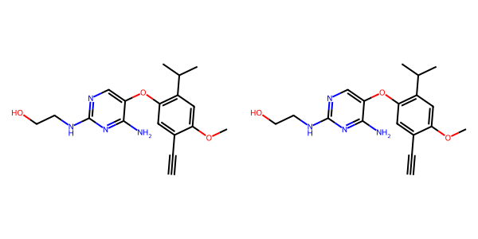

## US20070265270A1_p0029_x0481_y2386_c00115

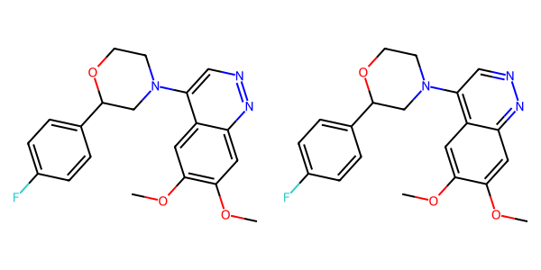

## US20070105909A1_p0024_x1463_y2489_c00059

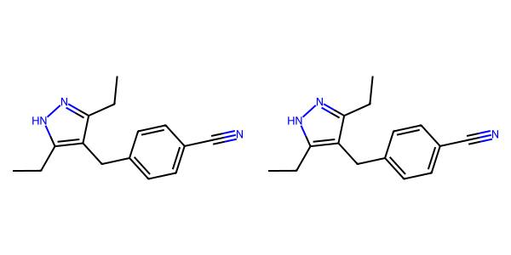

## US20050182067A1_p0033_x1526_y2110_c00120

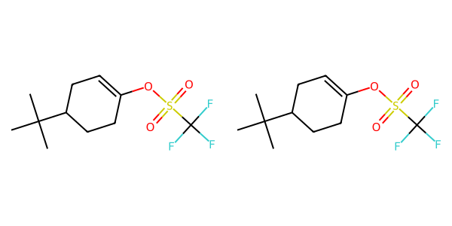

## US20070270434A1_p0018_x1376_y0766_c00041

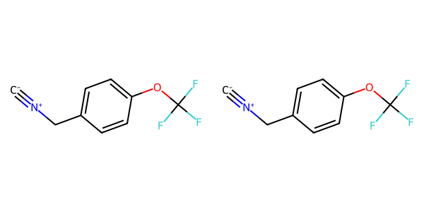

## US20070015754A1_p0001_x1502_y1304_c00000

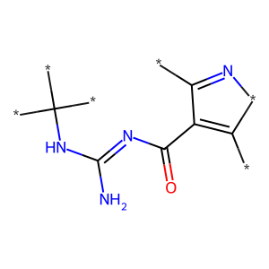

## US20050182067A1_p0034_x0612_y2474_c00123

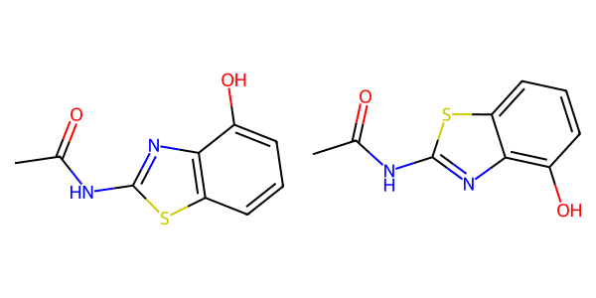

## US20070049758A1_p0025_x0463_y1954_c00048

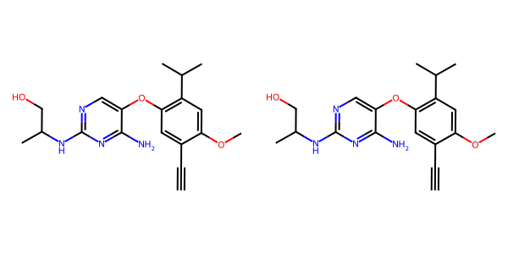

## US20040266789A1_p0031_x1302_y0640_c00053

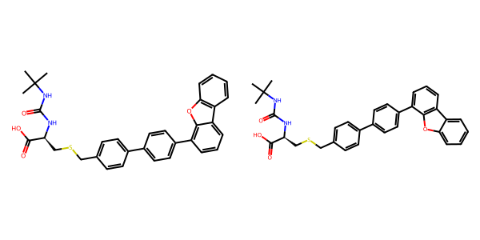

## US20050043351A1_p0020_x0450_y1126_c00068

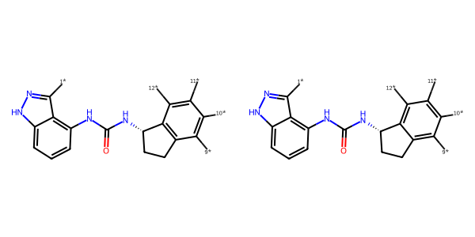

## US20070117785A1_p0046_x1305_y0651_c00087

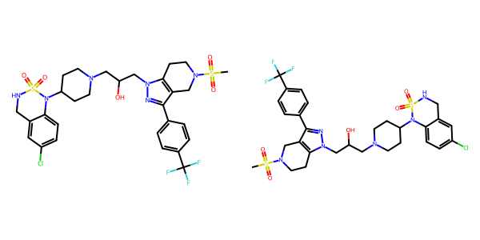

## US20050009817A1_p0018_x0606_y0669_c00059

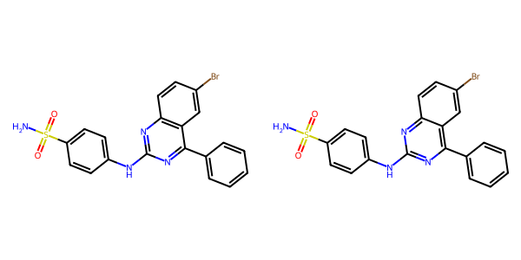

## US20050043351A1_p0021_x1545_y2613_c00084

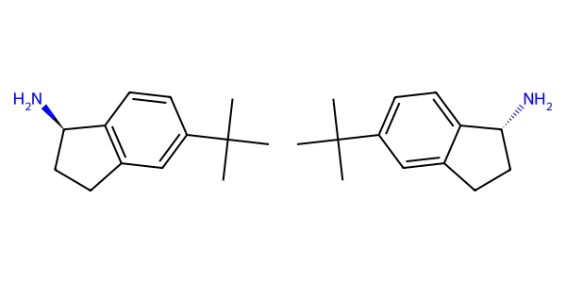

## US20050182067A1_p0038_x0446_y2363_c00145

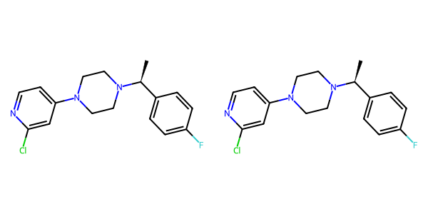

## US20060154945A1_p0014_x0402_y2312_c00043

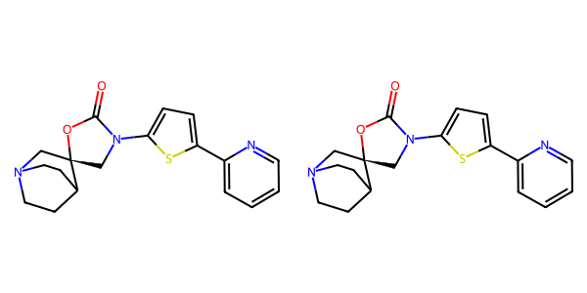

## US20050267177A1_p0018_x0335_y0667_c00040

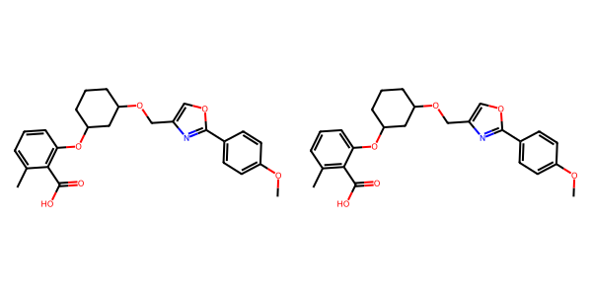

## US20060154945A1_p0015_x1375_y1092_c00050

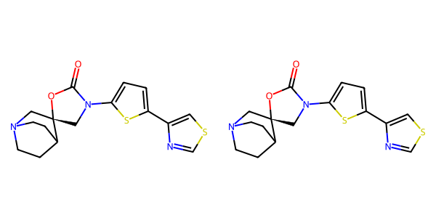

## US20050113580A1_p0047_x0347_y1692_c00082

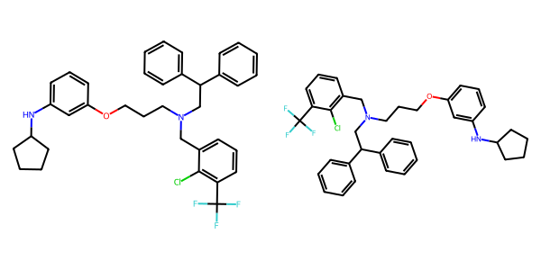

## US20080113922A1_p0014_x1312_y1952_c00046

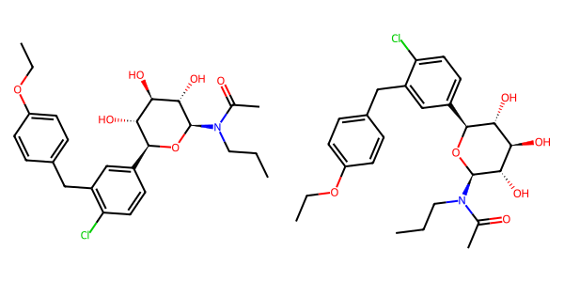

## US20050288357A1_p0052_x1465_y1283_c00100

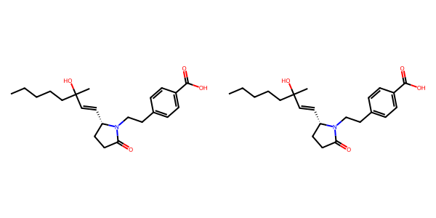

## US20070179154A1_p0033_x0508_y1894_c00018

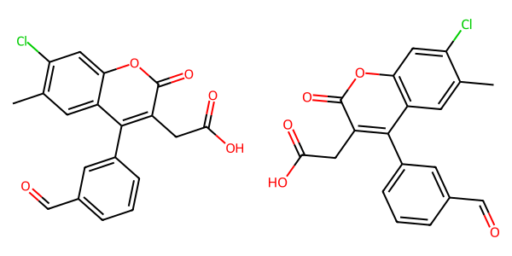

## US20060122222A1_p0038_x0349_y0762_c00099

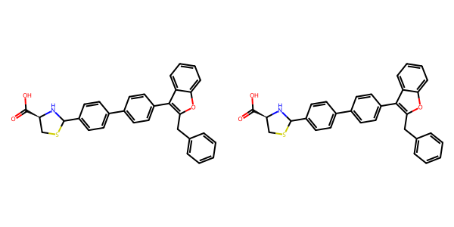

## US20060154945A1_p0012_x0404_y2159_c00034

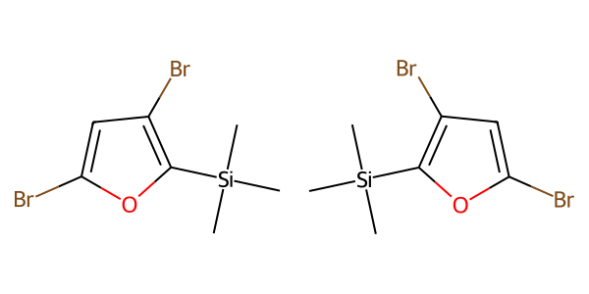

## US20040229890A1_p0011_x0530_y1393_c00046

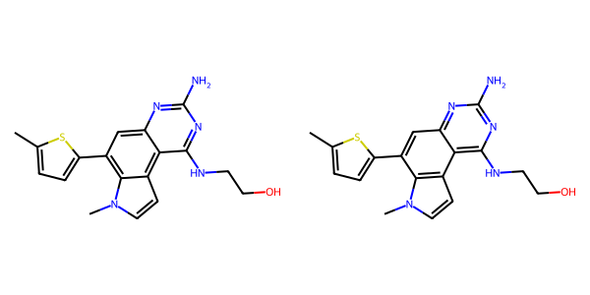

## US20060154945A1_p0022_x0402_y2785_c00088

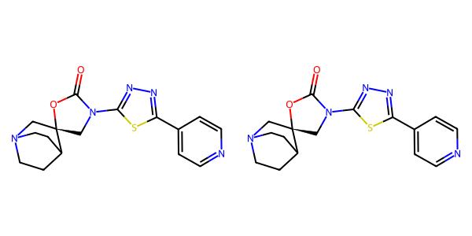

## US20050009817A1_p0024_x0621_y2159_c00078

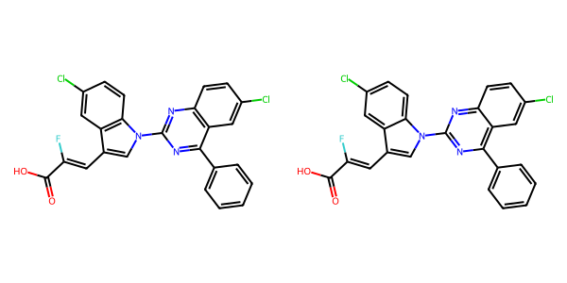

## US20060122222A1_p0026_x0521_y1482_c00074



## US20040266789A1_p0018_x0414_y2042_c00028

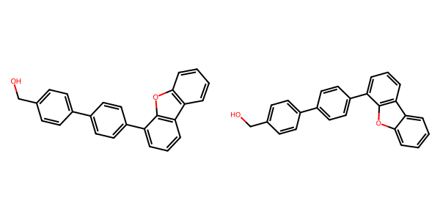

## US20050009817A1_p0026_x0590_y2391_c00081

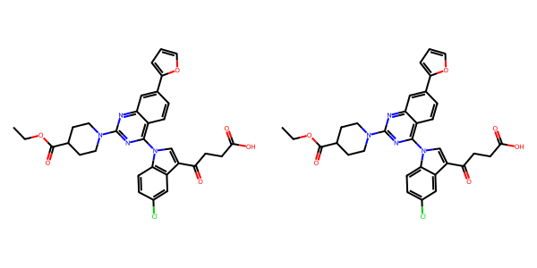

## US20070179154A1_p0052_x1376_y2053_c00107

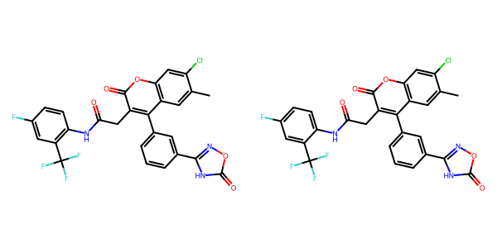

## US20040266789A1_p0033_x1312_y2193_c00057

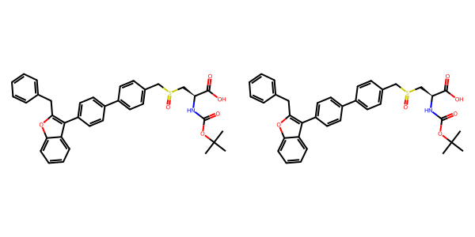

## US20050004369A1_p0019_x0524_y1621_c00026



## US20050009817A1_p0030_x0513_y2009_c00086



## US20060122222A1_p0015_x0638_y2146_c00043

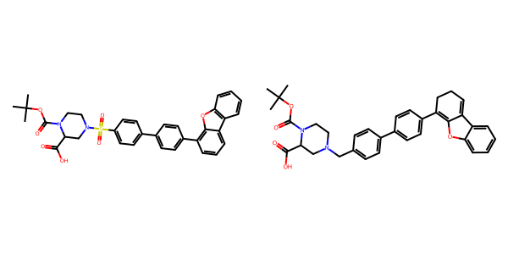

## US20070179177A1_p0003_x0558_y2478_c00000



## US20080113922A1_p0019_x1337_y0938_c00057

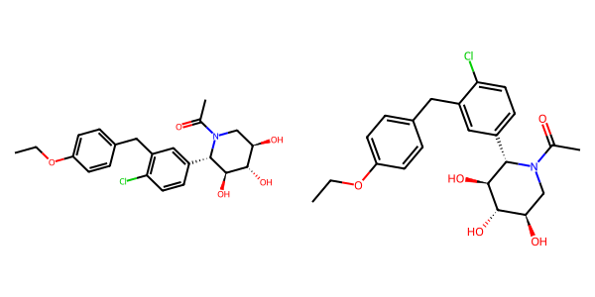

## US20070179154A1_p0031_x0508_y2694_c00013

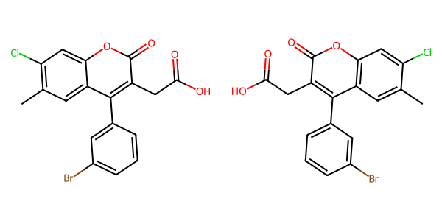

## US20060154945A1_p0022_x1376_y0638_c00089

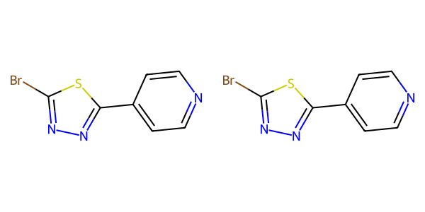

## US20070265270A1_p0034_x1487_y0703_c00137

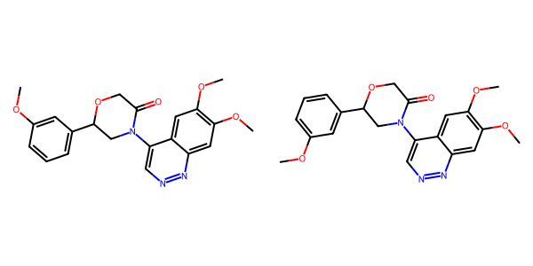

## US20070105909A1_p0022_x0484_y1966_c00048

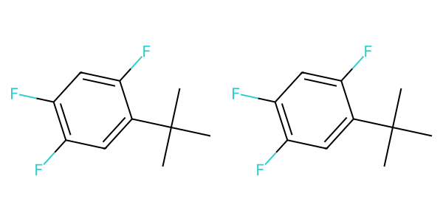

## US20070117785A1_p0057_x1308_y2609_c00111

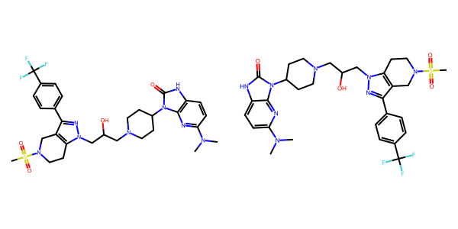

## US20050004369A1_p0034_x0445_y0632_c00068

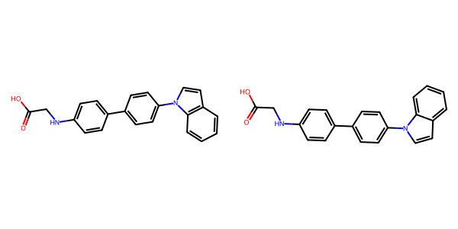

## US20060122222A1_p0016_x0482_y1084_c00046

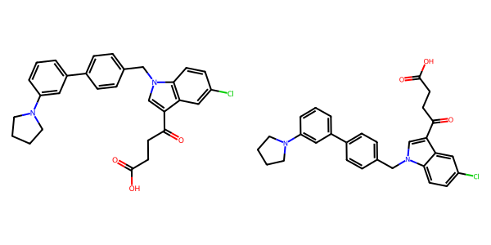

## US20050113580A1_p0041_x1328_y1816_c00063

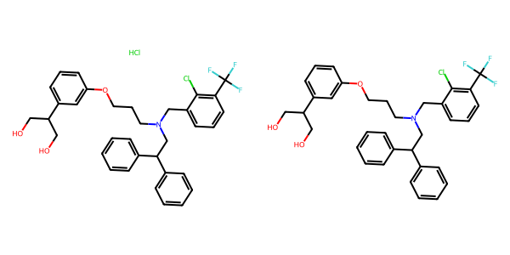

## US20060154945A1_p0017_x0402_y1439_c00058

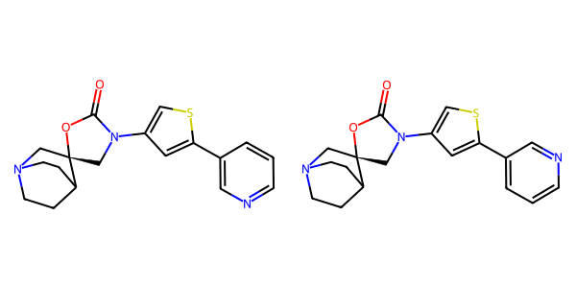

## US20050288357A1_p0057_x0482_y0671_c00110

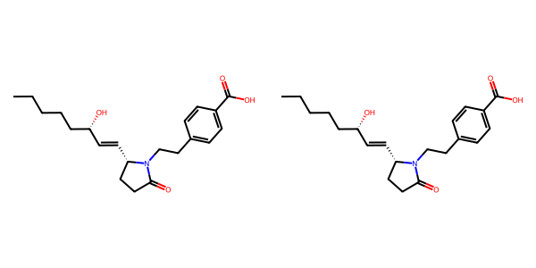

## US20050004369A1_p0016_x1307_y1730_c00021

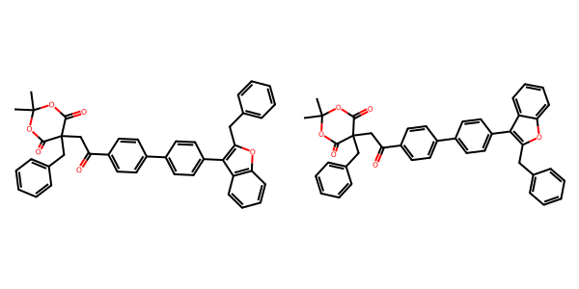

## US20070155803A1_p0017_x0328_y2222_c00024

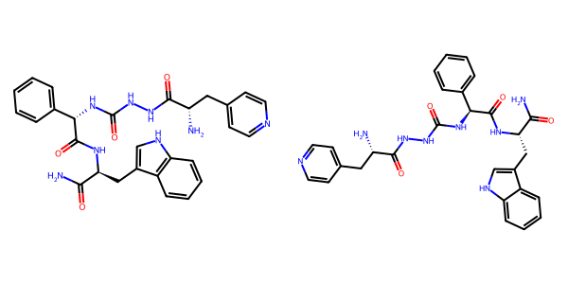

## US20060154945A1_p0014_x1375_y1924_c00045

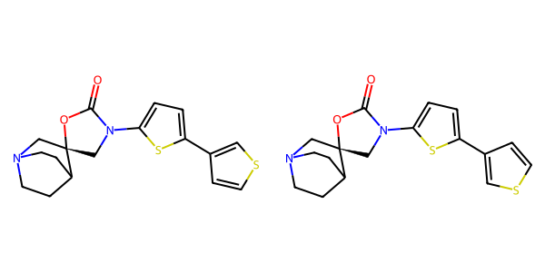

## US20070179154A1_p0041_x0610_y2041_c00052

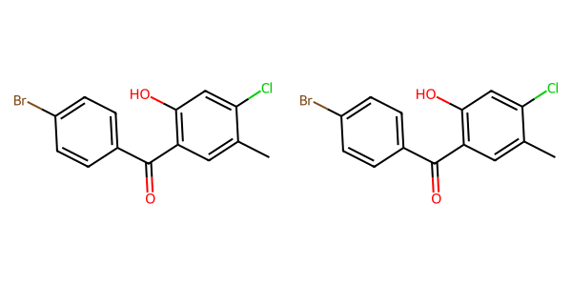

## US20050009817A1_p0031_x0485_y1946_c00088

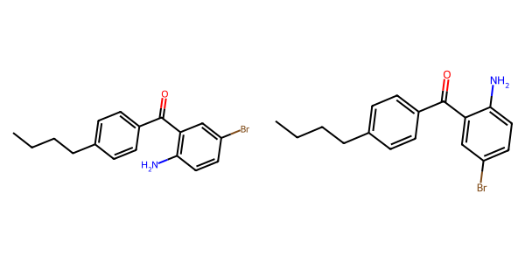

## US20070117785A1_p0045_x1306_y0895_c00086

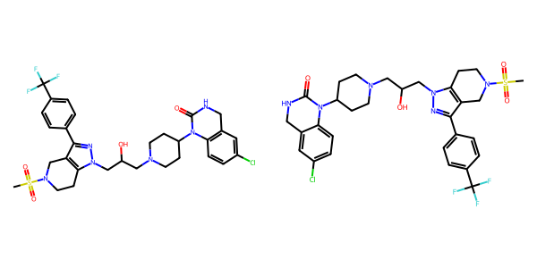

## US20060154945A1_p0021_x0402_y1074_c00081

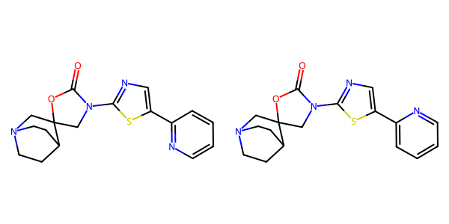

## US20060122222A1_p0007_x0571_y1069_c00005

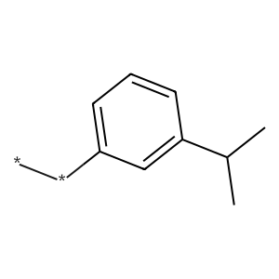

## US20050288357A1_p0034_x1487_y0954_c00064

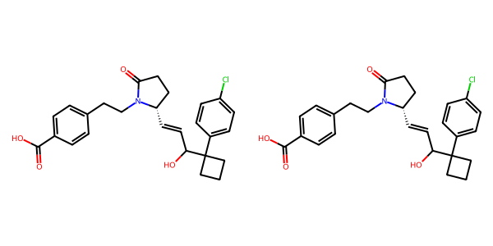

## US20070265270A1_p0025_x1377_y2537_c00102

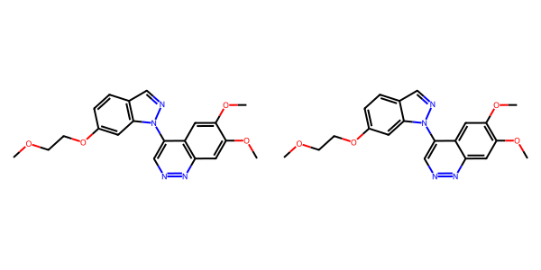

## US20070049758A1_p0018_x0521_y0695_c00017

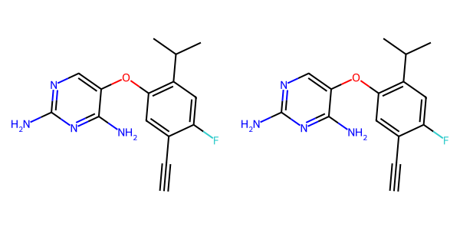

## US20070270434A1_p0022_x1376_y2616_c00060

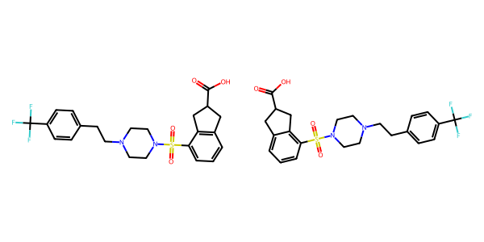

## US20070179154A1_p0041_x1376_y2190_c00054

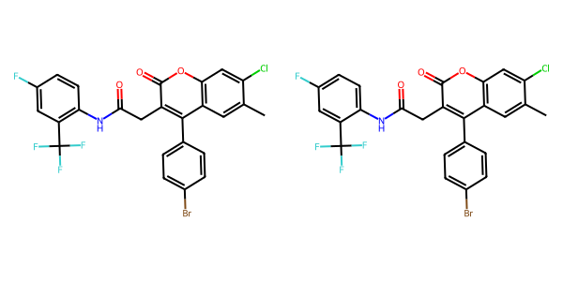

## US20040266789A1_p0036_x0328_y1889_c00061

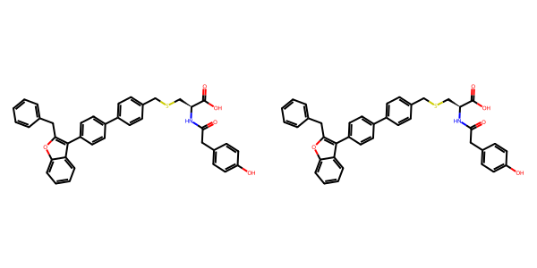

## US20070155803A1_p0025_x1439_y2371_c00060

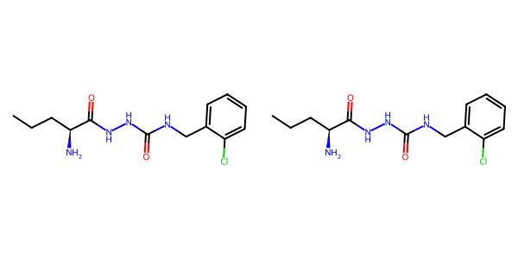

## US20070265270A1_p0026_x1451_y2335_c00106

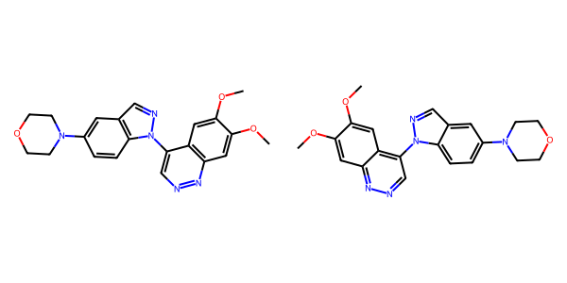

## US20040266789A1_p0011_x0769_y1471_c00016

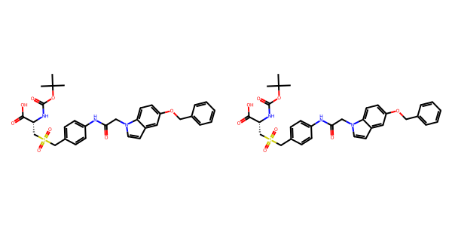

## US20050009817A1_p0015_x0592_y2614_c00053



## US20040254236A1_p0007_x0600_y0538_c00001

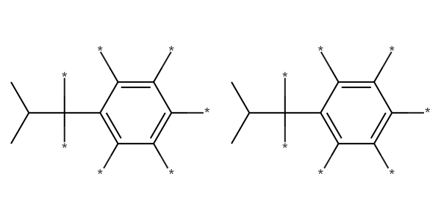

## US20070117785A1_p0035_x0337_y1712_c00073

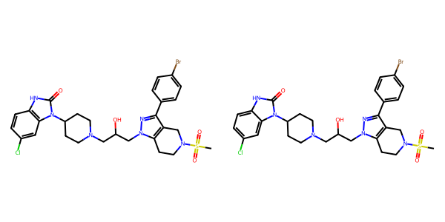

## US20070155803A1_p0022_x0466_y2476_c00043

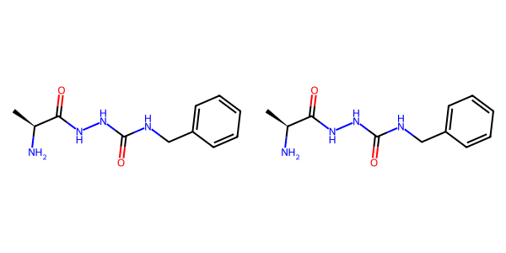

## US20070270434A1_p0018_x1376_y1817_c00042

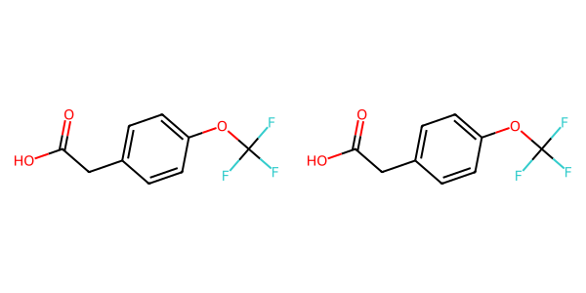

## US20050288357A1_p0051_x1488_y0880_c00097

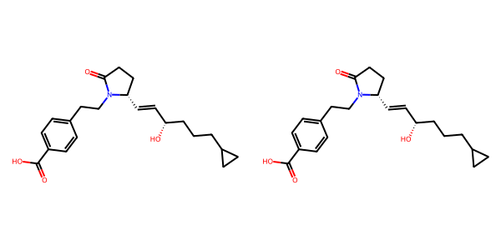

## US20060154945A1_p0016_x0402_y2741_c00054

